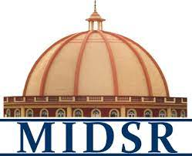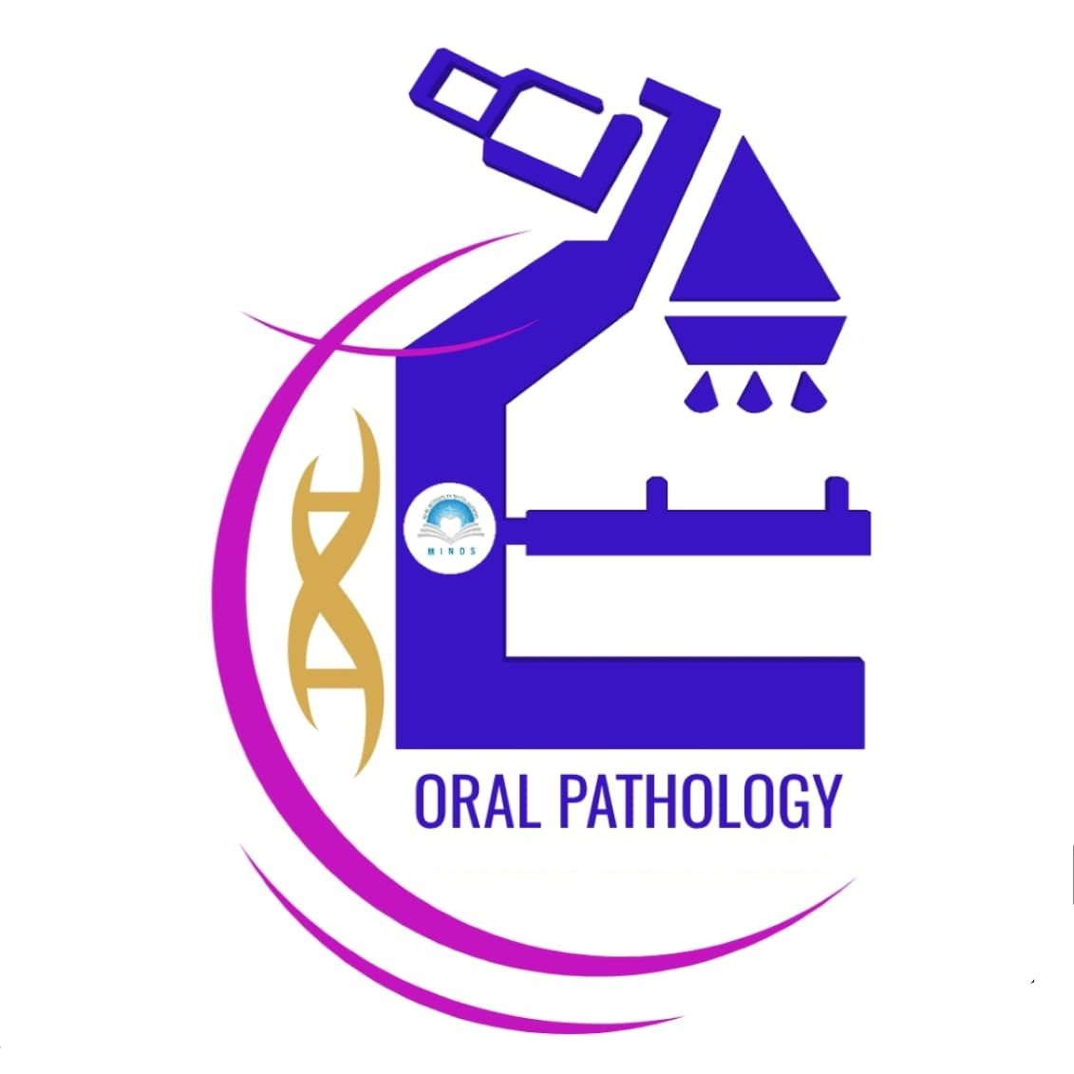**REPORT**

***Department of oral Pathology and Microbiology day celebration***

***No Tobacco Day-2024***

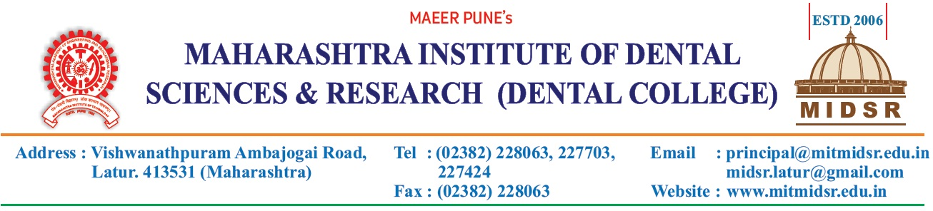

On occasion of World No Tobacco Day, dept of oral Pathology & Microbiology in association with Dept of Public Health Dentistry organized various activities and competitions for BDS undergraduate students on 1st of June 2024 (Saturday).

Program was conducted by Dr. Varsha Sangle, Dr Smita Chaure, Dr. Dipali Gundre And Dr. Pragya Bhatnagar from dept of Oral Pathology and Dr Ashwini Biradar, Dr Nehal Pawar and Dr Prakash Kasbe from dept of Public Health Dentistry.

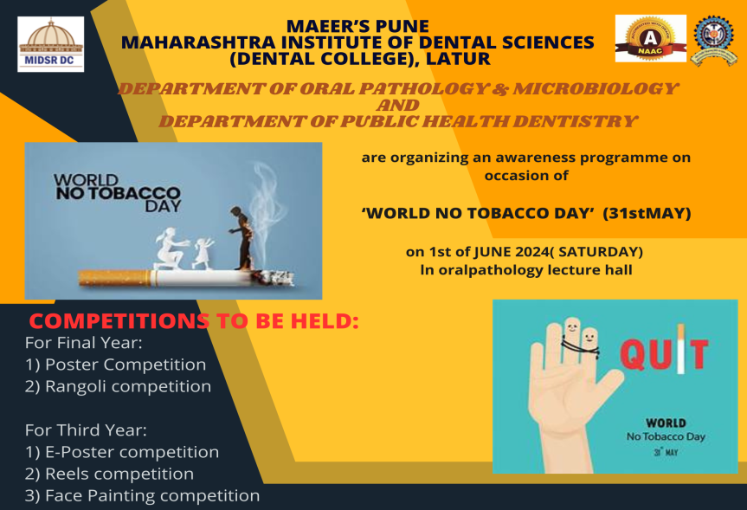

The host of the day was Dr Pragya Bhatnagar. The Day started with inaugural Vishwashanti Prayer.

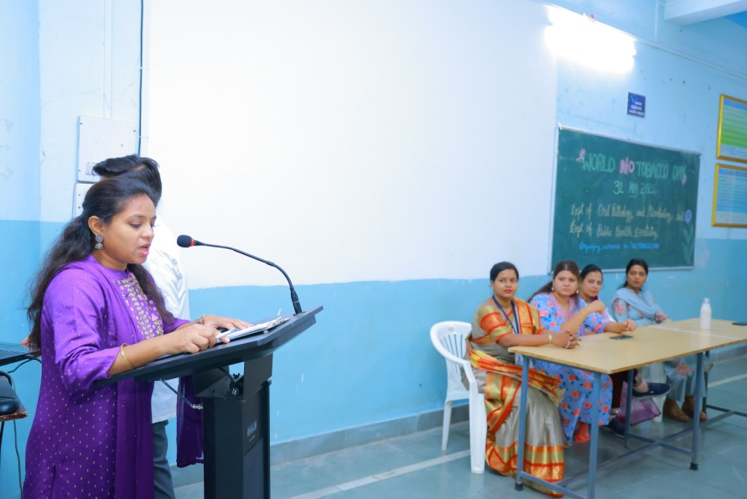

**Dr Pragya Bhatnagar as a host of event**

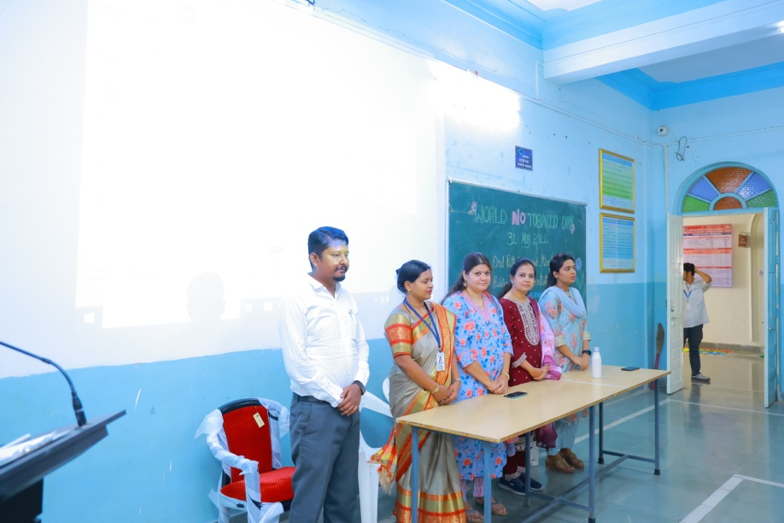

**Vishwashanti Parayer**

Following that the respective HOD from both departments addressed students regarding the importance of Tobacco awareness in young population.

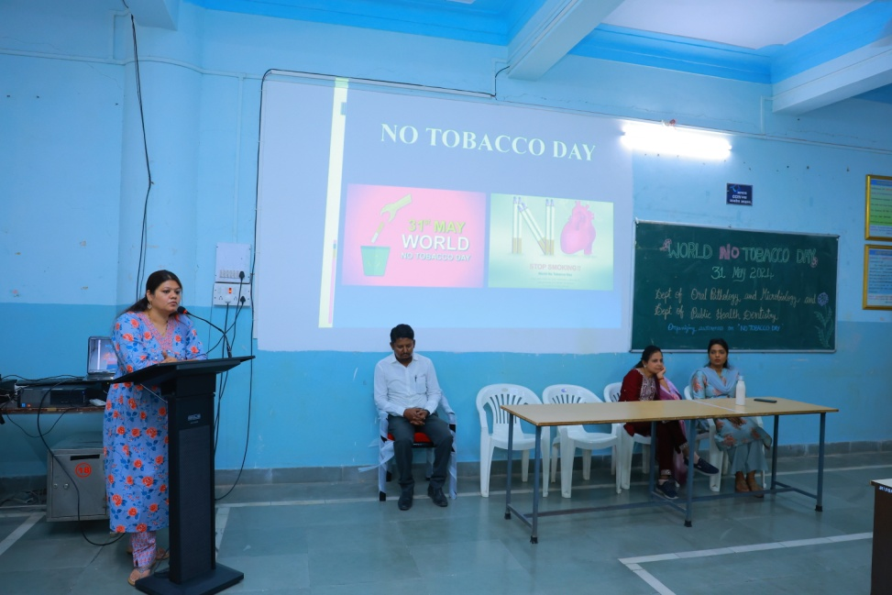

**Dr Varsha Sangle addressing students about effects of tobacco in oral cavity**

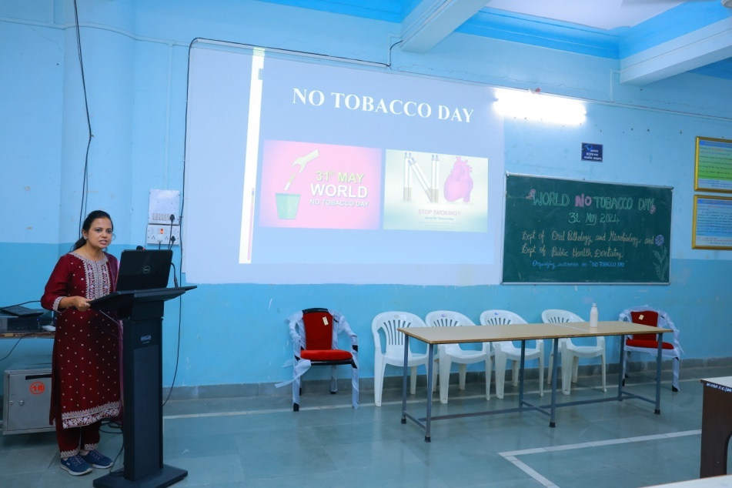

**Dr Ashwini Biradar talking about tobacco habit awareness in youths**

After that the participants of e-Posters, Reel competition, Poster competition and Face painting presented their creativity to the judges.

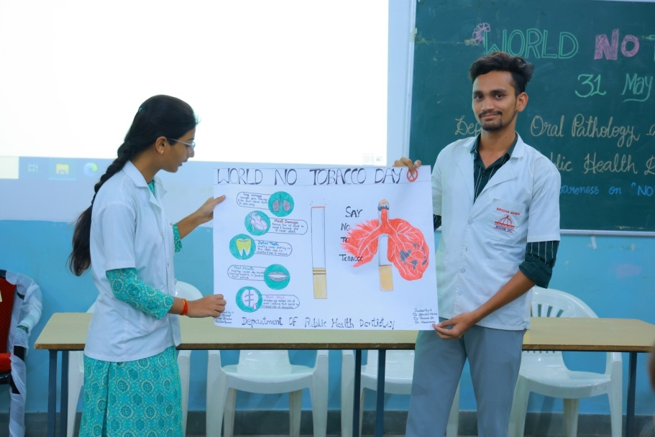

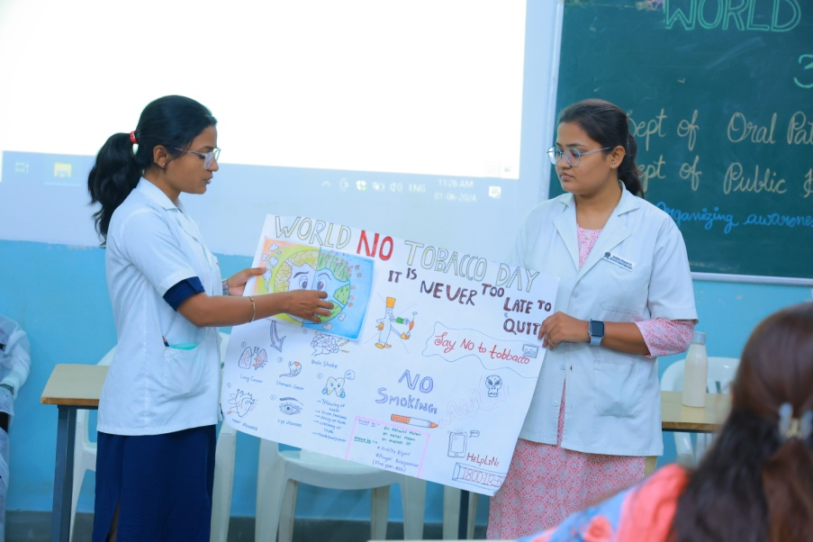

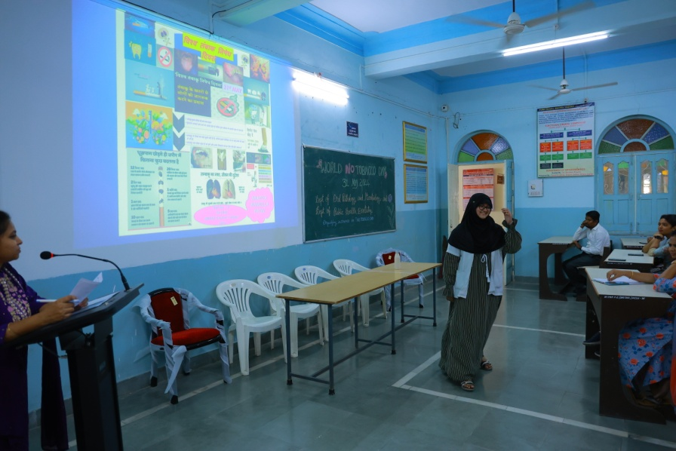

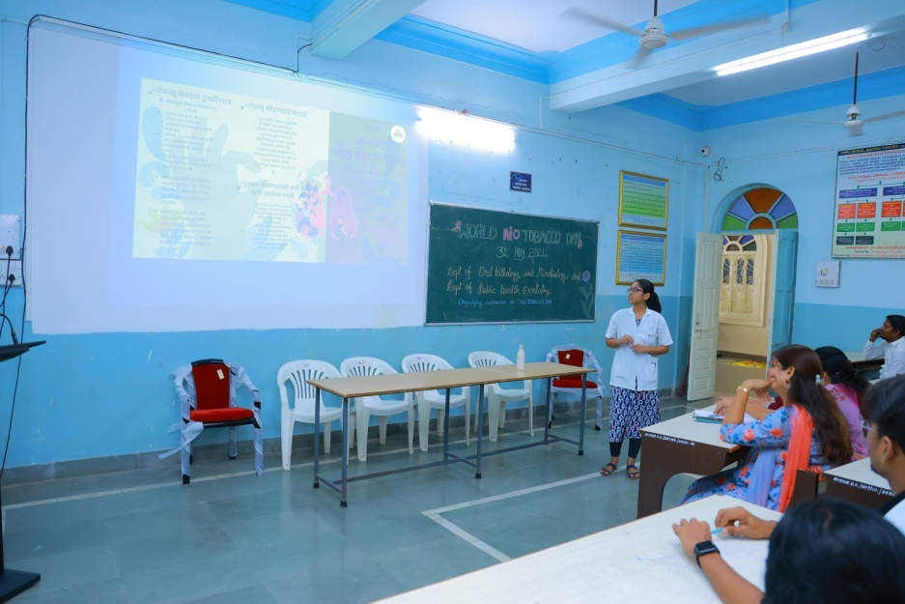

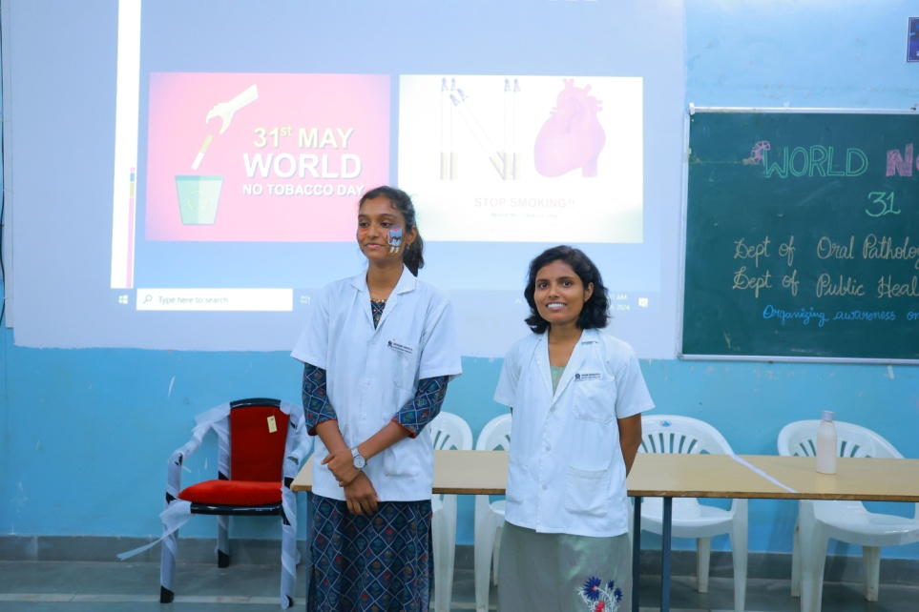

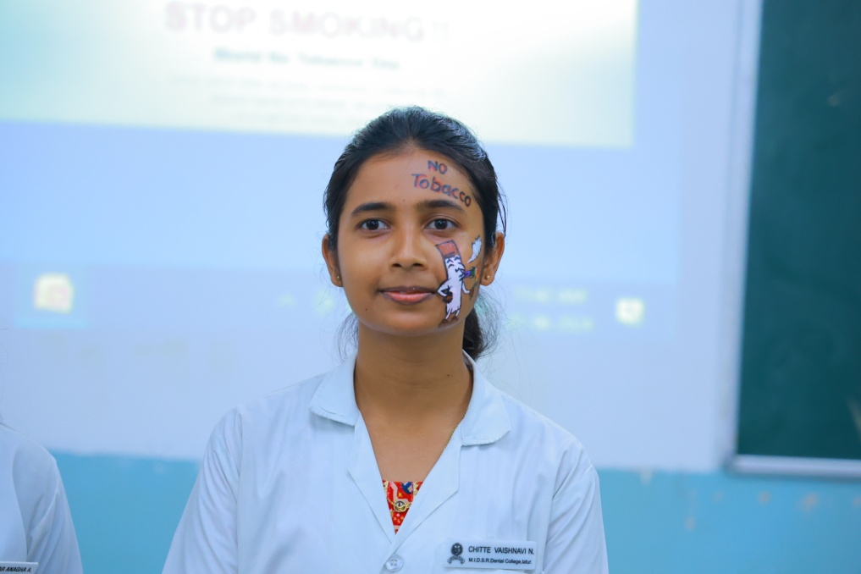

Rangoli competition was judged by Dr Vijayalakshmi ma’am.

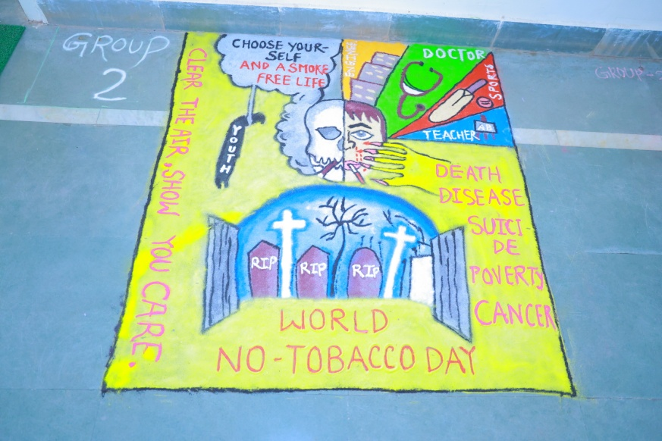

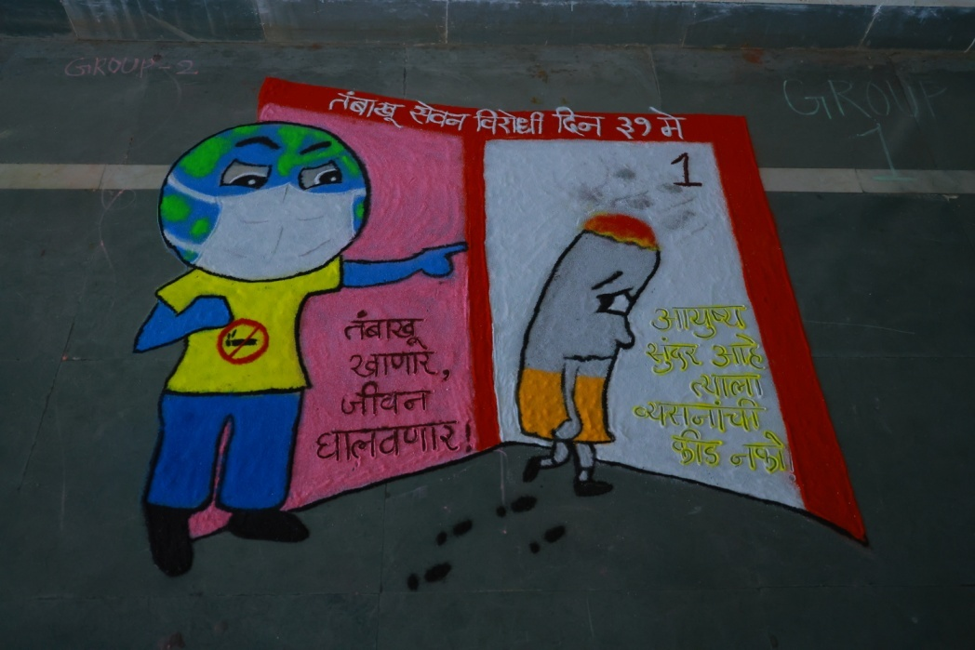

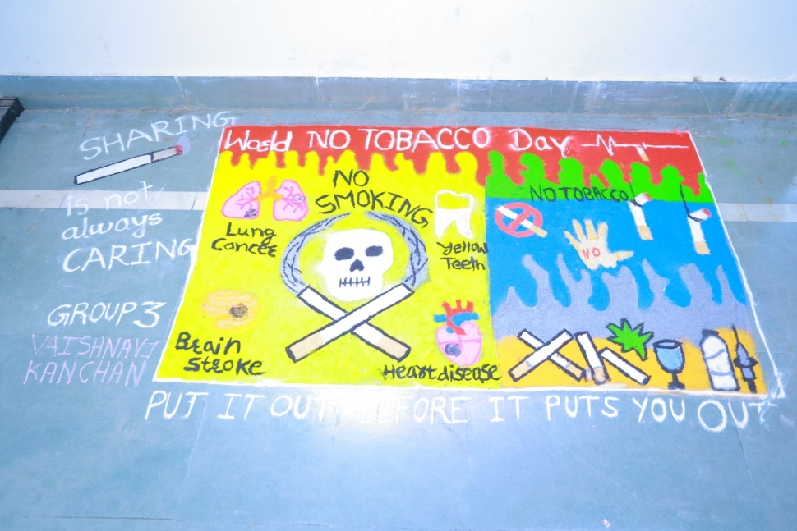

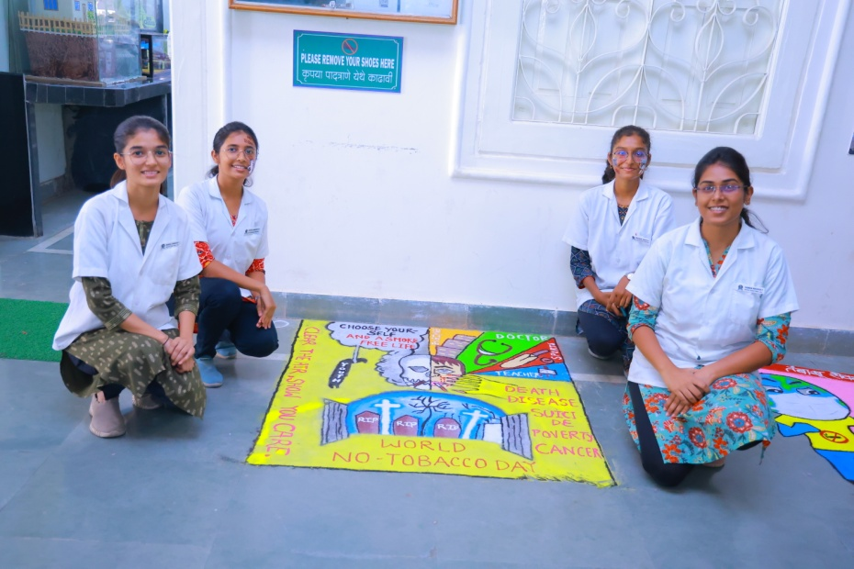

**Winners of Rangoli Competition**

All the winners were feliciteted by Dr Yatishkumar sir by giving certificates**.**

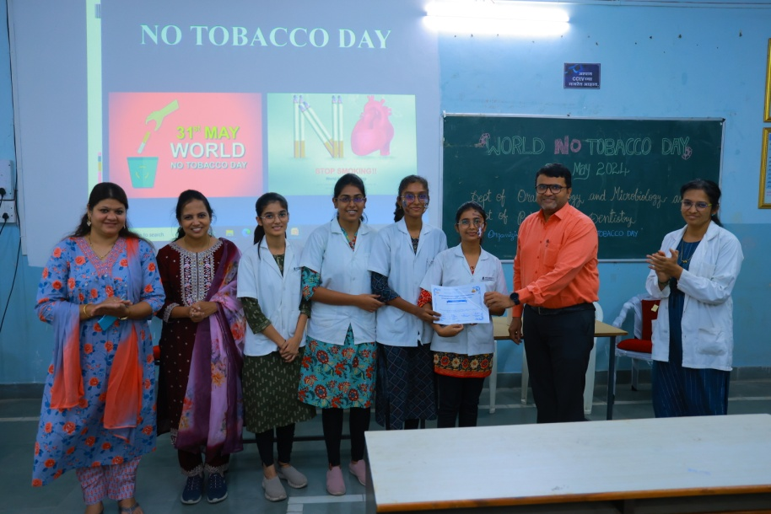

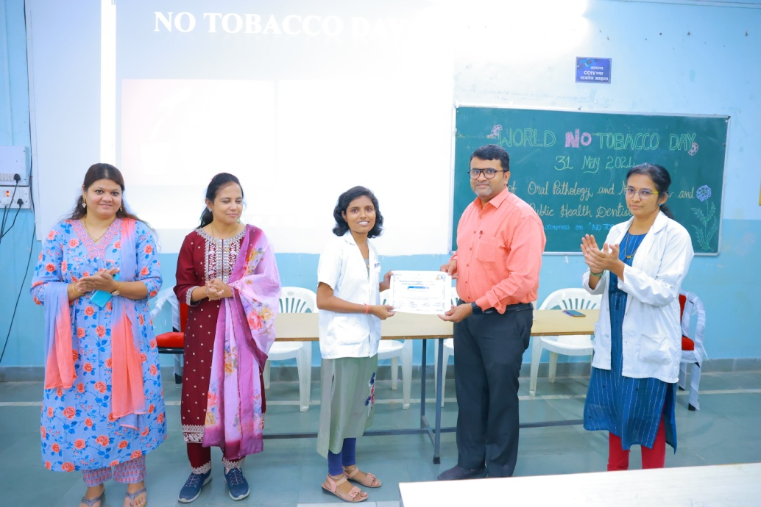

Vote of thanks was given by Dr Dipali Gundre.

This was followed by information pamphlet distribution to the patients.

