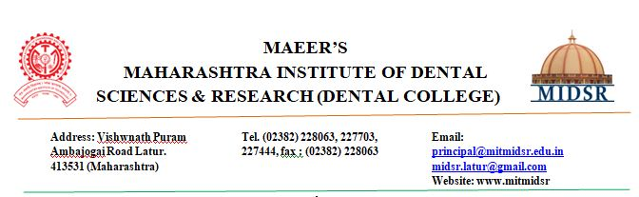**DEPARTMENT OF ORAL PATHOLOGY**

**Methods of the assessment of learning outcomes:**

* Mentoring students by the assigned staff
* Record keeping of students progress
* Regular parent teacher meeting
* Enforcement of minimum attendance (Theory-75% & Practical-80%)
* Posting quota
* Class assignments
* Seminars
* Special Case discussions
* Short studies
* Post end exams
* Conducting regular theory and practical exams

**The assessment of graduate attributes:**

* Subject Knowledge
* Skill Development
* Behavior with staff and colleague
* Communication skills
* Interest towards research
* Professional Ethics

These attributes are monitored and enforced by regular theory classes, seminars, projects, case discussions, assignments, interdepartmental discussions. The outcome is assessed through theory exams, practical exams and viva-voce.