SOP – TEACHING AND LEARNING

SOP – CURRICULUM
Purpose:
To elaborate the procedure for revising the curriculum and syllabus.
Objective:
The procedure for revising /or deciding the curriculum and syllabus.
Responsibility:
- All the teaching staff members
- HOD
- Principal

SYLLABUS: THEORY AND PRACTICAL
FOR FIRST BDS:
1] Dental anatomy,embryology and dental histology :
Inroduction –
Dental anatomy including embryology and oral histology - a basic dental sciences and clinical implications.
Skills :
The student should acquire basic skills in:
1] Carving of permanent teeth in wax.
2] Microscopic study of oral tissues.
3] Identification of deciduous and permanent teeth.
4] Age estimation by patterns of teeth eruption from plaster casts of different age groups.
TOPICS TO BE COVERED:
1] Tooth morphology –
1. Introduction to tooth morphology
Dentition, types of teeth and functions, tooth numbering systems, tooth surfaces, their junctions, line angles and point angles, definition of terms used in dental morphology, contact areas and embrasures, clinical significance.
2. Morphology of permanent teeth
Description of individual teeth along with their endodontic anatomy, chronology of development, differences between similar classes of teeth and identification of individual teeth.
3. Morphology of deciduous teeth
Differences between deciduous and permanent teeth. Description of individual teeth along with their endodontic anatomy, chronology of development, differences between similar classes of teeth and identification of individual teeth.
4. Occlusion
2] Oral Embryology :
1. Development of face, jaws, lip, palate and tongue with applied aspects.
2. Development of teeth: Epithelial mesenchymal interaction, different stages of development of crown, root.
3. Shedding of teeth
3] Oral Histology:
1. Detailed microscopic study of;
- Enamel,
- Dentin
- Cementum
- Pulp
- Periodontal ligament
- Alveolar bone
- Age changes and applied aspects.
3. Detailed microscopic study of oral mucosa, keratinization, clinical parts of gingiva, age changes, histological changes and applied aspects.
4. Salivary glands
5. TMJ joint
6. Maxillary sinus
7. Processing of hard and soft tissue specimens for microscopic study. Ground sections, decalcified sections and routine staining procedures.
8. Basic histochemical staining patterns of oral tissues.
9. Saliva
10. Theories of mineralization
11. Physiology of taste
12. Physiology of speech

FOR THIRD BDS:
1] ORAL PATHOLOGY AND MICROBIOLOGY -
- Microscopic study of common lesions affecting oral tissues through microscopic slides
- Study of teeth anomalies through tooth specimens and plaster casts
- Study of disease process by surgical specimens.
- Study of hematological preparations.
Topics covered:
1] Introduction
2] Developmental Disturbances of Oral & Paraoral Structure
- Introduction to developmental disturbances,
- Developmental disturbances of teeth – size, shape, number, structure and eruption of teeth and clinical significance.
- Developmental disturbances of jaws
- Developmental disturbances of oral soft tissues – lips, palate, tongue, gingival salivary glands
3] Odontogenic Cysts
4] Odontogenic Tumour
5] Dental caries:
- Etiopathogenesis, microbiology, clinical features, diagnosis, histopathology .immunology,prevention of dental caries.
6 ] Pulp and periapical pathology and osteomyelitis
- Etiopathogenesis, microbiology, clinical features, diagnosis, histopathology and radiological features of pulp and periapical pathology.
7] Peridontal diseases
- Etiopathogenesis, microbiology, clinical features, diagnosis, histopathology and radiological features of gingivitis, gingival enlargement and periodontitis.
8] Viral Infection
9] Bacterial infection
10] Viral infection
11] Tumors of oral cavity –
A] Benign epithelial
B] Benign mesenchymal
C] Malignant epithelial
D] Malignant mesenchymal
E] Nerve tissue tumors
12] Regressive alterations of oral cavity
13] Salivary gland tumors –
- Pleomorphic adenoma, warthin tumor, oncocytoma, adenoid cystic carcinoma, mucoepidermoid carcinoma, acinic cell carcinoma
14] Non neoplastic salivary gland tumors
- Sialothiasis ,sialosis,sialadenitis,xerostomia
15] Mucocutaneous diseases
- Etiopathogenesis,clinical features ,histopathology of lichen planus, lupus erythematous, pemphigus, pemphigoid ,erythema multiforme, psoriasis, scleroderma,ectodermal dysplasia,white sponge nevus.
16] Diseases of nerves
17] Diseases of maxillary sinus
18] Diseases of TMJ
19] Forensic odontology :
- Introduction, definition ,aims and scope
- Sex and racial differences in tooth morphology
- Dental DNA methods
- Bite marks,rugae marks, and lip prints
20] Biopsy:
- Types of biopsy, cytology, Histochemistry and frozen sections in diagnosis of oral diseases.

WEEKLY TEACHING SCHEDULE OF DEPARTMENT OF ORAL PATHOLOGY
DAY | DATE | TIME | YEAR | Lecture/Practical | TOPIC | STAFF SIGN
MONDAY |  | 4-5 | I BDS | Practical
TUESDAY |  | 12-1 | I BDS | Lecture
WEDNESDAY |  | 9-10 | II BDS | Lecture
WEDNESDAY |  | 12-1 | I BDS | Lecture
THURSDAY |  | 9-11 | III BDS | Practical
THURSDAY |  | 11-12 | III BDS | Lecture
THURSDAY |  | 2-4 | I BDS | Practical
FRIDAY |  | 9-11 | III BDS | Practical
FRIDAY |  | 11-12 | III BDS | Lecture
FRIDAY |  | 2-5 | I BDS | Practical
SATURDAY |  | 10-11 | III BDS | Lecture
SATURDAY |  | 11-1 | I BDS | Practical

1] THEORY
LECTURES DISTRIBUTION FOR I BDS
SR. NO. | DATE | TOPICS OF LECTURE | NAME OF TEACHING STAFF | SIGN
1 |  | Definitions and terminologies
2 |  | Histotechniques
3 |  | Special stains & cells
4 |  | Development of face
5 |  | Tooth numbering system
6 |  | Traits
7 |  | Development of tooth
8 |  | Enamel
9 |  | Dentin
10 |  | Cementum
11 |  | Pulp
12 |  | Periodontal ligament
13 |  | Alveolar bone
14 |  | Oral mucous membrane
15 |  | Salivary glands
16 |  | Eruption
17 |  | Shedding
18 |  | Occlusion
19 |  | Diff. bet deciduous-permanent
20 |  | Maxillary central incisors
21 |  | Maxillary lateral incisors
22 |  | Mandibular central incisors
23 |  | Mandibular lateral incisors
24 |  | Maxillary canines
25 |  | Mandibular canines
26 |  | Maxillary 1st premolars
27 |  | Maxillary 2nd premolars
28 |  | Mandibular 1st premolars
29 |  | Mandibular 2nd premolars
30 |  | Maxillary 1st molars
31 |  | Maxillary 2nd molars
32 |  | Mandibular 1st molars
33 |  | Mandibular 2nd molars
34 |  | Basic cells
35 |  | Character of deciduous teeth
36 |  | Blood, nerve, lymph supply of face
37 |  | Composition of saliva
38 |  | Functions of saliva
39 |  | Physiology of saliva
40 |  | Muscles of mastication
41 |  | Deglutition
42 |  | Speech
43 |  | Development of tongue
44 |  | Development of mandible
45 |  | Development of maxilla
46 |  | Trigeminal nerve
47 |  | Facial nerve
48 |  | Muscles of facial expression
49 |  | Histochemistry
50 |  | TMJ
51 |  | Calcium, phosphorous, fluoride metabolism
LECTURE DISTRIBUTION FOR THIRD BDS
SR. NO. | DATE | TOPICS OF LECTURE | NAME OF TEACHING STAFF | SIGN
1 |  | Stains
2 |  | Developmental Disturbance of tooth
3 |  | Benign Epithelial Tumor
4 |  | Premalignant Lesion
5 |  | Premalignant condition
6 |  | Malignant epithelial tumor
7 |  | Benign connective tissue tumor
8 |  | Malignant connective tissue tumor
9 |  | Nerve tissue tumor
10 |  | Salivary gland tumor
11 |  | Odontogenic cyst
12 |  | Odontogenic tumor
13 |  | Bacterial infection
14 |  | Fungal infections
15 |  | Dental caries
16 |  | Pulp and Periapical lesion
17 |  | Regressive alteration of the tooth
18 |  | Diseases of bone
19 |  | Diseases of skin
20 |  | Physical injury

2] PRACTICAL:
FIRST YEAR DENTAL ANATOMY JOURNAL BATCH INCHARGE
Roll No. | Staff Incharge | Signature
1-50 | Dr. Smita chaware
51-100 | Dr. Varsha Sangle

FIRST YEAR DENTAL HISTOLOGY JOURNAL BATCH INCHARGE
Roll No. | Staff Incharge | Signature
1-35 | Dr. Smita chaware
35-70 | Dr. Varsha Sangle
71-100 | Dr. Anuja maniyar /Dr.shah Nishat

THIRD YEAR ORAL PATHOLOGY JOURNAL BATCH INCHARGE
Roll No. | Staff Incharge | Signature
1-25 | Dr. Varsha Sangle
26-50 | Dr. Smita Chaware
51-77 | Dr. Anuja maniyar /Dr.shah Nishat

SOP – EXAMINATION
Purpose:
Internal assessment examinations and university exams are conducted in subjects according to regulations set by an MUHS Nashik.
Objective:
To elaborate the procedure for conducting internal assessment exams.
Responsibility:
- All the teaching staff members
- HOD
- Principal
Procedure
- The academic committee decides the internal assessment examination and university examination according to the guidelines of MUHS, Nashik
- The academic committee prepares the annual academic calendar and schedule of internal assessment examination before the start of academic year.
- 3 Internal assessment exams per year are conducted for first year, third year BDS Students in our department.
- Betterment exam are conducted according to the academic committee /or norms of the university

EXAMS:

INTERNAL EXAMS
THEORY
- A Separate internal time table is prepared based on university exam schedule.
- Three internal assessment exams are taken for each subject that is for I BDS Dental anatomy and histology and for III BDS Oral pathology and microbiology.
- The examination schedule is circulated to all the HOD S’ and Principal office.
- Exam schedule is displayed in all departmental notice boards.

- I and II Internal Examination carries 60 marks and III Internal exam carries 80 marks in both theory as well as practical exams. (below table is showing the distribution of theory and practical marks distribution)
- First Internal assessment is conducted 2 months after joining the college.
- Second internal assessment exam is conducted after 2 months covering half the portion of the subject.
- Prelim /third internal assessment exam is conducted in April 1st week covering all the topics
- While conducting the exam, first display exam timetable on notice board and then contact student section for hall arrangement. For theory exam duration of 3 hrs.

PRACTICAL:
Display of commencement dates of practical exams.
Conduction of practical exam is carried out in departmental practical lab during the practical hours of Ist and IIIrd BDS students.
During internal practical exams, theory viva is taken of all Ist and IIIrd BDS students.
Revision practical is conducted before each internal exam during practical classes.
BELOW TABLE IS SHOWING DISTRIBUTION OF THEORY AND PRACTICAL MARKS
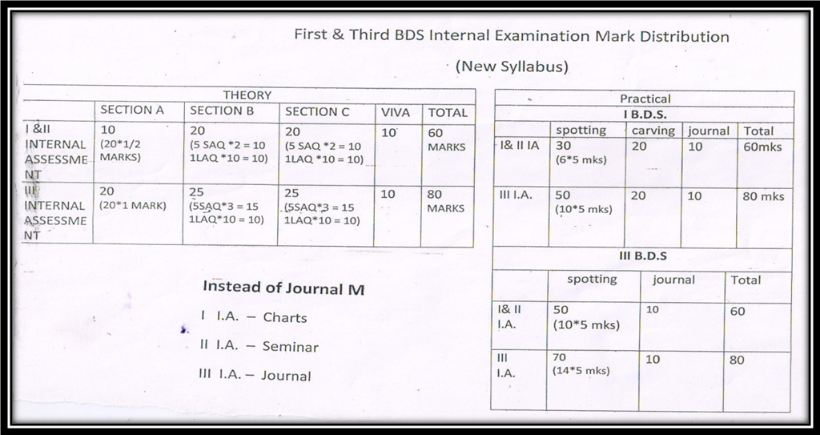
Departmental evaluation of internal exam marks:
- Evaluation of internal marks is done by respective staff members of the department
- In our department evaluation of intemal marks for Ist BDS is done by Dr. Smita Chaware and for IIIrd BDS by Dr. Varsha Sangle.
- Average of the marks obtained in both the examinations is converted to average internal assessment marks according to university norms.Showing of mark entry register and confirmation by student’s signature prior to sending to university. Receiving queries ,doubts and problems in the mark solved by respective incharges.
- BELOW TABLE IS SHOWING QUESTION PAPER SETTING AND CHECKING METHODOLOGY FOLLOWING IN OUR DEPARTMENT:
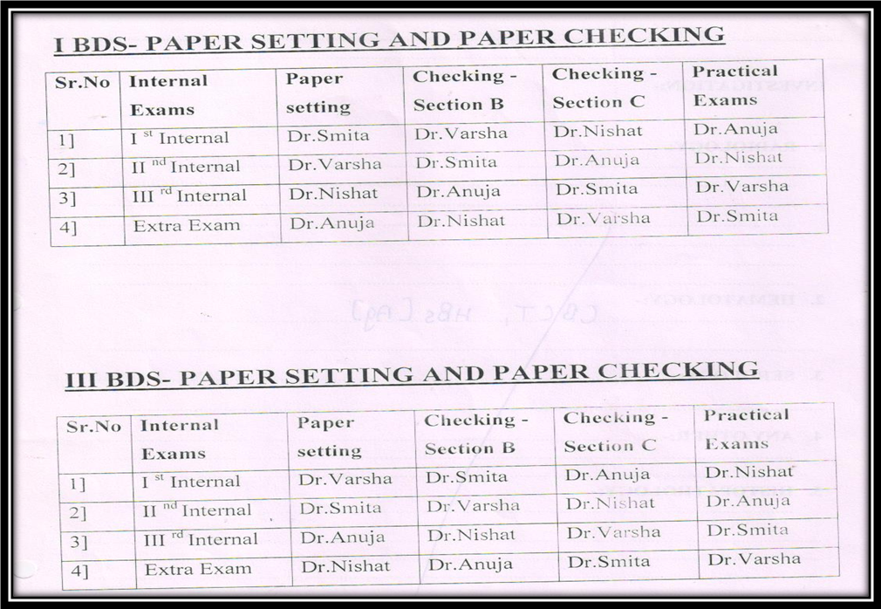

UNIVERSITY EXAMS:
THEORY:
University theory examination is done by the university through the MUHS University conducted at the end of academic year.
PRACTICAL:
- Once the timetable is given by university for practical exams, first display exam timetable on notice board according to batches.
- Display of revision practical timetable and conduction of revision practical batch wise.
- Revision practical is conducted in the departmental practical hall and journal certification is done.
- University practical exam is conducted in the departmental practical hall according to batches allotted by university.

BETTERMENT EXAM:
Betterment exam is conducted after third internal assessment exam.
Betterment exam applicable for:
- Those who have not given 1st and 2nd internal theory/ practical exam on basis of medical or genuine reasons.
- Those students who have informed their absence of internal assessments to class incharges as well as HOD’s.
- For repeater students.
Procedure:
- Display of timetable on the departmental noticeboard after third internal assessment exam
- Betterment Theory and Practical Exam is taken in the departmental practical hall.
- Evaluation of betterment exam marks is done by respective staff incharges.

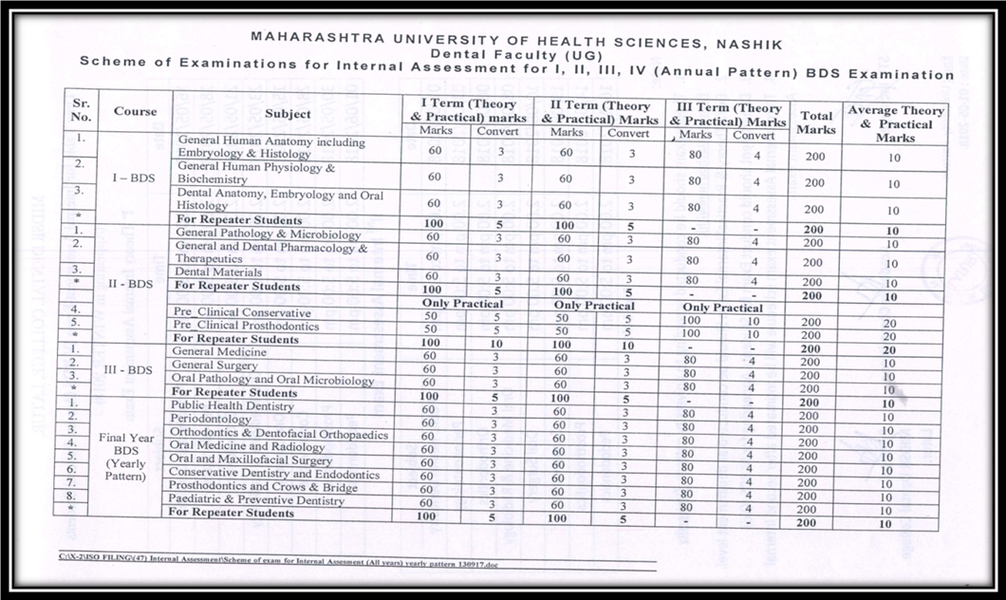

SOP- STUDENT
ATTENDANCE
Purpose:
To achieve their performance potential through level of attendance.
Objective:
To support the implementation of fair attendance monitoring policy.
Responsibility
- All students
- All the teaching staffs
- HOD
- Principal

ATTENDANCE
- No Student shall be permitted to appear for examinations unless he/she has attended the course in the subject.
- A candidate is required to show a minimum of 75% of attendance in theory and 80% of attendance in practical classes, individual in each subject so as to appear in the university examination.
PROCEDURE:
1) Maintain a record of the daily attendance of admitted students.
2) Maintain uniformity and consistency in implementation among the departments.
3) The respective department ensures that the attendance records are maintained in order and that the warning letters are issued to the defaulting students at the end of every month.
4) In addition to this in the first week of every month for the previous month defaulters list should be display on department notice board.
5) If the same student finds defaulter consistently for more than two months, then such students should called along with parent, wherever necessary to meet respective incharge, HOD.

- College will take following action-
1) Inform the importance of attendance and classes to the students.
2) Informed the students and parents about the rules of college and about the attendance requirement during academic year.
3) Inform the parents about shortage of attendance.
4) Inform the students to submit medical certificate supporting the reason for taking leave and when leave is availed.
5) Warn the students and parents if they are not attending classes regularly and maintain record of such students.

QUOTA:
- FIRST BDS STUDENT QUOTA :

Department of Oral and Maxillofacial Pathology which teaches the oral histology for the first years in view of making the first year students strong in the basics of embryology, histology and tooth morphology. At the beginning of the academic year, initial orientation to the subject is given. Basic topics to dental anatomy and histology covered in the theory and corresponding microscopic slides are shown to them in practical classes. At the end of each theory topics students draw diagrams of the chapter, give viva. With regards to practical aspect, the histology practical classes are conducted thrice in a week. Microscopic slides corresponding to theory topic that is in progress is focused in microscope to students which can be well correlated with theory knowledge for better understanding of the topics.
Practical class also focuses on tooth morphology, where students are given through knowledge on types, chronology of dentition and tooth numbering system before carving classes. After acquiring basic knowledge in tooth morphology, the staff members give a detailed practical demonstration of individual tooth carving along with videos played in the departmental projector. Tooth morphology practicals also focuses on teaching individual natural tooth with morphology, study models for age estimation which is a part of examination curriculum. The students are divided into batches for the entire academic year with individual staff allotted to them and they have to show all the histology and tooth morphology works to their respective staffs, get signature after completing each exercise and finally at the end of academic year, the staff incharge and HOD signature to be received in the record and submitted for the final university examination.

DENTAL HISTOLOGY JOURNAL
Sr. No. | Topic | Date | Grade | Staff sign
1 | Stain
2 | Tissue
3 | Development of tooth
4 | Enamel
5 | Dentin
6 | Pulp
7 | Cementum
8 | Periodontal ligament
9 | Bone
10 | Salivary gland
11 | Oral mucous membrane

DENTAL ANATOMY JOURNAL
Sr.No | Topic | Date | Grade | Staff Sign
1 | Definitions and terminologies
2 | Carving of maxillary permanent central incisor
3 | Carving of maxillary permanent lateral incisor
4 | Carving of maxillary permanent canine
5 | Carving of maxillary permanent 1st premolar
6 | Carving of maxillary permanent 2nd premolar
7 | Carving of maxillary permanent 1st molar
8 | Carving of maxillary permanent 2nd molar
9 | Carving of mandibular permanent central incisor
10 | Carving of mandibular permanent lateral incisor
11 | Carving of mandibular permanent canine
12 | Carving of mandibular permanent 1st premolar
13 | Carving of mandibular permanent 2nd premolar
14 | Carving of mandibular permanent 1st molar
15 | Carving of mandibular permanent 2nd molar

SECOND BDS STUDENTS QUAOTA
Department of Oral and Maxillofacial Pathology, after imparting basic histological and embryological knowledge in first year, the second year curriculum is designed in view of making basics stronger. The theory classes are scheduled to cover few basic topics in second year. To improve their basic pathology knowledge, seminar topics are allotted to each student. The students are given seminar topics at the beginning of the academic year. They have to present their seminars for the entire academic year in front of in charge staff allotted to them, get signature after completing the presentation of seminar.

SEMINAR LIST FOR SECOND BDS STUDENT

SR NO. | DATE OF PRESENTATION | NAME OF STUDENT | TOPIC ALLOTED | STAFF  SIGN
1. |  |  | Terminologies In Pathology
2. |  |  | Acute Inflammation Part-1
3. |  |  | Acute Inflammation Part-2
4. |  |  | Chronic Inflammation
5. |  |  | Chemical Mediators
6. |  |  | Repair And Regeneration
7. |  |  | Wound Healing Part-1
8. |  |  | Wound Healing Part-2
9. |  |  | Factors Affecting Wound Healing
10. |  |  | Granuloma
11. |  |  | Tuberculosis
12. |  |  | Tmj Disorders
13. |  |  | Lymphatic Drainage
14. |  |  | Platelet Disorders
15. |  |  | Wbc Disorders Part-1
16. |  |  | Wbc Disorders Part-2
17. |  |  | Rbc Disorders Part-1
18. |  |  | Rbc Disorders Part-2
19. |  |  | Vitamin Deficiency Part-1
20. |  |  | Vitamin Deficiency Part-2
21. |  |  | Hormonal Disorders
22. |  |  | Developmental Disturbances Of Jaw
23. |  |  | Disturbances In Mineral ,Protein,Carbohydrate Metabolism
24. |  |  | D/D –Teeth-Size,Number
25. |  |  | Pathologic Calcifications
26. |  |  | Diseases Of Nerve
27. |  |  | Maxillary Sinusitis
28. |  |  | Drug Allergy
29. |  |  | Diseases Of Muscles
30. |  |  | Developmental Disturbances Of Tongue
31. |  |  | Difference B/W Benign & Malignant Tumours
32. |  |  | Biopsy
33. |  |  | Regressive Alterations Of Teeth
34. |  |  | Diseases Of Pulp
35. |  |  | Diseases Of Periapical Tissues
36. |  |  | Viral Infections
37. |  |  | Fissural Cyst Of Oral Lesion
38. |  |  | Epidermal Inclusion Cyst
39. |  |  | Palatal & Alveolar Cyst Of Newborn
40. |  |  | Difference Between Benign & Malignant Tumour
41. |  |  | Tnm Classification
42. |  |  | Carcinoma Of Tongue
43. |  |  | Carcinoma Of Floor Of Mouth
44. |  |  | Carcinoma Of Gingiva
45. |  |  | Carcinoma Of Palate
46. |  |  | Carcinoma Of Maxillary Sinus
47. |  |  | Torus Palatinus
48. |  |  | Torus Mandibularis
49. |  |  | Metastatic Tumour Of Jaw
50. |  |  | Sialadenosis
51 |  |  | Necrotising Sialometaplasia
52. |  |  | Oncocytosis
53. |  |  | Sjogrens Syndrome
54. |  |  | Gorlin And Goltz Syndrome
55. |  |  | Pregnancy Tumour
56. |  |  | Primary Herpetic Stomatitis
57. |  |  | Recurrent Or Secondary Herpetic Labialis & Stomatitis
58. |  |  | Oral Manifestation Of Hiv Infection
59. |  |  | Classify Mycotic Infection Of Oral Cavity
60. |  |  | North American Blastomycosis, South American Blastomycosis, Histoplamosis
61. |  |  | Classification Of Periodontitis Diseases
62. |  |  | Necrotising Ulcerateive Gingivitis
63. |  |  | Desquamative Gingivitis & Gingival Abcess
64. |  |  | Gingival Enlargement
65 |  |  | Aggressive Perodontitis & Latral Abcess
66. |  |  | Ghost Cell
67. |  |  | Ruston Body
68. |  |  | Spread Of Infection From Mandibular Teeth
69. |  |  | Ludwigs Angina
70. |  |  | Focal Infection
71. |  |  | Cellulitis
72. |  |  | Maxillary Sinusitis
73. |  |  | Bruxism
74. |  |  | Tooth Ankylosis
75. |  |  | Traumatic Cyst
76 |  |  | Physical Injury Of Soft Tissue
77. |  |  | Non Allergic Reaction To Drugs & Chemical Used Systemically

THIRD BDS STUDENT QUAOTA
Department of Oral and Maxillofacial Pathology, after imparting basic histological and embryological knowledge in first year, the third year curriculum is designed in view of making basics stronger and imparting histopathological knowledge. The theory classes are scheduled according to topics, of which few basic topics are covered in second year, so that major pathological topics are concentrated well in the third year to impart a sound pathological knowledge and which is the main aim of the department. The practical classes are designed according to the corresponding theory classes which will help students to correlate the slides with the theory knowledge. Histologic pictures of slides focused in microscope. Hand diagrams charts are distributed amongst the students in practical classes and drawing the diagrams by students under the in charge staff observation. After staff approval, to be transferred in the oral pathology journals.

Sr.No. | Topic Name | Date | Grade | Staff Sign
1 | Stains
2 | Developmental Disturbance of tooth
3 | Benign Epithelial Tumor
4 | Premalignant Lesion
5 | Premalignant condition
6 | Malignant epithelial tumor
7 | Benign connective tissue tumor
8 | Malignant connective tissue tumor
9 | Nerve tissue tumor
10 | Salivary gland tumor
11 | Odontogenic cyst
12 | Odontogenic tumor
13 | Bacterial infection
14 | Fungal infections
15 | Dental caries
16 | Pulp and periapical lesion
17 | Regressive alteration of the tooth
18 | Diseases of bone
19 | Diseases of skin
20 | Physical injury

INTERNS QUOTA

The interns for each academic year attend a 15 days regular posting. During the period of posting, the interns are enlightened about basic protocol and disciplinary action to be followed in the department. The interns are given instruction regarding attendance, quota and cases to be done. As a part of internship curriculum, the interns have to complete 5 special cases, hematological investigations (turn wise), ground section and projects. The students have to complete a set of ground sections which they are allowed to interpret on their own in the microscope and followed by a discussion with the staff. They also have to prepare models or charts based on topics and which is well preserved in department museum for further academic use in theory and practical classes.
The interns are also given an overview on hematological exercises and also assist, perform basic hematological investigations like Hemoglobin estimation, Bleeding and clotting time. Interns have regularly posted to the department of oral medicine for screening of oral lesions, which they have record in the special cases registers which maintains the details of all lesions with regards to habits, frequency and various other parameters. At the end of the posting, the interns are instructed to submit all the works in a folder as hard and soft copy along with ground section submitted and signature of the staff to be received in quota sheet and log book. After final approval, the interns have to get HOD signature in the quota sheet, interns log book and evaluation sheet with HOD signature to be submitted to college.

INTERNS QUOTA
NAME OF INTERN:-
DATE OF POSTING:-
SR.NO | EXERCISE | NO | WORK DONE | REMARK
1 | HISTORY RECORDING& CLINICAL EXAMINATION | 5
2 | PREPARATION OF GROUND SECTION | 2
3 | SUBMISSION OF MIXED DENTITION CAST WITH CHART | 1
4 | SUBMISSION OF PATHOLOGICAL CAST WITH CHART | 1
5 | SUBMISSION OF GOOD /PATHOLOGICAL TOOTH SPECIMAN | 2
6 | SUBMISSION OF CARVING- TOOTH/ MODEL SPECIMEN (In a group )
7 | SUBMISSION OF DIAGRAM WITH CHARTS
8 | OTHERS

INTERNS INCHARGE

HOD
DEPT. OF ORAL PATHOLOGY

