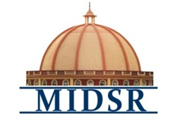
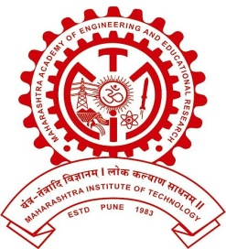
MAEER PUNE’S
MAHARASHTRA INSTITUTE OF DENTAL SCIENCES AND RESEARCH, LATUR
(DENTAL COLLEGE & HOSPITAL)

DEPARTMENT OF PROSTHODONTICS

REPORT

PROSTHODONTIST DAY CELEBRATION 2020

Department Of Prosthodontics, Crown & Bridge & Implantology held a program on the occasion of prosthodontic day 22/01/2020 in the premises of MIDSR Dental College, Latur

The program began with lighting of the lamp at 9.30 am by the esteemed chief guests .
Around 80 staff and students of MIDSR Dental College, Latur participated in the event which ended with a high Tea.

PROSTHODONTIST DAY CELEBRATION
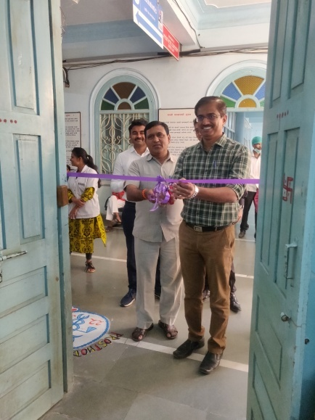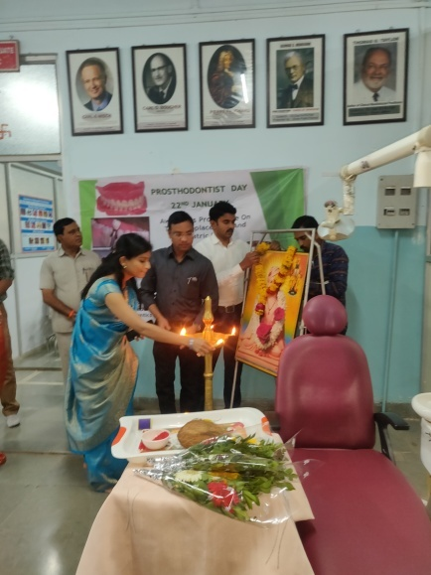
INAUGURATION OF THE PROSTHODONTICS DAY BY DR YOGESH KALE HOD DEPT OF PEDODONTICS

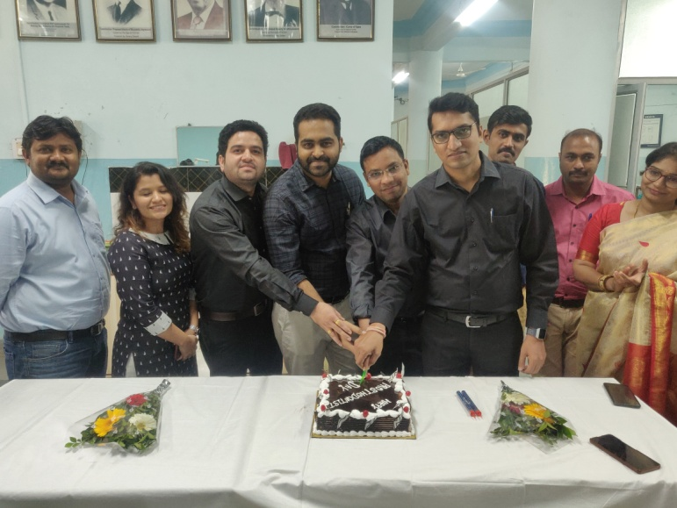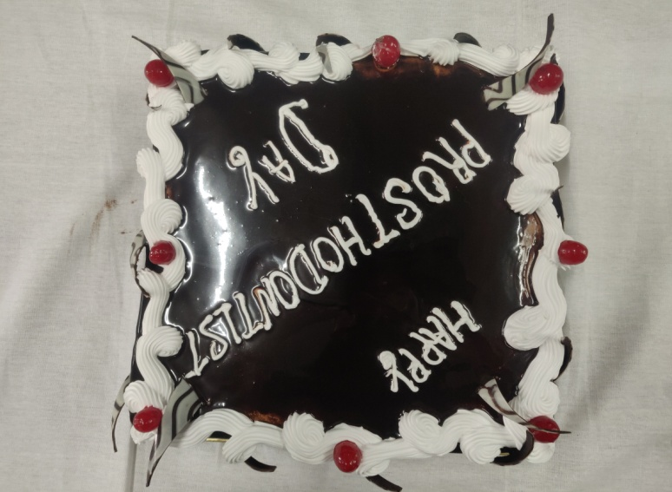
CAKE CUTTING CEREMONY ON THE OCCASION OF PROSTHODONTIC DAY

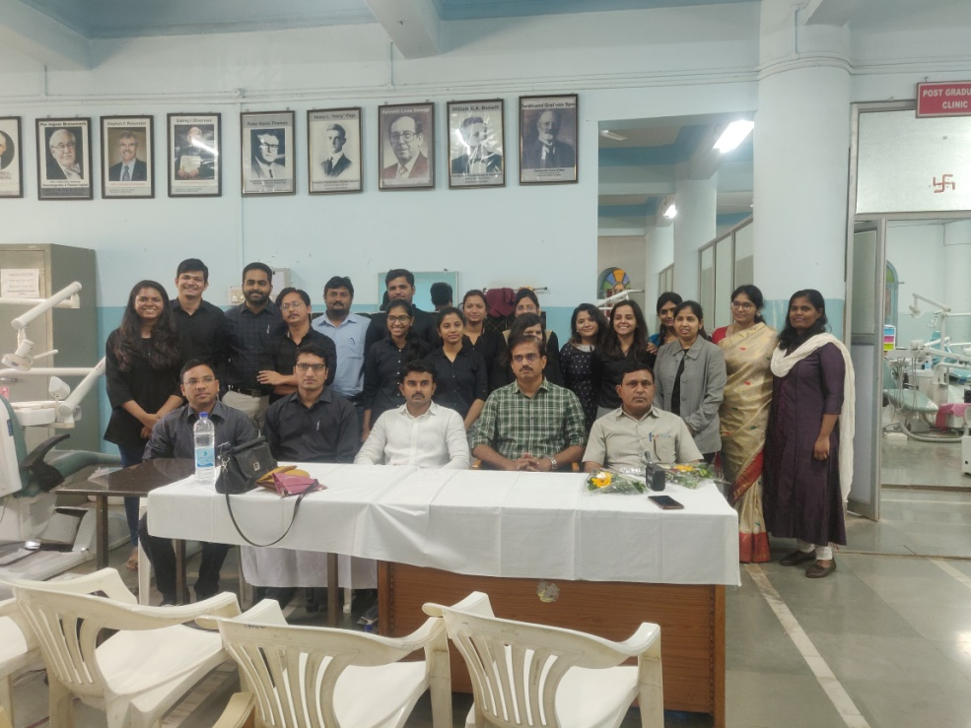

ORGANIZING COMMITTEE OF PROSTHODONTIC DAY 2020

