**Title Of The Year 2019**

**Programme :** Prosthodontics Day

**Title** : Prosthodontics Day

**Introduction :-** This Is An Indian Prosthodontic Society Initiative For Promotion Of Specialty. Department Of Prosthodontics Will Be Celebrating This Day And Request You To Come Forward Together To Make Public Masses And Friends From Other Medical Fraternity Aware Regarding Prosthetic Dentistry.

**Circular Of The Programme** :-Attached

**Evant Conducted :-** Rangoli Competition:

Quiz:

Face Painting / Tattoo:

Slogan Competition:

Best Smile Competition:

Soap Carving Competition:

Poster And Placard Making For Selfie Booth:

Teeth Arrangement Competition:

**Venue, Date & Time** :- Department Of Prosthodontics 21st January 2019 09.00 To 04.00

**Report :-**On the occasion of this day teaching staff , post graduate student BDS studants and Non- teaching Staff participants were present

**Scanned List Of Participants ,Certificate And Photo :-** Attachments

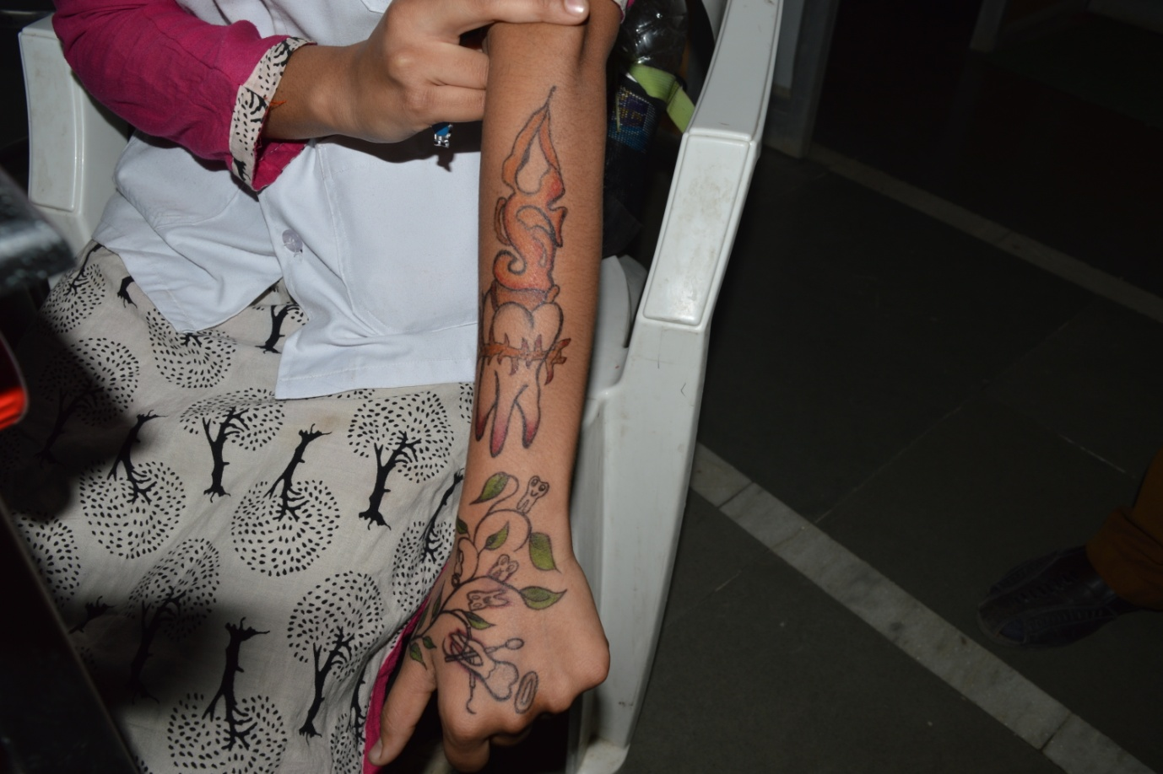

**Tatto competition**

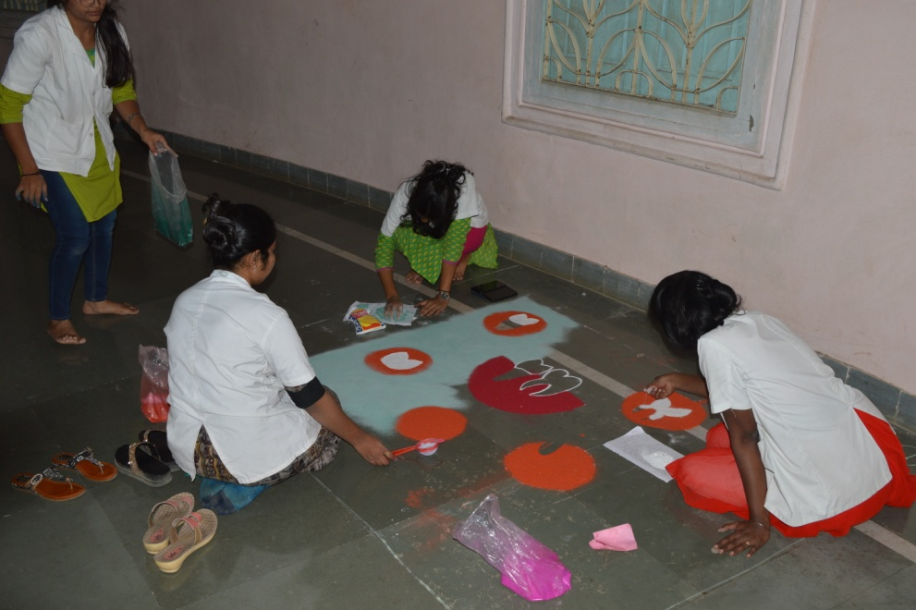

**Rangoli Competition**

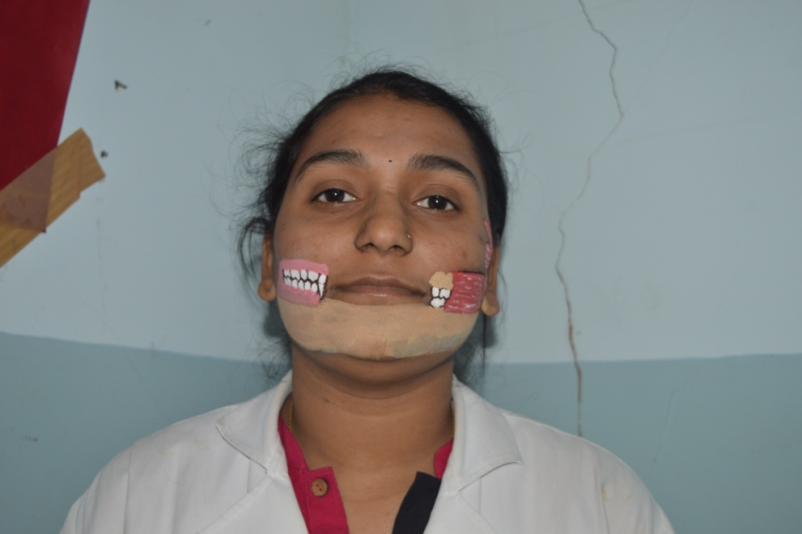

**Face painting**

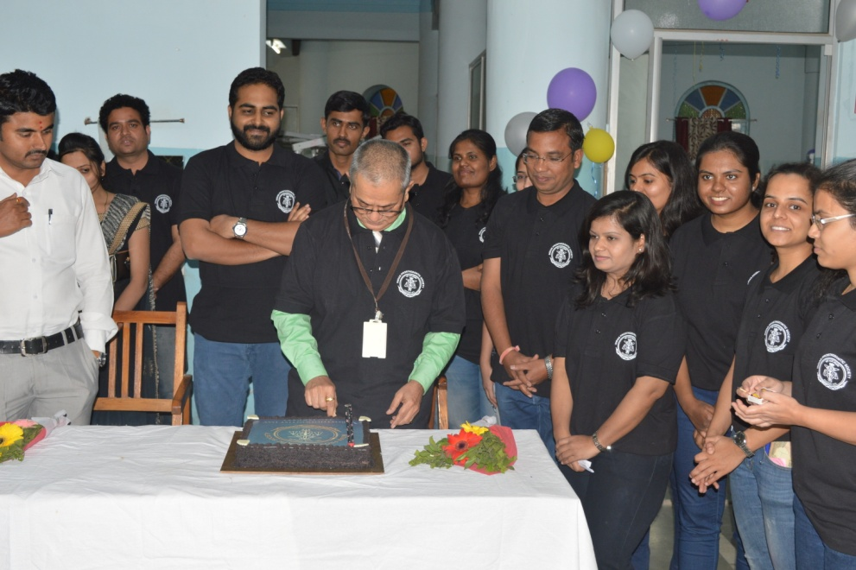

**Celebration**