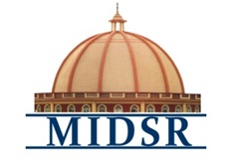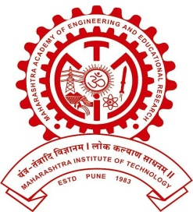MAEER PUNE’S

**MAHARASHTRA INSTITUTE OF DENTAL SCIENCES AND RESEARCH, LATUR**

(DENTAL COLLEGE & HOSPITAL)

**DEPARTMENT OF ORAL PATHOLOGY**

***REPORT***

*Department of Oral Pathology, MIDSR Dental College Latur, in collaboration with Pandit Deendayal Upadhyay Dental College, Solapur organized a Slide-seminar, “Understanding Odontopathy”on 24th Sept, 2022.*

|  |  |  |
| --- | --- | --- |
| ***Sr. no.*** | ***Title*** | ***No. of Prticipants*** |
| *1* | *Understanding Odontopathy: A slide Seminar* | *28* |

**A. Introduction:**

*Department of Oral pathology organized a Slide seminar based on odontogenic cysts and tumors, for better understanding of the subject. Department of Oral Pathology, MIDSR Dental College Latur, in collaboration with Pandit Deendayal Upadhyay Dental College, Solapur organized a Slide-seminar, “Understanding Odontopathy”on 24th Sept, 2022.*

**B. Communication Letters of the programme:-** (ANNEXURE I)

**C. Report:**

A slide-seminar was conducted in Department of Oral Pathology, *MIDSR Dental College Latur. Students of MIDSR college and Pandit Deendayal Upadhyay Dental College, Solapur attended the slide-seminar.*

*Dr. Anuja Maniyar(HOD &Prof), Dr. Varsha Sangle(Reader), Dr. Smita Chaware (Lecturer), Dr. Pragya Bhatnagar (Tutor) and Samad Shaikh(Technician) had conducted the program. Orientation lecture conducted by Dr. Anuja Maniyar, Slide Discussion by Dr. Varsha Sangle and Validectory function conducted by Dr. Smita Chaware.*

Following slides discussed during slide discussion:

1) Dentigerous Cyst

2) Odontogenic Keratocyst

3) Radicular Cyst

4) Follicular Ameloblastoma

5) Plexiform Ameloblastoma

6) Acanthomatous Ameloblastoma

7) Granular Cell Ameloblastoma

8) Unicystic Ameloblastoma

9) Adenomatoid Odontogenic Tumor

10) Calcifying Epithelial Odontogenic Tumor

**Communication Letters**  (ANNEXURE I)

**I**

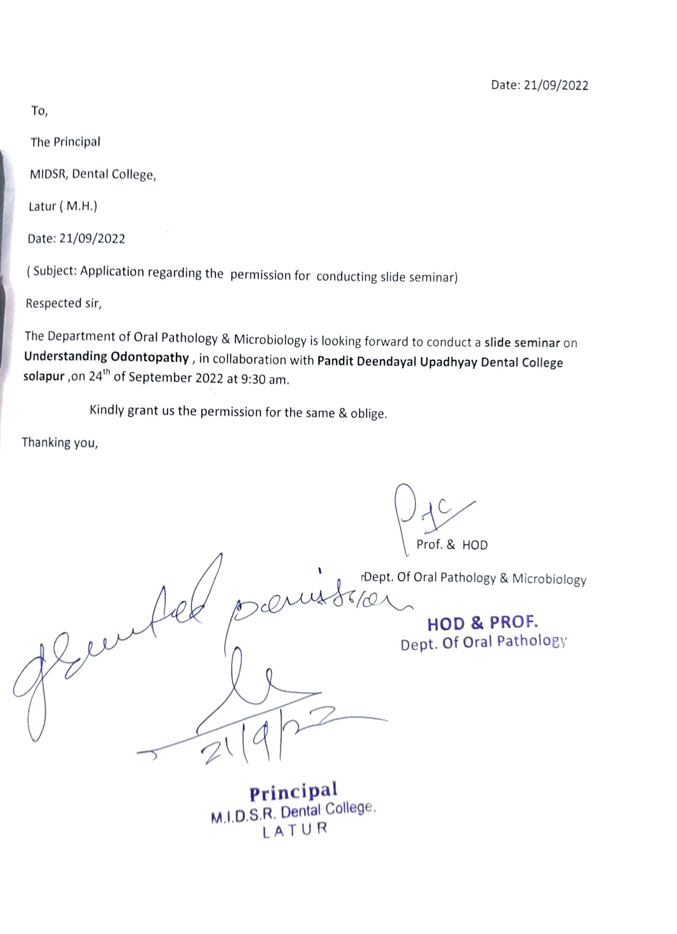

**II**

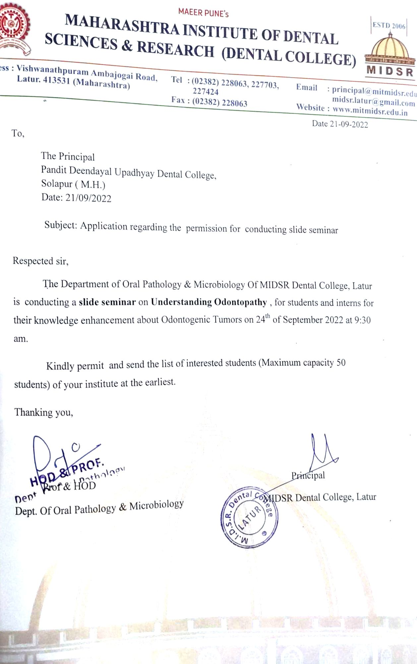

**III**

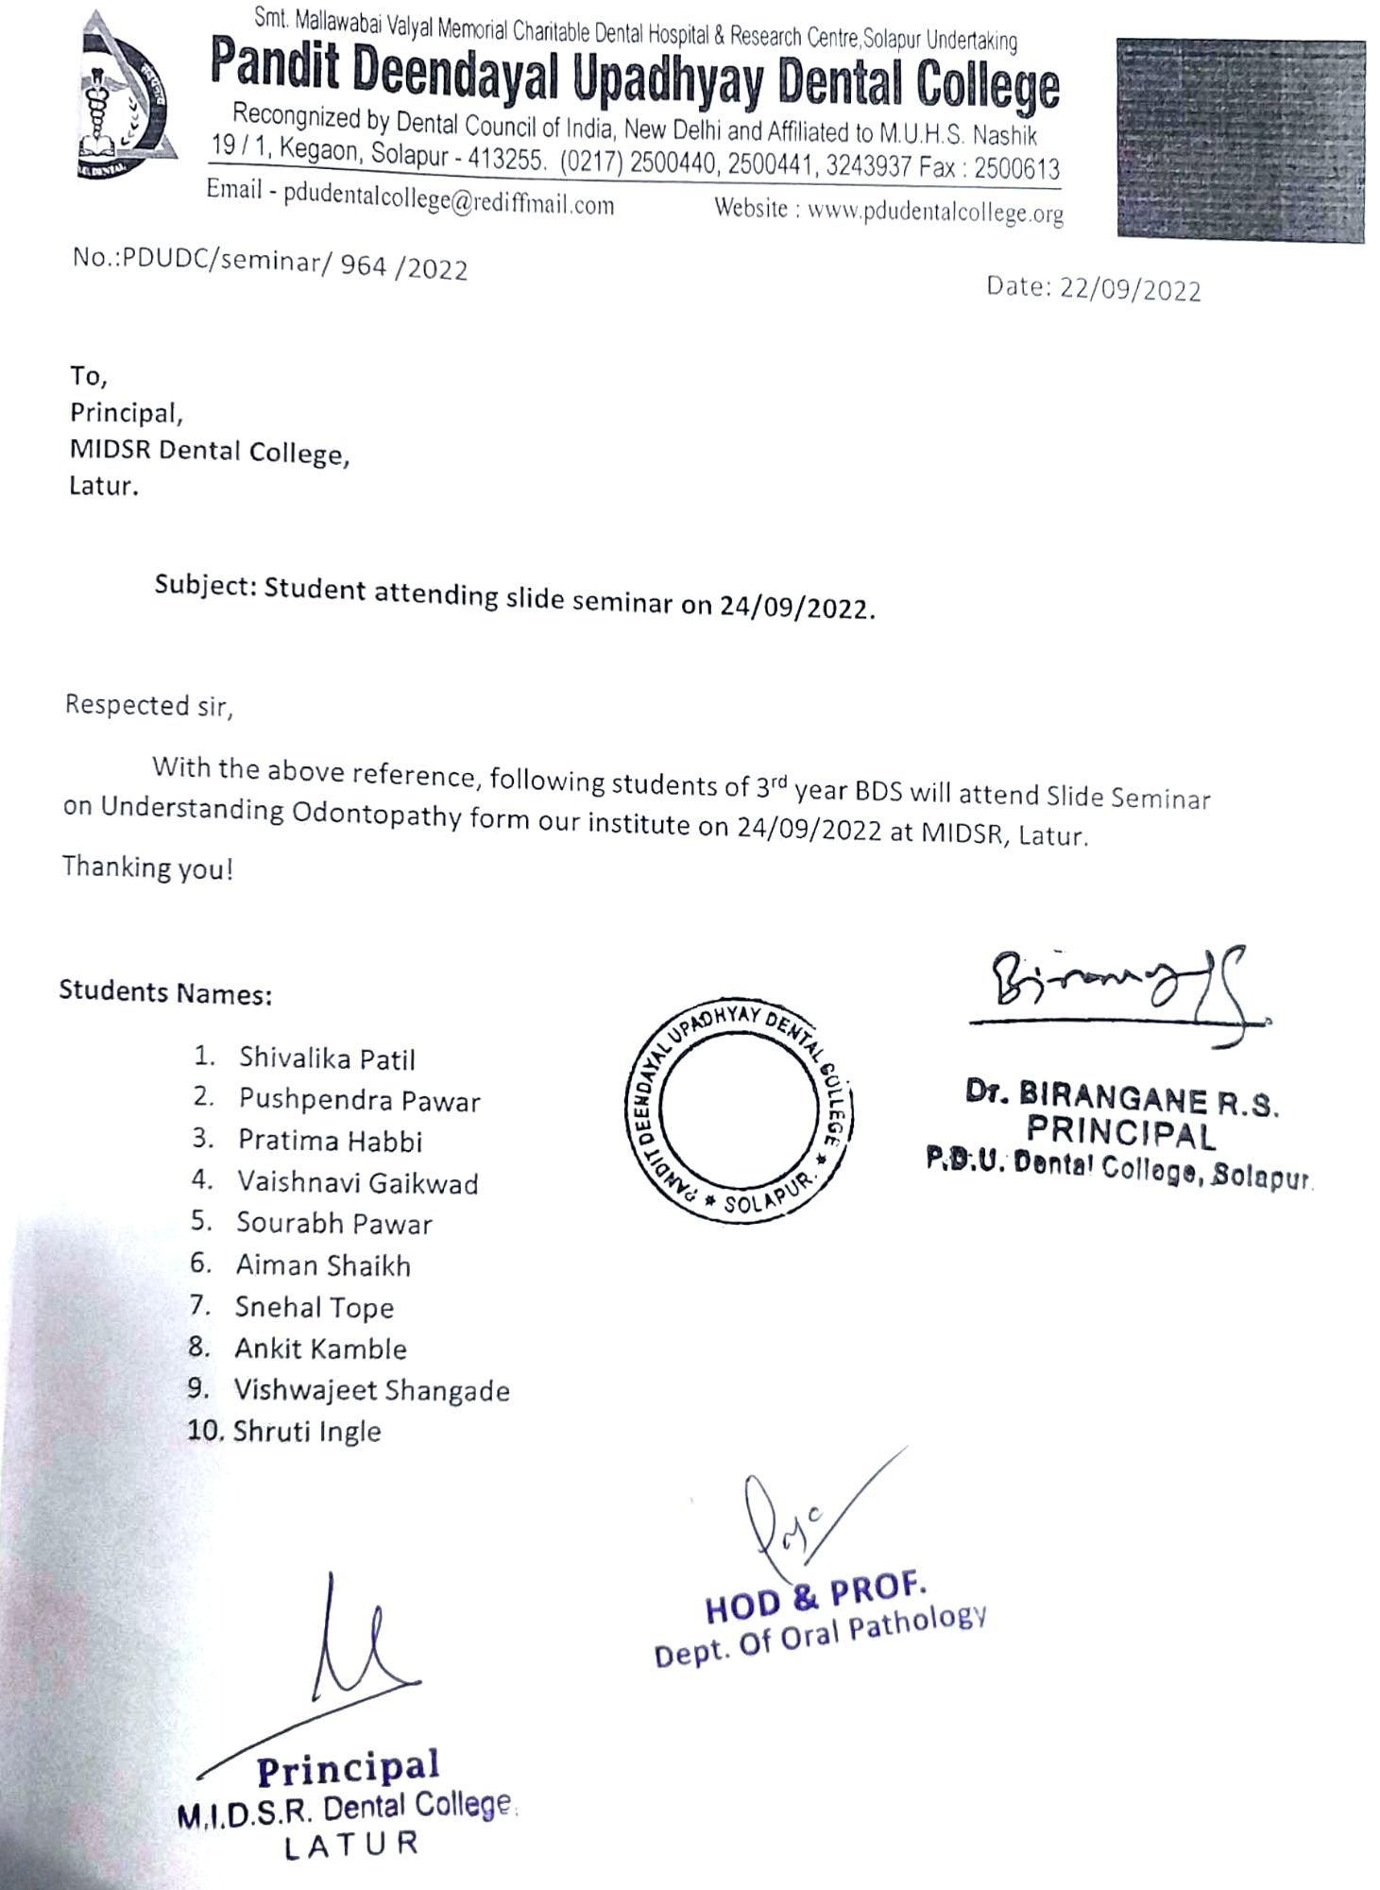

**D Geotag Photos:**

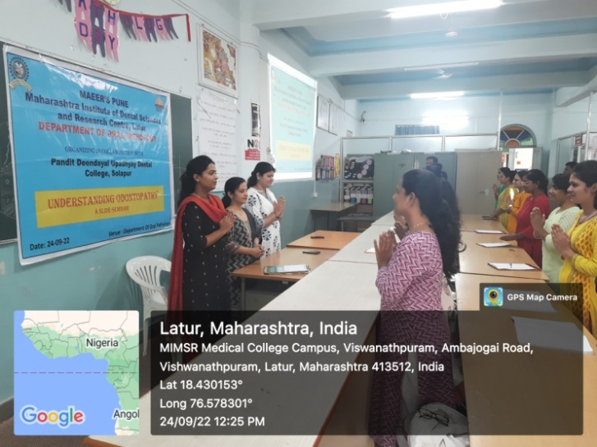

**Staff and Students during Vishwashanti prayer**

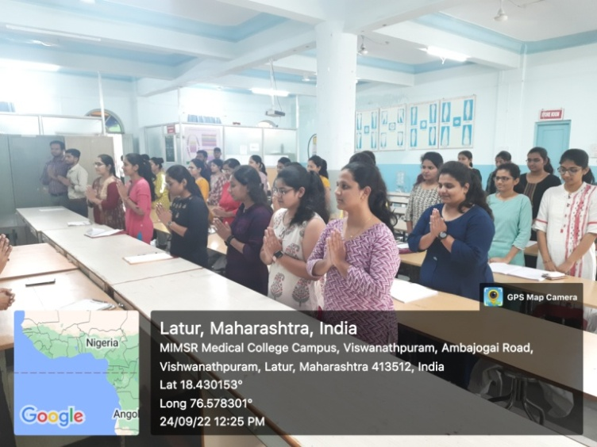

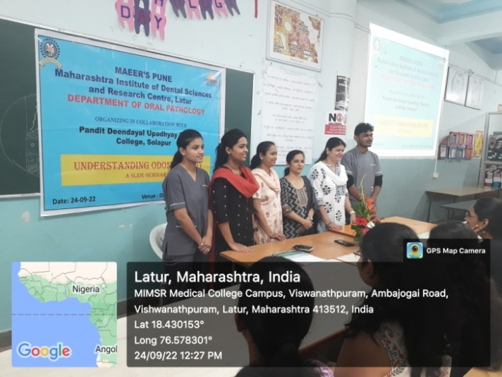

**Organizing team**

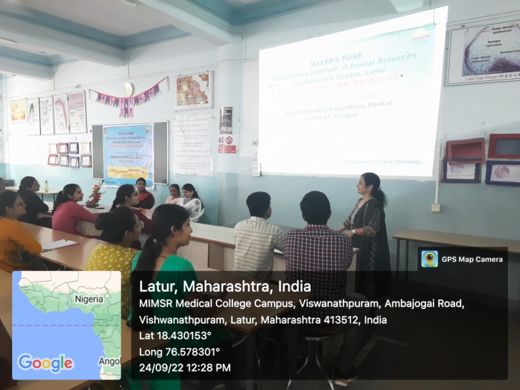

**Dr. Anuja Maniyar taking lecture**

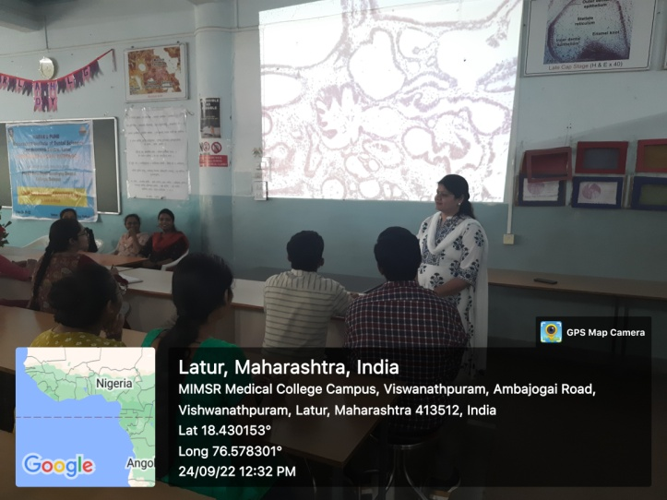

**Dr. Varsha Sangle- Slide Discussion**

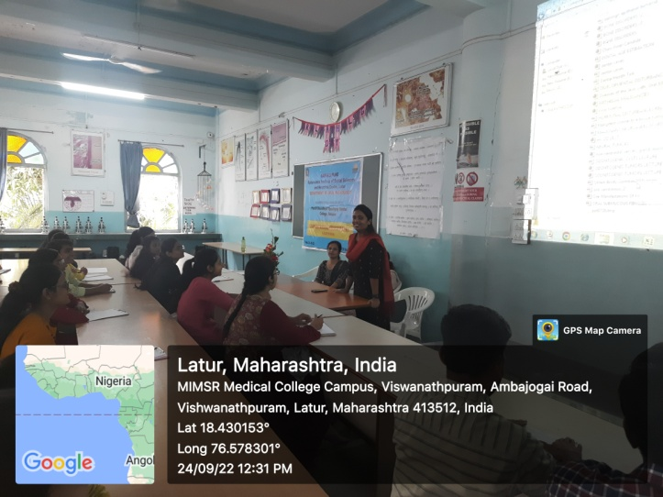

**Dr. Smita Chaware presenting vote of thanks**

**E. LIST OF PARTICIPANTS** (ANNEXURE II)

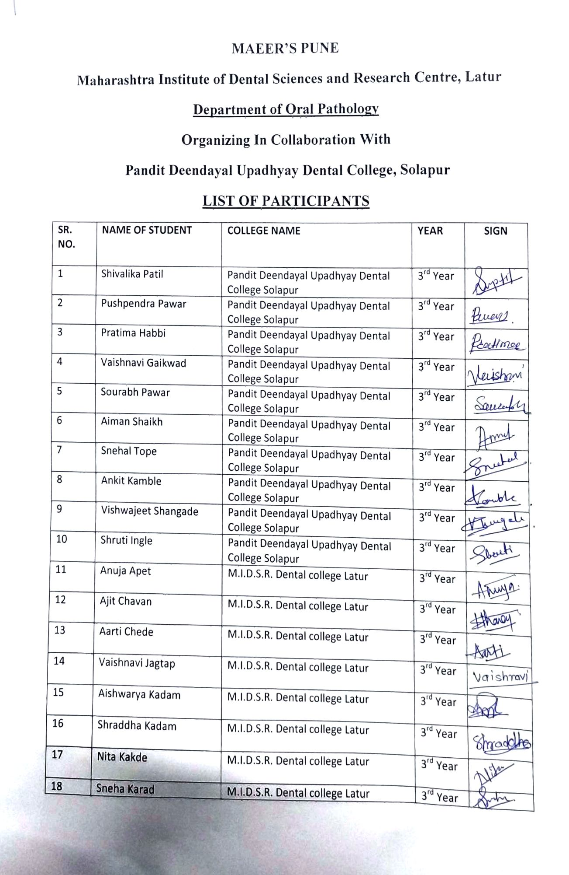

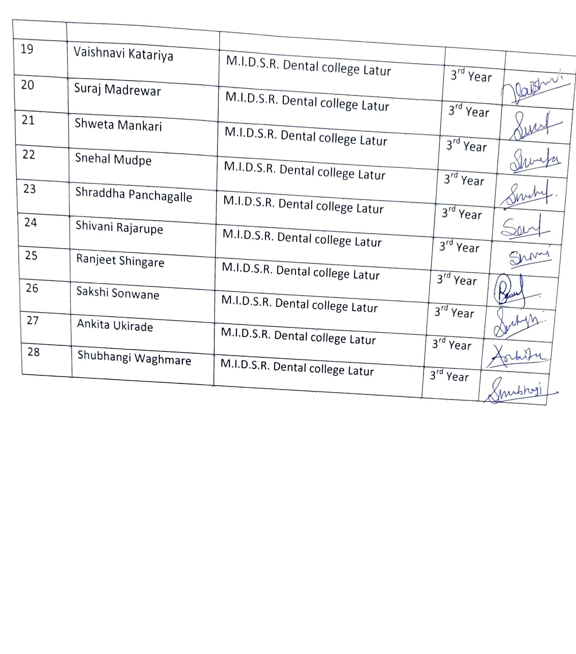

**F. Overview of the Programme:**

The programme was successful. Students get knowledge and cleared their queries regarding odontogenic cyst and tumours. Collaboration improves interactions and sharing of valuable knowdge.