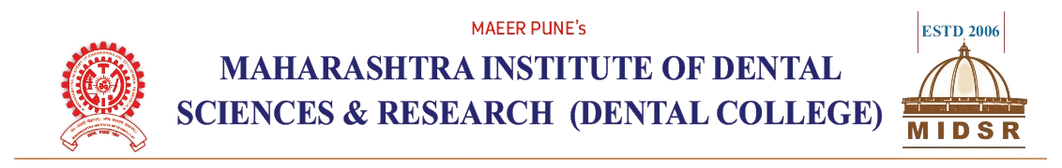

***Date: 01/06/2018***

***To,***

The Chairman,

Academic Committee,

MIDSR Dental College,Latur

***sub: Regarding Permission to conduct Add on course.***

Respected Sir,

Department of Orthodontics & Dentofacial Orthopedics want to conduct an Add on course on 4,5 & 6 June 2018. The duration of course will be 06 hrs. This course will be conducted for PG Students and certainly will benefit to these students to improve their skills.

So, I request you to allow us to conduct Add on course & do the needful.

Thanking you.

***Yours faithfully***

Head of the Department

Department of Orthodontics

MIDSR Dental College and Hospital

***Date: 01/06/2018***

***To,***

The Head of Department

Dept of Orthodontics & Dentofacial Orthopedics

MIDSR Dental College,Latur

***sub: Regarding the permission for Add on course .***

Respected Sir,

With reference to your application regarding the permission for Add on course, here by you are allowed to conduct an Add On course on 4,5 & 6 June 2018.

Thanking you.

***Yours faithfully***

The Chairman

Academic Committee

MIDSR Dental College,Latur

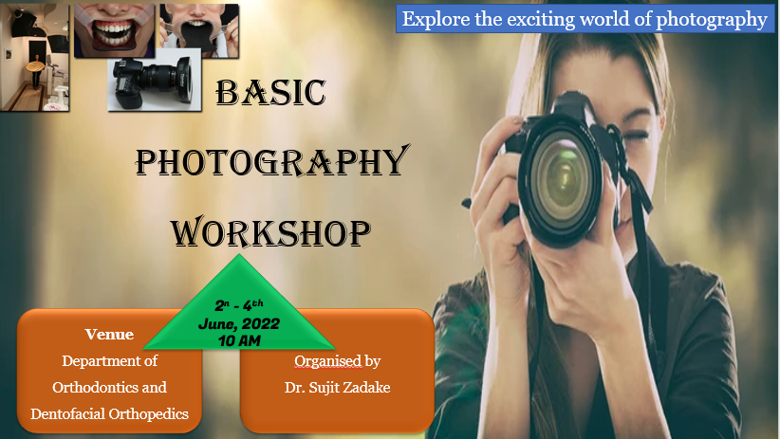

4th - 6th June,2018

10 AM

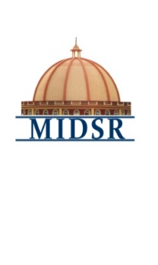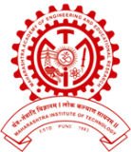**MAHARASHTRA INSTITUTE OF DENTAL SCIENCES AND RESEARCH, DENTAL COLLEGE, LATUR (MAHARASHTRA)**

Workshop On“ **Basic Photography**’’

Organized By – Department of Orthodontics and Dentofacial Orthopedics

Maharashtra Institute of Dental Sciences and Research, Latur

I**CONTENT:**

**The study of the following–**

1. Extra Oral Photography
2. Intra Oral Photography
3. Mobile Photography
4. **LEARNING OBJECTIVES:**
5. To use the manual settings on your camera to properly expose a photo.
6. To learn Basic composition rules that will automatically improve your photography.
7. To learn What aperture is, and how to use it creatively.
8. To learn What shutter speed is, and how to prevent common beginner mistakes.
9. To learn What ISO is, and how to prevent 'noisy' photos.
10. To learn Different photo settings and resolutions.

You will understand the basic settings and rules that all pro photographers once learned.

1. **THE PROGRAM CURRICULUM AND SCHEDULE INCLUDES:**
2. Theoretical lectures
3. Demonstration
4. **WORKSHOP DESCRIPTION**

Basic Photography Workshop is a planned, well organized departmental event that provides an introduction about the basic settings and rules you should know as you start taking photos.Most DSLR, mirrorless, point and shoot, and bridge camera users will benefit from this course. Even smartphone photographers might benefit from taking this course, though not all the settings will be available on all cameras.



1. **TOPICS INCLUDE:**

**Module I :**

1. Extra Oral Photography Theoritical
2. Extra Oral Photography Demonstration.

**Module II :**

1. Intra Oral Photography Theoritical
2. Intra Oral Photography Demonstration.

**Module III :**

1. Mobile Photography Theoritical
2. Mobile Photography Demonstration



1. **WORKSHOP OUTCOME**

After completion of Basic PhotographyWorkshop, post graduate students will be equipped with basic understanding of the following:

* Provide post graduates with the principles of Basic Photography and guideline of importance of photography in dental treatment planning in daily clinical practice.



1. **WORKSHOP SUMMARY**

|  |  |
| --- | --- |
| MODULES | III MODULES / 3 DAYS |
| Duration : | 06 HOURS COURSE |
| Start Date : | 04/06/2018 |
| End Date : | 06/06 /2018 |
| Category : | Post graduate Student Education |
| WORKSHOP Level : | Continuing Education |

|  |  |
| --- | --- |
| **Basic Photography** | |
| **Module I** | 1. Extra Oral Photography Theoritical 2. Extra Oral Photography Demonstration. |
| **Module II** | 1. Intra Oral Photography Theoritical 2. Intra Oral Photography Demonstration. |
| **Module III** | 1. Mobile Photography Theoritical 2. Mobile Photography Demonstration |



1. **ELIGIBILITY OF CANDIDATES**:Post Graduate students
2. **EXPECTED COURSE OUTCOME**:

All the post graduate students will be getting benefit by gathering basic knowledge about Photographyand demonstration will help to understand its clinical implementation in dentistry.

1. **ASSESSMENT METHODOLOGY**:

All orthodontic post graduate will be informed through circular regarding curriculum and schedule of the course. All the participants are suppose to gather in the lecture hall 10 minutes prior to start of the workshop and this workshop is compulsory for all the orthodontic post graduates and attendance is compulsory for all 3 modules.

1. **REGISTRATION FEES**: **Free for all students**
2. **FACILITIES:**

Participation and lecture presentation certificate will be given after completion of workshop.

Workshop “ Basic Photography”

Organized By – Department of Orthodontics and Dentofacial Orthopedics

Maharashtra Institute of Dental Sciences and Research, Latur

|  |  |  |  |  |  |
| --- | --- | --- | --- | --- | --- |
| **Sr. No.** | **Date** | **Timing & duration** | **Topic name** | **Speaker** | **Signature** |
|  | Day 1  (04 /06/2018) | 10 am -11 am  (1 hour) | Extra Oral Photography Theoritical- LECTURE | Dr. Sujit Zadake |  |
|  | 11am -12pm  (1 hour) | Extra Oral Photography - Demonstration. | Dr. Sujit Zadake |  |

Workshop “ Basic Photography”

Organized By – Department of Orthodontics and Dentofacial Orthopedics

Maharashtra Institute of Dental Sciences and Research, Latur

|  |  |  |  |  |  |
| --- | --- | --- | --- | --- | --- |
| **Sr. No.** | **Date** | **Timing & duration** | **Topic name** | **Speaker** | **Signature** |
|  | Day 2  (05 /06 /2018) | 10 am -11 am (1 hours) | Intra Oral Photography Theoritical | Dr. Sujit Zadake |  |
|  | 11 am -12pm  (1 hour) | Intra Oral Photography - DEMONSTRATION | Dr. Sujit Zadake |  |

Workshop “ Basic Photography”

Organized By – Department of Orthodontics and Dentofacial Orthopedics

Maharashtra Institute of Dental Sciences and Research, Latur

|  |  |  |  |  |  |
| --- | --- | --- | --- | --- | --- |
| **Sr. No.** | **Date** | **Timing & duration** | **Topic name** | **Speaker** | **Signature** |
|  | Day3  (06/06/2018) | 10 am -11 am (1 hour) | Mobile Photography Theoritical- LECTURE | Dr. Sujit Zadake |  |
|  | 11 am -12pm (1 hour) | Mobile Photography - DEMONSTRATION | Dr. Sujit Zadake |  |

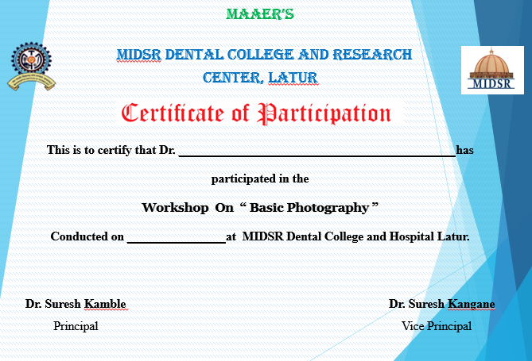

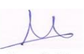

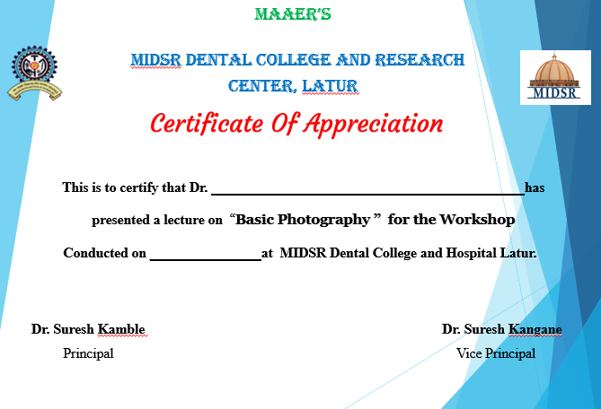







Workshop “**Basic Photography**”

Organized By – Department of Orthodontics and Dentofacial Orthopedics

Maharashtra Institute of Dental Sciences and Research, Latur

**ATTENDENCE SHEET**

**DAY 1**

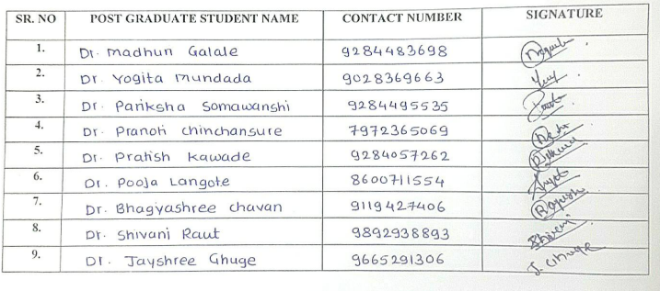



Workshop “**Basic Photography**”

Organized By – Department of Orthodontics and Dentofacial Orthopedics

Maharashtra Institute of Dental Sciences and Research, Latur

**ATTENDENCE SHEET**

**DAY2**





Workshop “**Basic Photography**”

Organized By – Department of Orthodontics and Dentofacial Orthopedics

Maharashtra Institute of Dental Sciences and Research, Latur

**ATTENDENCE SHEET**

**DAY 3**

These participants have successfully completed the course.

**Dr. Suresh Kangane**

**Professor & HOD**

Department of Orthodontics

Lecture and Demonstrationtaken Basic Photography

