MIDSR DENTAL COLLEGE, LATUR
DEPARTMENT OF PERIODONTICS
National Periodontist Day 2023
To commemorate the registration of Indian Society of Periodontology under the state laws as a nonprofit front organization formed in 1975 with the primary aim of promoting and enhancing the knowledge and science of Periodontology in India, it was decided by ISP that national Periodontist day will be celebrated on 23rd February.
Department of Periodontics had arranged National Periodontist Day celebration on 23/02/2023 for IInd, IIIrd, IVth year students & Interns. The theme was on ‘Healthy Gums - Healthy Body’ as per the guidelines given by ISP.
On this occasion we arranged different activities for team coordination development, tattoo competition with theme of Periodontics, slogan competition for the undergraduate students.
We also conducted reels competition, skit competition, treasure hunt competition for third year, final year students, interns and post graduate students which all was related to the subject of Periodontology.
The inter-relationship of periodontal disease and systemic health has been suspected for centuries, in past few decades. It was evidenced with many researches. The speaker elaborated the importance of oral health and its impact on systemic health.
A total 119 attendants from 2nd year BDS, 3rd year BDS, 4th year BDS, Interns and Periodontics PGs attended Periodontics day celebration. 44 Students and Periodontics PGs participated in different games and competitions.
The programme was organized by Department of Periodontics. Hon. Principal Dr. Suresh kangane inaugurated function and addressed students. Dr. Vishnudas Bhandari introduced guest speaker and welcome guests. Dr. Trupti Giri had given vote of thanks. The organizing secretary Dr. Gauri Ugale, staff Dr. Raghavendra Metri, Dr. Priya Lahane, Dr. Mithila Kakade, Dr. Amruta Kendre taken efforts for success of programme.

List of participants -
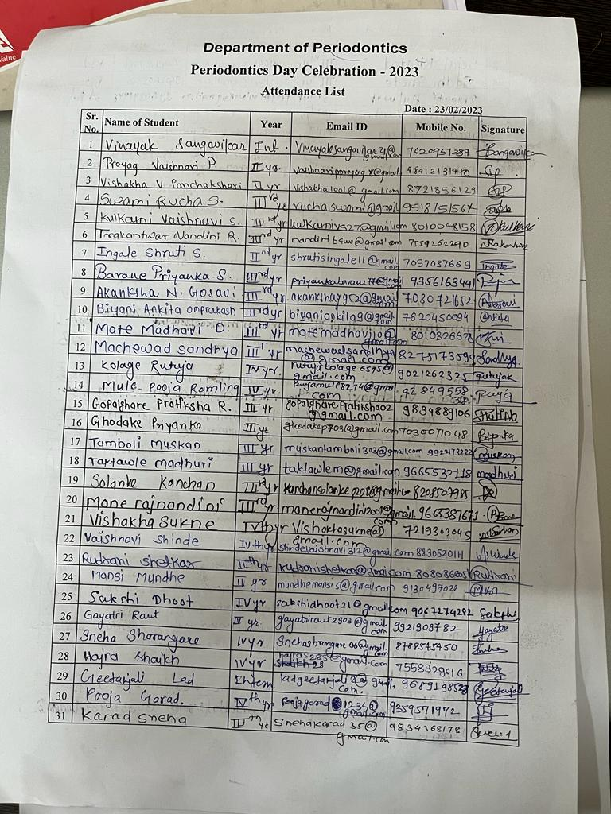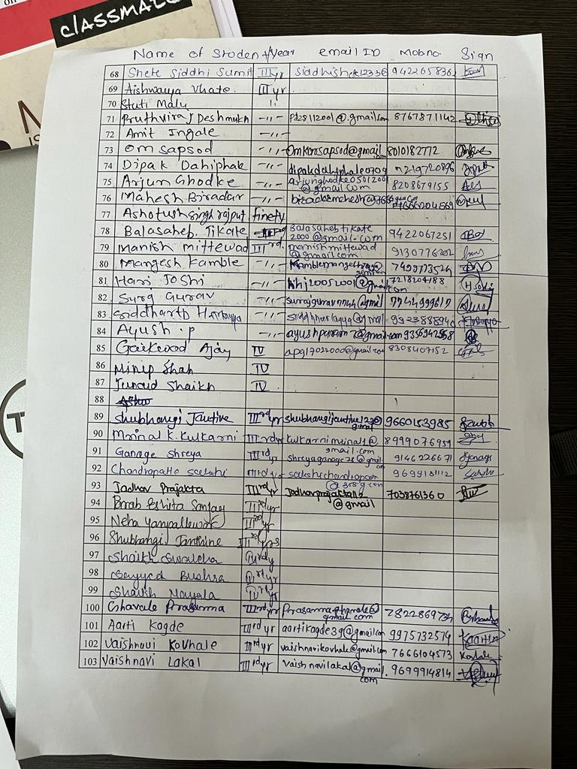
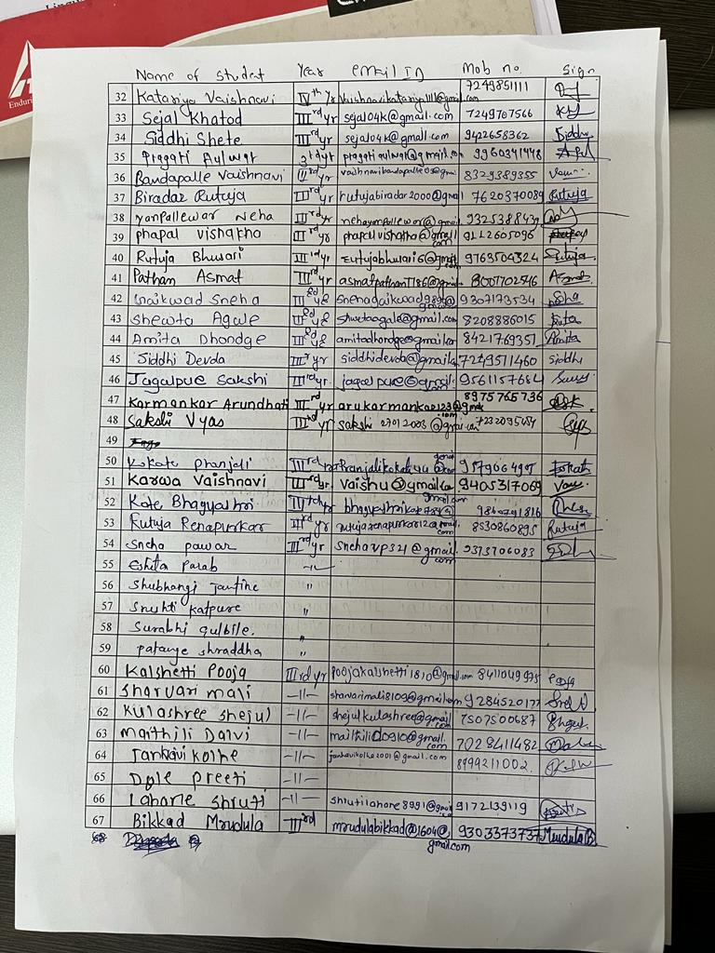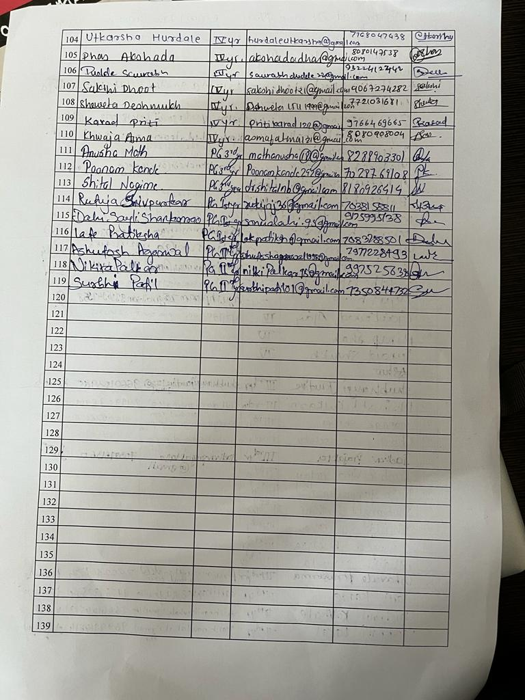

Inauguration and lamp lightening of function -
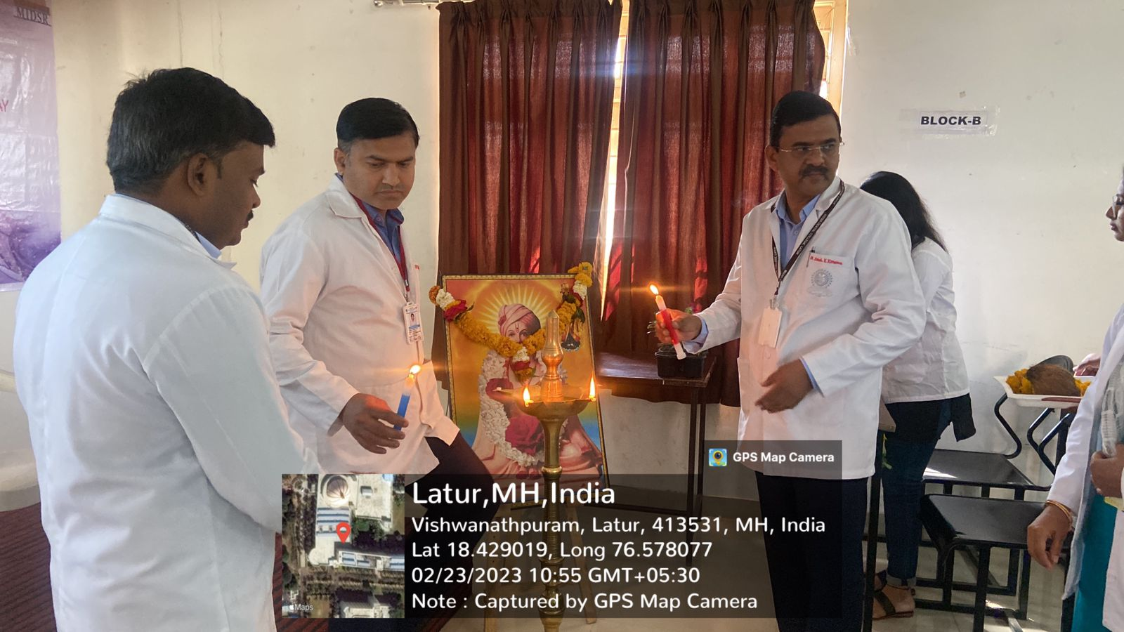
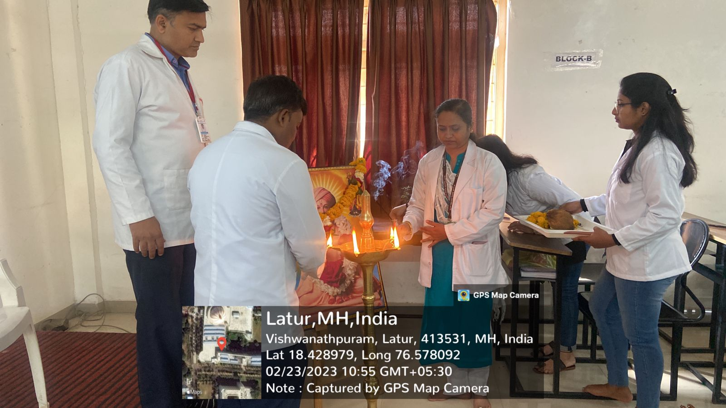
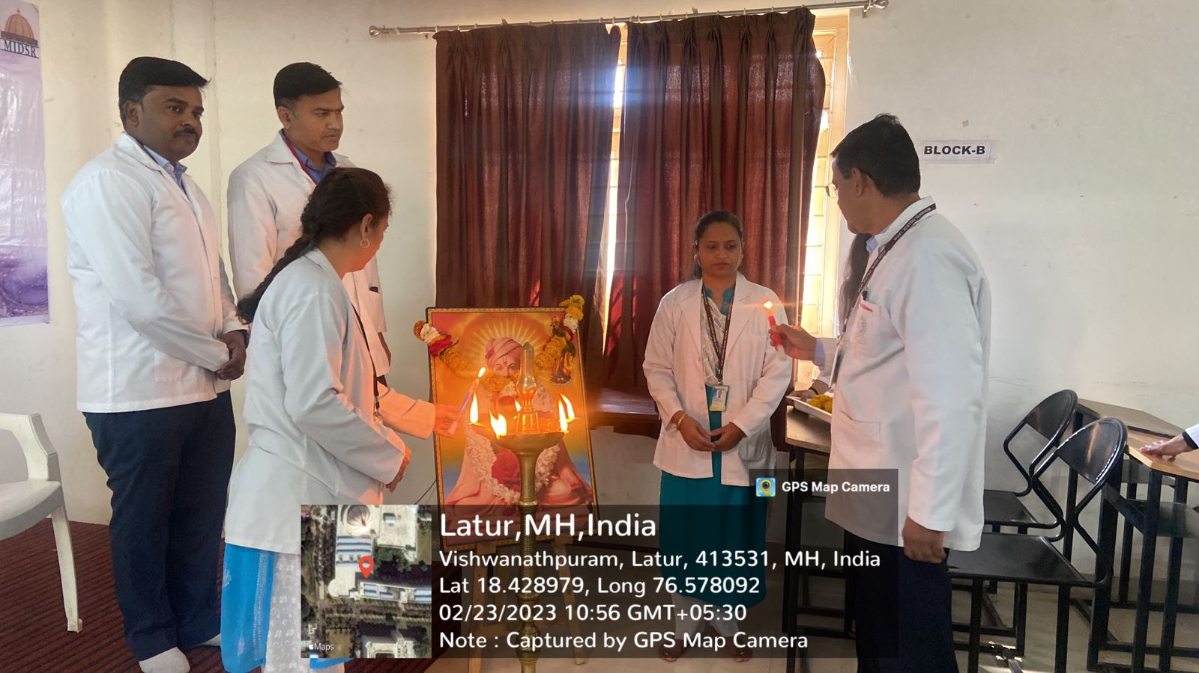
Speaker delivering lecture -
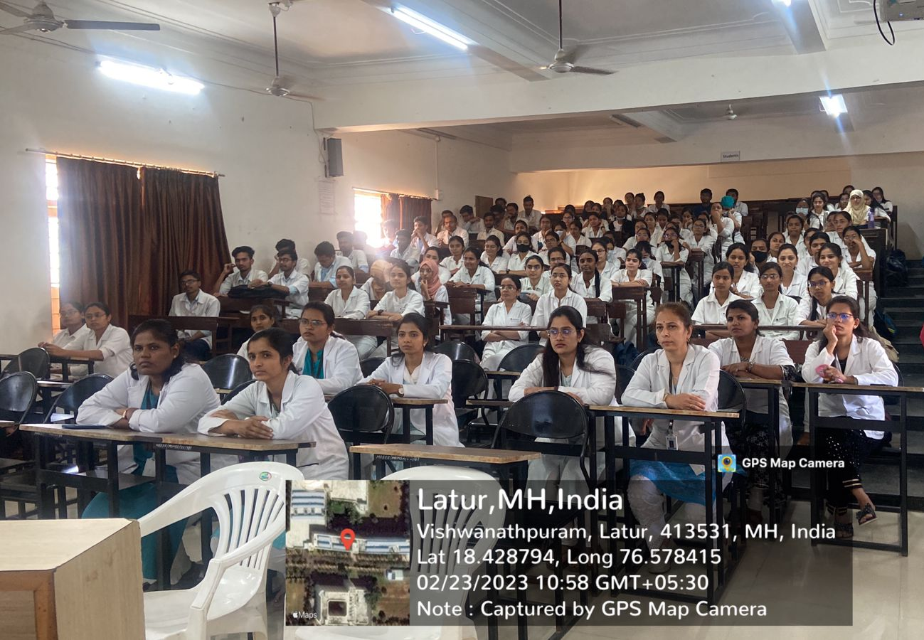
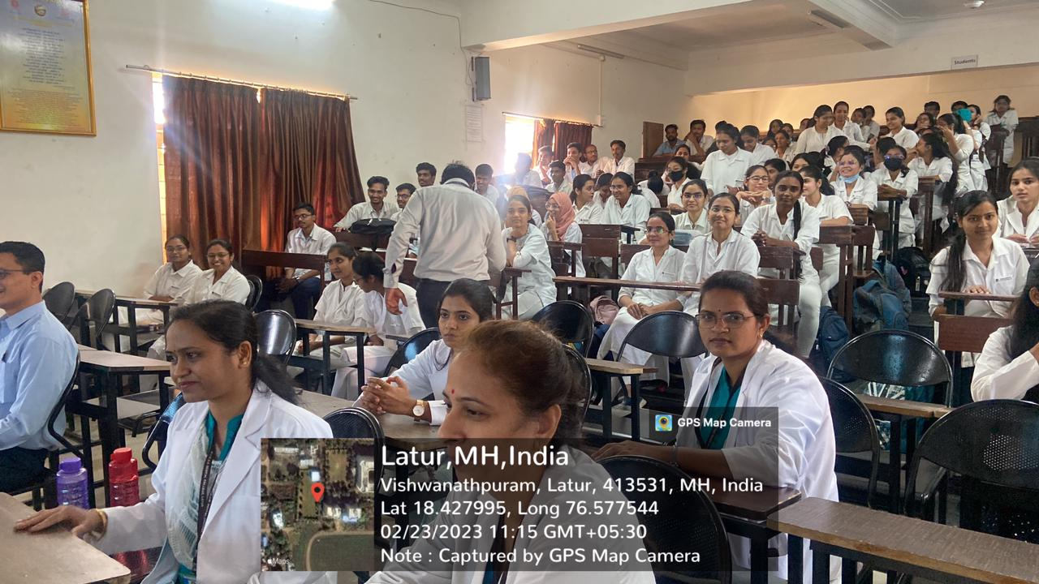
Skit competition -
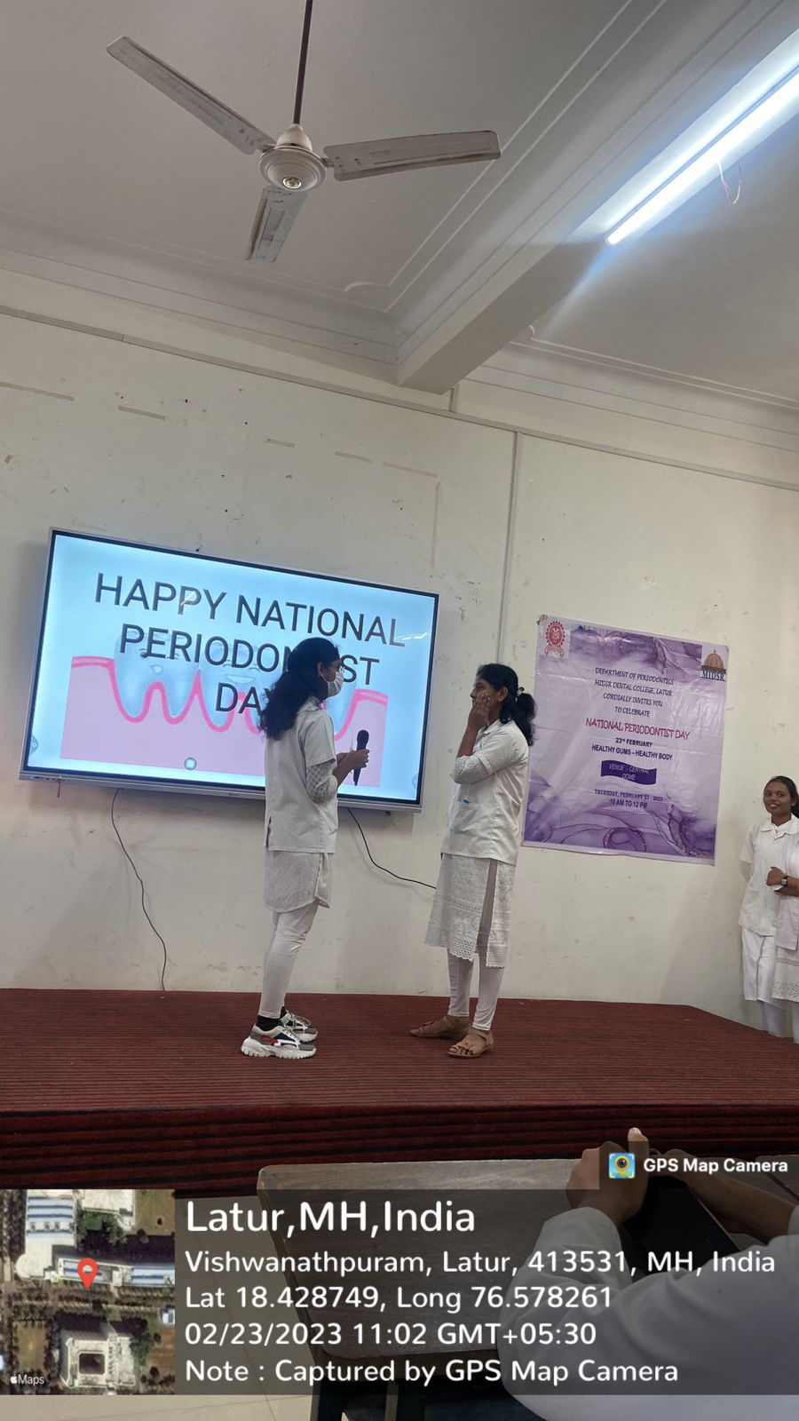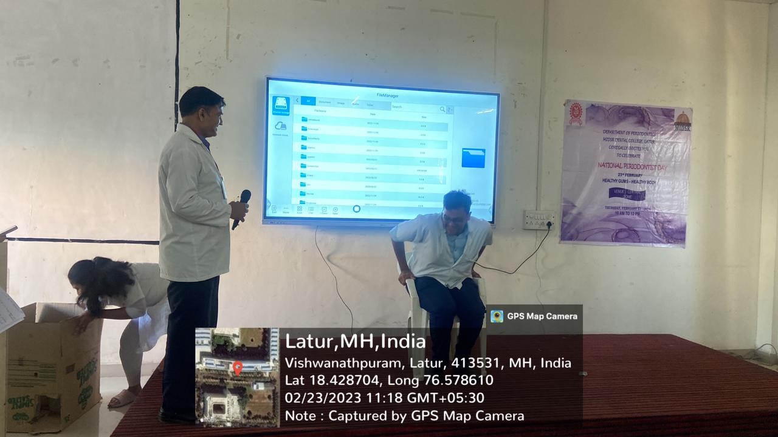
Games conducted -
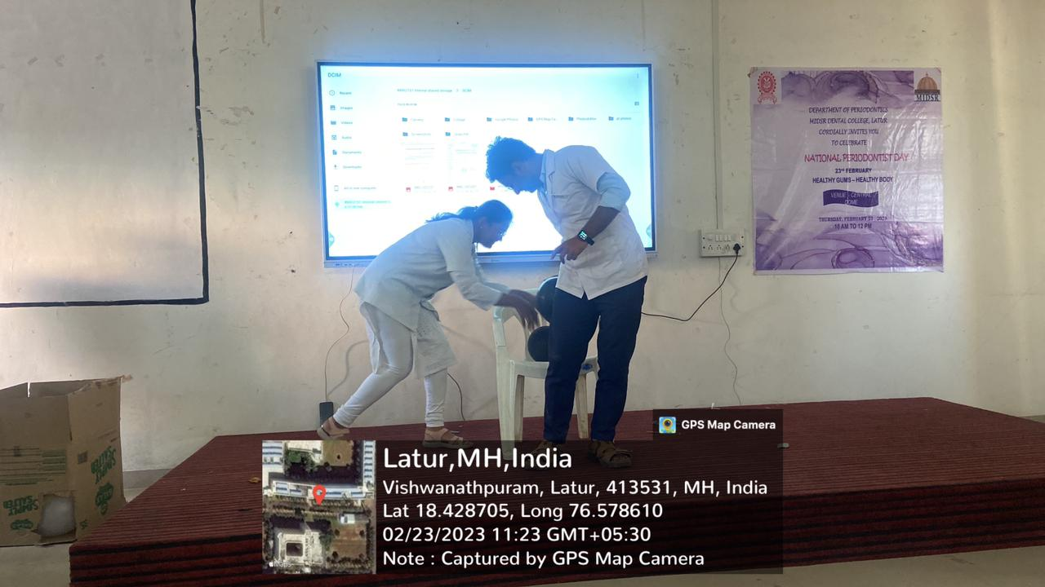
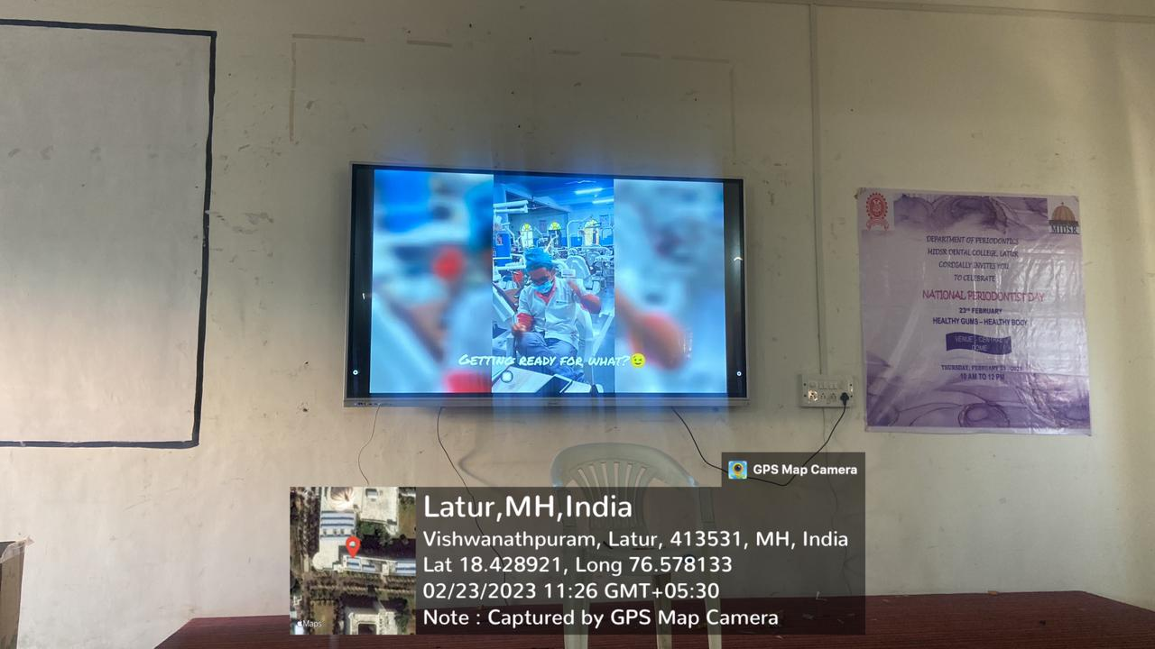

Tattoo competition - 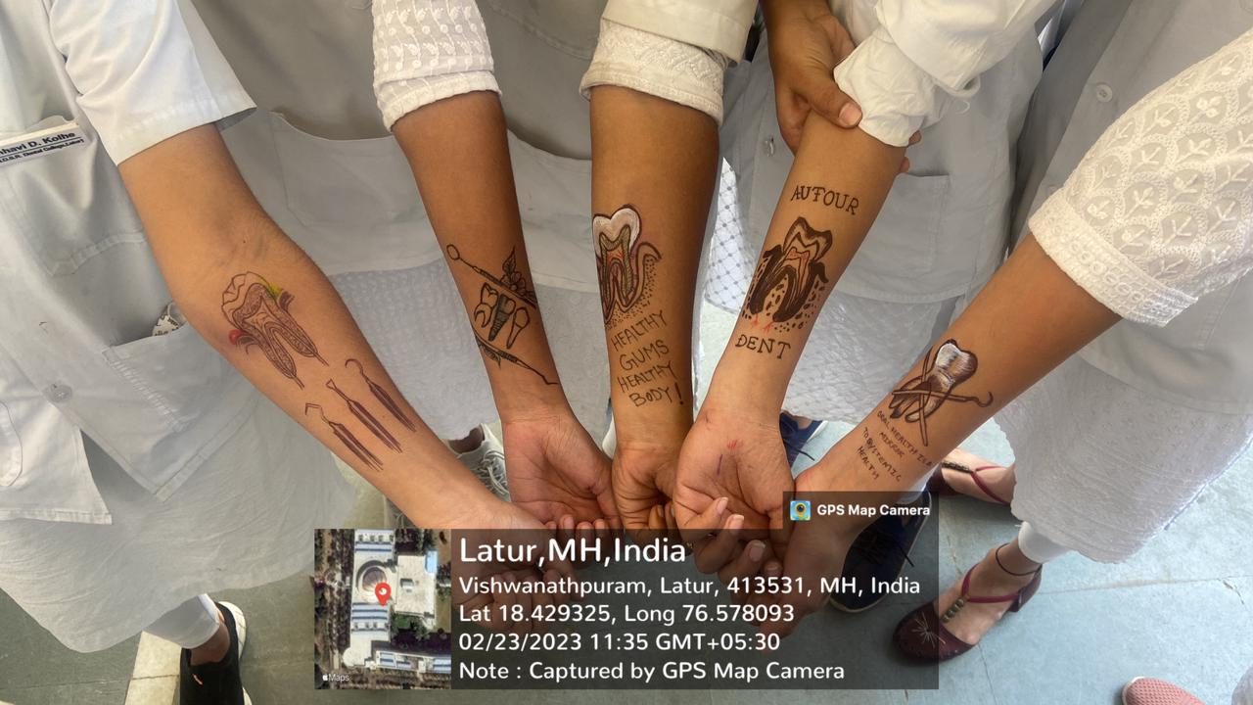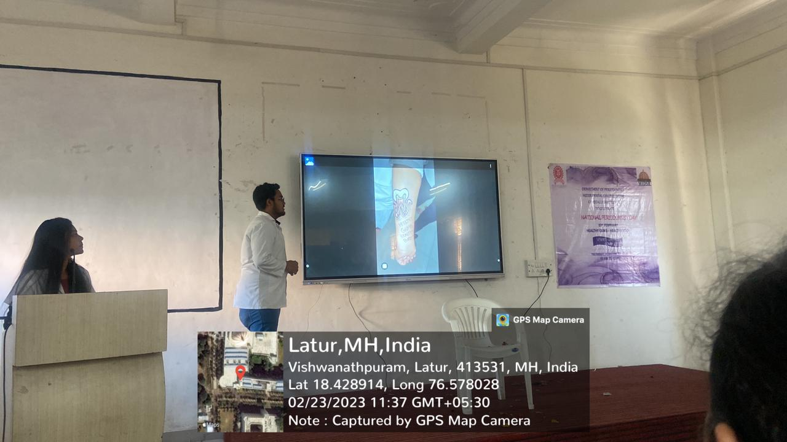
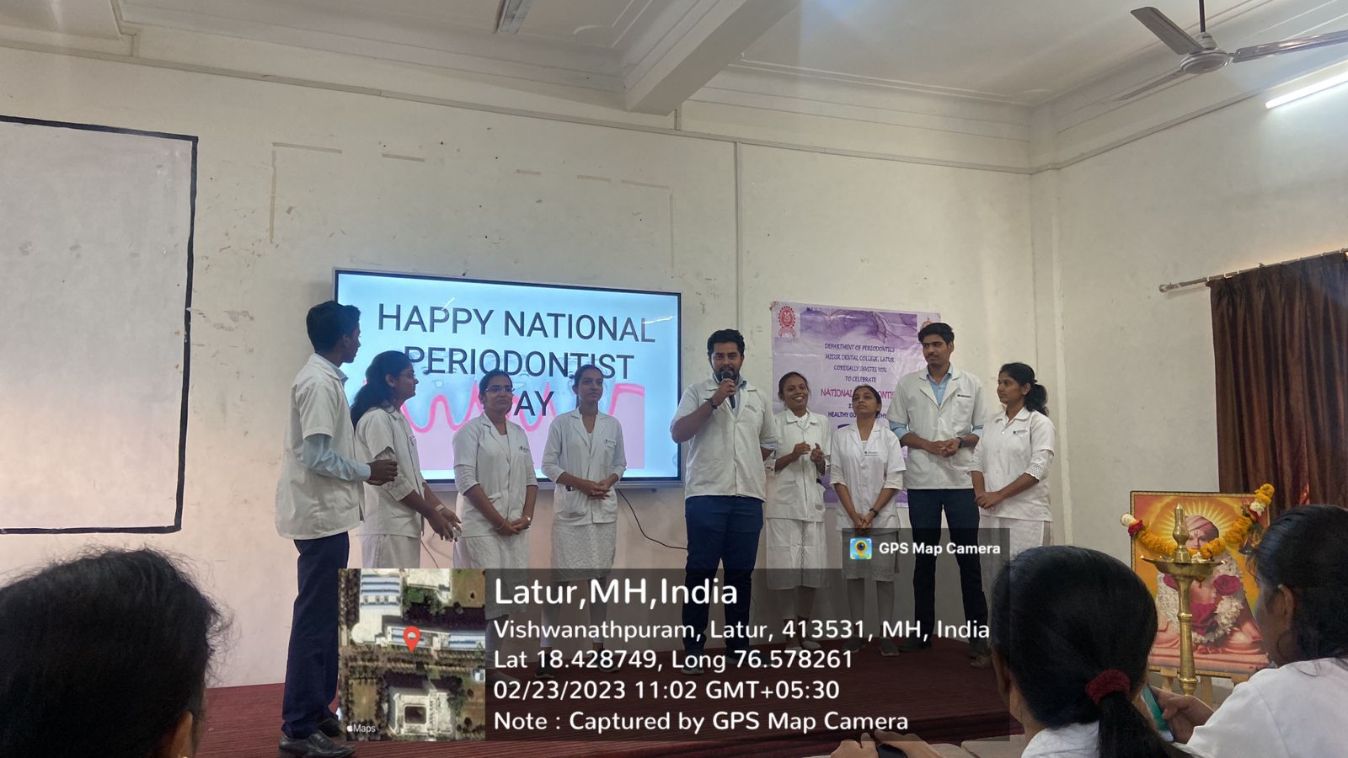
Slogan compition –
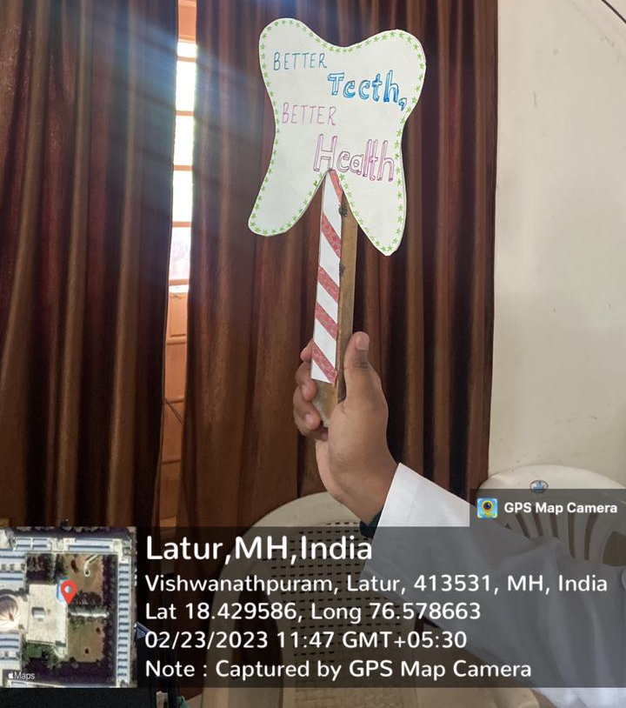
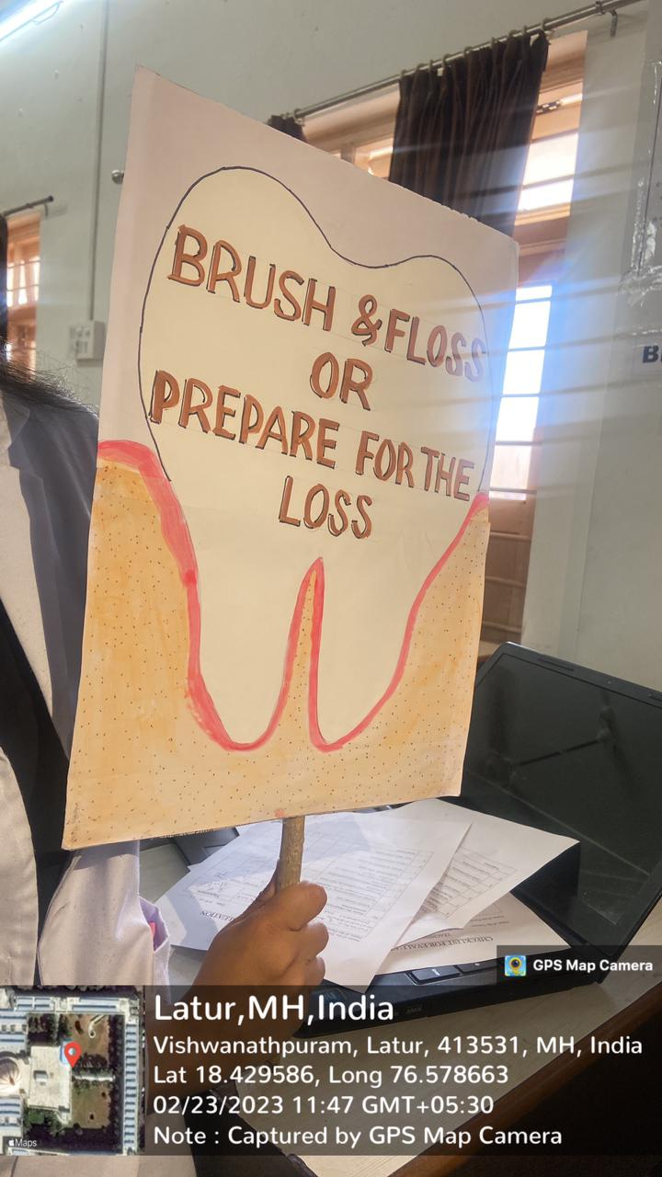

Prize distribution –
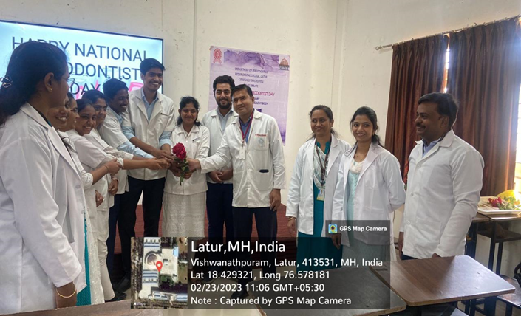

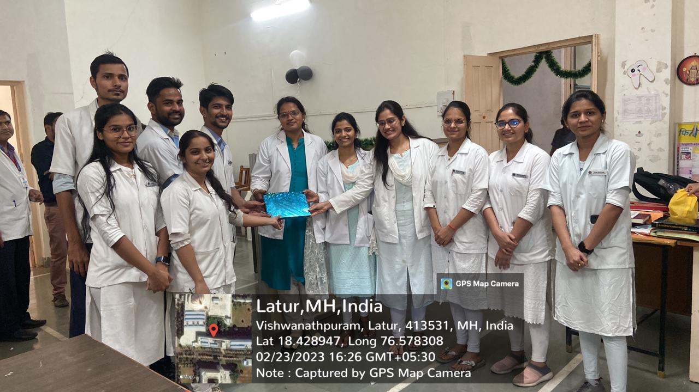

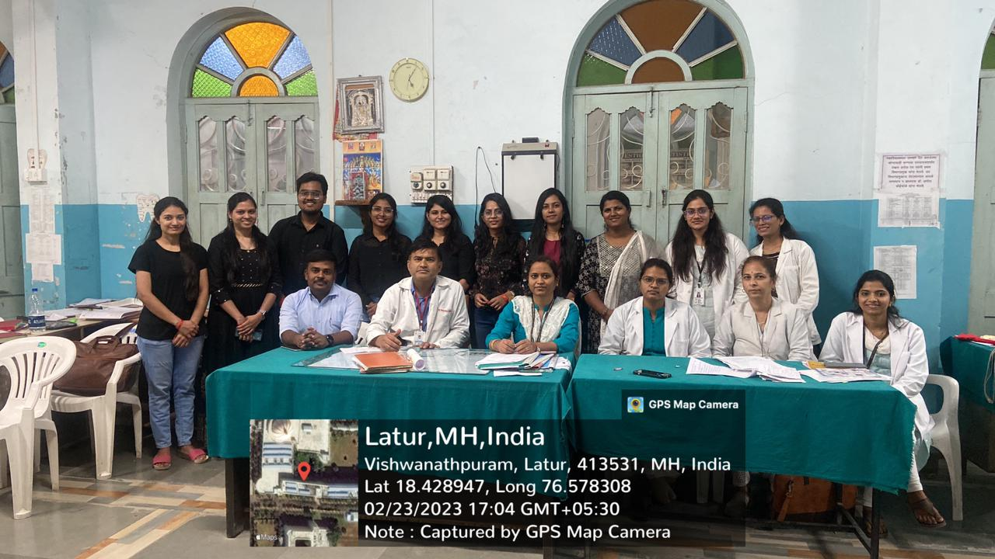

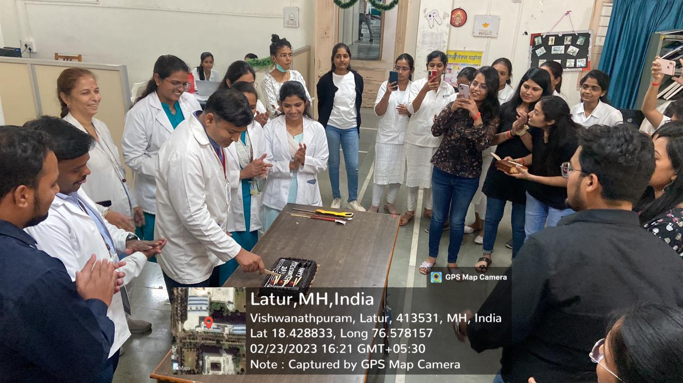
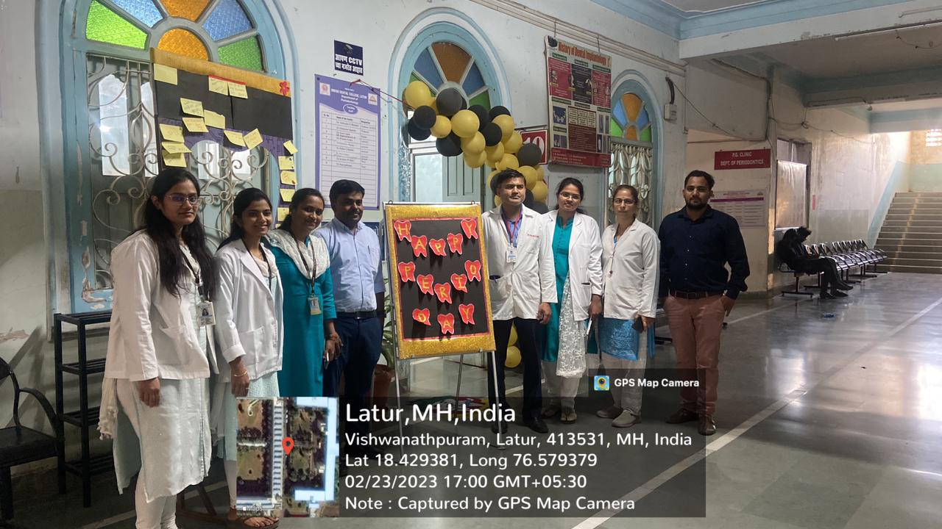

Vote of thanks –
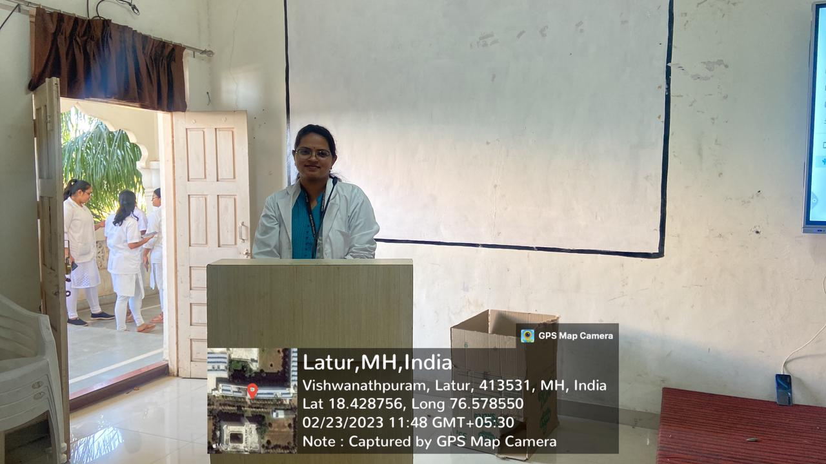
Brochure -
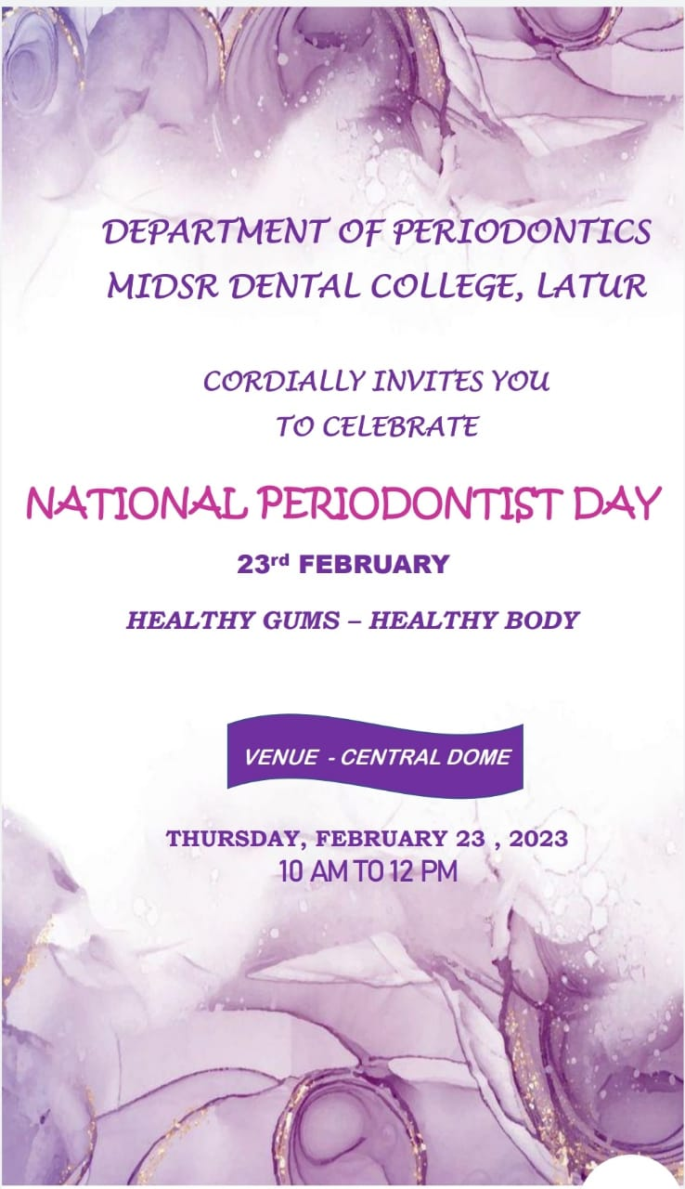
List of winners –
Competition | Winners
Skit | Prajkta Jadhav and group
Tattoo | Mrinal
Balloon burst | Pruthviraj and Priyanka
Treasure hunt | Ajay Gaikwad and group
Reel | Diksha Sarpe and group

