Program report

Name of Program- Oral Hygiene Day celebration
Date- 2 nd August, 2021.
Time- 11.00 AM – 12.00PM (1 hour)
Conducted by- Department of Periodontology and Implantology and Department of public health dentistry, MIDSR Dental College and Hospital, Latur
Organizing committee:
- Dr. Vishnudas Bhandari
Head of department and PG Guide, MIDSR Dental College and Hospital, Latur
- Dr. Omkumar Baghele
Professor and PG guide, MIDSR Dental College and Hospital, Latur
- Dr. Gauri Ugale
Professor and PG Guide, MIDSR Dental College and Hospital, Latur
- Dr. Raghavendra Metri,
Professor, MIDSR Dental College and Hospital, Latur
- Dr. Mukesh Aradle,
Sr. lecturer, MIDSR Dental College and Hospital, Latur

Chief Guest:
Dr.Suresh Kamble.
Principle, MIDSR Dental College, Latur
Introduction of the program- By Dr. Rohini Male and Dr. Khushbu Bezalwar

Competitions Organized- 1. Best and Beautiful smile
2. Slogan competition
3. Jingle Making
List of Winners-1.Best and Beautiful smile: Kirti Pandey
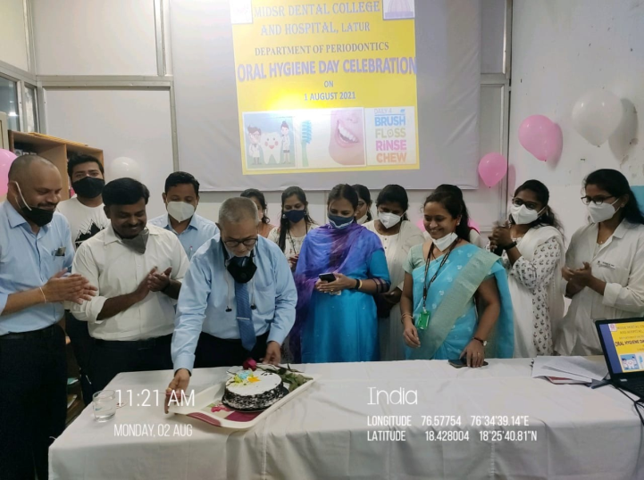
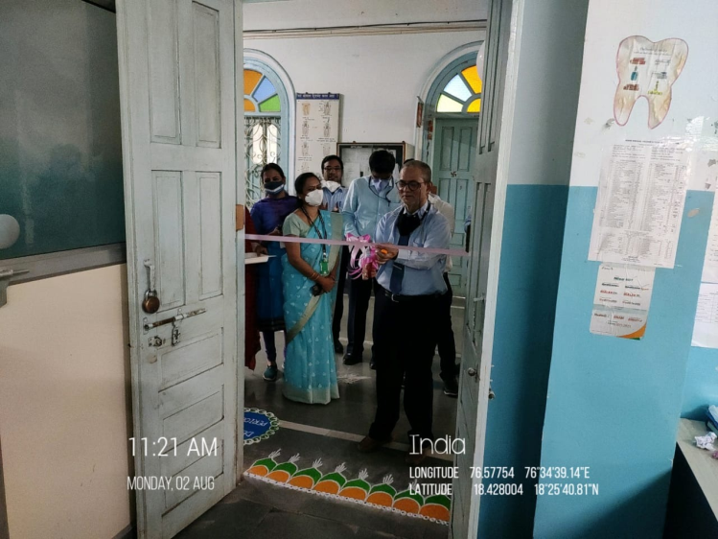
2. Slogan competition- Dr. Smita Warpe
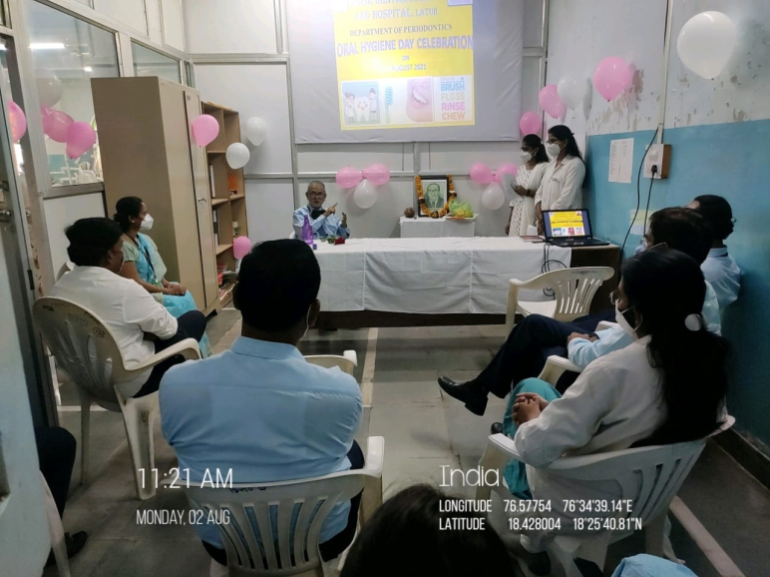
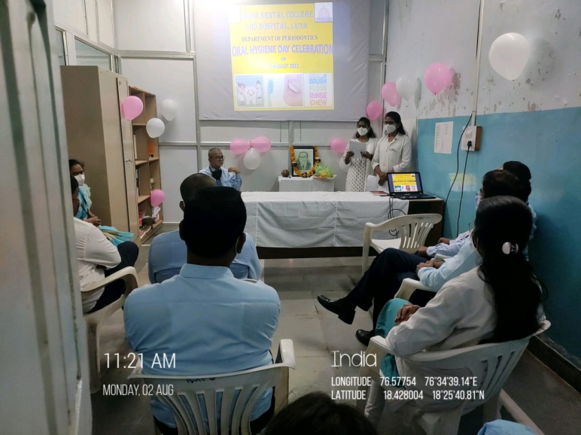

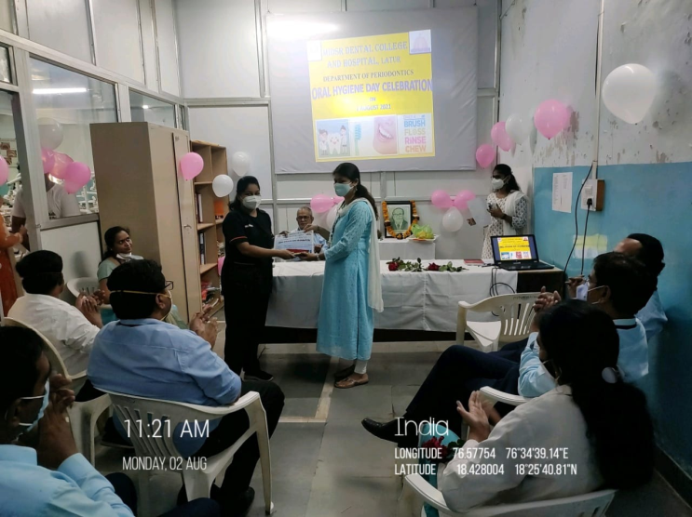
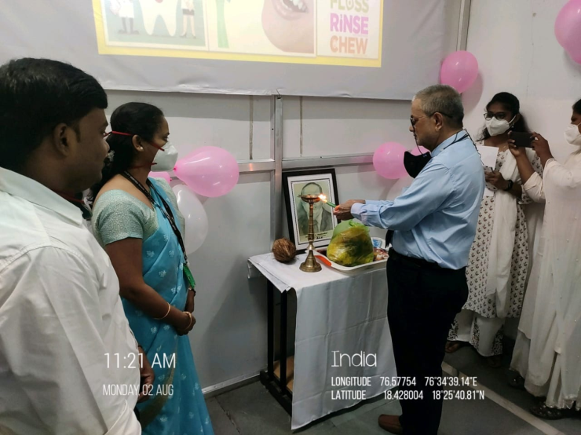
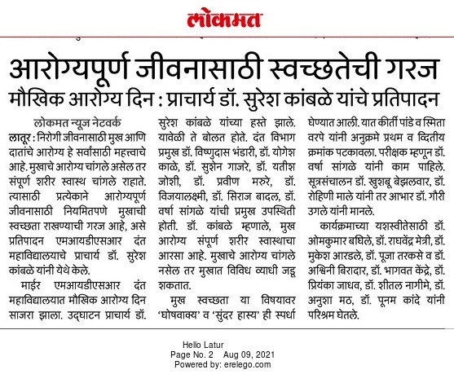
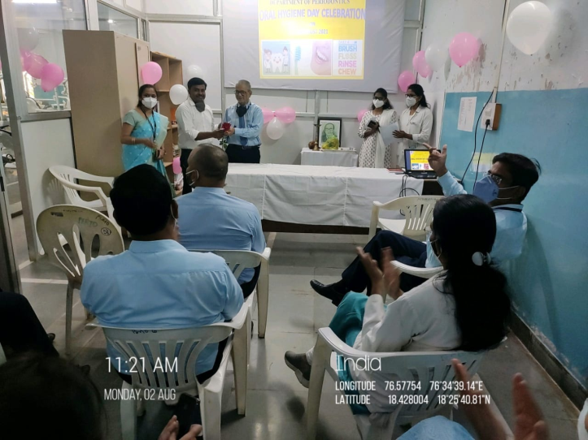

Camp Conducted: At Mamdapur on 3th August on occasion of “Oral Hygiene Day”
No. of patients screened: 126
No. of patients advised treatment: 45

