MIDSR DENTAL COLLEGE AND HOSPITAL
5/08/2019
LATUR
DEPARTMENT OF PERIODONTICS

ORAL HYGIENE DAY CELEBRATION REPORT
August 01, 2019

Oral hygiene day is celebrated all across India on August 1st to commemorate the ‘Birth Anniversary of Dr. G. B. Shankwalkar’ the doyen of Indian Periodontics. As part of the oral hygiene day, DEPARTMENT OF PERIODONTICS took the opportunity to spread awareness and importance of oral health in the community by conducting programs on August 1St . A free dental check-up , free scaling of the patients was done and Poster competition for interns & postgraduates was organized in the college. The theme for the poster was “BRUSH & FLOSS OR PREPARE FOR A LOSS”, which was judged by Dr. Kamble sir (principal) , Dr. Kangne sir (vice principal). Dr. Vishnudas Bhandari (HOD of Periodontics department) along with all the staff of periodontics department Dr. Omkumar Baghele, Dr. Gauri Ugale, Dr. Raghvendra Metri, Dr. Mukesh Aradle, Dr.Sukanya Vyavhare, Dr. Poonam Kedar prearranged this programme and post graduate students Dr. Fatima Pathan, Dr. Smita Malbhage, Dr. Saleem Khan, Dr Kanishka Magdum, Dr. Madhura Vairagi , Dr. Shrirang Sangle, Dr. Khushbu Bezalwar, Dr. Priyanka Jadhav, Dr. Rohini Male and students have enthusiastically participated in the program. There was an active participation by the students and the 1 best poster was awarded a prize to Dr Sphurti Joshi from Department of Pedodontics. All the posters were put on display for the patients visiting the hospital premises.
Number of students participated= 18
Total OPD = 70
Total free oral prophylaxis = 44

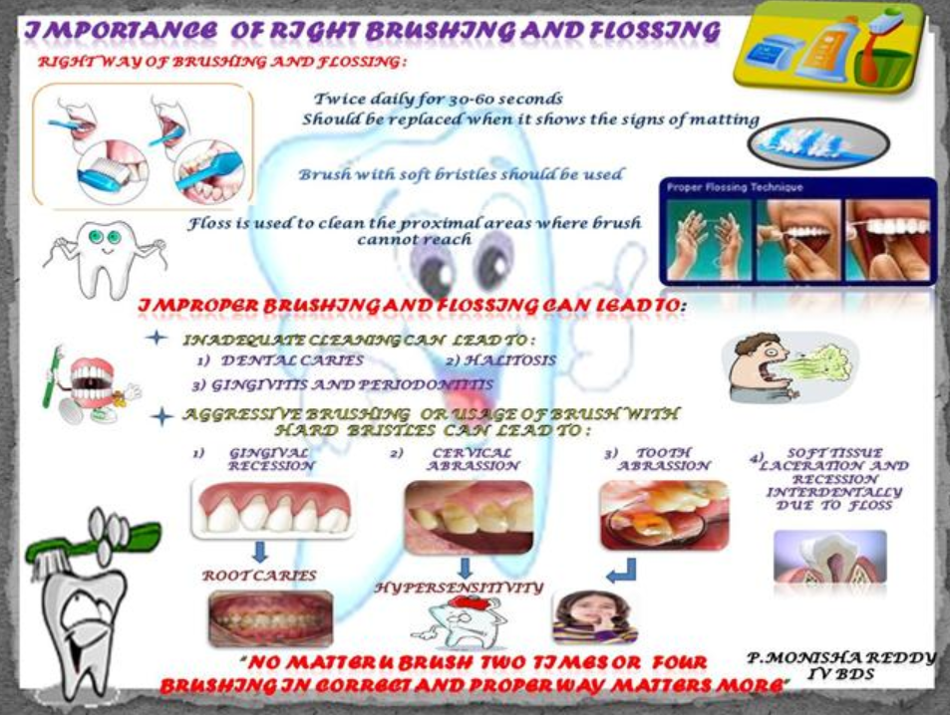
1 best poster :

