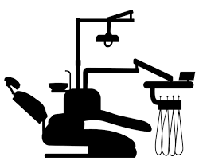

**D**

W

**Reader Room**

**Lecture Room**

**PG Student Room**

**PG Sterilization Room**

**Dark Room**



**Esthetic Clinic**



**RVG Room**



**Endo Micro Surgical Room**

Door

W

W

W

W

W

W

W

W

W

W

W

W

D

Door

**D**

**D**

**D**

**D**



**D**

**D**

**PG Clinical Area**





**D**





**Museum**

W

W

W

W

W

W

W

W

D

D

D

D

**Record Room**

**Wash Basin**

**Wash Basin**

**Duct**

**HOD Room**

**Sterilization Room**

**Autoclave Room**

**Toilet**

**Toilet**

**Toilet**

**D**

**Door**

**Door**

**UG Clinical Area**

**Door**

**Door**