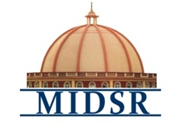
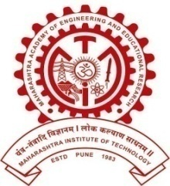
MAEER PUNE’S
MAHARASHTRA INSTITUTE OF DENTAL SCIENCES AND RESEARCH, LATUR
(DENTAL COLLEGE & HOSPITAL)
DEPARTMENT OF PUBLIC HEALTH DENTISTRY

Women’s Day Programme

The NSS students organized and celebrated Women’s Day in collaboration with the women’s welfare and grievance committee of the MIDSR Dental College, Latur. The women’s day rally was organized inside the campus & different cultural programs dedicated to the women were conducted in collaboration with the other institutes of the campus.

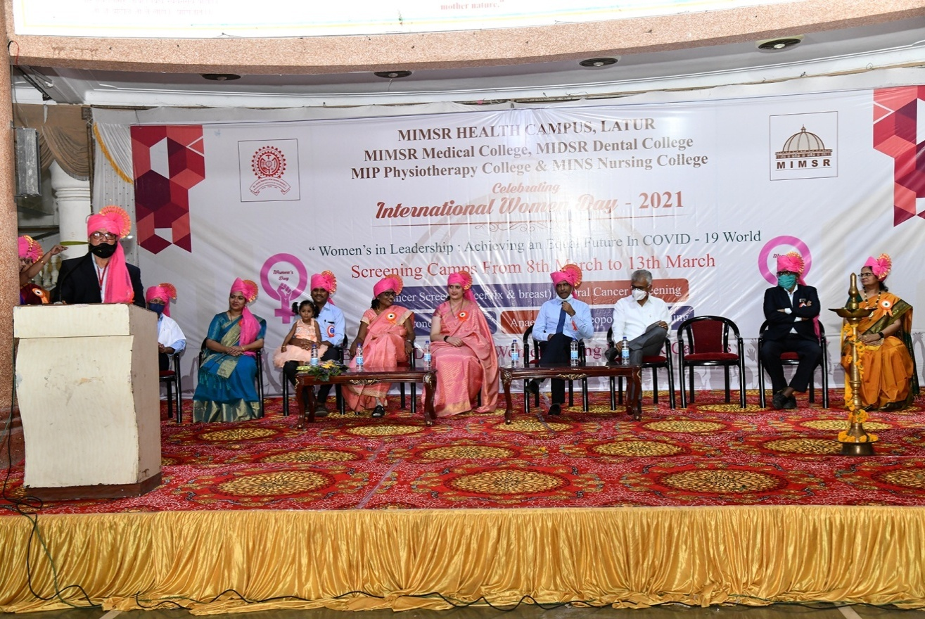

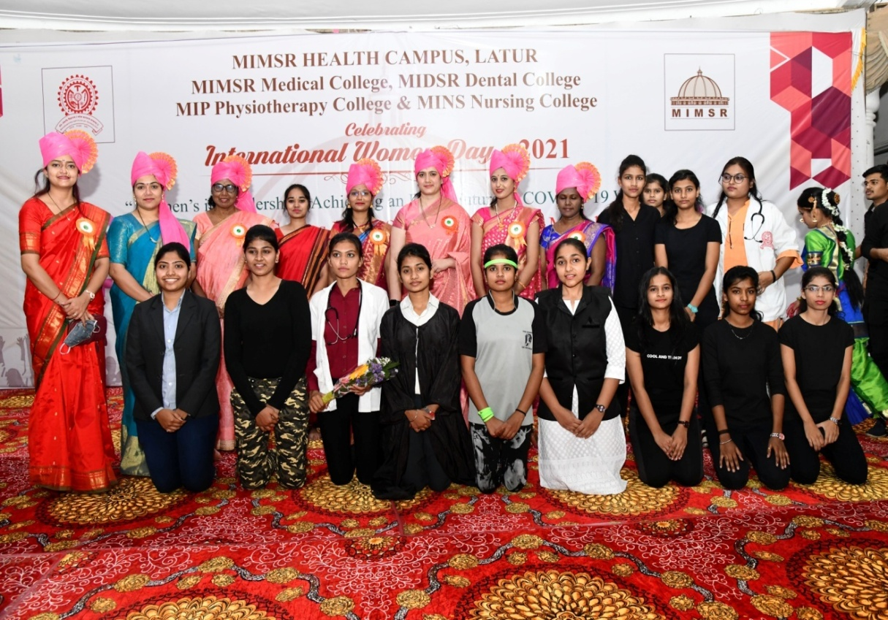

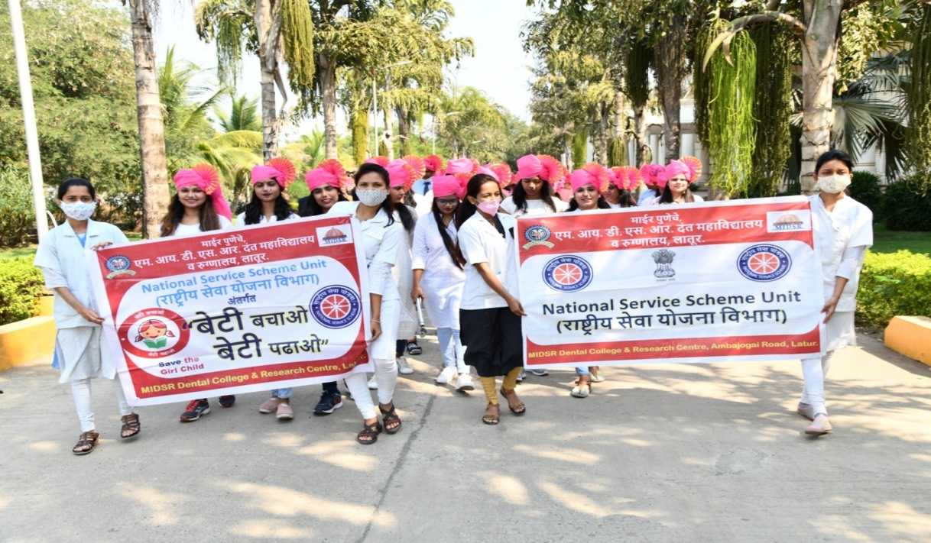

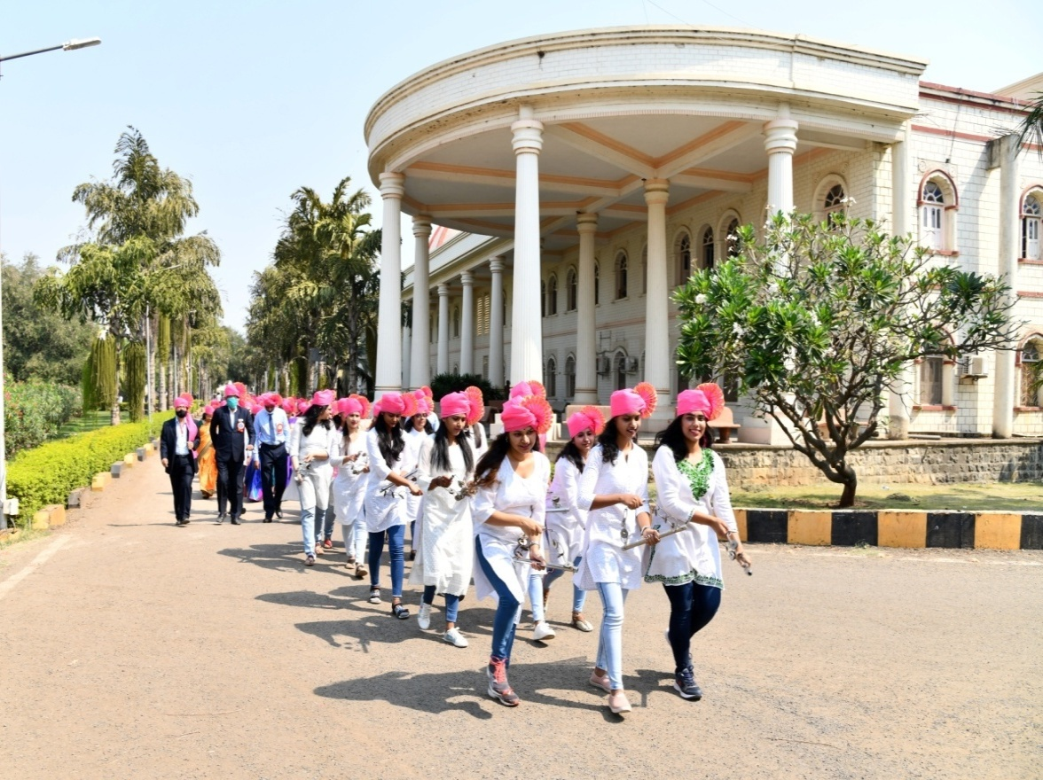

World No Tobacco Day Programme
On the occasion of WORLD NO TOBACCO DAY in the presence of honorable principal of MIDSR, DENTAL COLLEGE LATUR Dr. Suresh Kamble sir, HOD of public health department Dr Ashwini Biradar maam with Dr. Saffalya Kadtane sir & Dr Bhagwat Kendre sir. Dr Saffalya Kadtane sir Informing All students about Tobacco & its variants & their effects on Human Body as well as on Society. Students along with staff took Oath that they won’t themselves consume nor let anyone consume any type of Tobacco. Along with this as to encourage NSS unit conducted E-POSTER competition and all winning and participating students were certified.

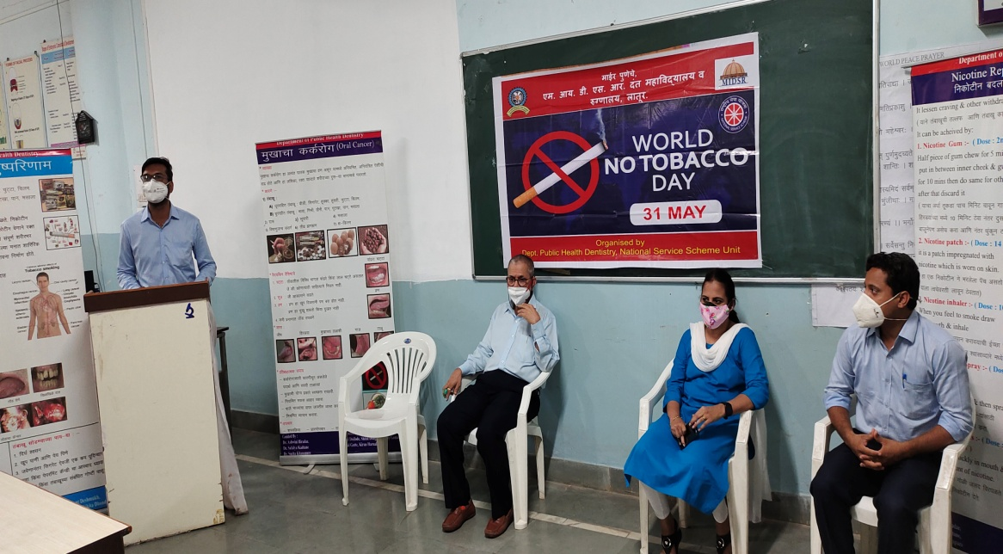

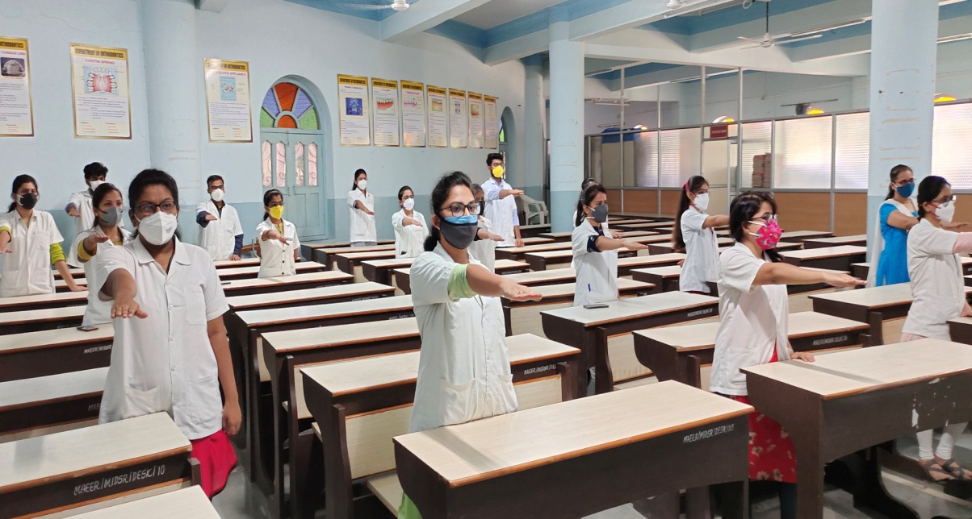

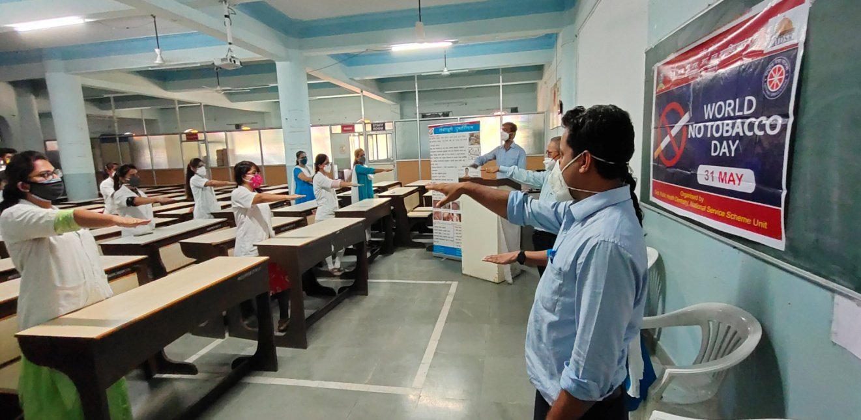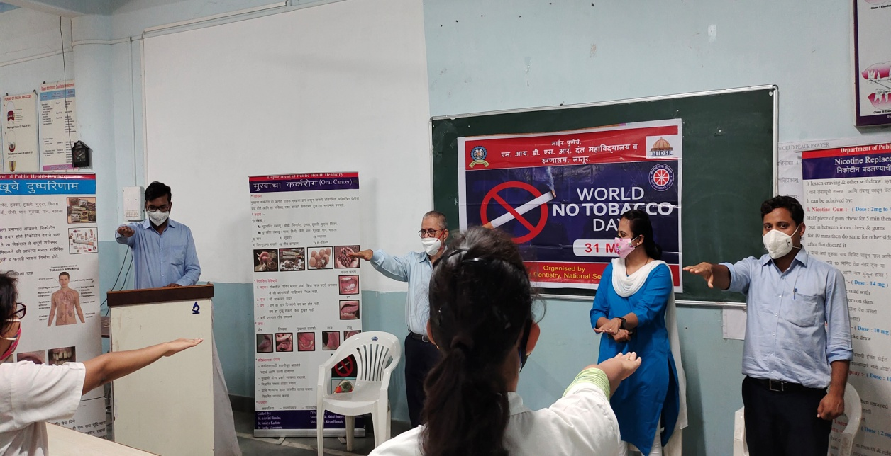

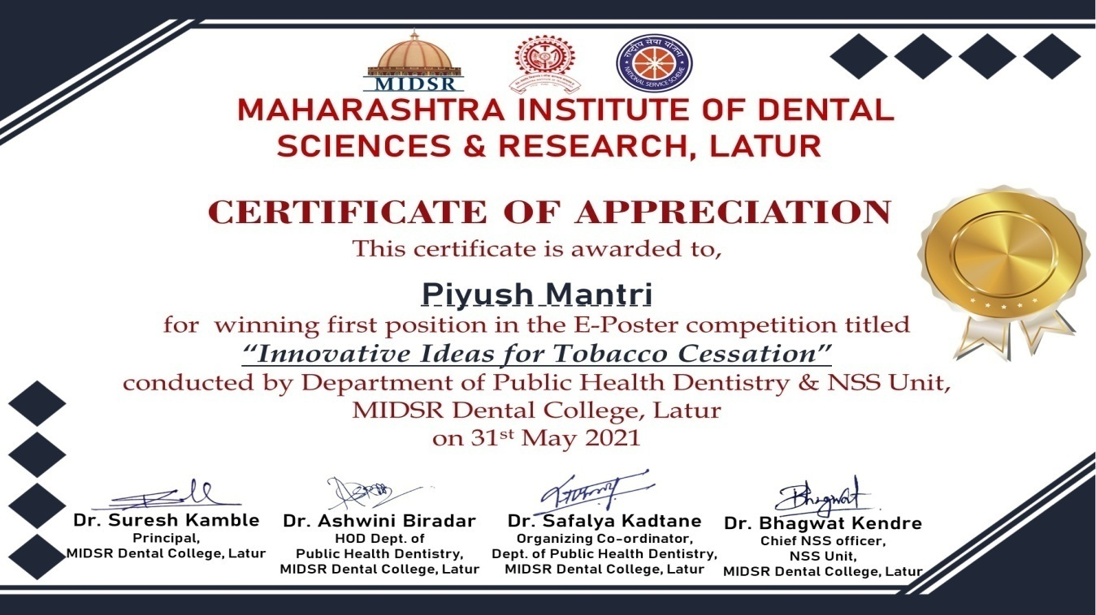

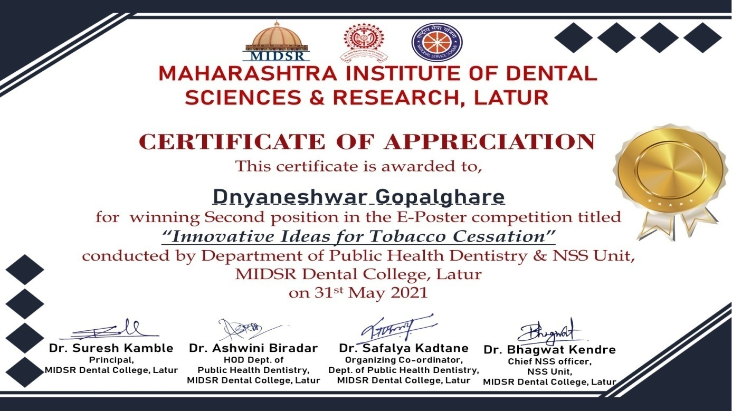

National PHD Day Programme
On occasion of National PHD Day 19th June 2021 the Department of Public Health Dentistry organized MCQ Master Competition in which interns, final years & third years participated for the same. All winners & participating students were felicitated.
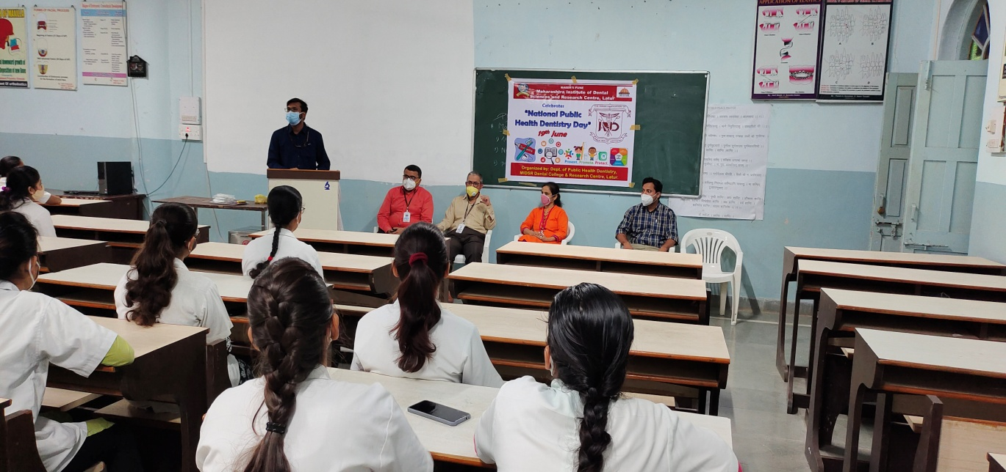
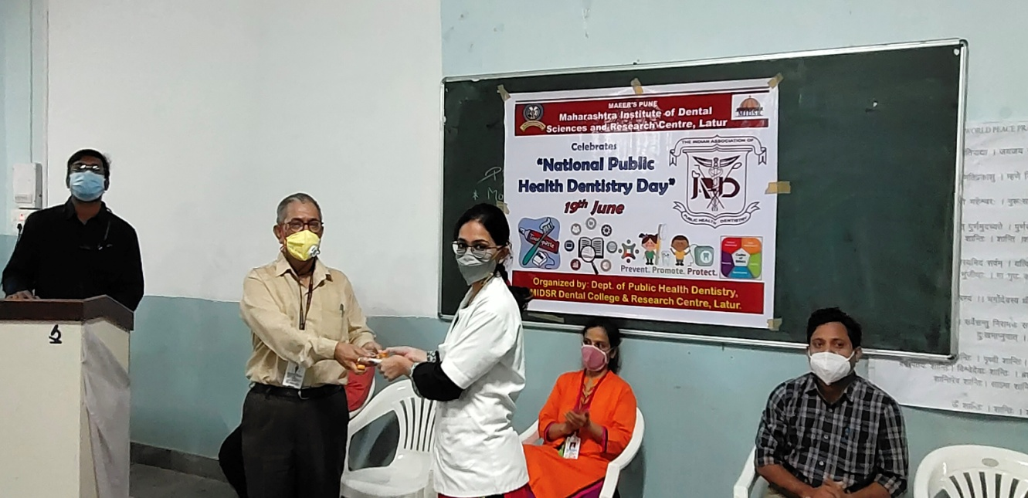

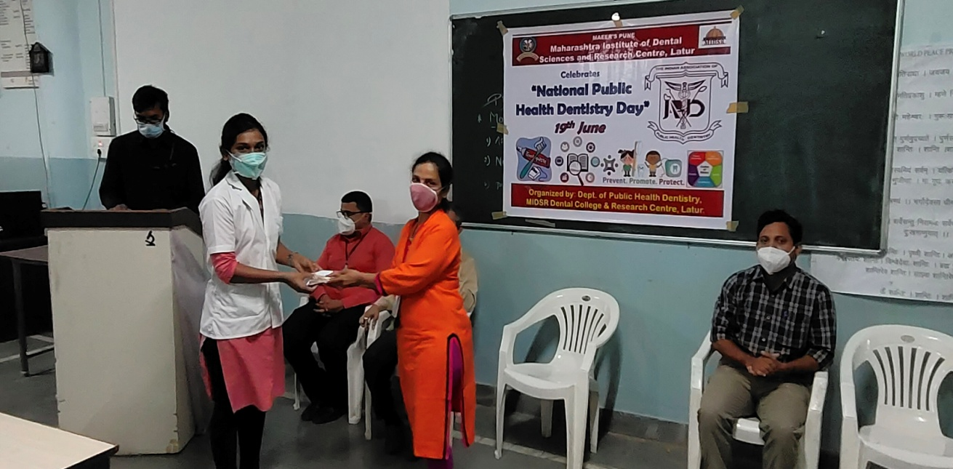

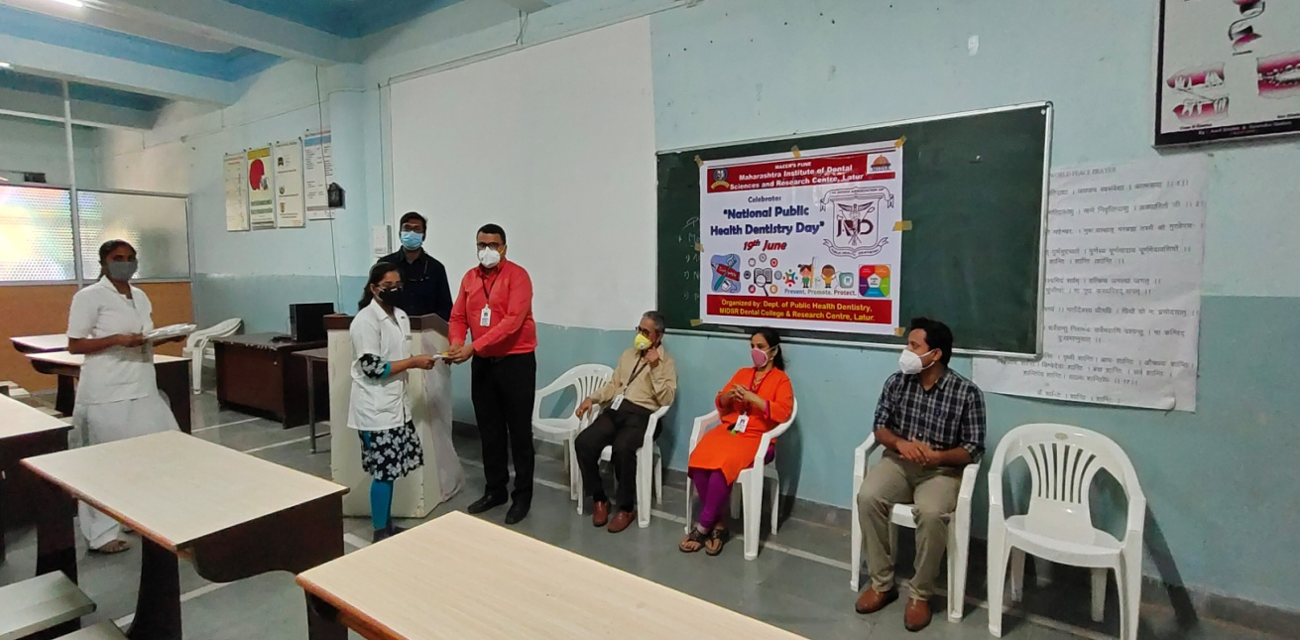

Yoga Day Programme
The Yoga Day was observed in MIDSR Dental College & Hospital on the 21st June 2021. The program was conducted by the joint adventure of the NSS & Cultural Committee of the MIDSR Institute. The session was inaugurated at 9:30am in the presence of the Principal Dr. Suresh Kamble, Yoga instructor Dr. Dole Madam and the other dignitaries. The total no. of participants was approximately 65 including the students, teaching staff and nonteaching staff. In the practical session demonstration of various asan such as kapalbharati, bhujangasan, vajrasan, matsyendrasan, uttana padasan, dhanurasan, naukasan and trikonasana. The yoga session was followed by the meditation. The valedictory speech and vote of thanks has been given by the Principal of the institute.

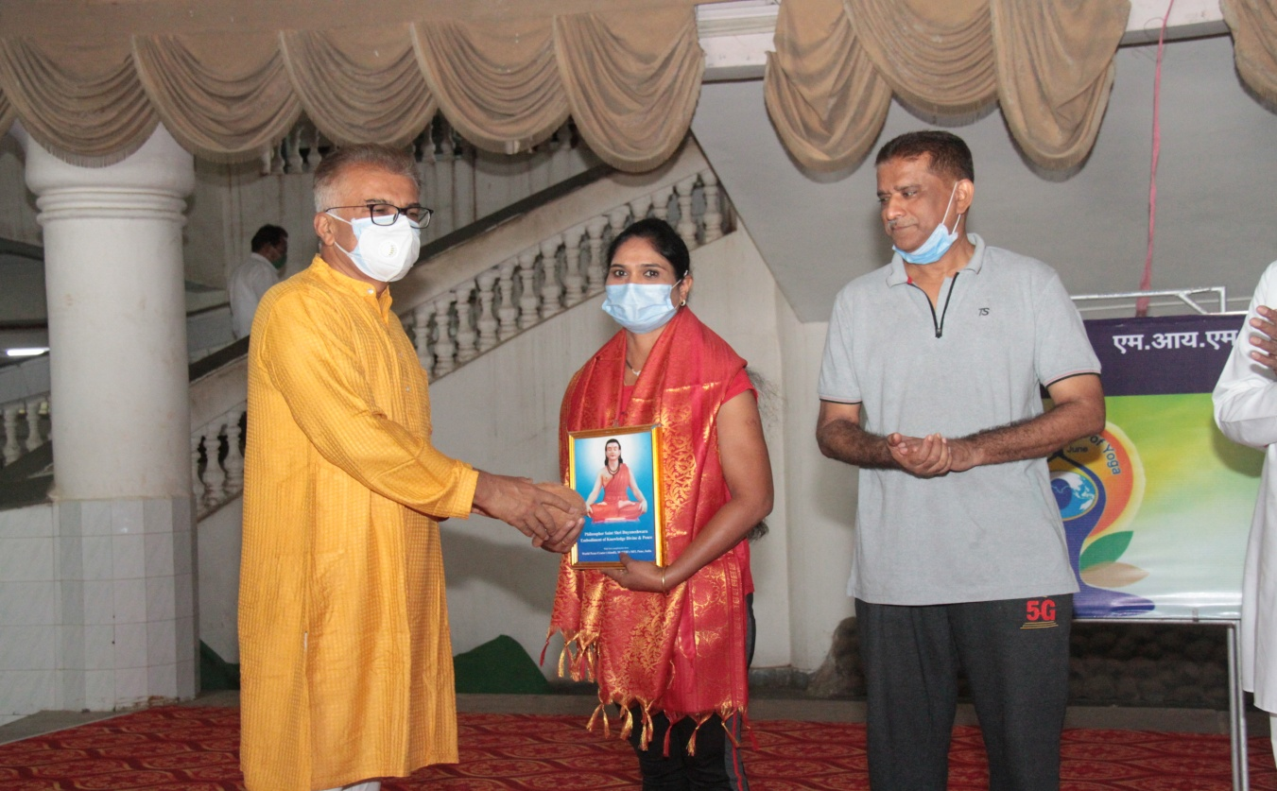

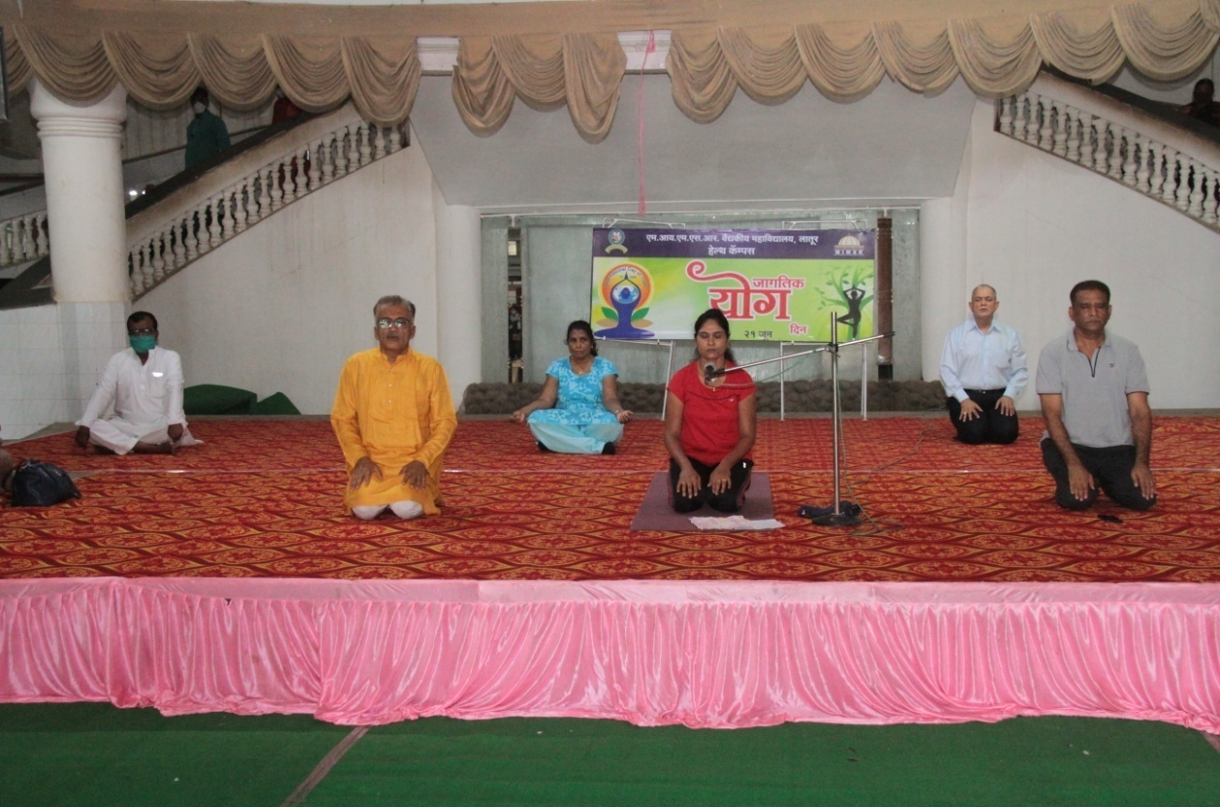

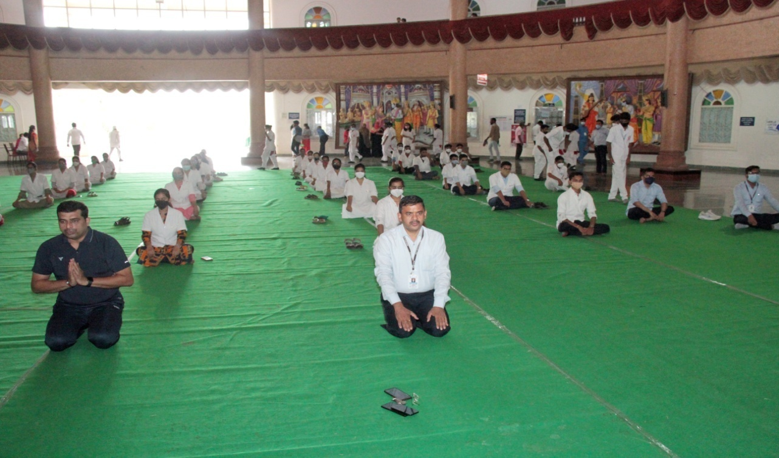

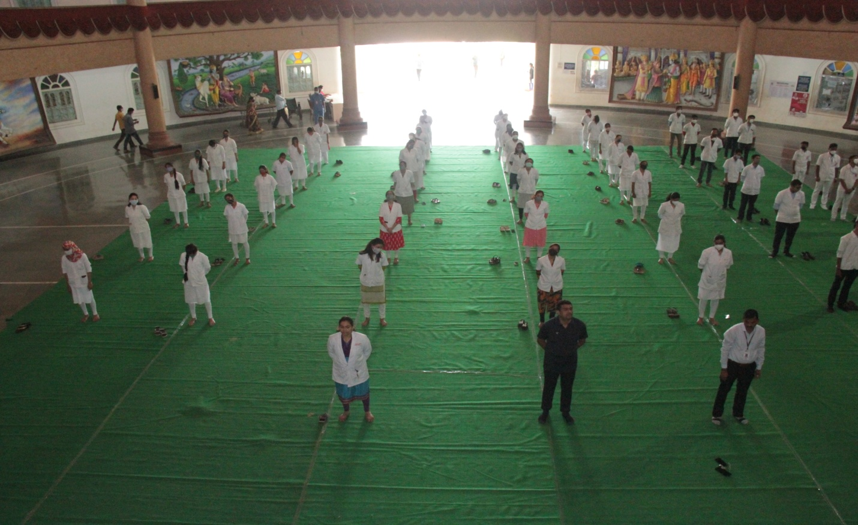

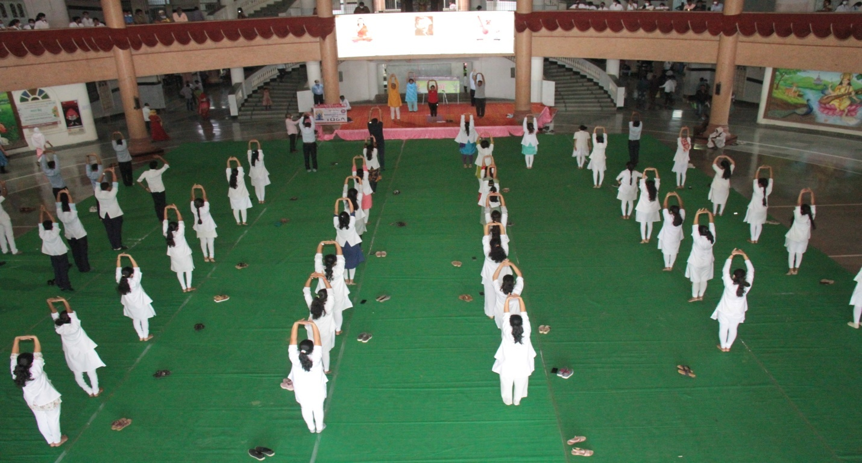
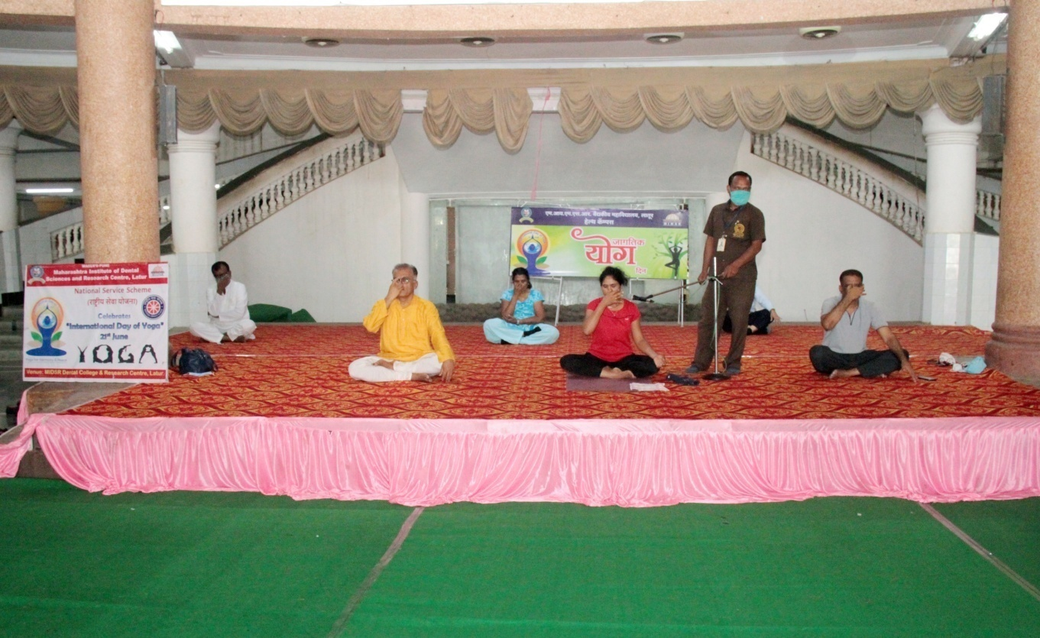

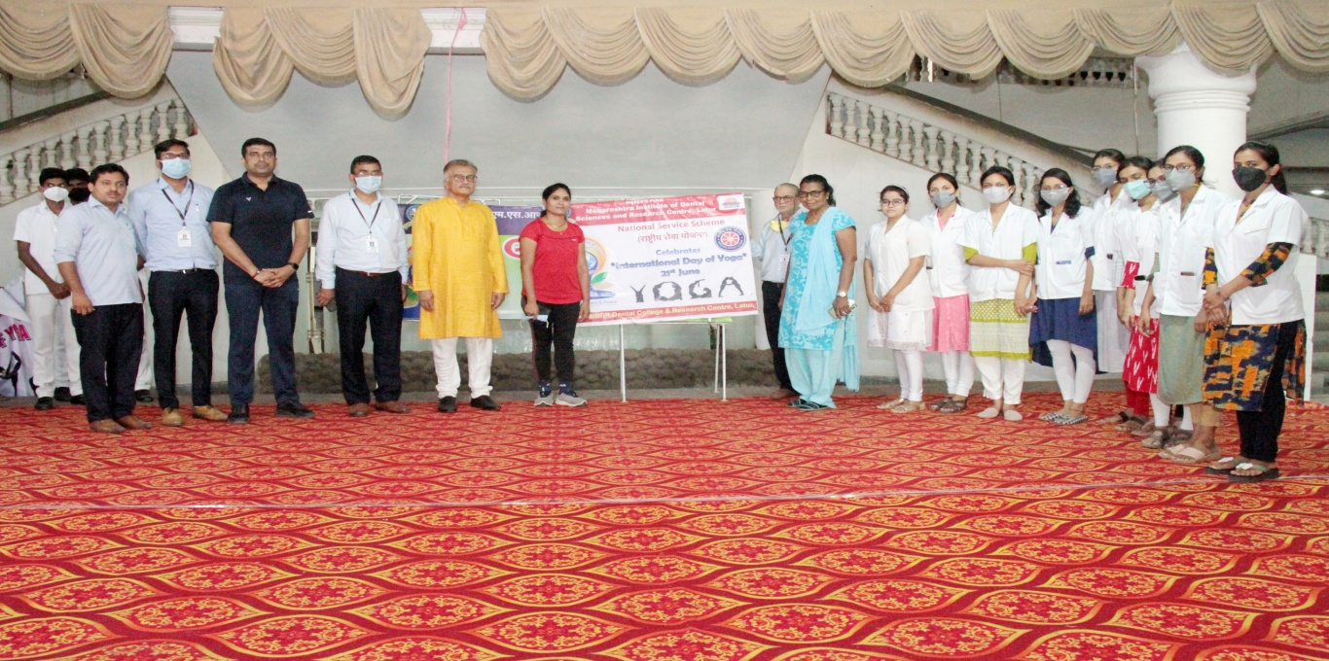

Doctor’s Day Programme
On the occasion of Doctors Day NSS unit of MIDSR Dental College, Latur conducted a webinar on ORAL HEALTH AWARENESS for students of Sant Tukaram National Model School. The speaker of the webinar Dr. Safalya Kadtane of department of public health dentistry at MIDSR encouraged students on oral health awareness. The webinar was emphasized to inform and motivate importance of oral health, oral hygiene practices, etc.

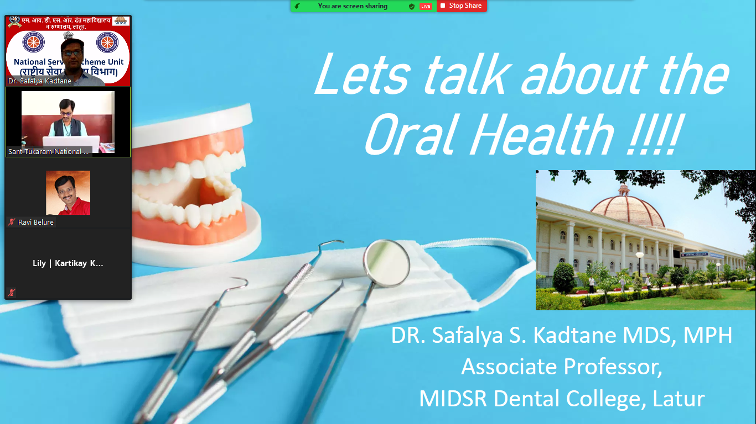

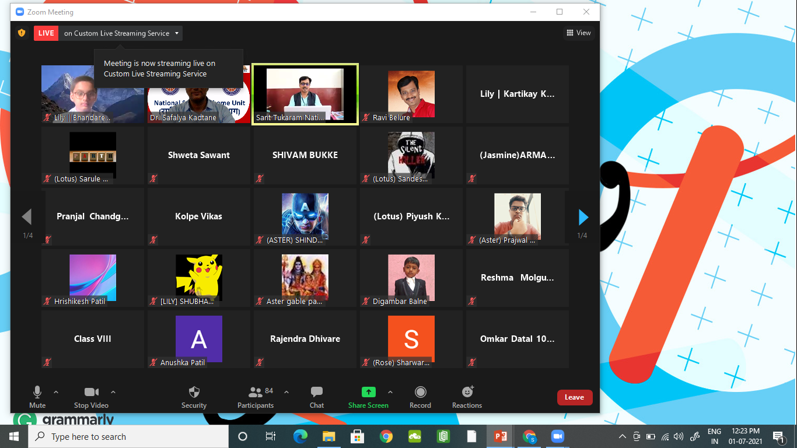

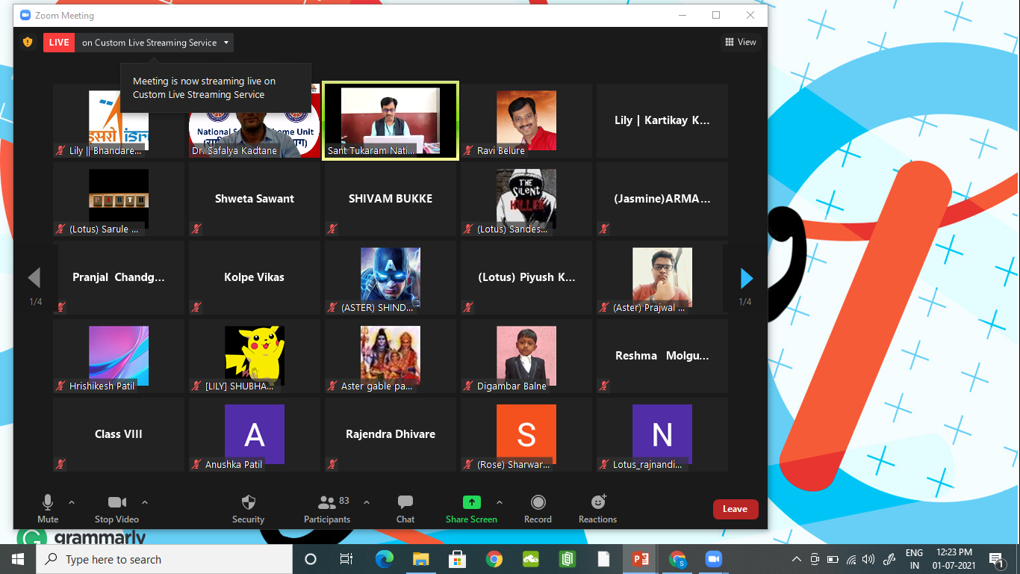

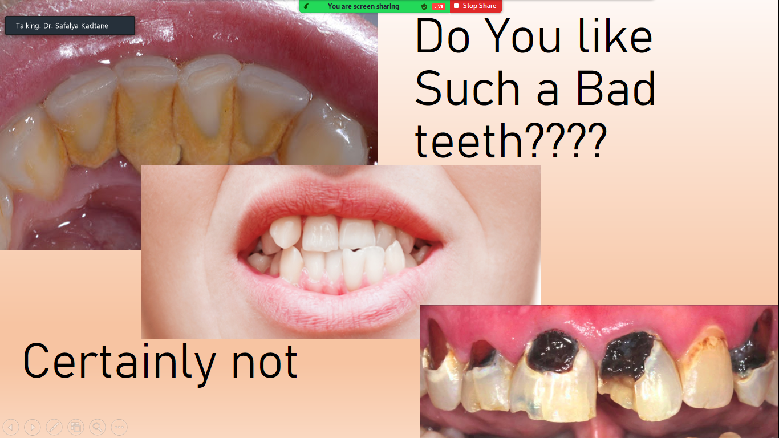

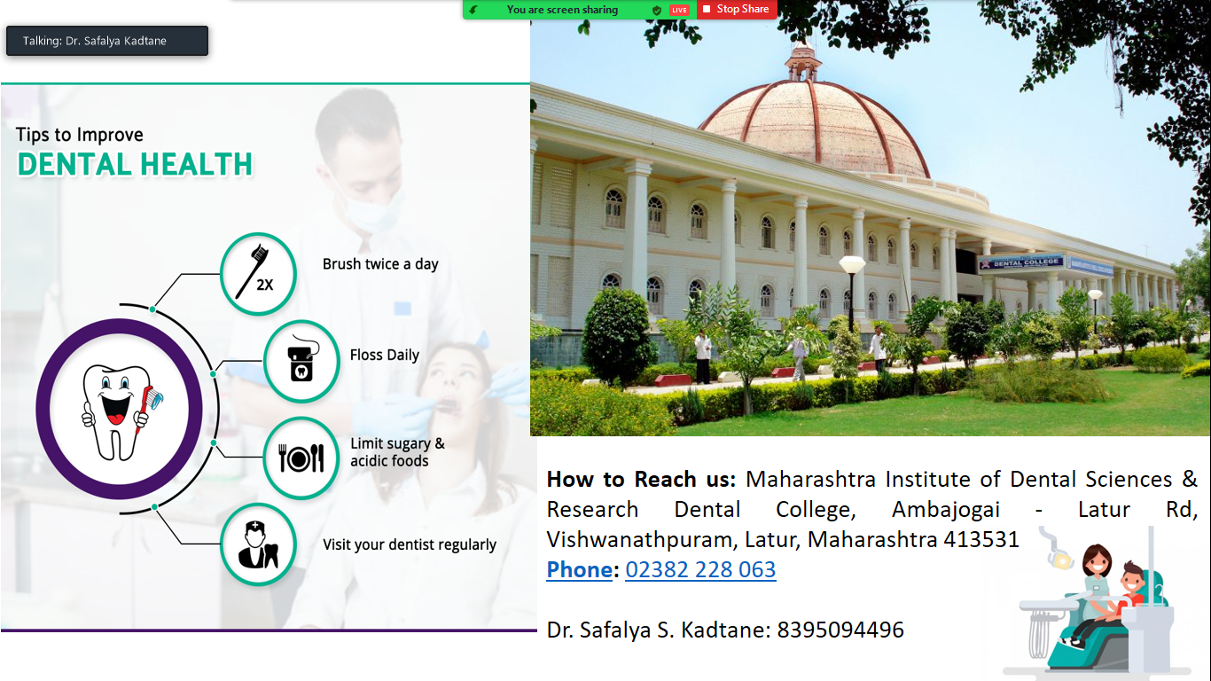

Oral Hygiene day Programme
On occasion of Oral Hygiene Day 1st August 2021 the NSS Unit organized free dental check-up camp and dental education lecture. Free dental check-up and education camp in school at Mamdapur was organized and about 126 patients were seen.

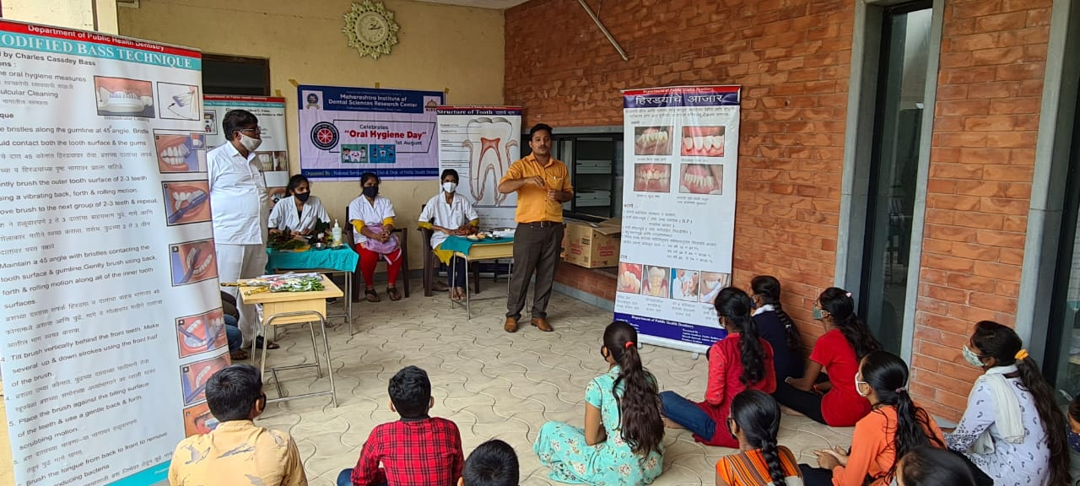

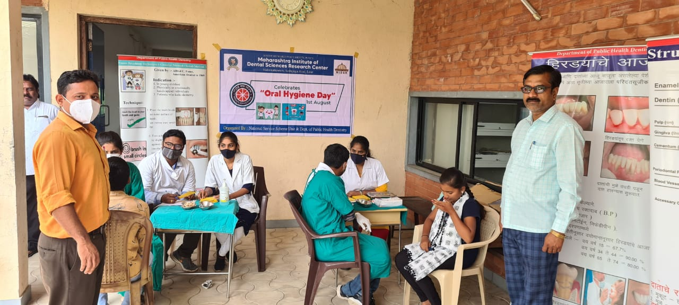

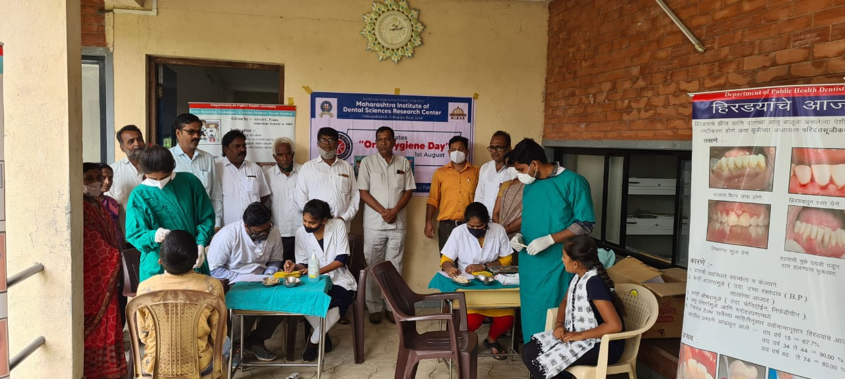

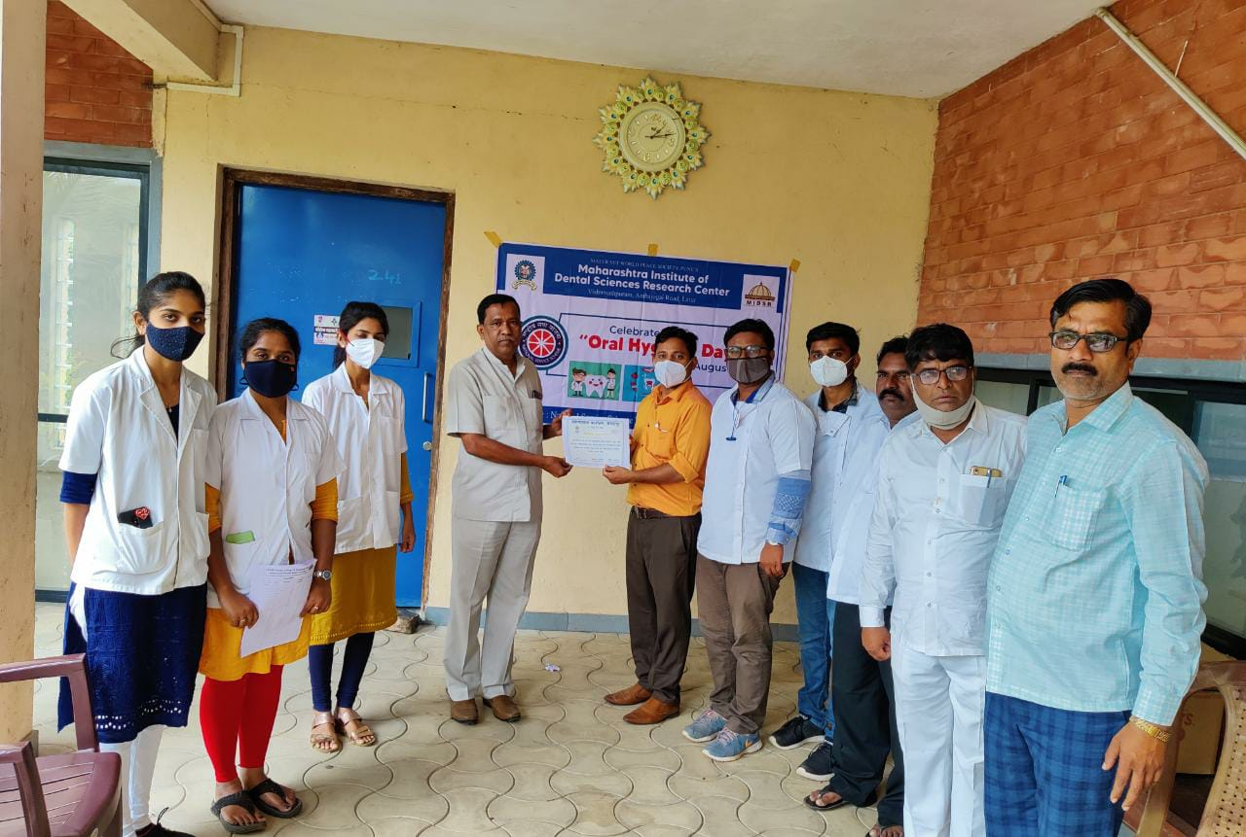

World Oral Health Day Celebration, 2022
World Oral Health Day is observed on March 20 every year. The FDI World Dental Federation launch a year-long campaign dedicated to raising awareness and issues around oral health and the importance of oral hygiene. The day holds significance to reflect the importance of oral hygiene and care. A baby must have 20 teeth and senior citizens must have 20 teeth at the end of their life. A healthy adult should have 32 healthy teeth.

On this occasion A rally and Dental Diagnosis and Awareness camp was organized by the Department of Public Health Dentistry of Maharashtra Institute Of Dental Science and Research, Latur, Maharashtra, 09.00 am onwards at Bathangali village, Ta. Renapur, Dist Latur. The programs were conducted under the guidance of Principal Dr. Suresh Kamble & Vice Principal Dr. Suresh Kangane.

The rally was conducted using IEC Material and posters with the aim to create awareness of the benefits of a healthy mouth and to promote worldwide awareness of the issues around oral health and the importance of oral hygiene.

The theme for World Oral Health Day 2022 is ‘Be Proud of Your Mouth for Your Happiness and Well-Being’. With the motto of encouraging as many people as possible to look after their mouths and protect their quality of life. An unhealthy mouth not only impacts general health but also has a severe impact on people’s emotional, social, mental, and overall physical well-being. It highlights were the associations between oral diseases and non communicable diseases (like diabetes, hypertension, respiratory disease and some cancers), raises awareness of common risk factors and promotes good oral hygiene habits.

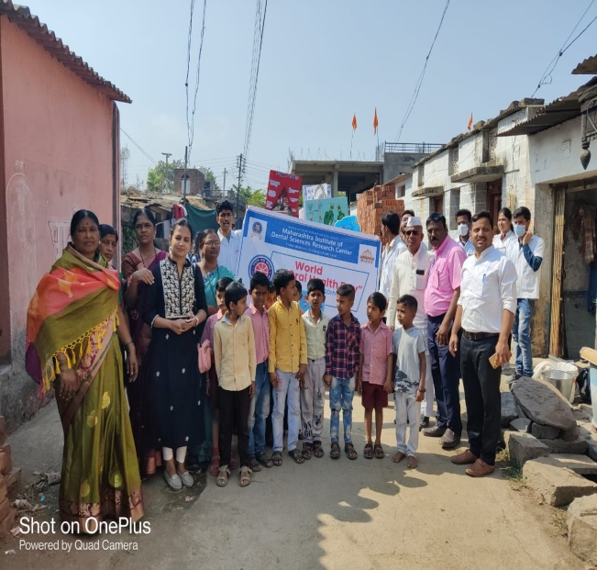
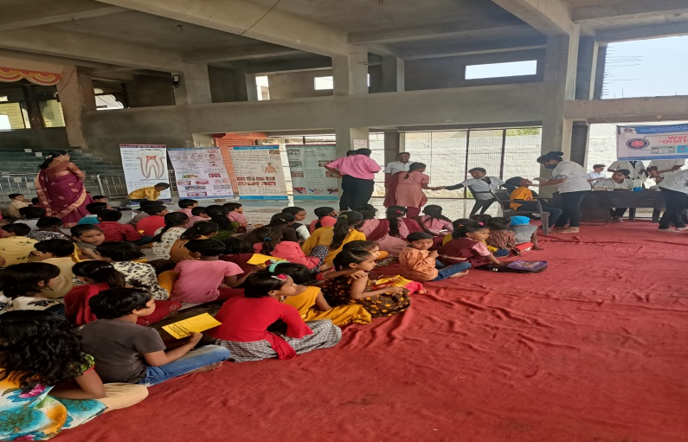
The camp was conducted in the school, 263 children were checked for dental; cavities and other dental problems by students and staff who also spoke to the children about brushing their teeth twice a day, avoiding too much sweets and practicing other good habits for proper oral hygiene. A power point presentation was prepared for children’s and school teachers for providing information about the importance of oral health and explained in detail about the root cause of the dental and oral health problems, methods of preventing the diseases, and different treatment facilities available.The screening of 87 villagers was also carried out in the Mobile Dental Van and also educated about oral health in Bathangali village.

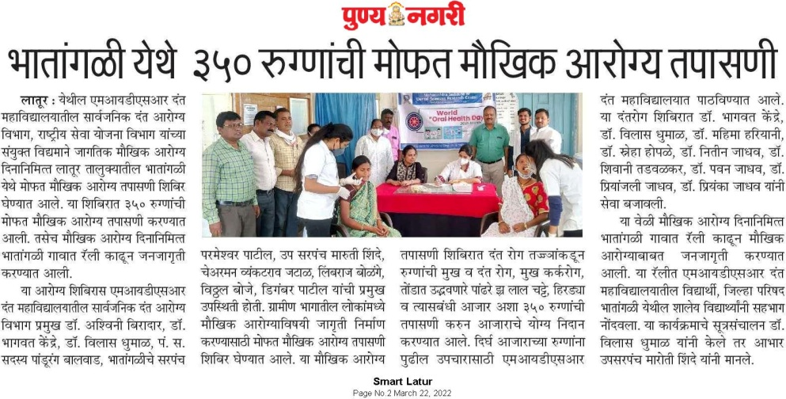
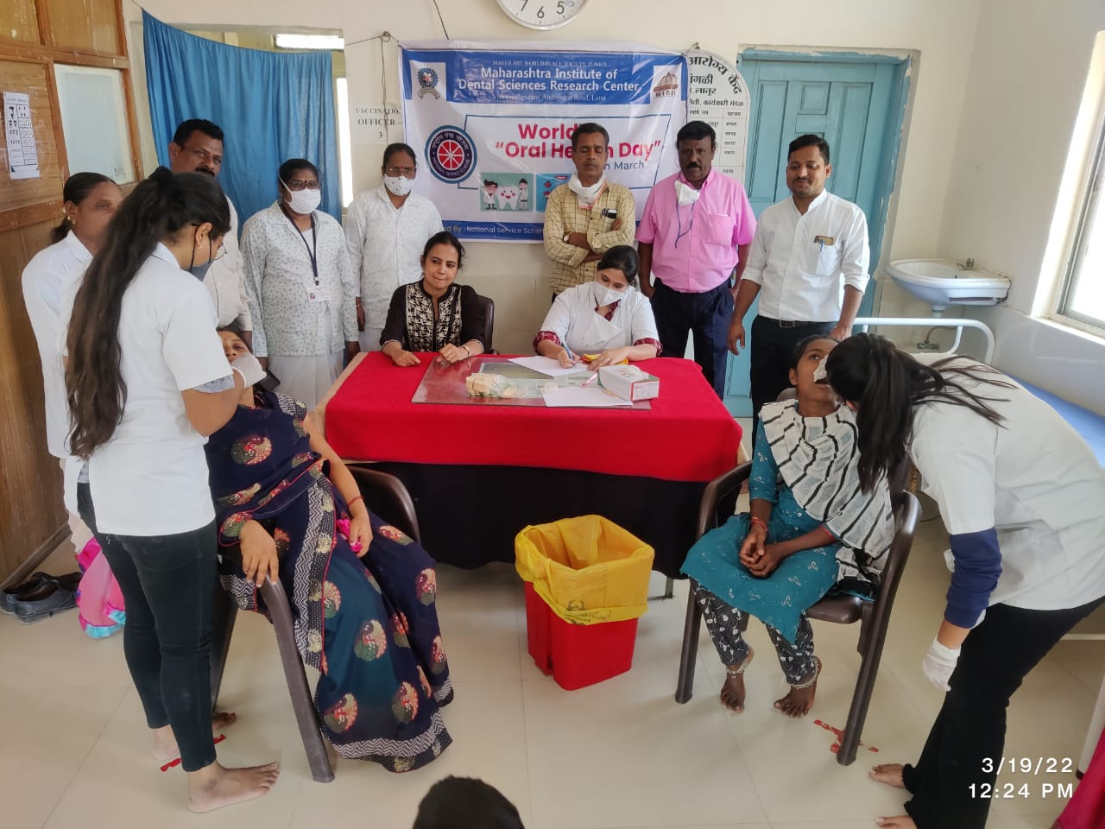
On this event a special programme was also organized in PHC of Bathangali village. The power point presentation was given for the staff members of PHC regarding the importance of oral health and explained in detail about the etiological factors of oral health problems, methods of preventing the diseases, and different treatment modalities available. Pregnant ladies were screened in the PHC and also educated about the importance of oral health during pregnancy.

Yoga Day Programme
The Yoga Day was observed in MIDSR Dental College & Hospital on the 21st June 2022. The program was conducted by the joint adventure of the NSS & Cultural Committee of the MIDSR Institute. The session was inaugurated at 10:00am in the presence of the Principal Dr. Suresh Kamble, Vice Principal Dr. Suresh Kangane Yoga instructor Dr. Dole Madam and the other dignitaries. The total no. of participants was approximately more than 150 including the students, teaching staff and nonteaching staff. In the practical session demonstration of various asan such as kapalbharati, bhujangasan, vajrasan, matsyendrasan, uttana padasan, dhanurasan, naukasan and trikonasana. The yoga session was followed by the meditation. Importance of yoga day has been demonstrated by performing skits and play. The valedictory speech and vote of thanks has been given by the Principal of the institute.
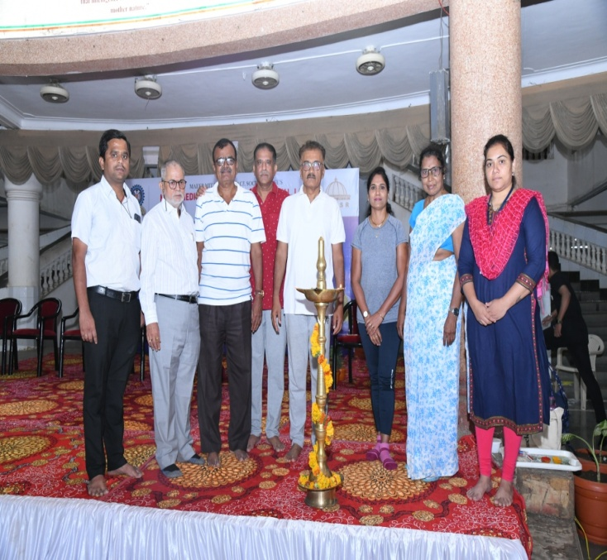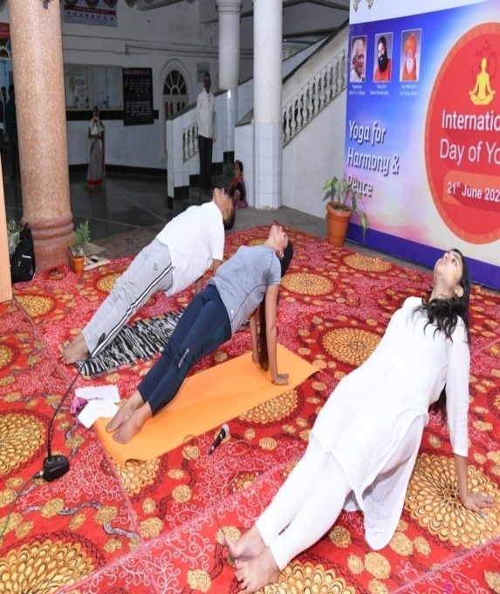

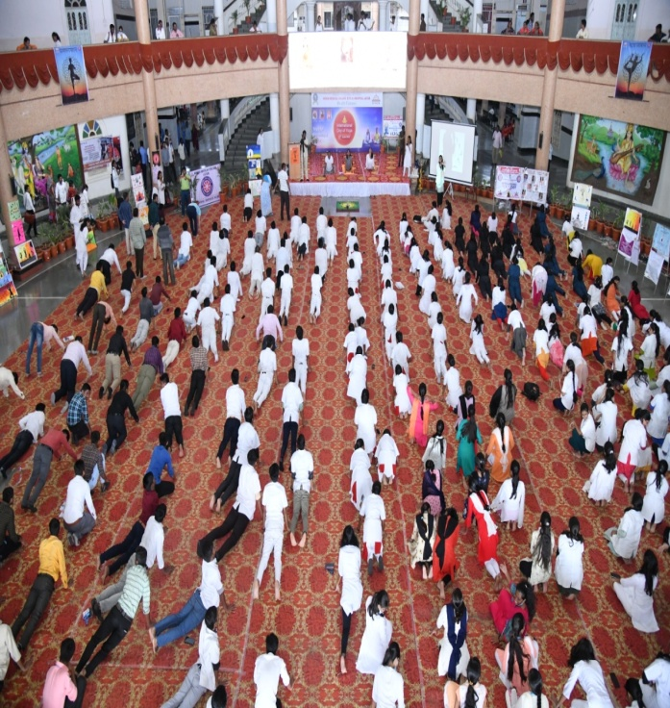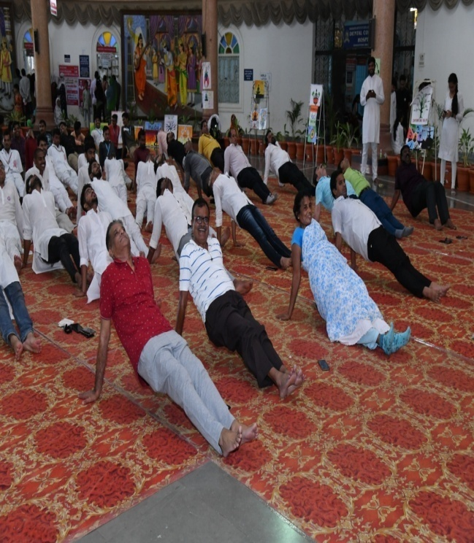

World AIDS Day observed
1 December 2022

The world AIDS day has been observed in MIDSR Dental College, Latur on 1st December 2022.
The various programs has been conducted including the awareness rally at Talani Village

The various awareness posters, slogans were the part of the rally and around 50 students from MIDSR dental college has been participated in it. The aim of the same was to make people aware about AIDS and to promote social skills of the students.

The program was successfully conducted under the observance of Public Health Dentistry Department Dr. Vilas Dhumal.

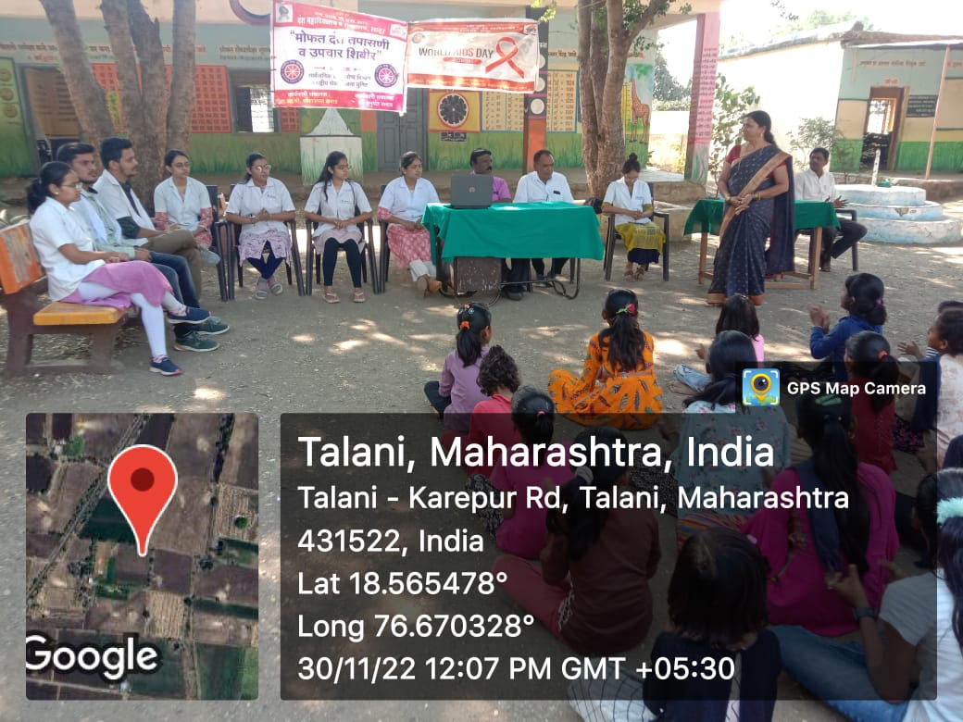
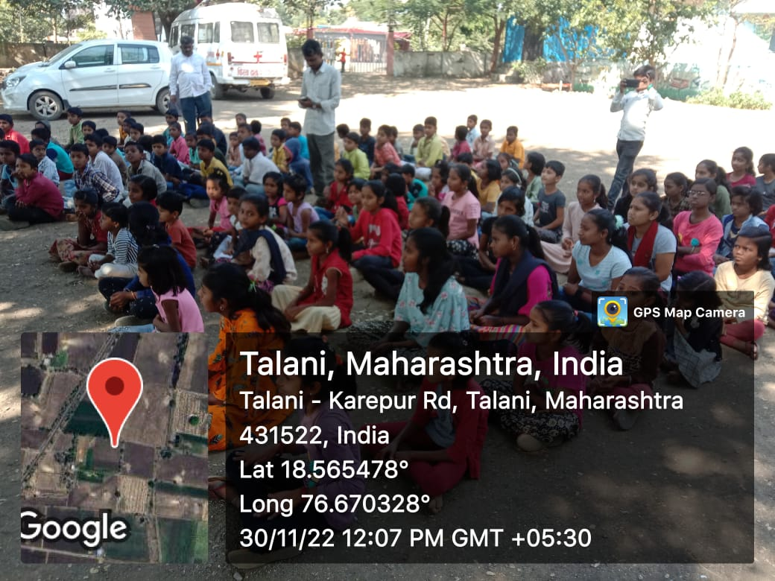

World Oral Health Day Celebration, 2023

World Oral Health Day is observed on March 20 every year. The FDI World Dental Federation launch a year-long campaign dedicated to raising awareness and issues around oral health and the importance of oral hygiene. The day holds significance to reflect the importance of oral hygiene and care. A baby must have 20 teeth and senior citizens must have 20 teeth at the end of their life. A healthy adult should have 32 healthy teeth.
On this occasion A rally and Dental Diagnosis and Awareness camp was organized by the Department of Public Health Dentistry of Maharashtra Institute Of Dental Science and Research, Latur, Maharashtra, 09.00 am onwards at Sarola village, Ta. Ausa , Dist Latur. The programs were conducted under the guidance of Principal Dr. Suresh Kangane & Vice Principal Dr.Yatishkumar Joshi .
The rally was conducted using IEC Material and posters with the aim to create awareness of the benefits of a healthy mouth and to promote worldwide awareness of the issues around oral health and the importance of oral hygiene.
Good oral health can help you live a longer, healthier life. World Oral Health Day 2023 aims to educate people about oral health and encourage people to take action. For this year, the overarching theme for the WOHD campaign is “Be Proud of Your Mouth.

Slogans On World Oral Health Day 2023 Rally
- Strong teeth for good eat.
- Don’t rush when you brush.
- Brush up and down and all around.
- Keep teeth safe.
- Brush and floss or prepare for loss.
- Brush your teeth every day, To keep the dentist away.

- Better teeth, Better health.
- Mrs. Smile loves Mr. Teeth

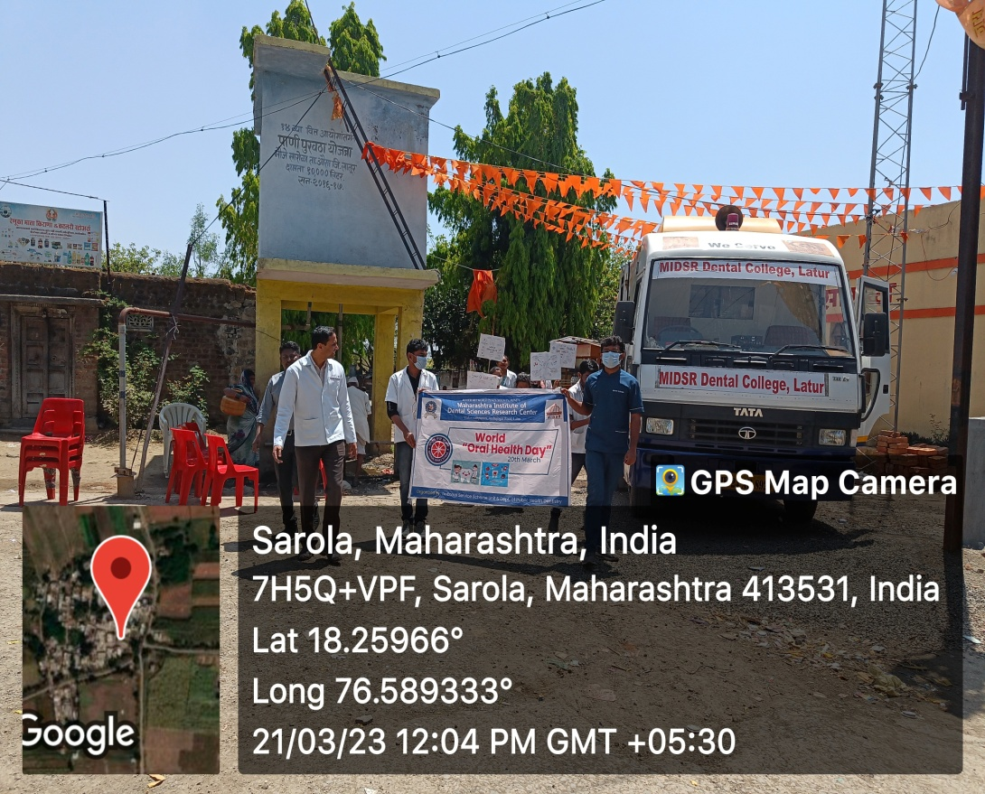

The theme for World Oral Health Day 2023 is ‘Be Proud of Your Mouth for Your Happiness and Well-Being’. With the motto of encouraging as many people as possible to look after their mouths and protect their quality of life. An unhealthy mouth not only impacts general health but also has a severe impact on people’s emotional, social, mental, and overall physical well-being. It highlights were the associations between oral diseases and non communicable diseases (like diabetes, hypertension, respiratory disease and some cancers), raises awareness of common risk factors and promotes good oral hygiene habits.

The camp was conducted in the school 220 children were checked for dental; cavities and other dental problems by students and staff who also spoke to the children about brushing their teeth twice a day, avoiding too much sweets and practicing other good habits for proper oral hygiene. A power point presentation was prepared for children’s and school teachers for providing information about the importance of oral health and explained in detail about the root cause of the dental and oral health problems, methods of preventing the diseases, and different treatment facilities available
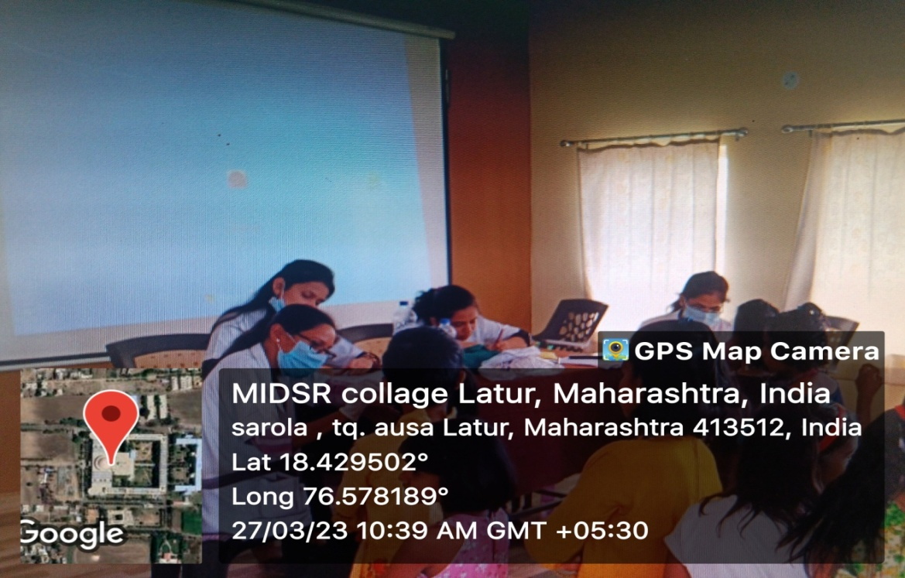

The screening of 87 villagers was also carried out in the Mobile Dental Van and also educated about oral health in Sarola village.

World Health Day Celebration, 2023
Health For All
On 7th April2023 – World Health day –Celebrated in MIDSR Dental College.
On the occasion of WHO’s 75th anniversary year is an opportunity to look back at public health successes that have improved quality of life during the last seven decades .It is also an opportunity to motivate action to tackle the health challenges of today and tomorrow.
To celebrate the 75th anniversary of WHO the MIDSR Dental College ,Latur organised the Organ Donatiom Rally in the MIT Campus .
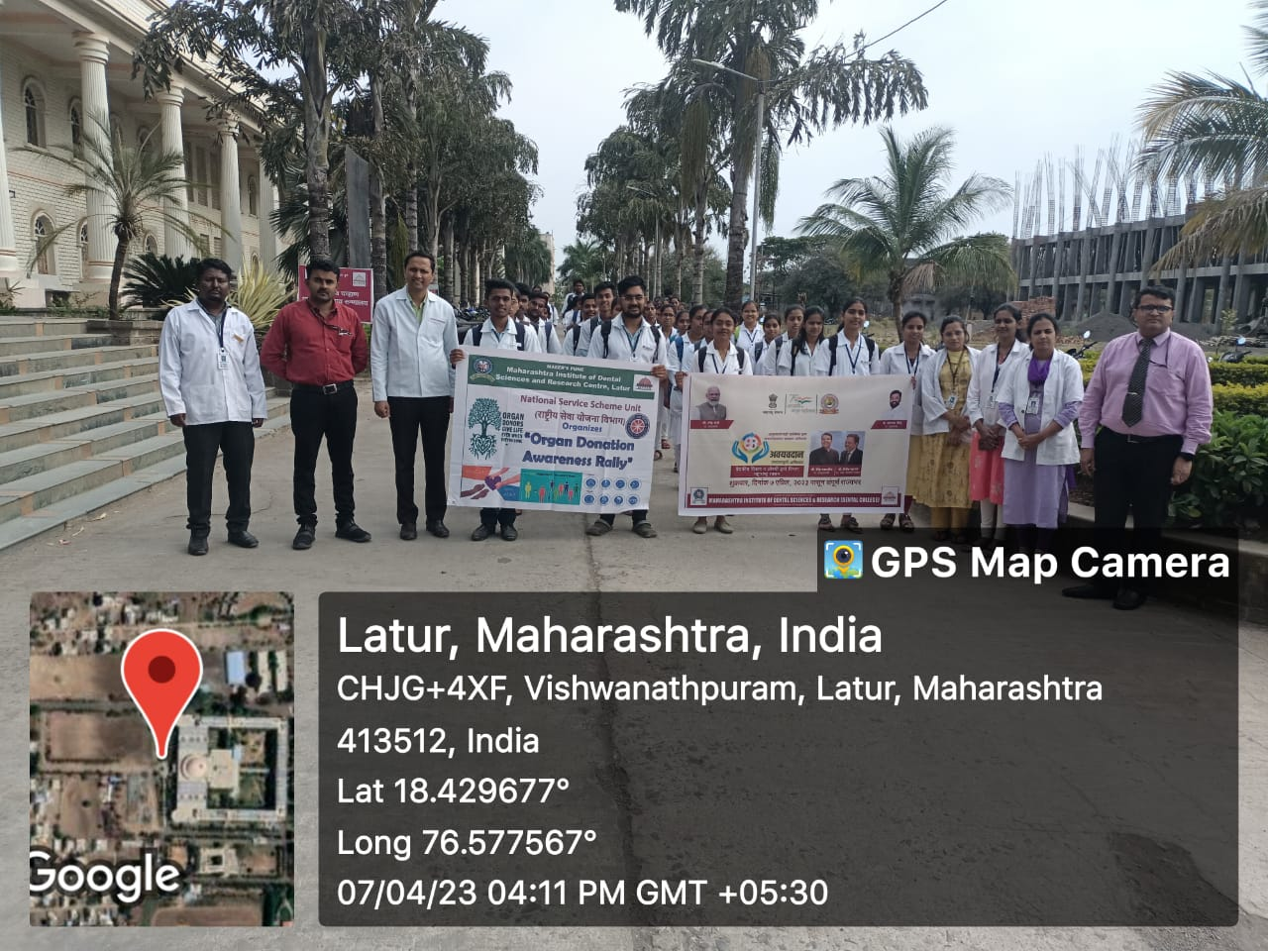

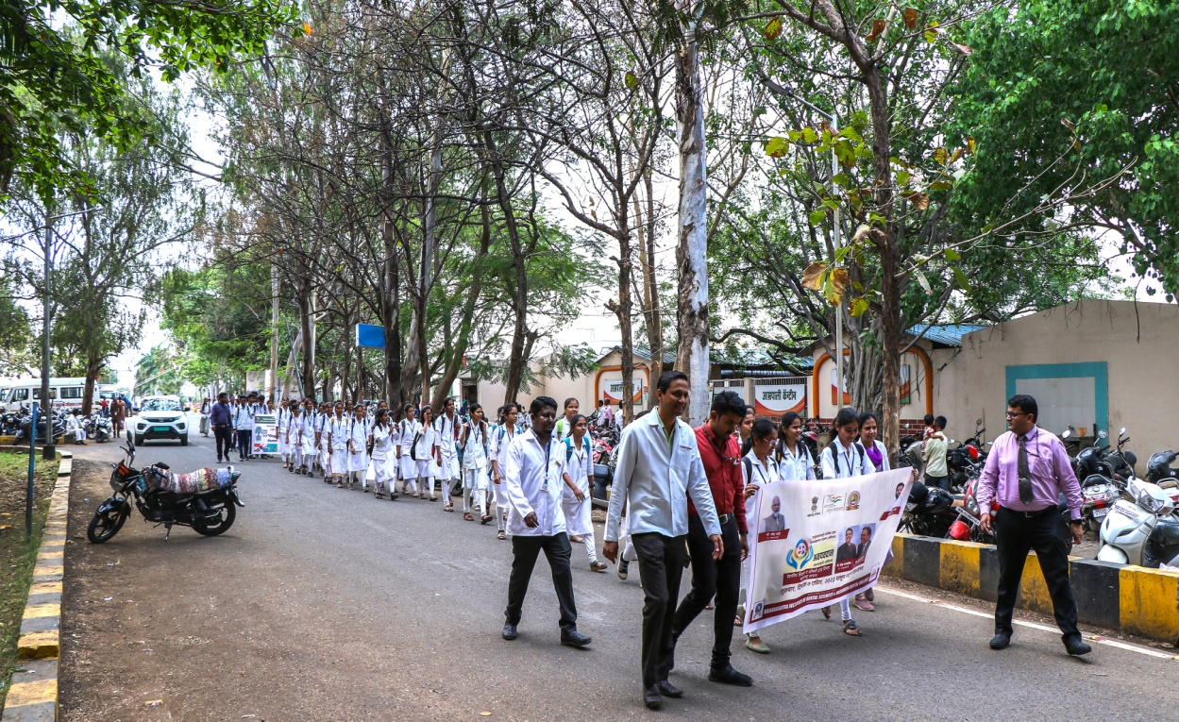

World No Tobacco Day Programme
On the occasion of WORLD NO TOBACCO DAY in the Guidance of honorable principal of MIDSR, DENTAL COLLEGE LATUR Dr. Suresh Kangne sir, HOD of public health department Dr Ashwini Biradar maam .the rally Was conducted to spread awareness about tobacco products and its ill effects of tobacco and Dr. Prakash kasbe sir leading the Rally of All students.

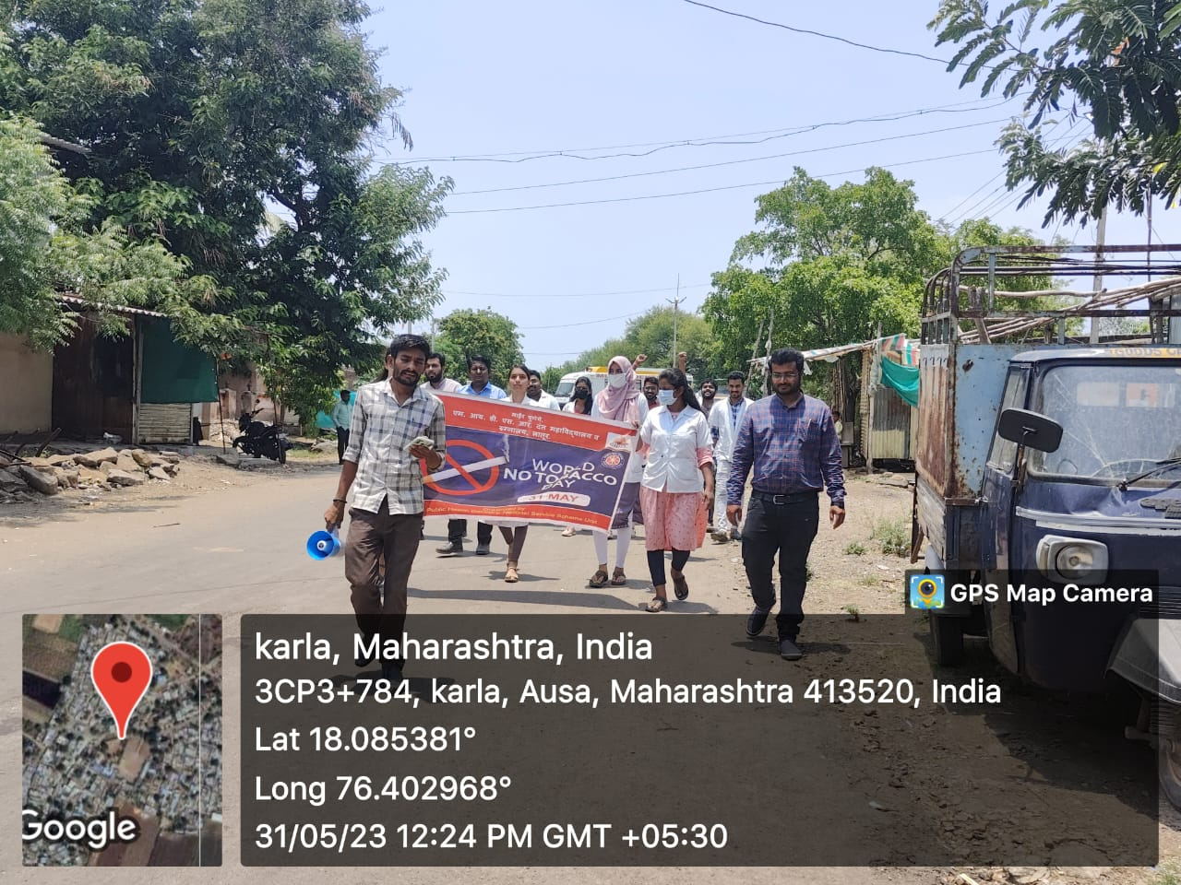
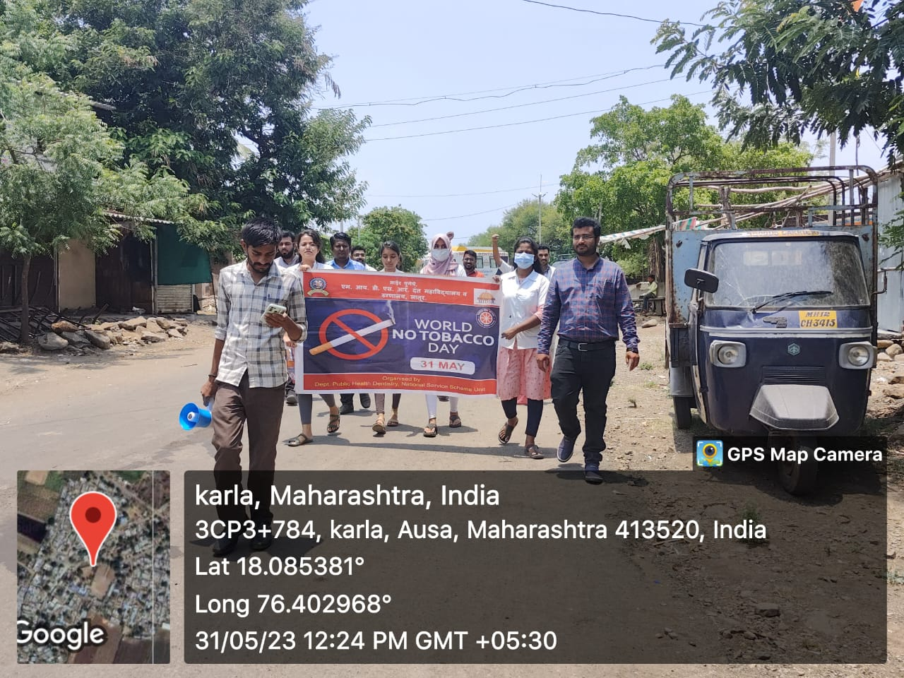
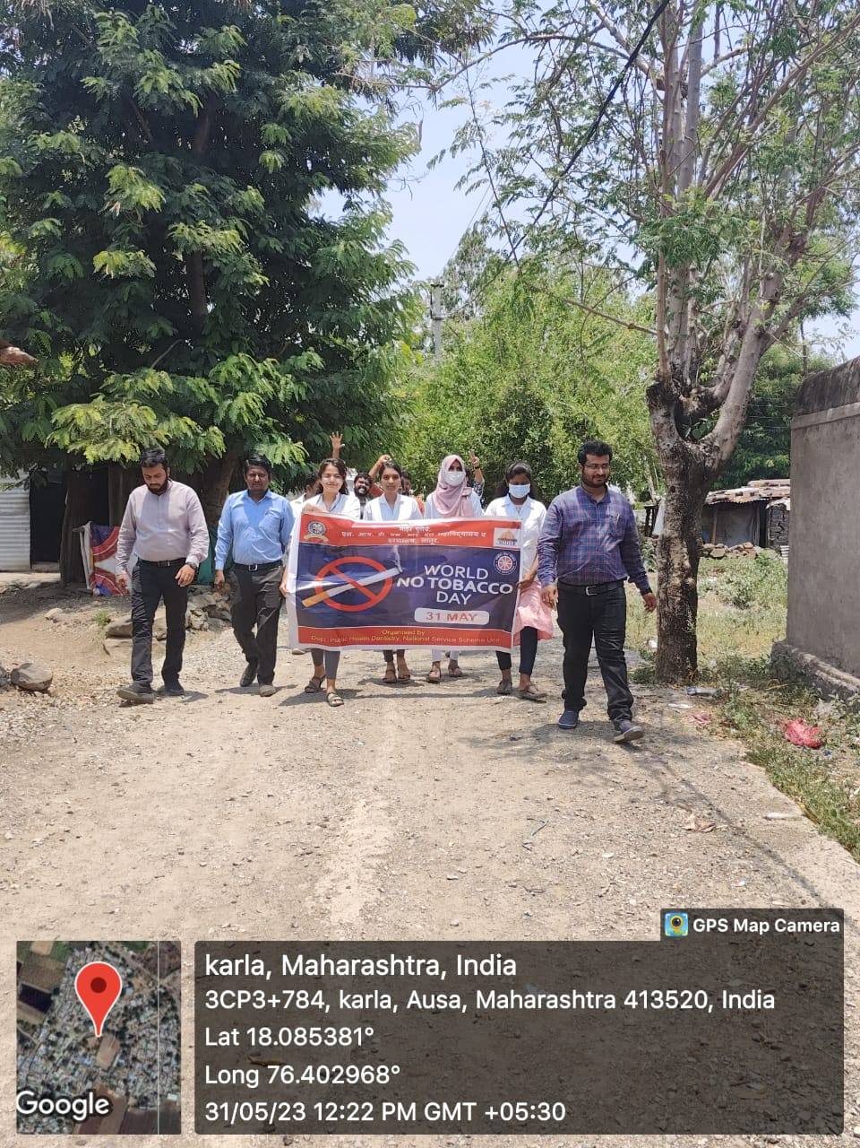

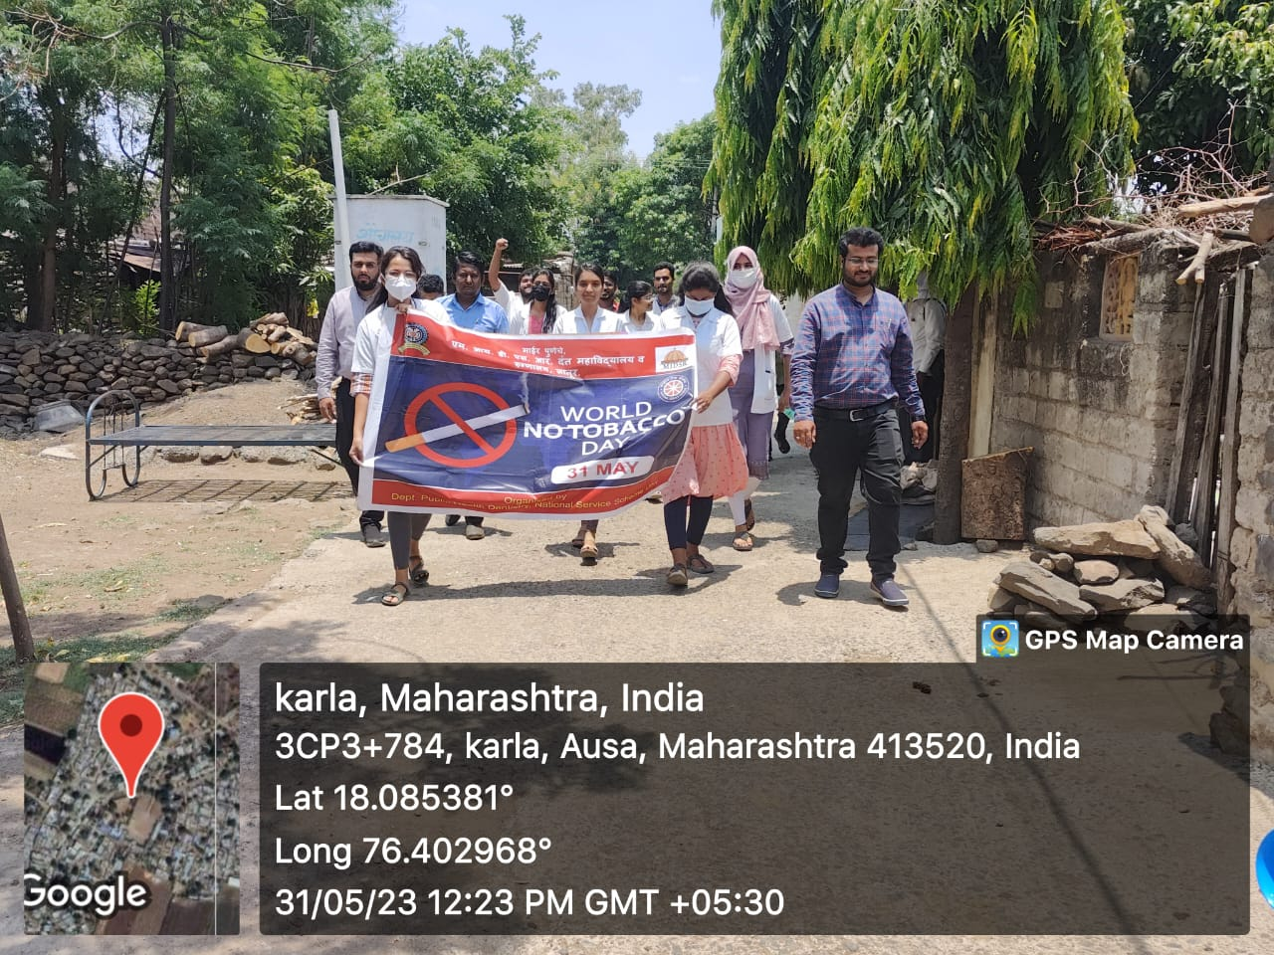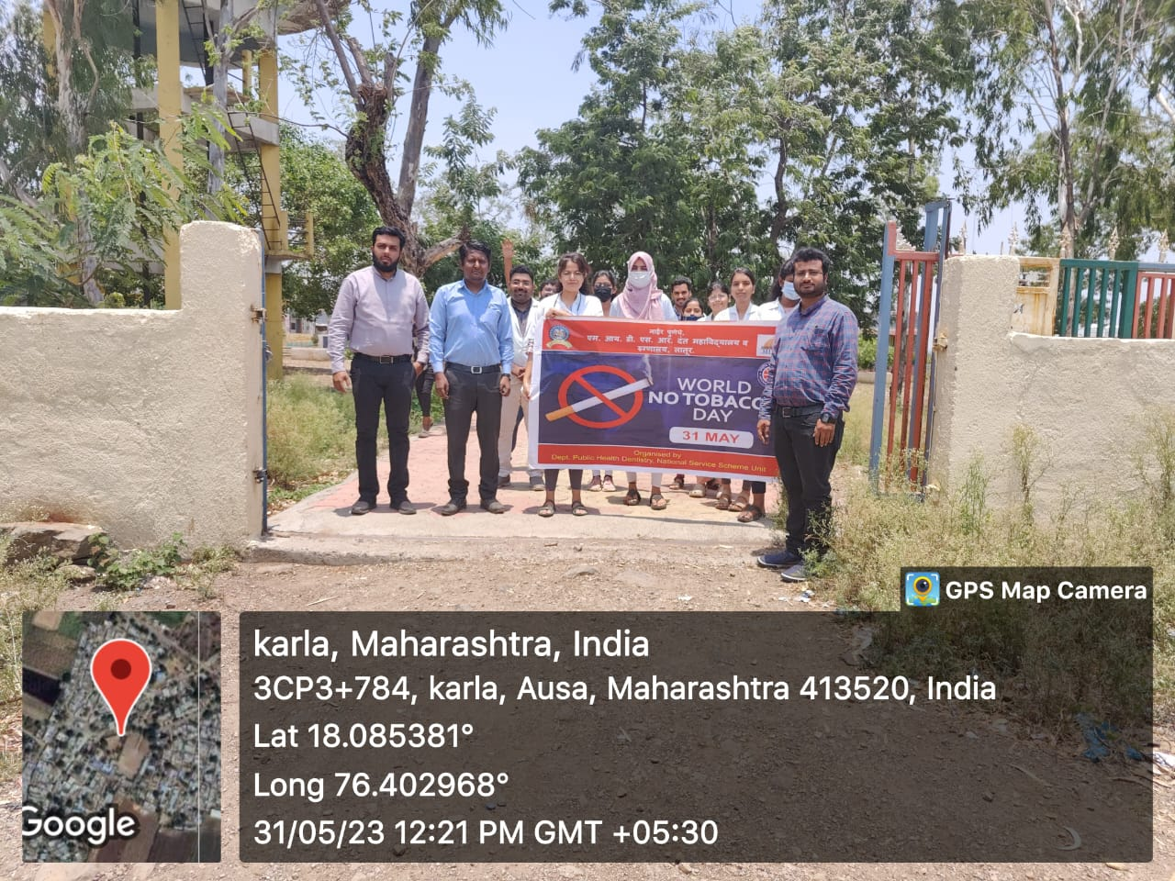

Tobacco Cessasion Programme

Tobacco use is a major preventable cause of premature death and disease, currently leading to over five million deaths each year worldwide. Smoking or chewing tobacco can seriously affect general health as well as oral health. Oral health professionals play an important role in promoting tobacco-free lifestyles. They should counsel their patients not to smoke, reinforce the anti-tobacco message, and refer the patients to smoking cessation services. Dentists are in a unique position to educate and motivate patients concerning the hazards of tobacco to their oral and systemic health and to provide intervention programs as a part of routine patient care.
The World Health Organization's (WHO) World No Tobacco Day 2005 campaign emphasized that health professionals, including oral health professionals, have the greatest potential of any group in society to promote the reduction of tobacco use. They have several roles to play in comprehensive tobacco control efforts, including that of role model, clinician, educator, scientist, leader, opinion builder, and alliance builder.
We have organized a lecture on tobacco cessation in collaboration with the Alumni Committee of MIDSR Dental College and Research Center, Latur, for our students, as students have access to a wide spectrum of patients, such as those willing to quit, those who have unsuccessfully attempted to quit, and patients in need of support, motivation, or enhanced awareness about nicotine dependence and avenues of treatment.
For this session, we have invited a well-known speaker, Dr. Eknath Male, Office Superintendent at YCRH Latur, who has done tremendous work in this field and served the society. We also have one more speaker, who is our own staff member, Dr. Rohini Divekar, Lecturer in the Dept of Oral Medicine and Radiology, who is witnessing the number of tobacco users on a daily basis.

Brief insight to the programme
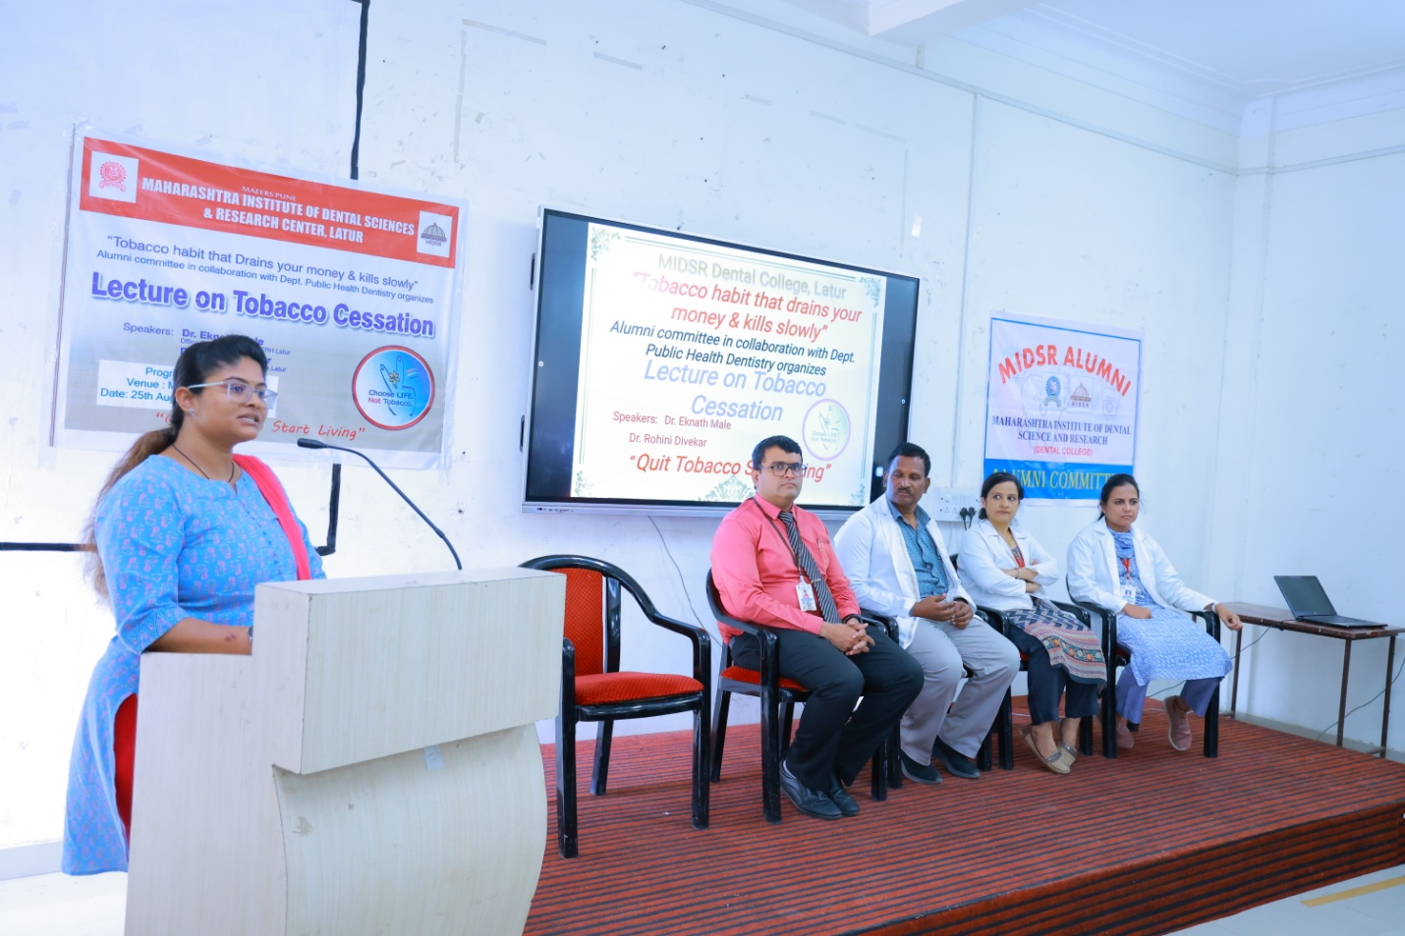
Dr. Rohini, giving Introduction and explaining about the purpose of conducting the programme

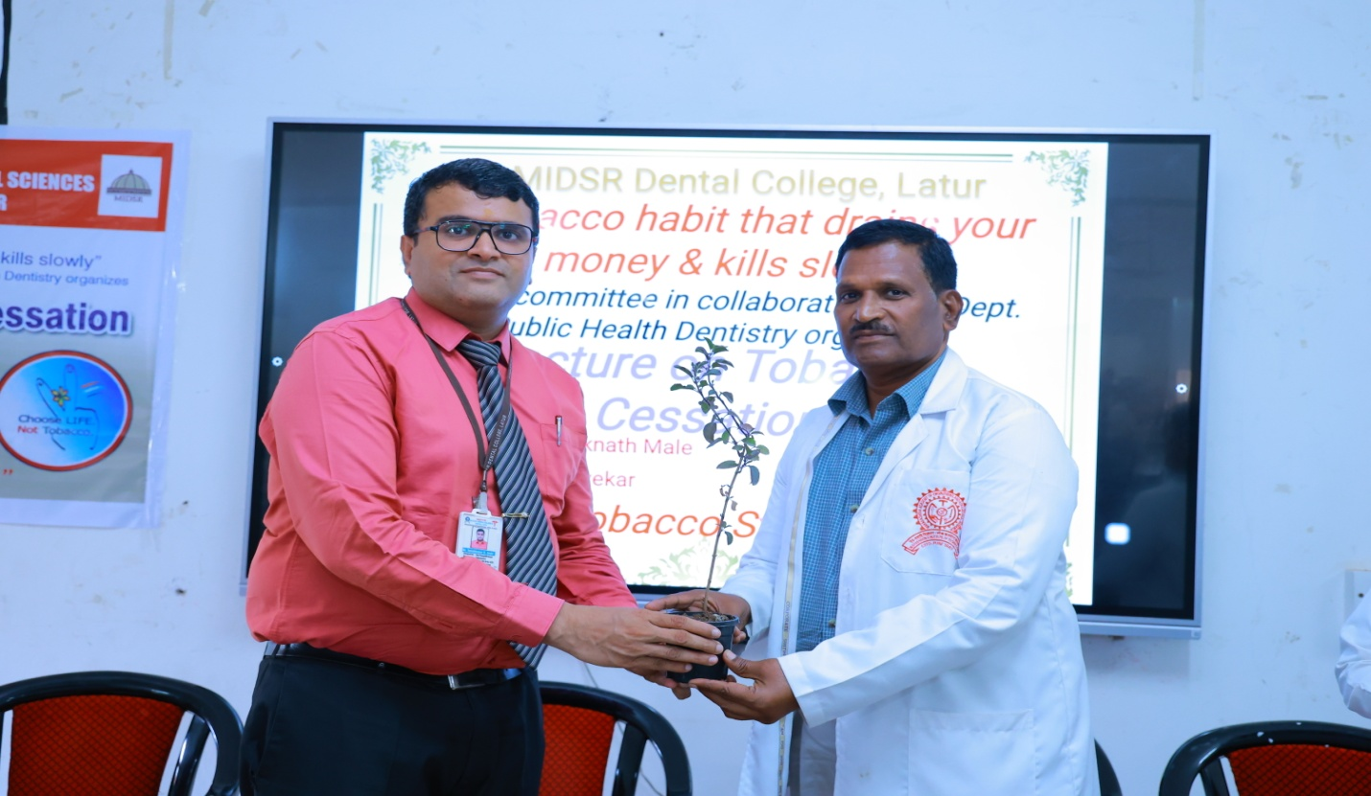
Felicitation of the Guest Speaker Dr. Eknath Male by our Vice Principal, Dr. YatishKumar Joshi
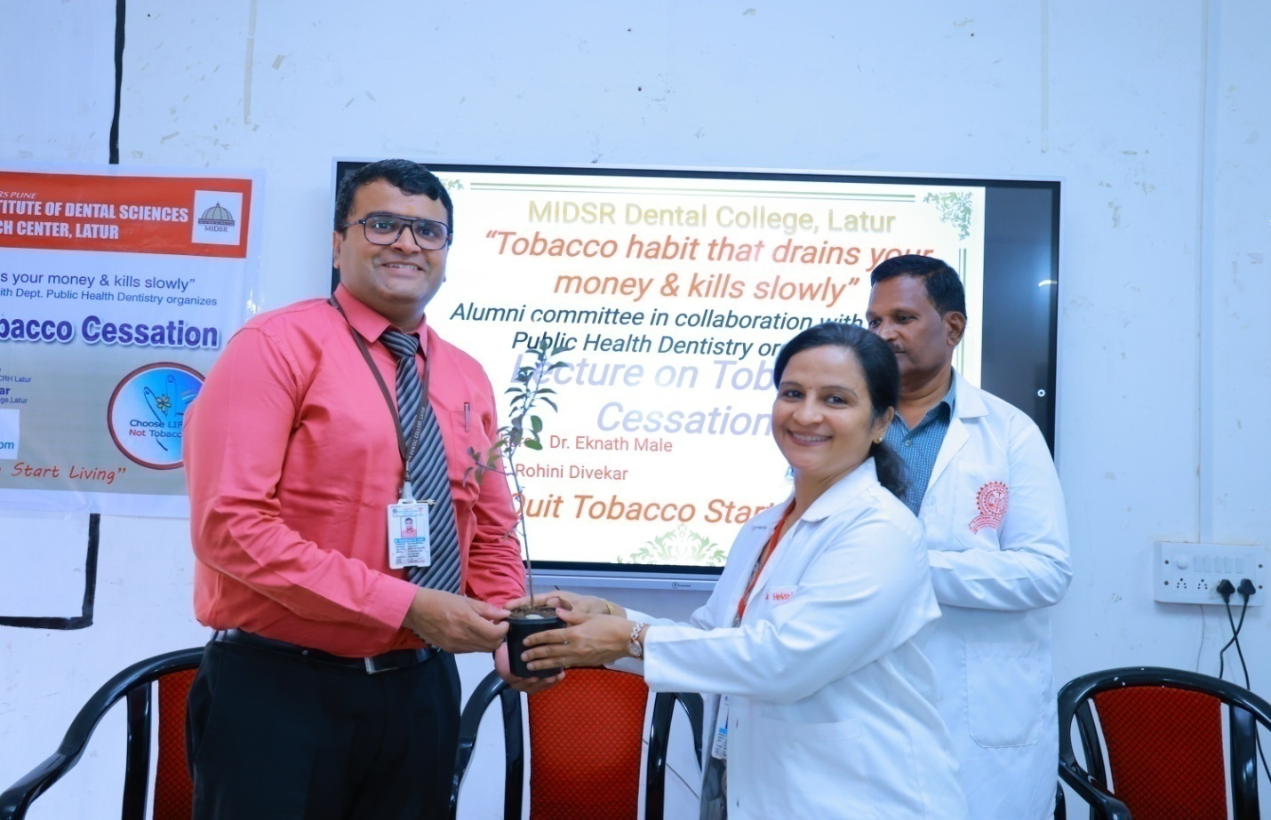
Felicitation of our Vice Principal, Dr. YatishKumar Joshi by Dr. Anuja Maniyar, Chairman of Alumni Committee

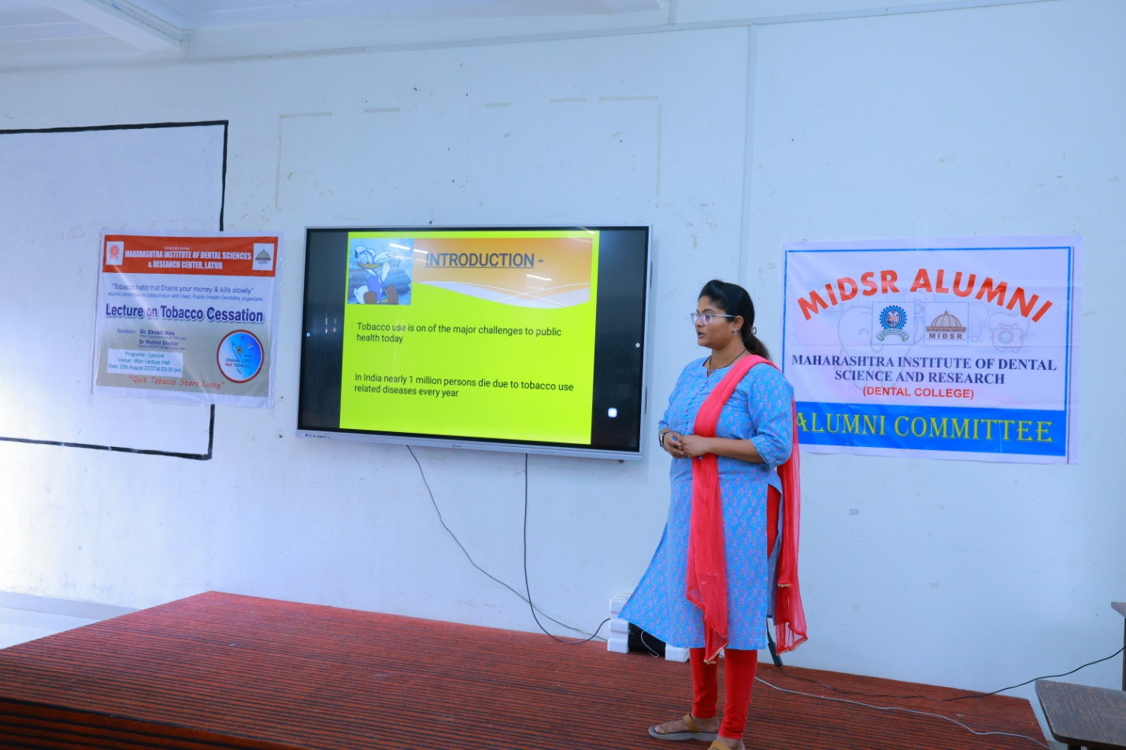
Dr. Rohini Diwekar addressing the students by providing the information regarding the usage of different forms of tobacco and its ill effects on systemic as well as oral health, as well as about 5A’s and 5R’s used in Tobacco Cessation

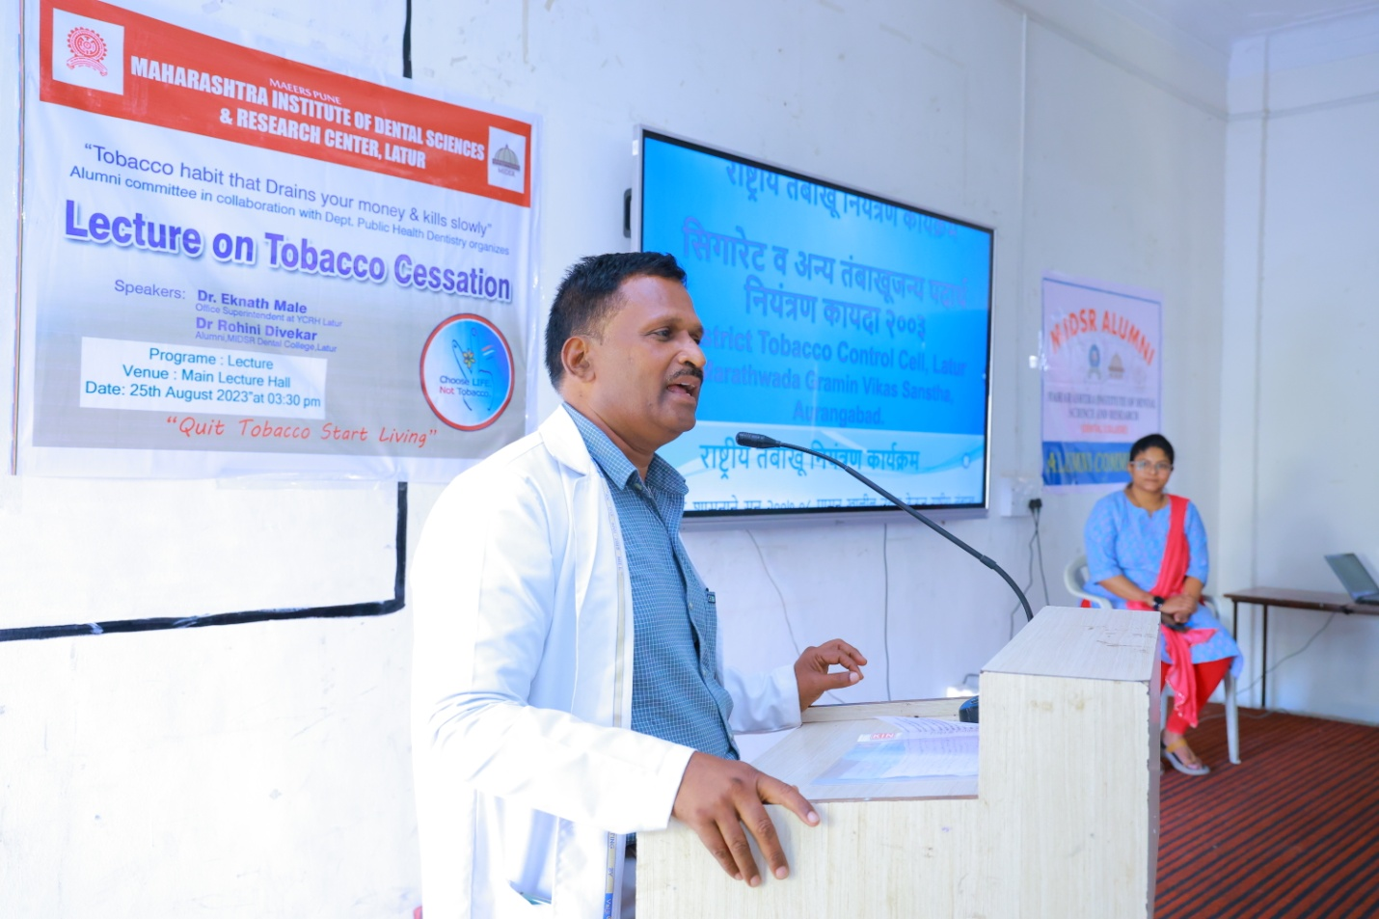

Guest Speaker Dr. Eknath Male Sir, explaining the students regarding the various Acts and Amendments made by the Government on Tobacco usage

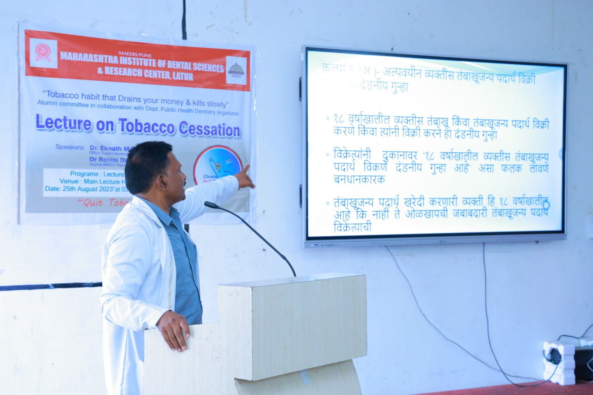
Explaining the Rules and Regulations regarding the tobacco

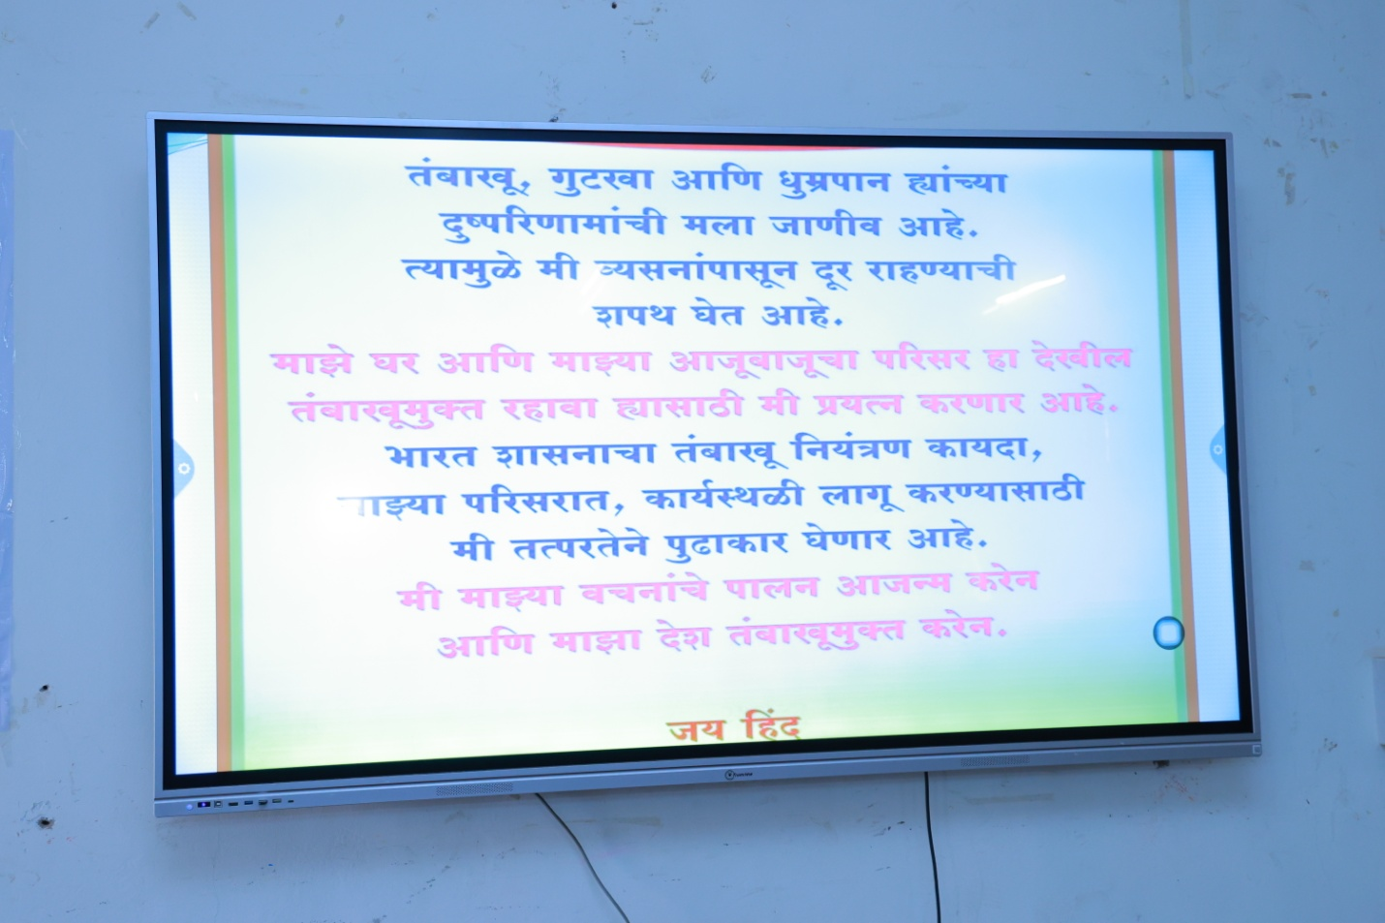
Oath to make tobacco free campus

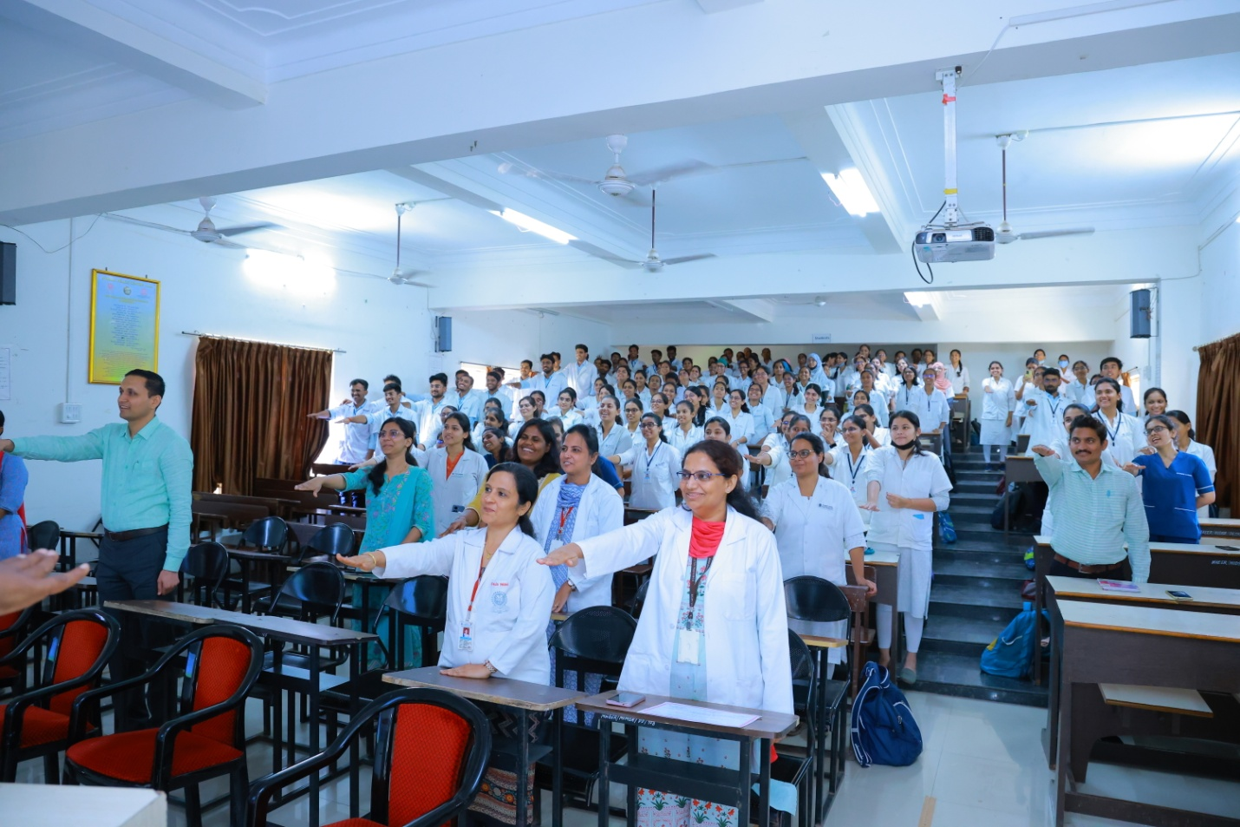
Staff and Students taking Oath to make tobacco free Campus

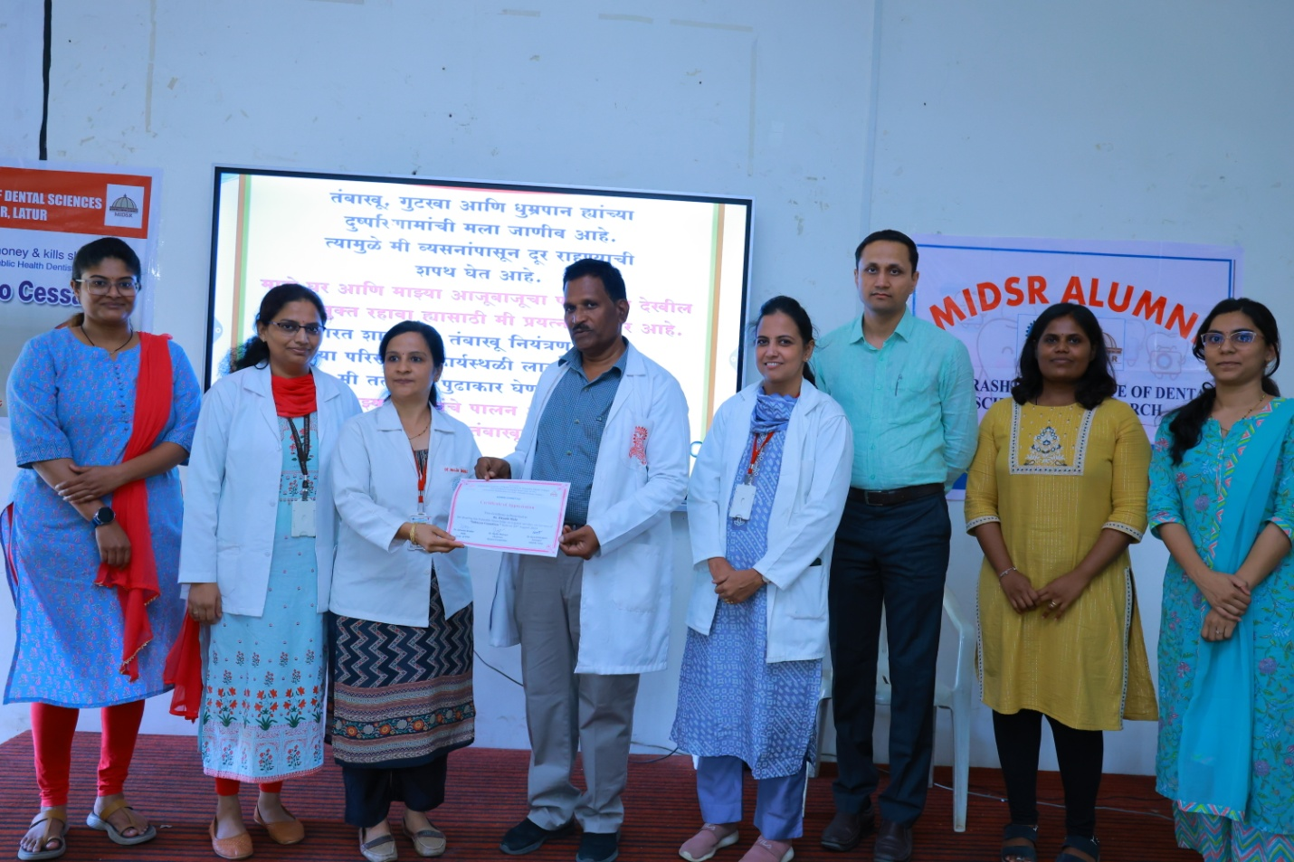
Token of appreciation by providing certificate to the Guest Speaker

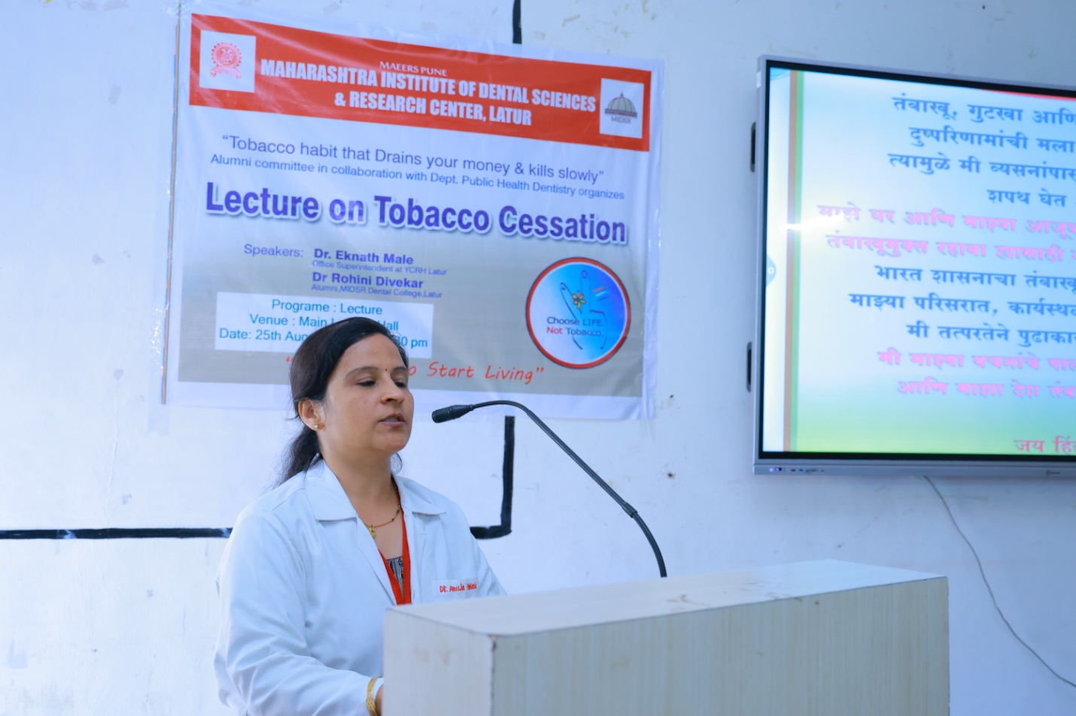
Vote of Thanks by Dr. Anuja Maniyar Maam, Maam thanked all the persons who have put their efforts to make this programme successfull

ATTENDANCE LIST OF THE PARTICIPANTS
