**Clinical Services Provided by Dept of Orthodontics**



After completion of treatment retention late will be given and post treatment instructions will be given

Activation

Patient will be recalled after 1 month

Appliance delivery, instructions and activation

Appliance fabrication and acrylization

Extraction treatment plan



Activation

Appliance delivery, instructions and

Appliance delivery, instructions and activation

Appliance fabrication and acrylization

Non Extraction treatment plan



After completion of treatment retention late will be given and post treatment instructions will be given



**Removable Appliance**



Case presentation and treatment plan discussion

Cephalometric analysis, model analysis, photographs editing and

Extra-oral and Intra-oral photographs if required lateral cephalogram &

Basing of study models

Study Model Impression (SMI) and trimming of model

Recording Case History

Case Allotment

OPD & diagnostic radiograph



OPD & diagnostic radiograph

**Growth Modulations**



Case presentation and treatment plan discussion

Cephalometric analysis, model analysis, photographs editing and printing.

Extra-oral and Intra-oral photographs lateral cephalogram & OPG

Banding with 7 6 6 7

7 6 6 7

Non Extraction treatment plan

Extraction treatment plan



Case Allotment



Finishing & detailing after 19x25 SS wire

Bonding fixed appliance & wire placement till 19x25 SS wire



Correction of malocclusion

Post treatment records Debonding appliance & hawleys retention plate given, instructions to the patient about wearing the plate, recalled after 6 months.



**Fixed Appliance Therapy**

|  |  |  |
| --- | --- | --- |
|  | Recording Case History |  |
| Study Model Impression (SMI) and trimming of model | | |
|  | Basing of study models |  |

|  |  |  |
| --- | --- | --- |
| Banding with 7 6 | 6 7 |  |
| 7 6 | 6 7 |



Active/passive lace back wire placement till 19x25 niti wire

Debonding

Follow up done till settling occlusion after space closure

Post debonding records & retainer (fixed & removable

Retraction by frictional & frictionless mech.

Intra-oral photography mid treatment records after 19x25 Niti wire

Bonding

Extraction

Alginate impression for making TPA & lingual arch if required

## Myofunctional Appliance Therapy

Removable Retainer

After Myofunctional therapy Fixed appliance therapy will be

Routine follow up

OPD & Diagnostic radiograph



Case allotment

Recording case History

Preparation of study models, trimming, Basing, Working model

Extra-Oral and Intra-oral photographs, hand wrist radiograph lateral cephalogram & OPG

Visual treatment objective (VTO) Photography

Preparation of case with model analysis, Cephalometric analysis, Intra-oral & extra-oral photographs & case history

Case Presentation and treatment plan discussion

**One phase Therapy**

**Two Phase Therapy**

Bite Reigstration

Bite Reigstration

Appliance Construction

Appliance Construction

Appliance delivery and instructions given to patient and intra-oral Photography

Appliance delivery and instructions Intra-oral photography

Trimming of appliance

Trimming of appliance



Achievement of class I molar relation & improvement in facial profile

# Orthognathic Surgery

OPD & diagnostic radiograph

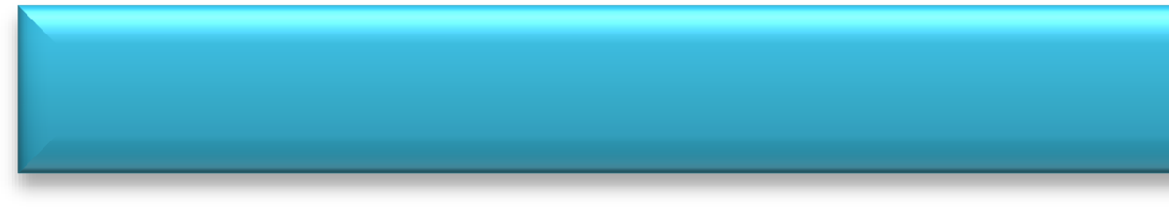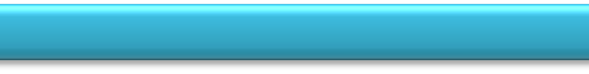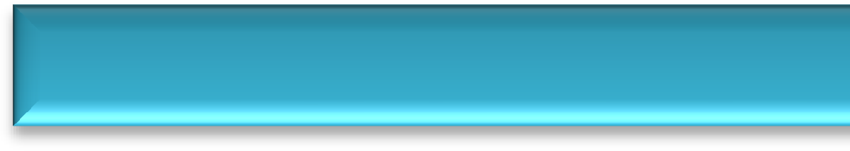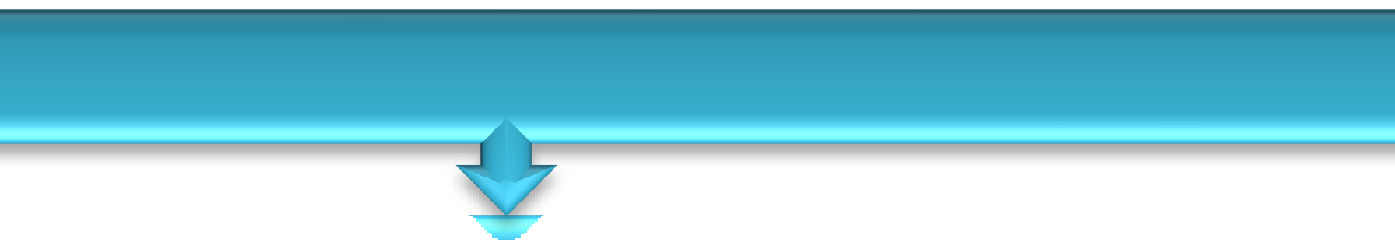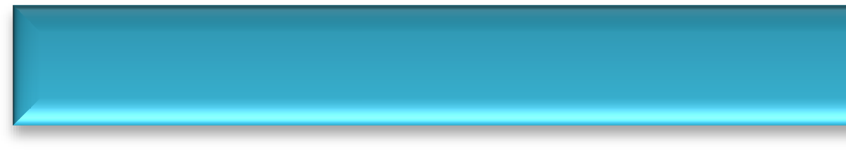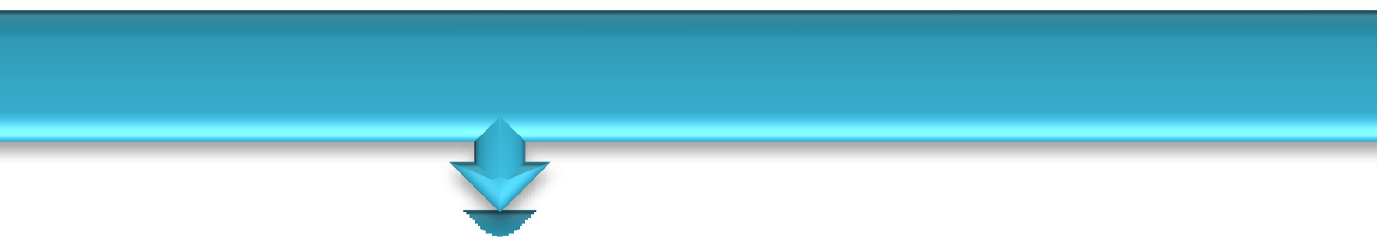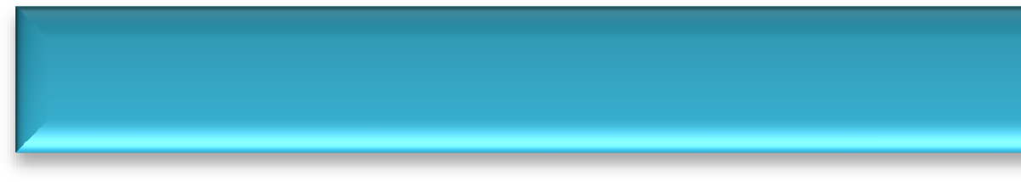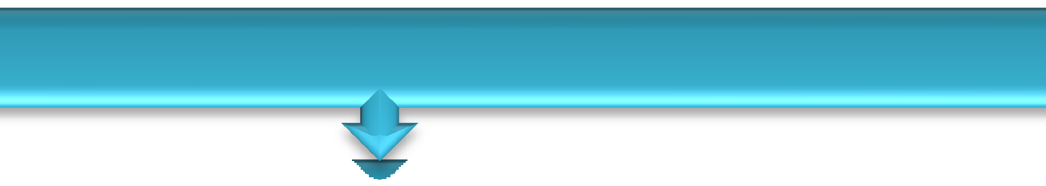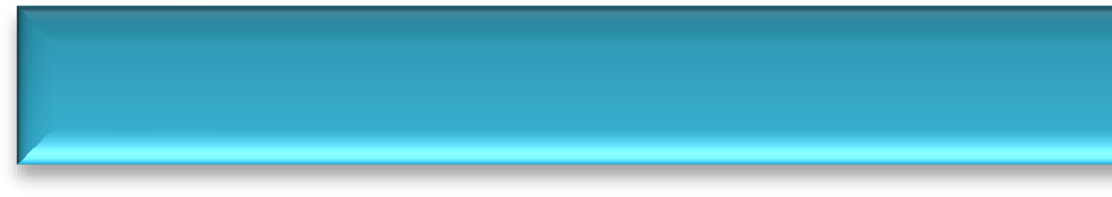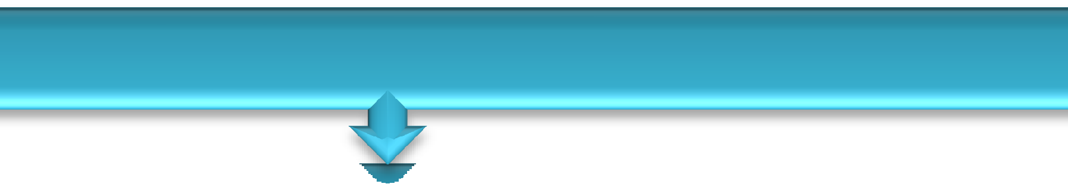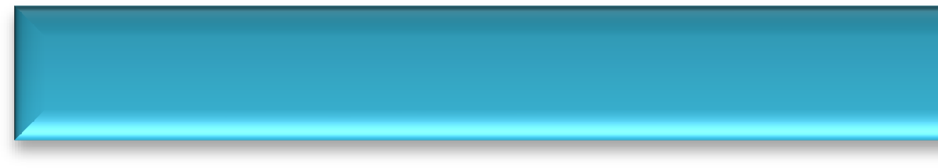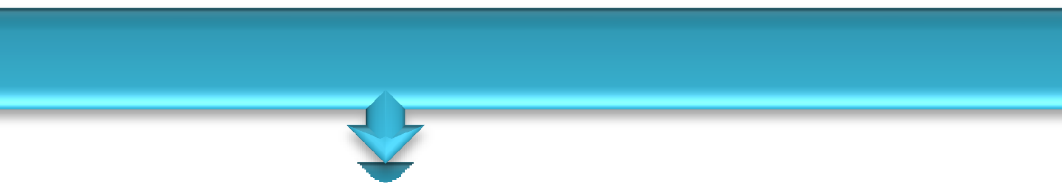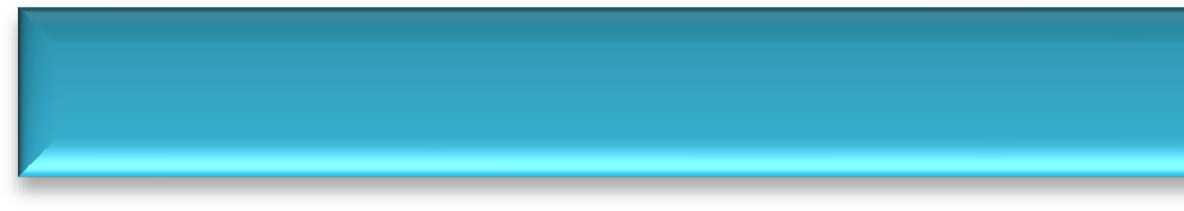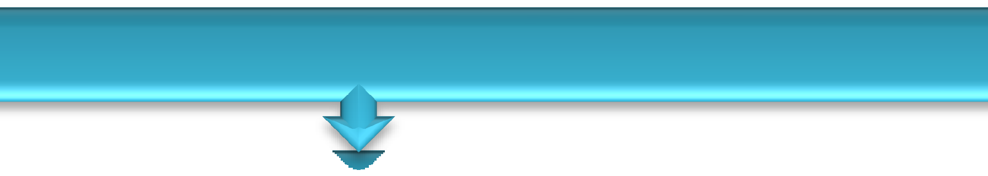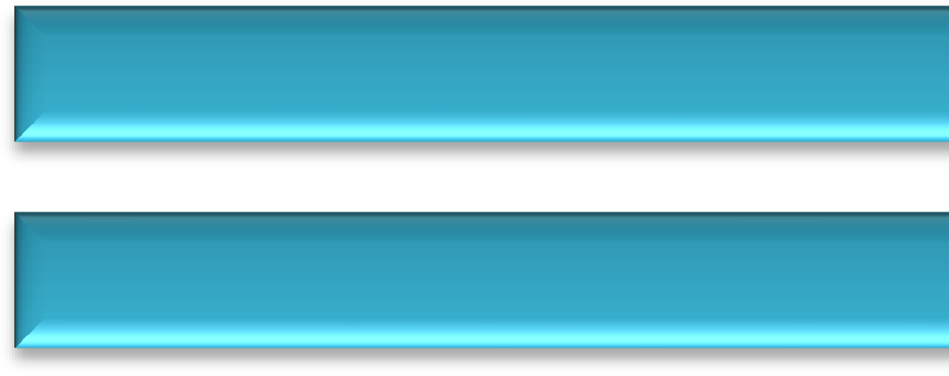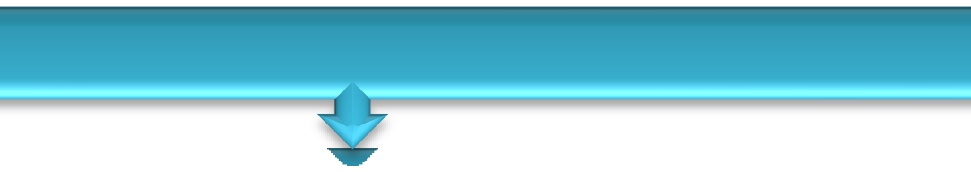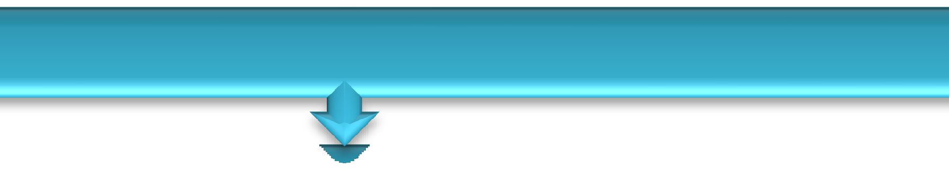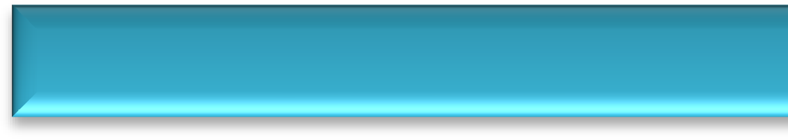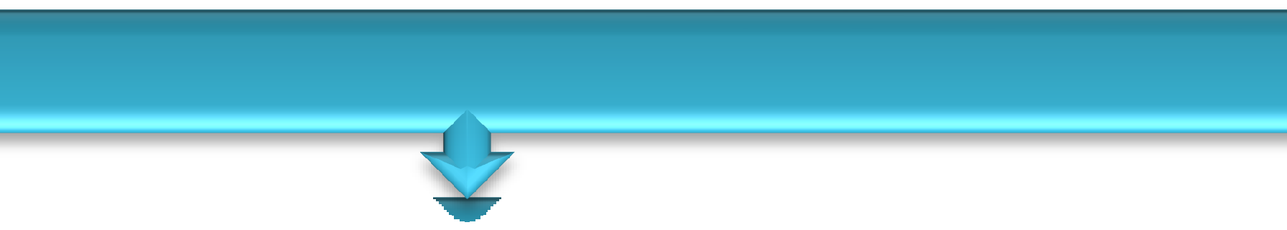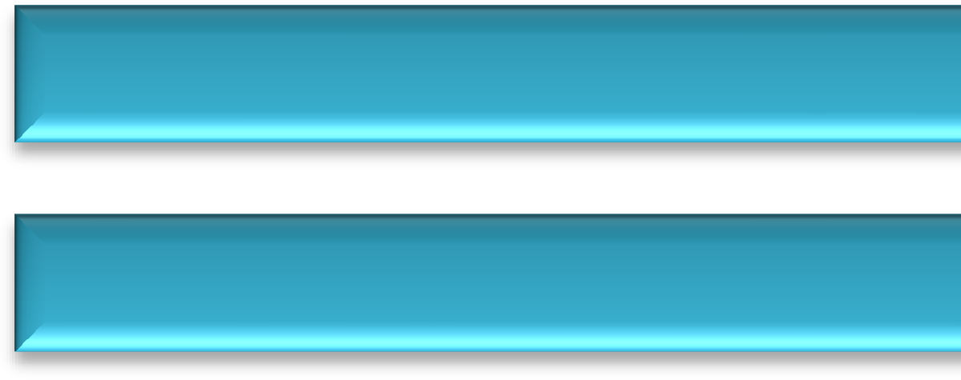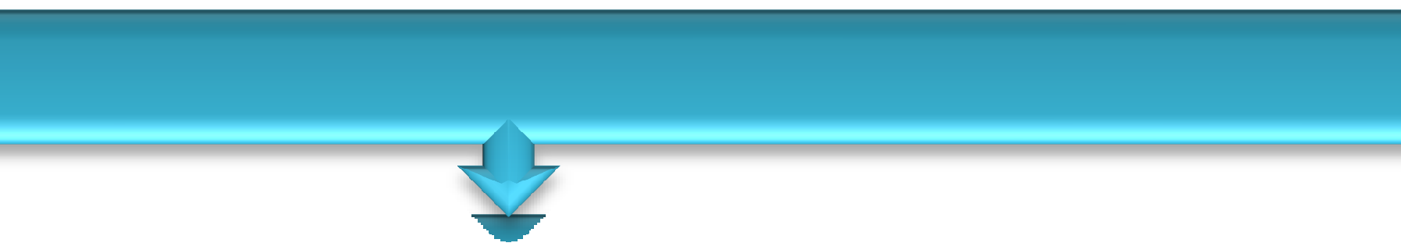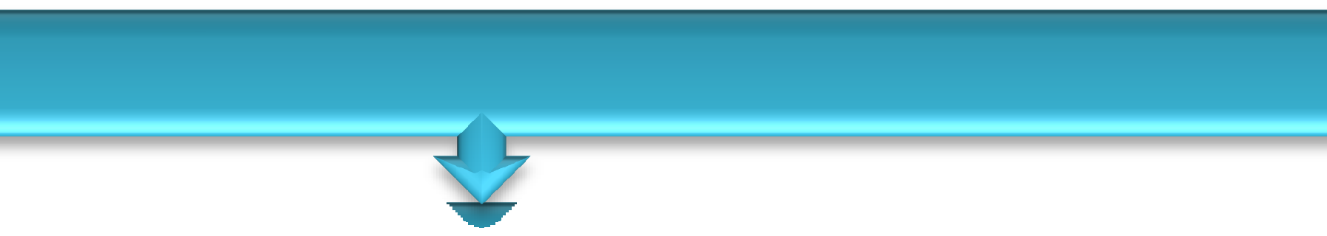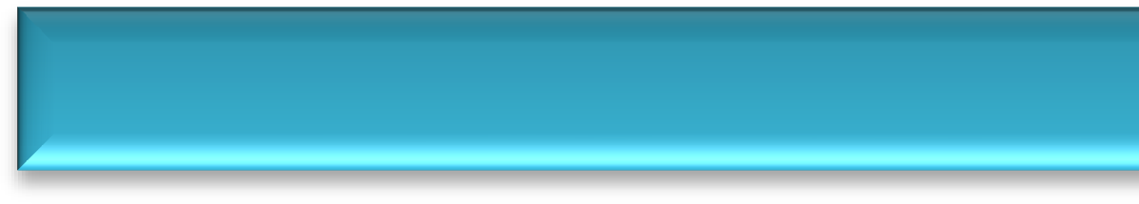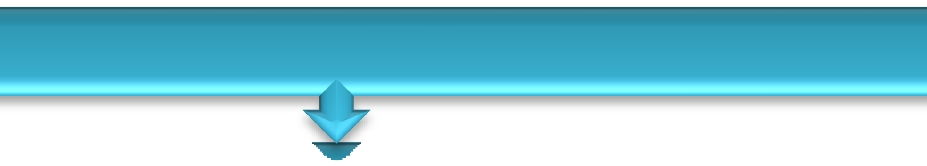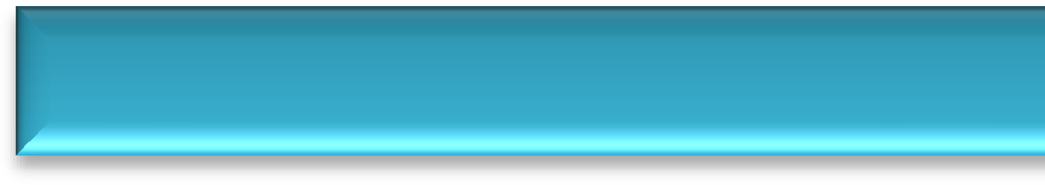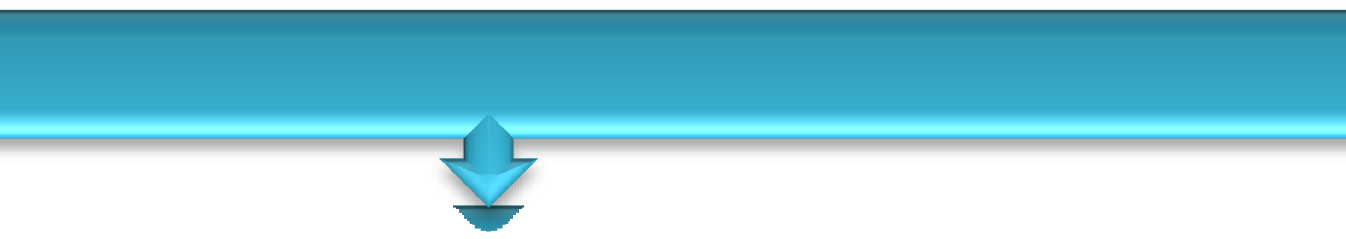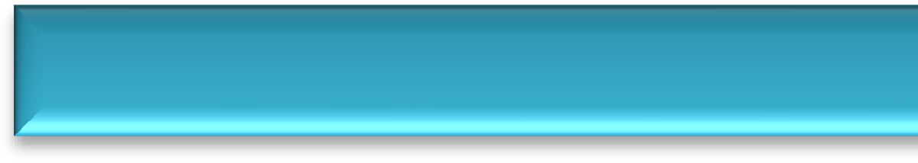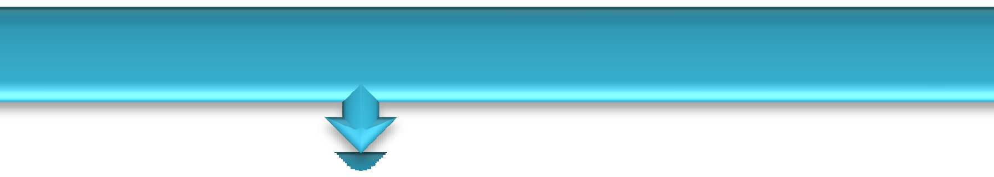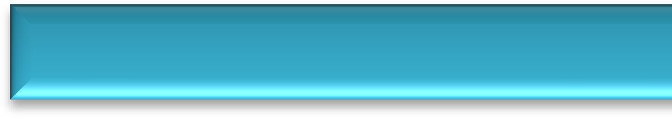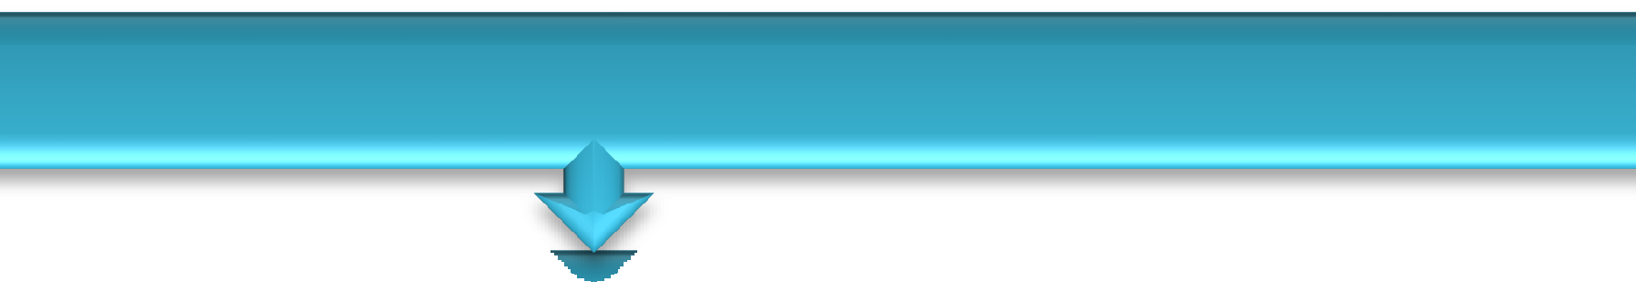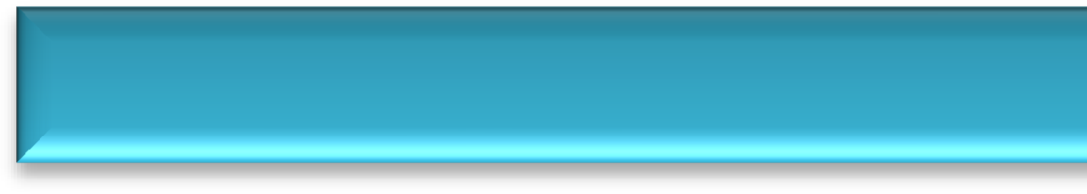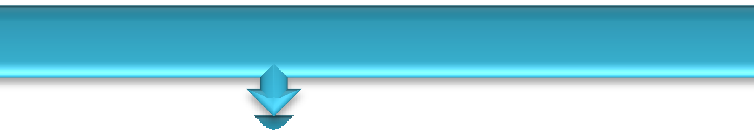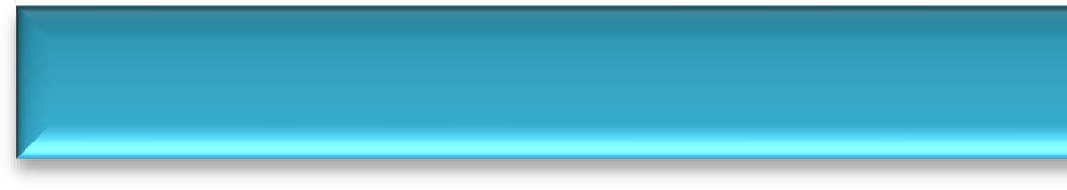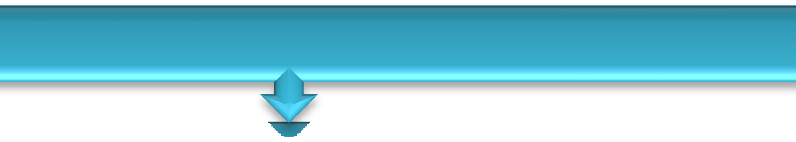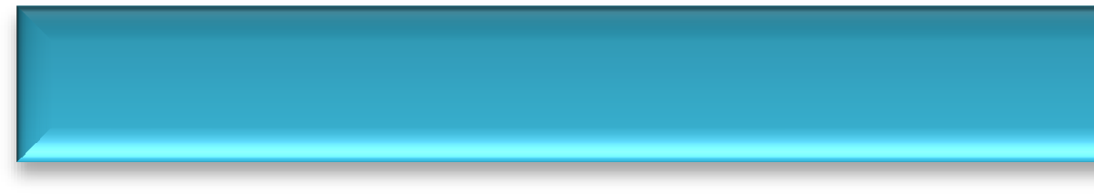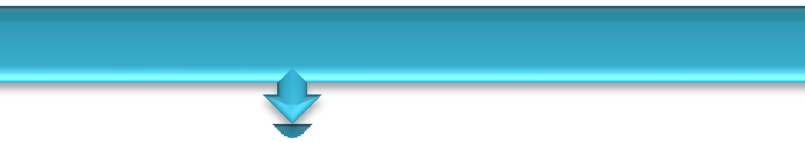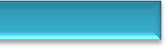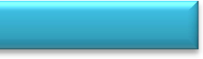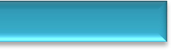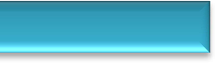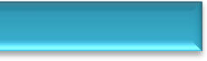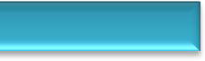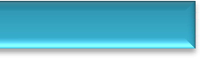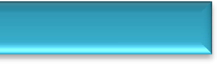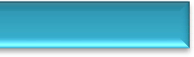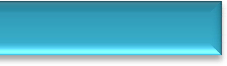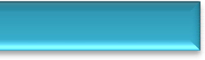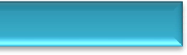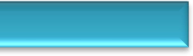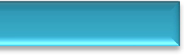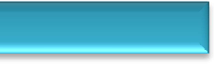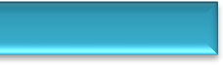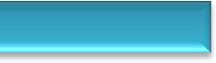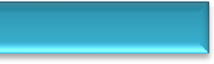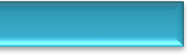

Case allotment

Recording Case history

1. Recording & Trimming of model
2. Basing of study models
3. Extra-Oral & Intra-Oral Photography lateral cephalogram & PA view OPG
4. Cephalometric analysis (cog’s) and model analysis
5. Case presentation & treatment plan Discussion
6. Surgical Treatment

**Phase I**

Pre Surgical orthodontics will be done up to 0.019 x 0.025”” 5.5 wire

Mock surgery & digital predication surgery

Preparation of surgical splint

**Phase II**

Performance respective surgery

**Phase III**

Finishing & detailing

Debonding & lingual bonded retainer & retention plate, post treatment records

Correction of skeletal discrepancy & improvement of facial profile