**3rdORTHODONTIC CDE**

Organized by

**DEPARTMENT OF ORTHODONTICS & DENTOFACIAL ORTHOPEDICS**

MIDSR DENTAL COLLEGE & HOSPITAL, LATUR

**ON** 24/01/2021

**title:**

**“workshop on tad’s”**

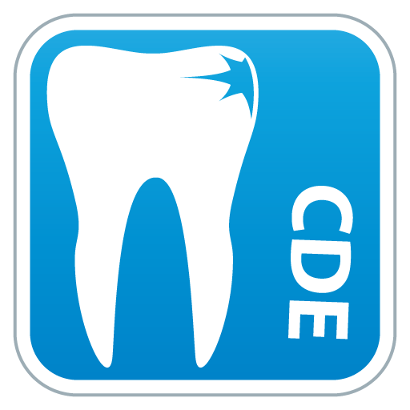

This CDE was graced by auspicious presence ofDr. Pavankumar Vibhute as chief guest &speaker. CDE program started with vishwashanti prayer,Dr Pavankumar Vibhute inaugurated the program by lighting the traditional lamp with chairman of CDE and principal Dr. Suresh Kangane,Organizing chairman, Dr. Anand Ambekar organizing secretary, Dr.Pravinkumar Marure Scientific Committee in-charge and Administrative officer Mr. Sachin Munde. Following lamp lightning Principle, Dr Suresh Kamble felicitated Dr Vibhute.

**About Speaker –**

**Dr. Pavankumar VibhuteMDS, HOD & P.G guide at dept of Orthodontics,Yogita dental college Khed.**

**Teaching experience: - Around 12 years**

**Award: - Dr. George Jacobs Award** for the best orthodontic clinical innovation (2010) for article: Molar stabilizing power arm (MSPA) Anchorage for anterior retraction.

24 publication including 12 clinical innovation in international and national journal , 7 presentation in various conference and programme, attended around 20 workshop and various conference and convention, contributing author of textbook of oral surgery for orthognathic Surgery chapter(jaypee Publisher).Proprietor of JSV orthodontic manufacturing company which manufacture miniscrew, ligation ties, molar band, etc.

**Participants –** 55PG students from Parbhani, Solapur, Beed, khed,& MIDSR Latur participated and made the program successful.

**SCHEDULE :**

|  |  |  |  |
| --- | --- | --- | --- |
| ***Sr. no.*** | ***Event*** | ***Time*** | ***Duration*** |
| 1 | Registration &Breakfast | 8.00am-9.15am | *30min* |
| 2 | Inauguration and lamp lighting | 09.15 am -9.30 am | *30 min* |
| 3 | Introduction to TAD’S, IZC, Buccal Shelf and biomechanics | 9.30 am- 10.30 am | *60 min* |
| 4 | TAD’s indication | 10.30 am- 11.00 am | *30 min* |
| 5 | TAD site and size selection | 11.00 am- 11.30 am | *30 min* |
| 6 | Sterilization and surgical Protocol | 11.30 am –12.00 pm | *30 min* |
| 7 | Biomechanics, risk and management with TAD’S | 12.00 pm- 1.00 pm | *60 min* |
| 8 | Lunch | 1.00 pm – 2.00 pm | *60 min* |
| 9 | Demonstration on patient | 2.00pm – 2.30 pm | *30min* |
| 10 | **Poster presentation in Group A, B and C** | **\*2.00 pm -3.30 pm** | *90 min* |
| 11 | Hands on | 2.00 pm – 3.30pm | *90min* |
| 12 | Discussion and prize Distribution | 4.00pm – 5.00 pm | *60min* |

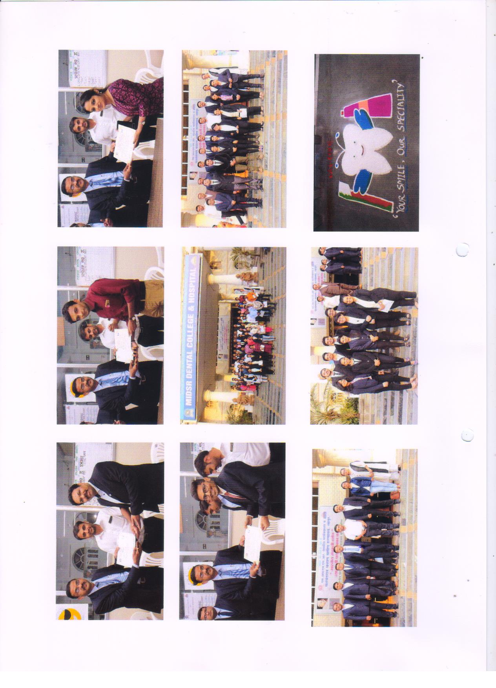Morning lecture schedule started sharp at 9.30am with thoroughly informative lectures and impressive presentations by Dr.Pavankumar Vibhute. After lunch the afternoon demonstrative session was scheduled in department oforthodontics where Dr. Pavankumar Vibhutedemonstrated on patient followed by the poster presentation in Group A, B, and C with hands on TAD’s. And program ended with discussion and prize distribution.

Participants received certificates with 5 CDE points at the end of session. The program was hugely appreciated by all the participants

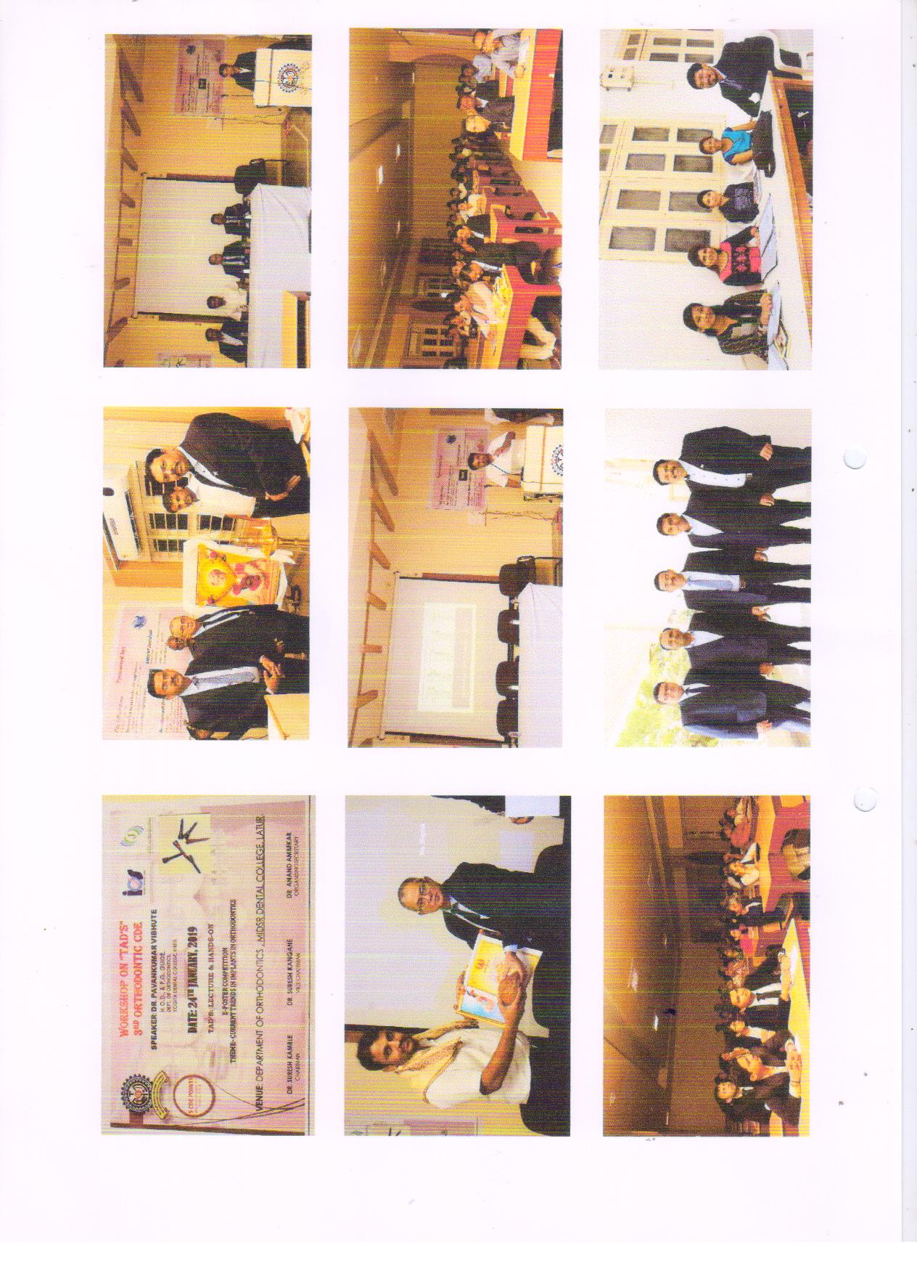**Third orthodontic CDE programme**



