WORLD ORTHODONTIC HEALTH DAY CELEBRATION AT DEPARTMENT OF ORTHODONTICS & DENTOFACIAL ORTHOPEDICS
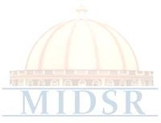
Department of Orthodontics & Dentofacial Orthopedics MIDSR Dental College, Latur celebrated a World Orthodontic Health Day on 15th May, 2022. Faculty, post graduate students, interns and under graduate students actively participated in the events organized on the occasion of Ortho Day. Programme was inaugurated by Dr Anita Kale. Celebration started with the Pooja of sant dnyaneshwar and vishwashanti prayer and lamp lighting was done with the hands of Administrative Officer Mr Baliram Handge and all faculty members. Various competition were conducted like, rangoli competition, best smile competition, poster competition, fastest E – module ligation, correct bracket sequence identification and treasure hunt. Prize distribution was done for the respective competition. Articles regarding the Orthodontic Day celebration were published in many newspapers.
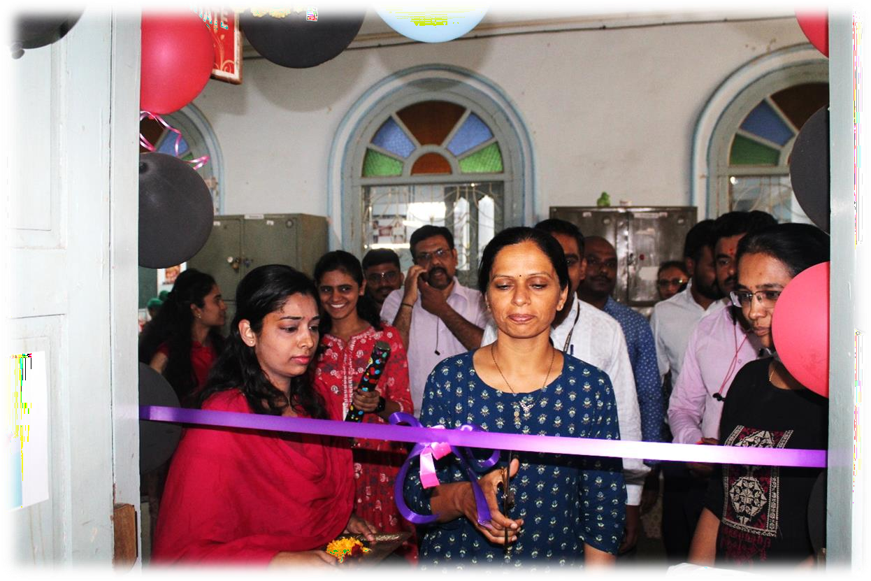

Programme was inaugurated by Dr Anita Kale.

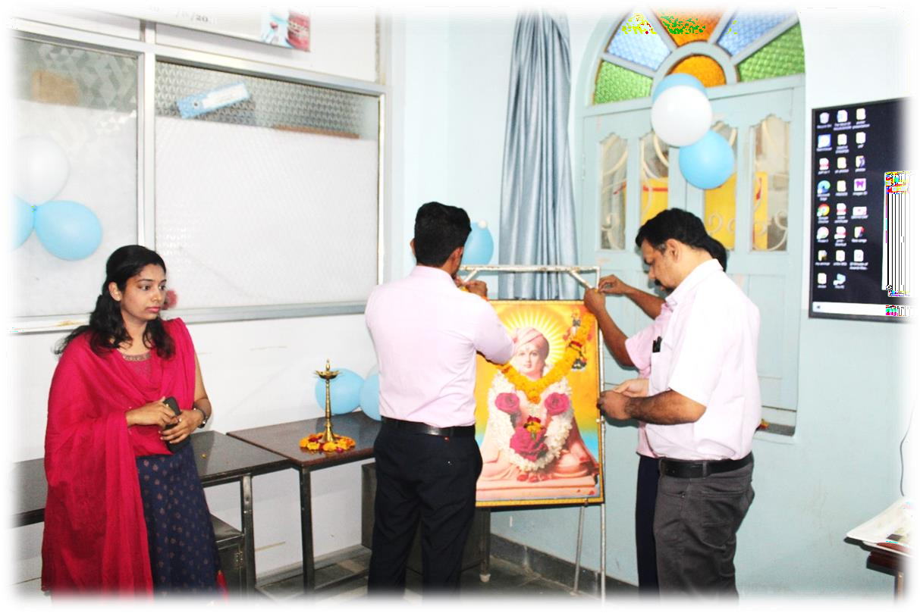

Celebration started with the Pooja of sant dnyaneshwar

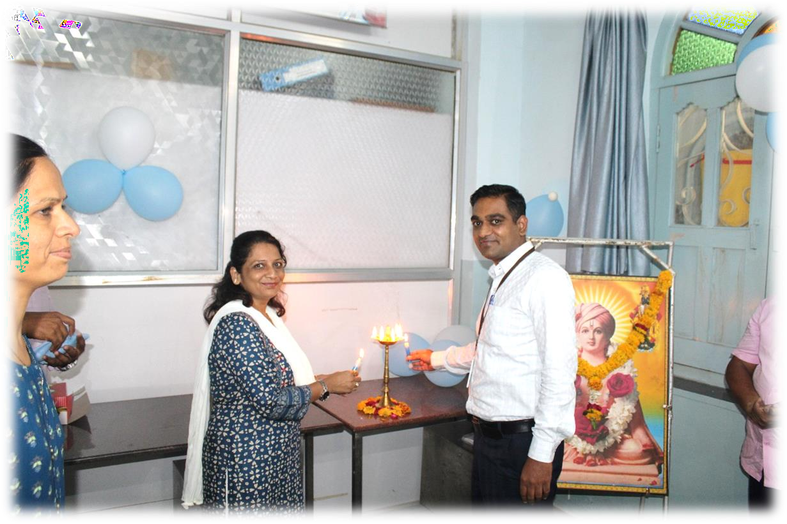

Lamp lighting ceremony

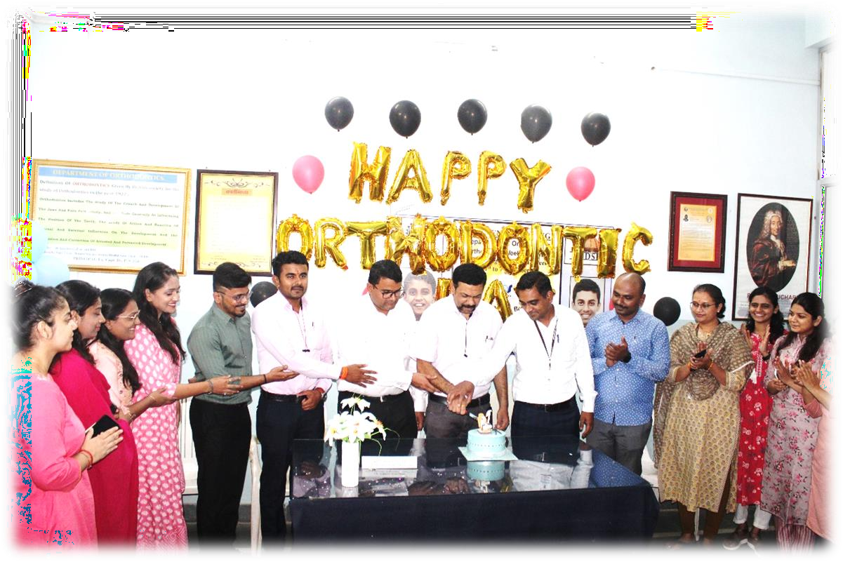

Cake cutting by the faculty members and post graduate students

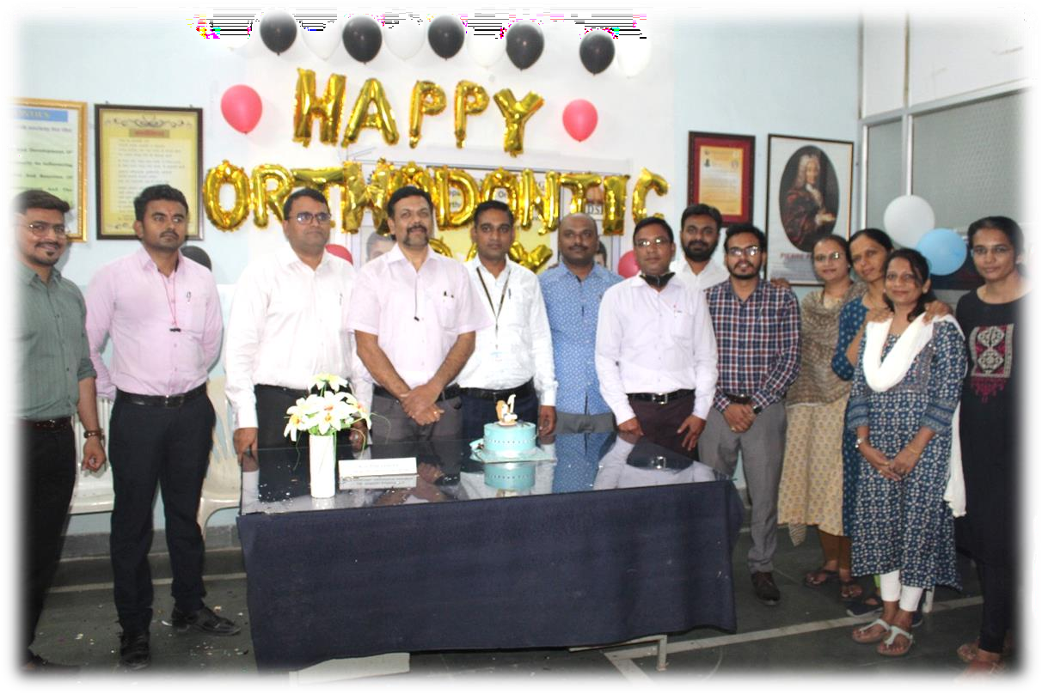
Department faculty and all the guests

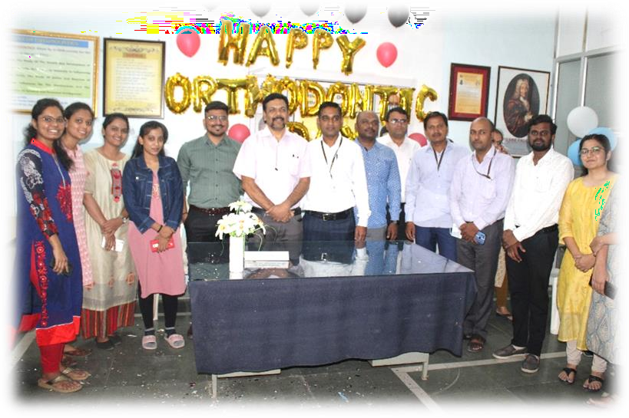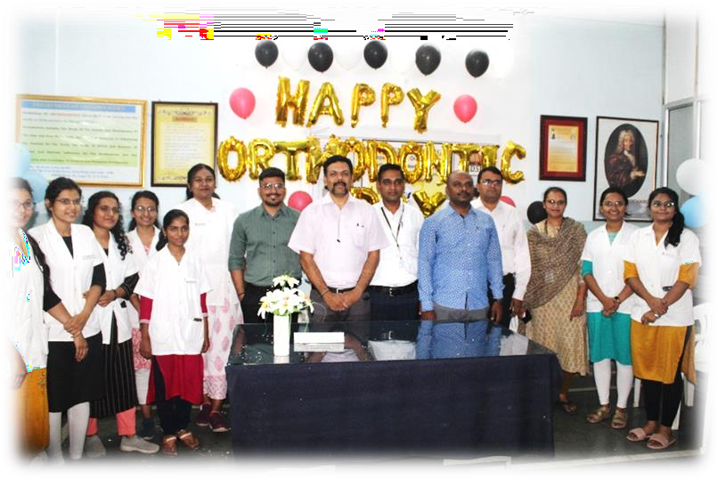

Teaching staff group picture along with interns and under graduate students
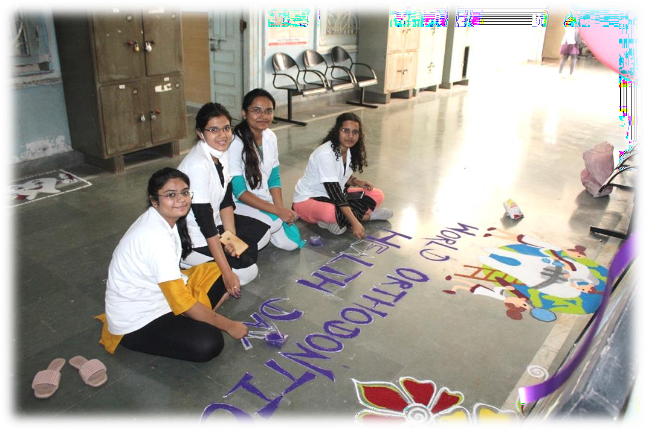

Under graduate students participated in rangoli competition.

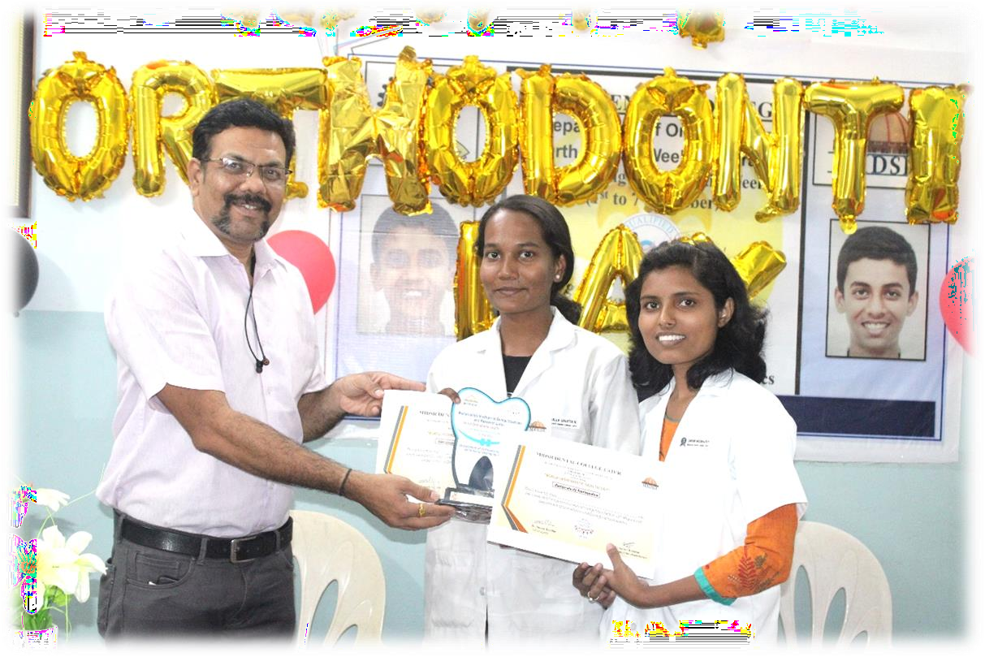

Prize distribution for the “Rangoli competition”.

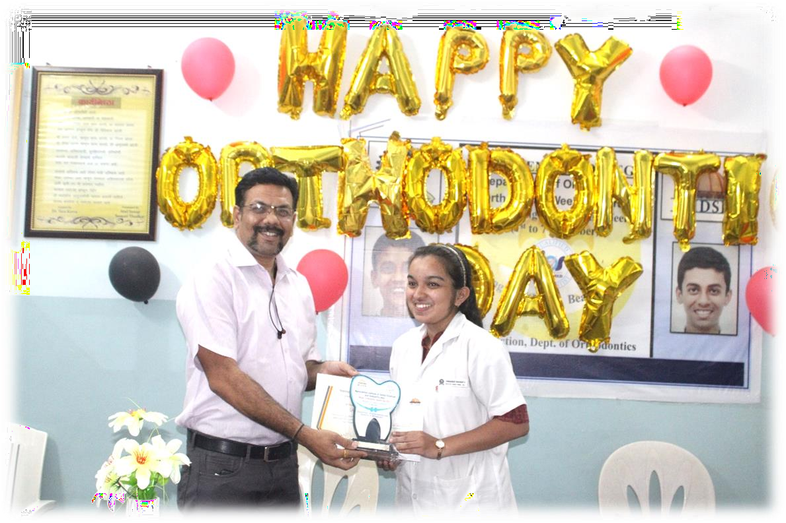

Prize distribution for the “Poster competition”.

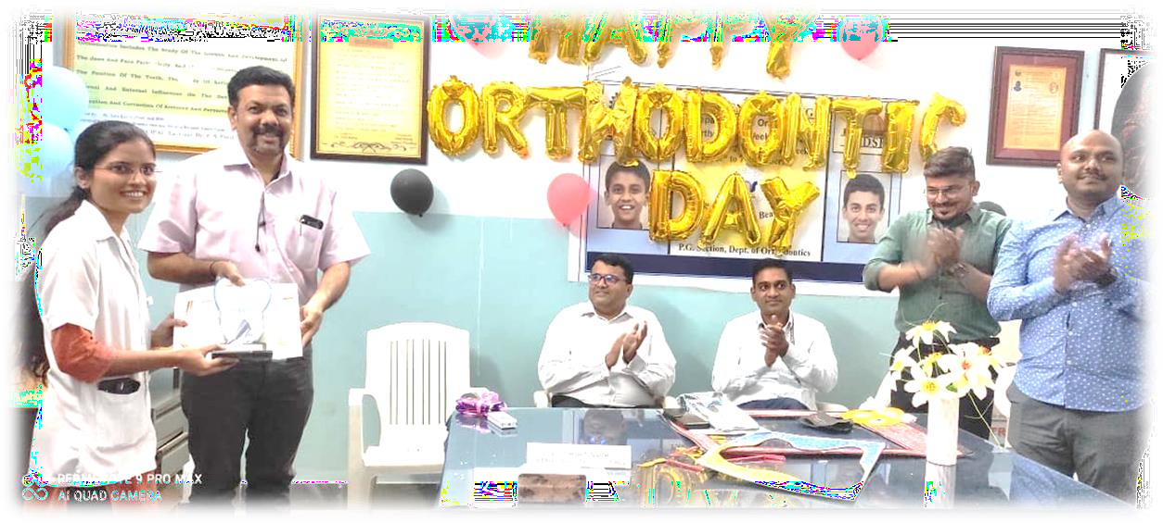

Prize distribution for the “Best smile competition”.

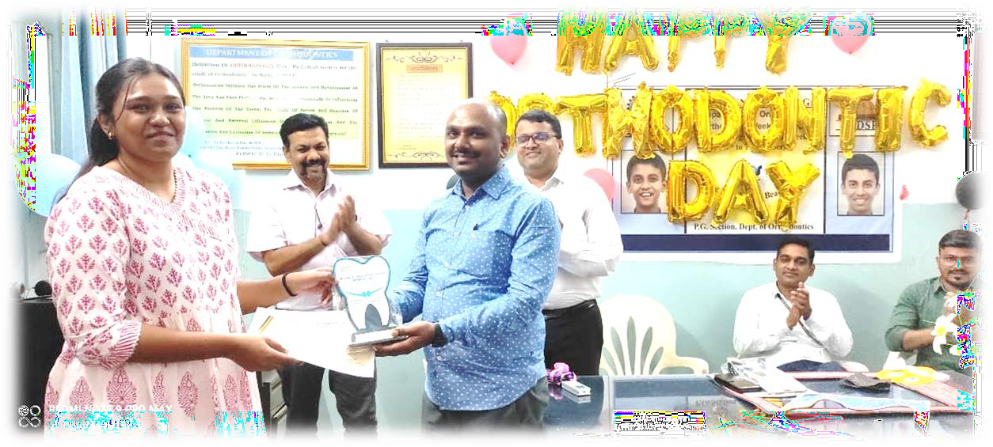

Prize distribution for the “Best Reel competition”.

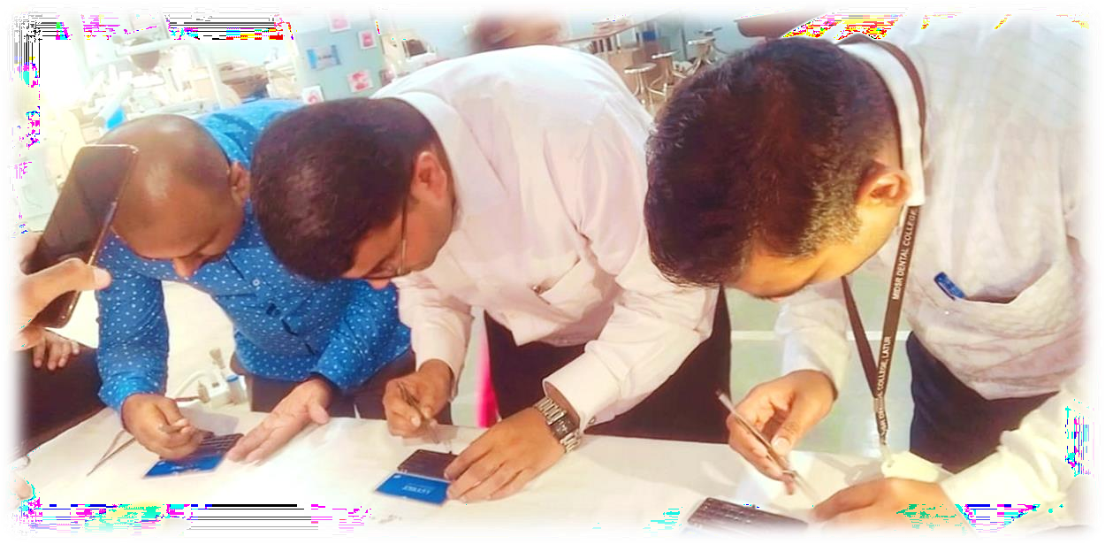

Correct bracket sequence identification competition.

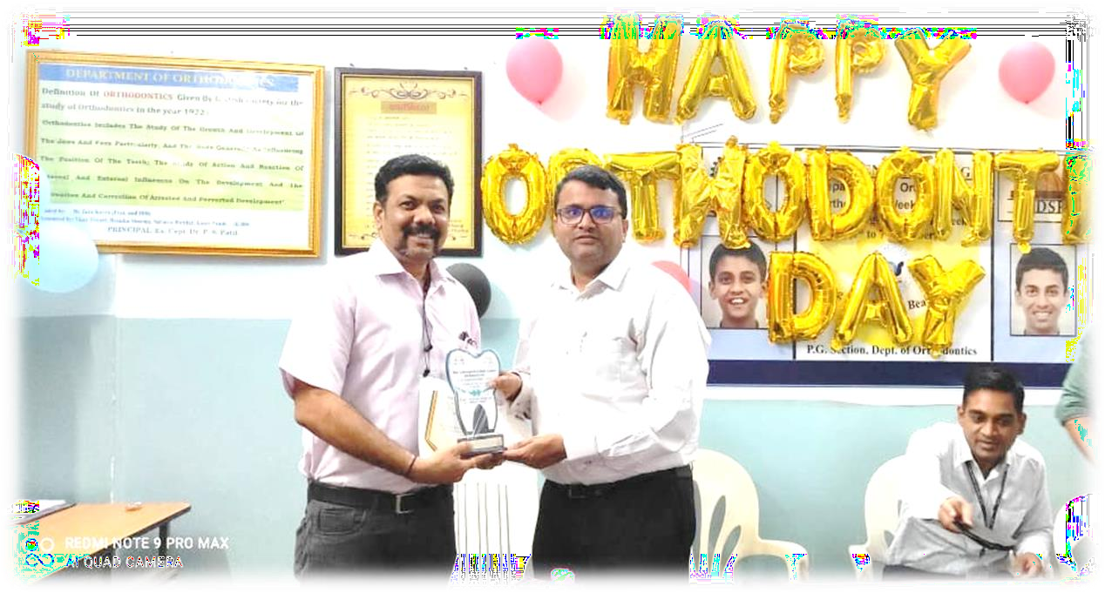

Winner of correct bracket sequence identification competition.

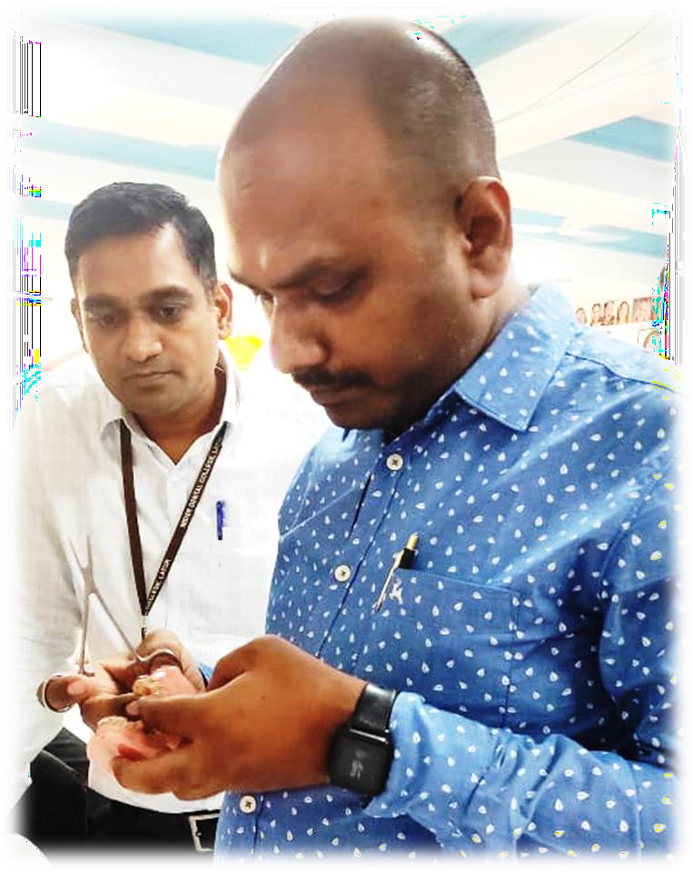

Fastest E – module ligation in figure of 8 manner competition.

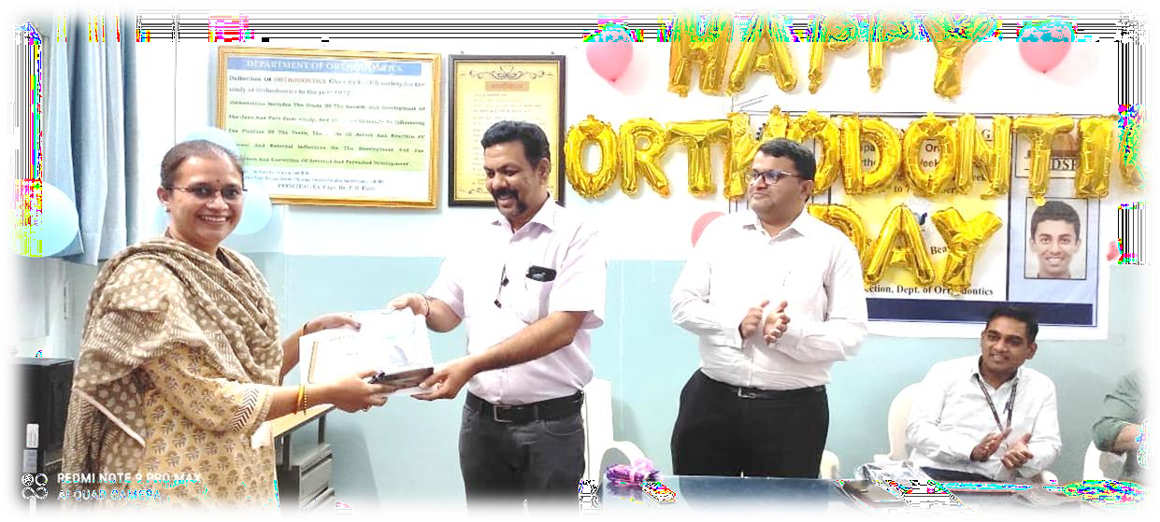
Winner of fastest E – module ligation in figure of 8 manner competition.

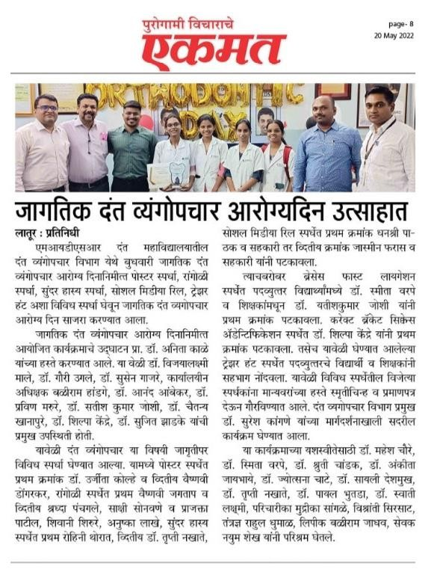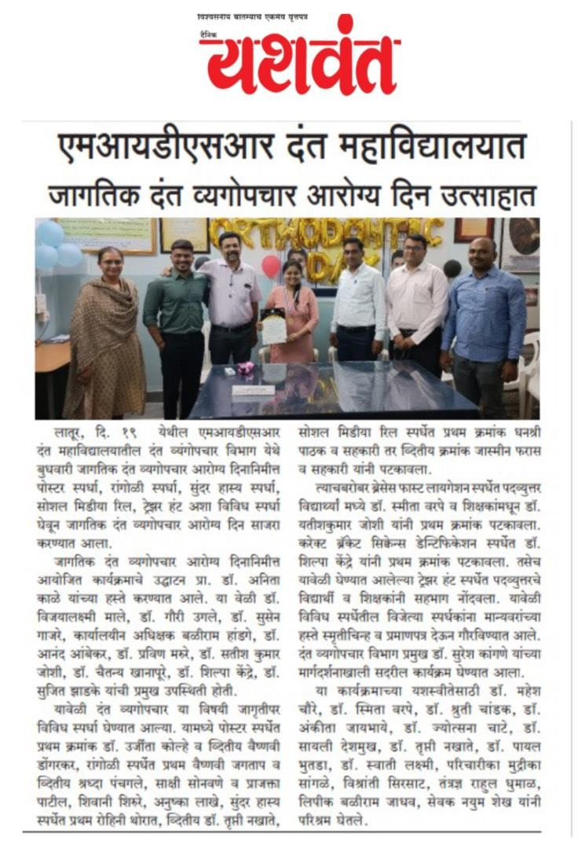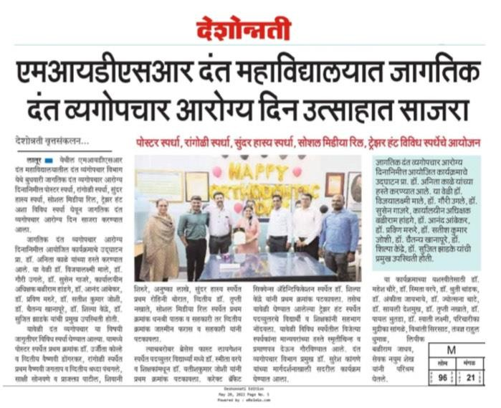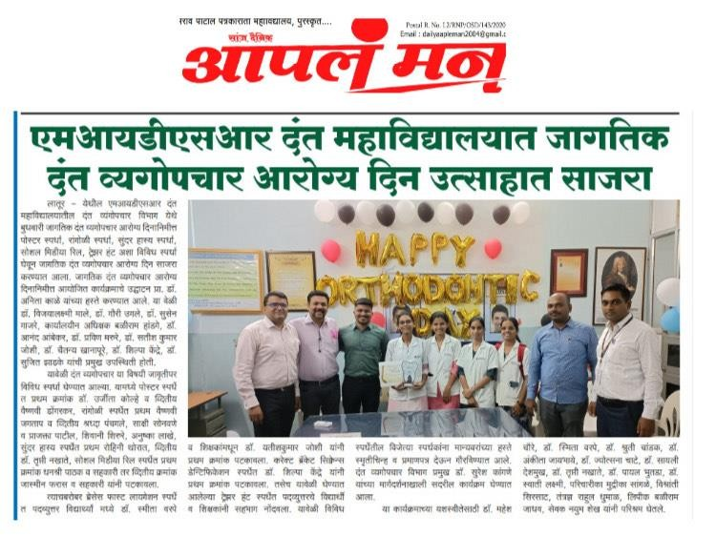

Articles regarding the Orthodontic Day celebration were published in multiple newspapers.

