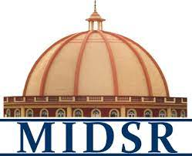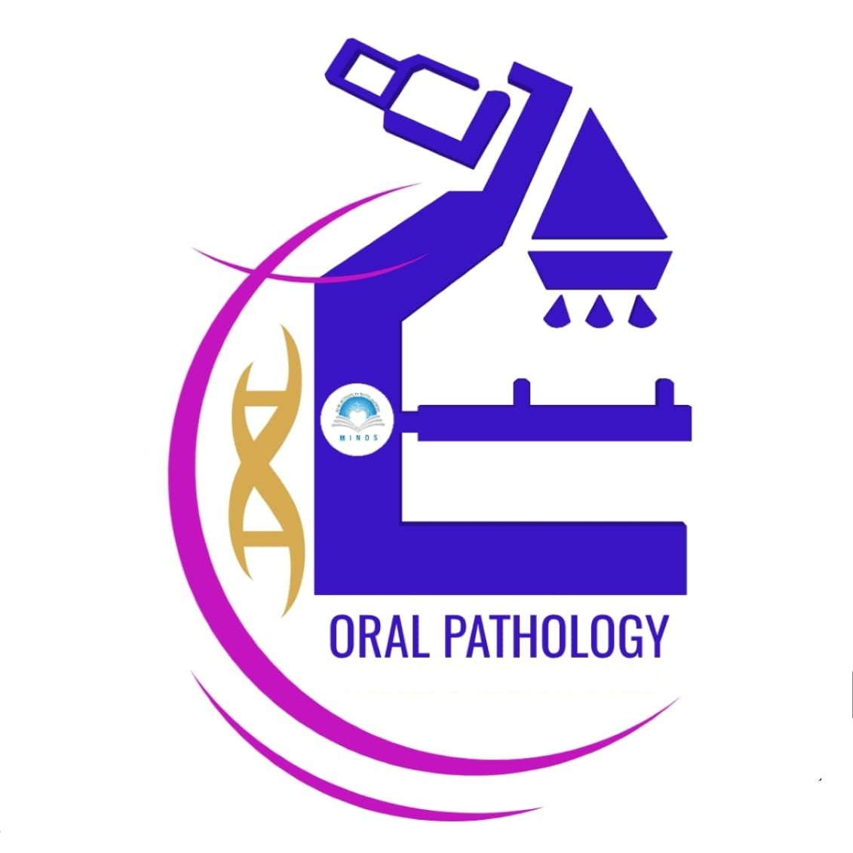**REPORT**

***Department of oral Pathology and Microbiology day celebration -2023***

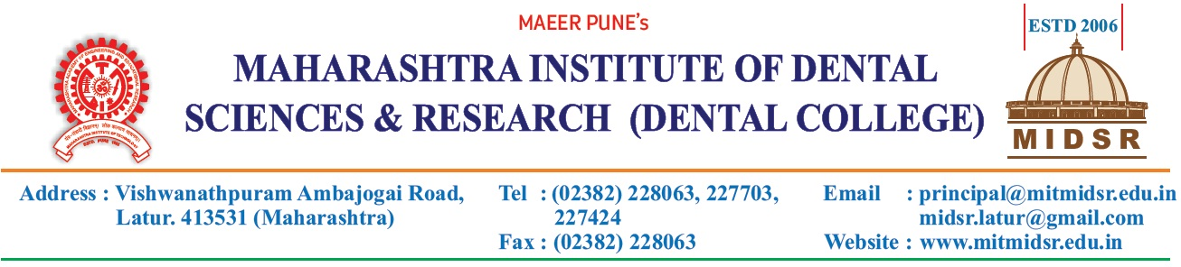

On occasion of birth anniversary of Dr. H. M. Dholkia, National Oral Pathologist Day was celebrated on 25th Feb., 2023 (Saturday).

Program was conducted by dr. Anuja maniyar, dr. Varsha sangle,dr. Smita chaware and dr. Pragya bhatnagar.

Day celebration was started with the warm welcome of our beloved vice principal sir Dr. Yatish kumar joshi followed by **Vishwashanti prayer.**

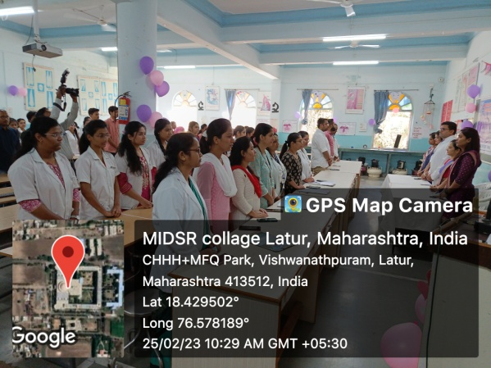

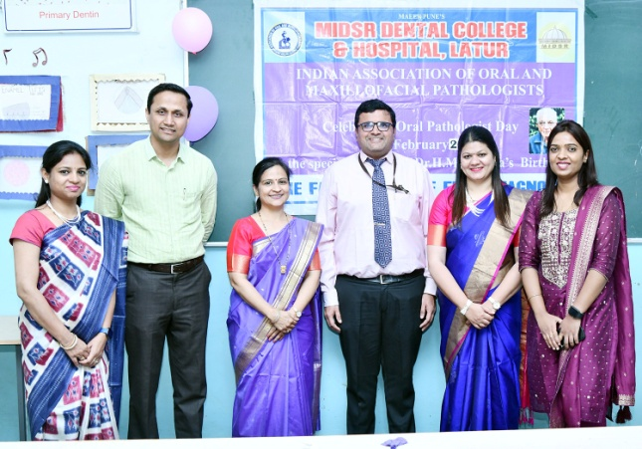

The **anchoring** was done wonderfully by Jasmin Faras & Ruta Gaikwad our intern students.

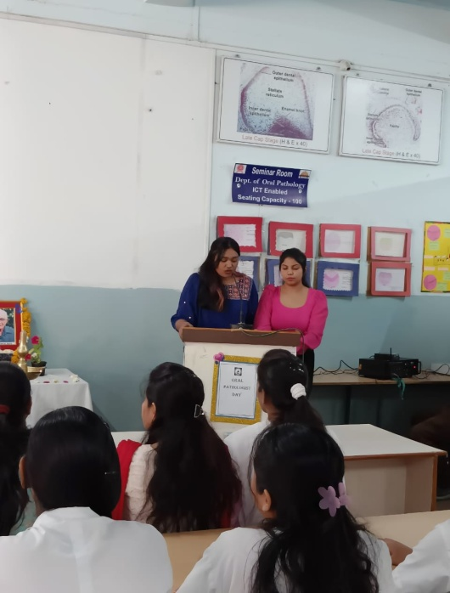

The lamp lightening by vice principal sir and department staff and it was graced by **saraswati vandana** which was melodiously sung by Aishwariya Dixit (intern student).

A fabulous **speech** was given by head of the department, Dr. Anuja Maniyar, which was very educational and motivational for the under graduate students.

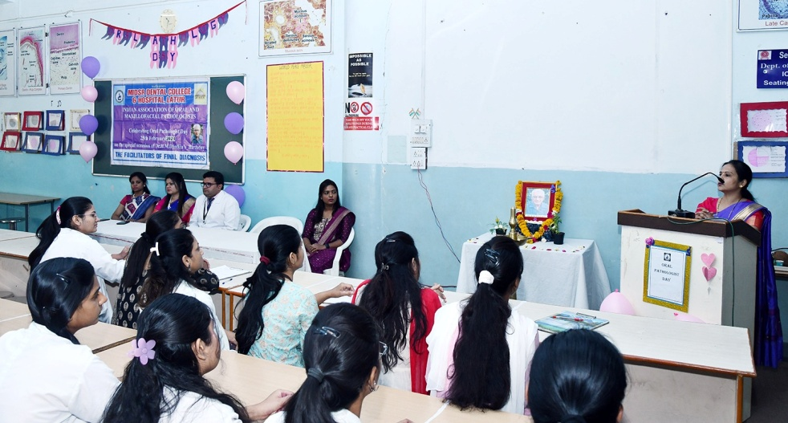

The department has set the theme of hematoxylin & eosin colours and was beautifully decorated with the theme coloured balloons and decorative items and posters showing the artistic and creative side of our students and staff. The welcome rangoli in H&E colours at the department gate was beautiful.

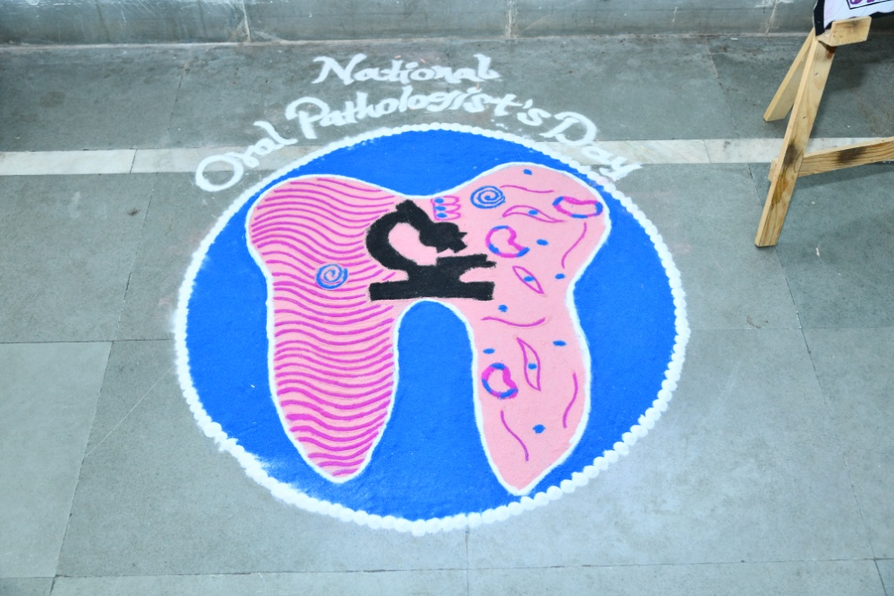

**A wall of fame** was inaugurated showing list of toppers of dental anatomy/ histology and oral pathology for last 8 years. This boost up the spirit in students to study harder to grit their names engraved on the list.

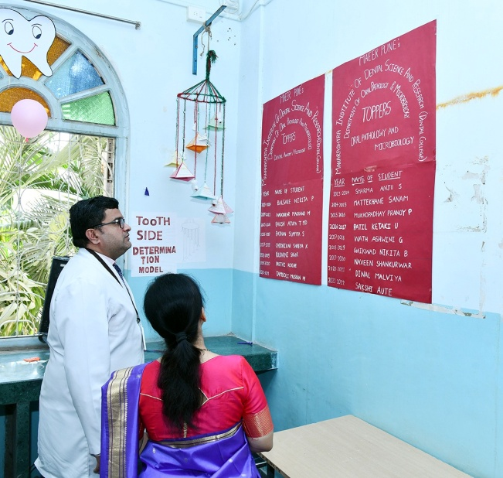

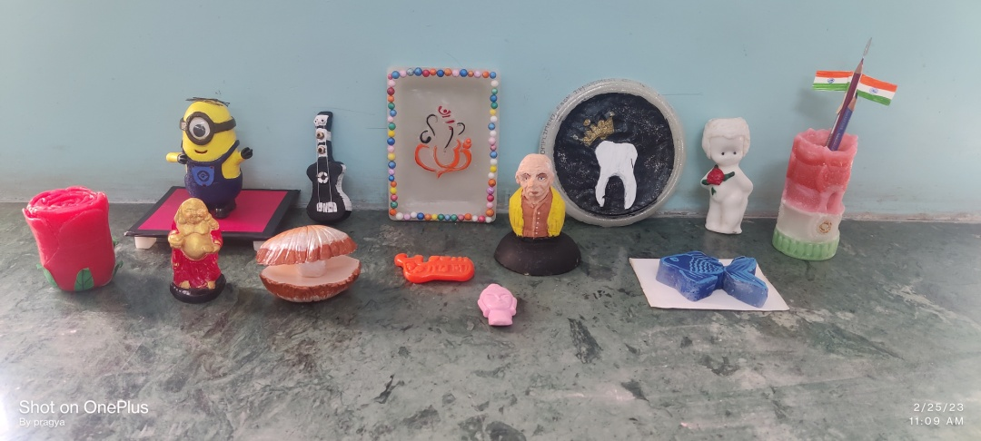Adding to this joyfully environment our department have arranged various entertaining & educational competitions for the students. We have **best from waste** (carving waste wax/ soap) carving competition in which .................3re year student secured 1st position by carving mandibular jaw showing various cysts on soap. 2nd position was secured by our 1st year students group ( Ruchika Kshirsagar, Kannaki Gojamgunde, Rutuja Patil, Aditi Gaikwad, Sakshi Bhise, Aditi Hedda & Maithili Swami) who carved a beautiful sea shell with pearl in it.

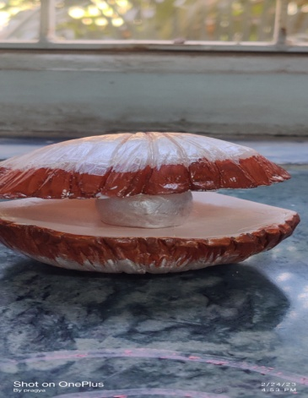 Various carvings of best out of waste competition

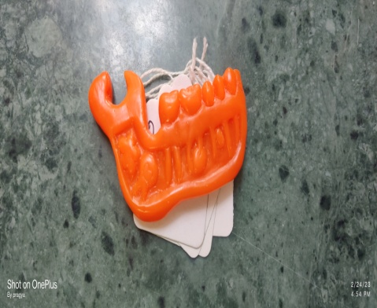

Next we had a **rangoli competition** in which 1st prize winners were 3rd year students Shrushti Katpure, Sneha Pawar, Surabhi Gulbhile & Shubhangi Jantine ,who used H&E colours along with other colours beautifully to represent various oral diseases clinically as well as Histologically in their rangoli.

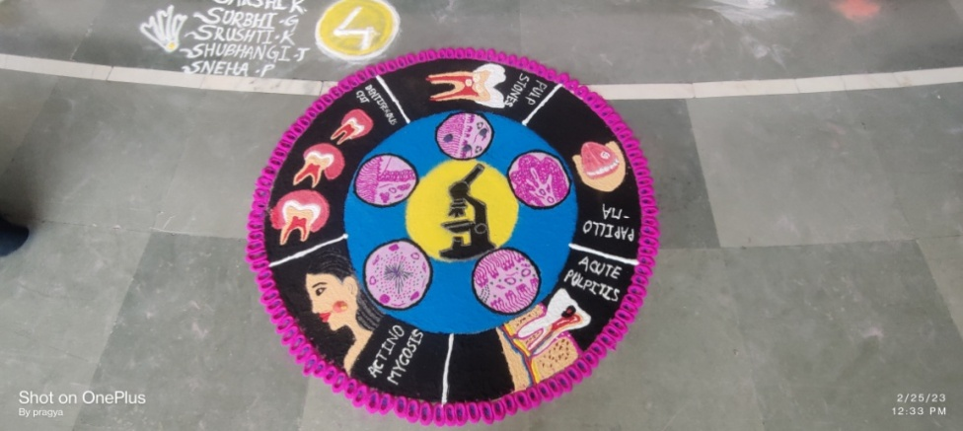

Winner of rangoli competition

Next in the line was **Spin the wheel competition** which gave the chance to our students to show off their knowledge about the subject and the winner was Vaishnavi Kovhale of 3rd year.

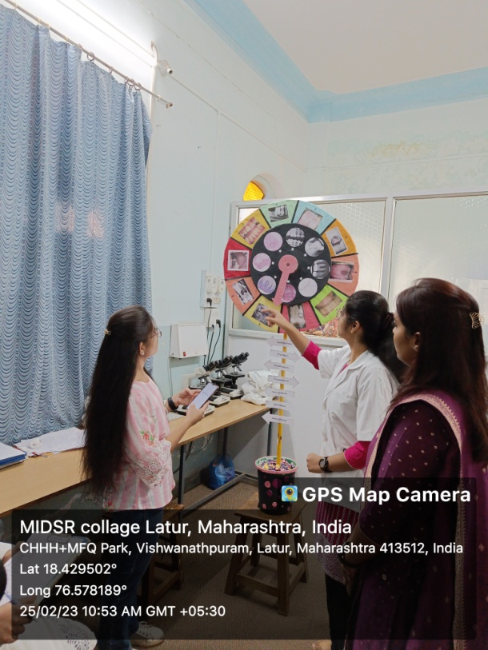

Then there was **e-poster competition** where Vaishnavi Kovhale & Vaishnavi Lakle secured 1st position by presenting poster on Mucormycosis.

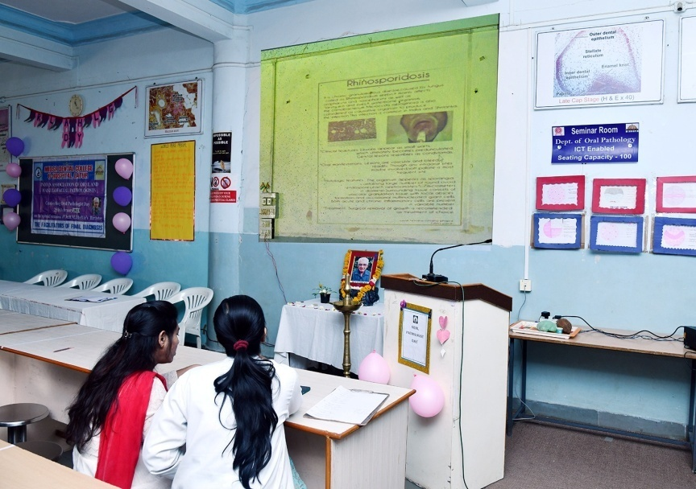

Our student’s entusiatically participated in all competitions and made it really difficult for the judges to find the winners. At the end the winners were awarded with certificates.

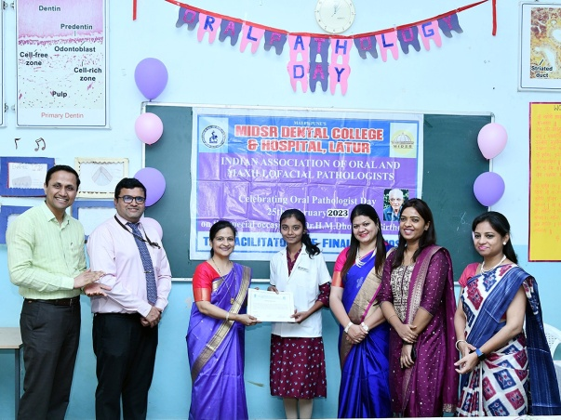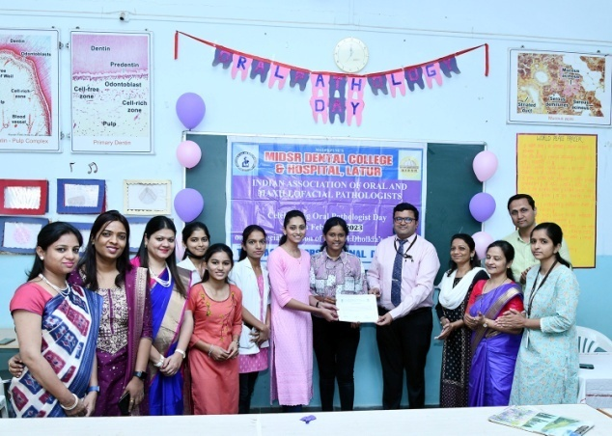 \

**Certificates given to the winners**

The **vote of thanks** was given by Aishwariya Dharne & Shivani Shirure our intern students.