**1st ORTHODONTIC CDE**

Organized by

**DEPARTMENT OF ORTHODONTICS & DENTOFACIAL ORTHOPEDICS**

MIDSR DENTAL COLLEGE & HOSPITAL, LATUR

**ON** 07/02/2019

**title:**

**“NOVAL TREATMENT STRATEGIES IN ORTHODONTICS”**

**.**

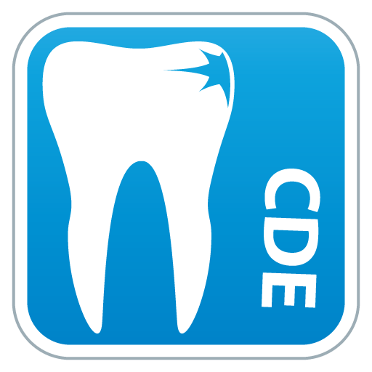

The CDE was graced by auspicious presence of Dr. Krishnanayak as chief guest & speaker and Dr Sameer Patil &Dr. Toshinwal as guest of honoue. CDE program started with vishwashanti prayer, Dr. Krishnanayak & Dr Toshinwal inaugurated the program by lighting the traditional lamp with chairman of CDE and principal, organizing deputy chairman Dr. Suresh Kangane, organizing Secretary Dr. Anand Ambekar. Following lamp lightning Principle, Dr P S Patil felicitated Dr. Toshinwal & Dr. Krishnanayak & Dr Sameer Patil

**About Speaker –**

**Dr. Toshniwal**

MDS ,Orthodontics & Dentofacial Orthopedics ,Vice Principal & HOD Rural Dental college Pravara nagar

**Dr. Krishnanayak**

MDS ,Orthodontics & Dentofacial Orthopedics

President in ternational college of Dentist, DCI Member,Dean academics,HOD AB Sheety memorial institute of dental science,Manglore

**Dr Sameer Patil**

MDS ,Orthodontics & Dentofacial Orthopedics

Principal and HOD sinhagadh cdental college pune

**participants –**  55 final year and intern students of MIDSR dental college actively participated in the CDE

**SCHEDULE : Details Of Lecture**

|  |  |  |  |  |
| --- | --- | --- | --- | --- |
| **Date:- 07-02-2019** | | | | |
| **Sr. No** | **Time** | **Course Curriculum** | **Guest of Honor/Speaker** | **Course Content** |
| 1 | 8.30 am-9.00 am | Registration |  |  |
| 2 | 9.00 am-10.00 am | Inauguration |  | Inauguration |
| 3 | 10.00 am-11.00 am | Session I | Dr. Krishna Nayak | A Straight Talk about Crooked teeth |
| 4 | 11.00 am-12.00 am | Session II | Dr. Sameer Patil | Rapid Canine Retraction by Distraction Osteogenesis |
| 5 | 12.00 pm-1.00 pm | Session III | Dr. Toshniwal N.G | Bite and jet |
| 6 | 1.00 pm-2.00 pm | Lunch Break | ----------------- |  |
| 7 | 2.00 pm-3.00 pm | Session IV | Dr.Tara Kavra | Dilemma in Retention of Treated Midline Diastema. |
| 8 | 3.00 pm-4.00 pm | Session V | Dr. N.G.Toshniwal | Oral Physiotherapist-a Need of Hour |
| 9 | 4.00 pm-5.00 pm | Session VI | Dr. Sameer Patil | Presurgical Naso-Alveolar Molding |
| 10 | 5.00 pm-5.30 pm | Panel Discussion & Validation |  |  |

Morning lecture schedule began sharp at 10am with thoroughly informative lectures and outstandingly impressive presentations address by Dr. Krishnanayak, Dr Sameer Patil, Dr. Toshniwal

After the lunch in afternoon Dr. Tara Kavra ,Dr. Sameer Patil ,Dr. Toshniwal also addressed a crystalclear concepts enclosing lecture and superefficient , idiomatic innovative presentation.

Receptive and inquisitive participants received certificates with 6 CDE points by the end of session. The program was hugely appreciated by all the participants

Welcome to All the Speakers:

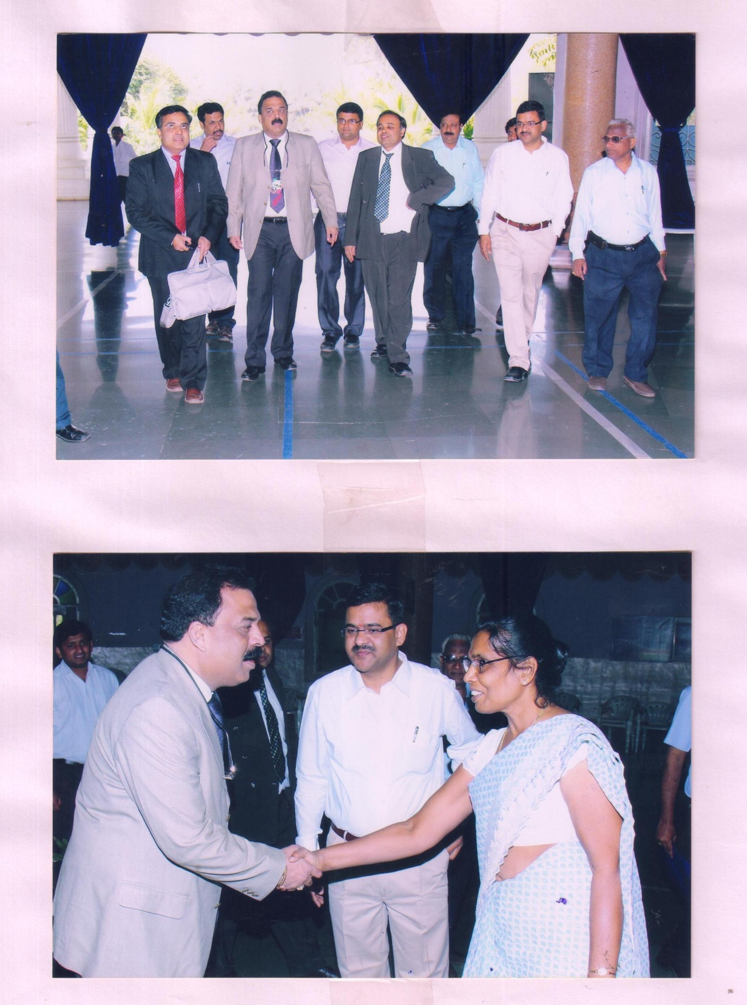

Guest Speakera in MIDSR & MIMSR Campus:

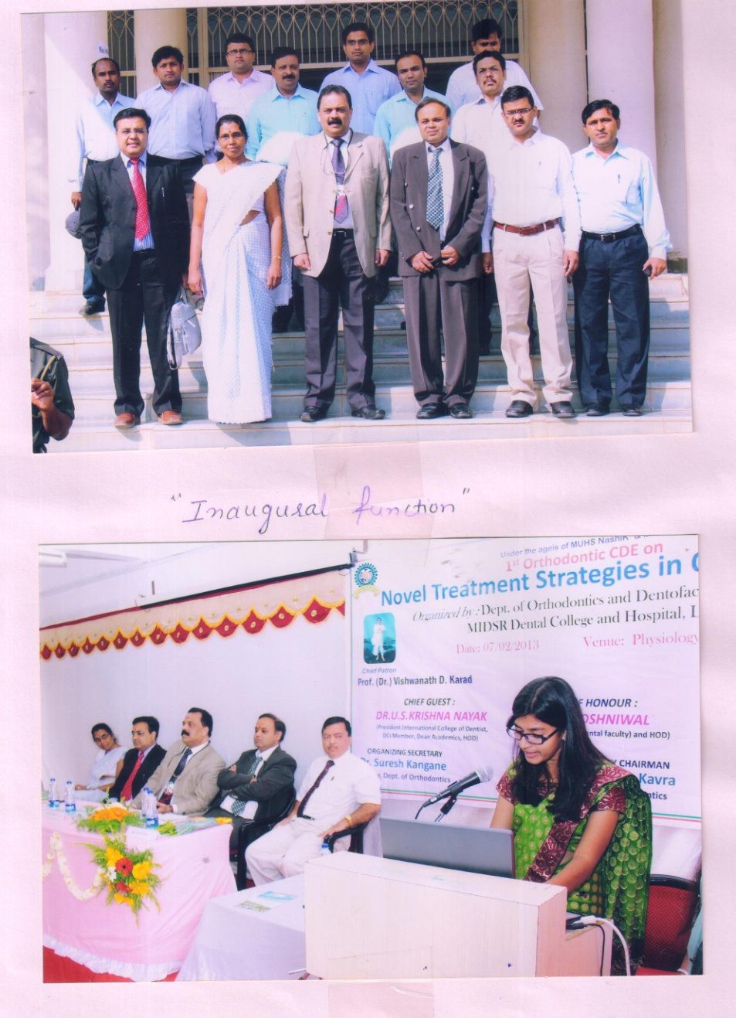

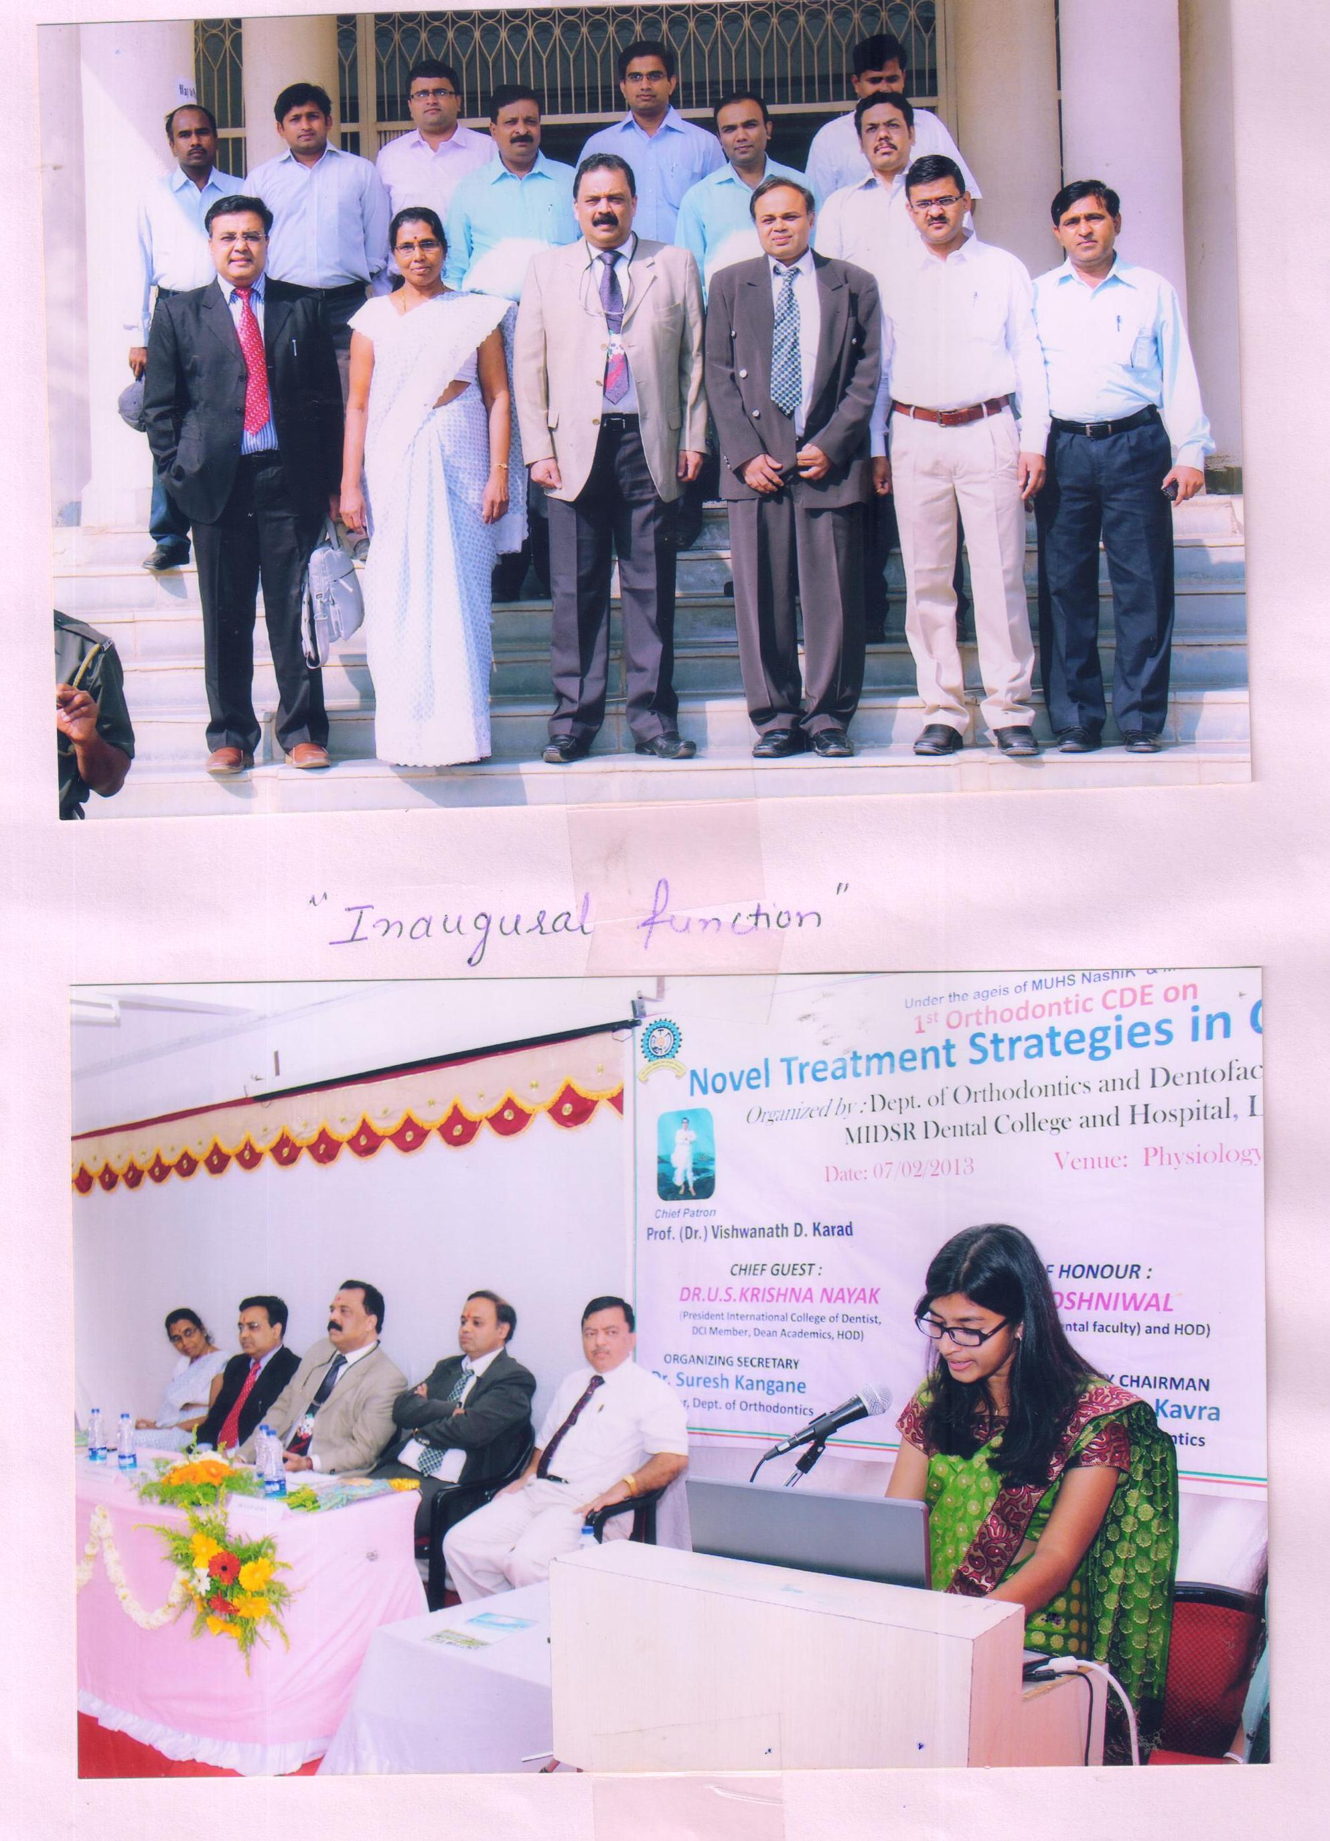

Vishwashanti Geet Prayer:

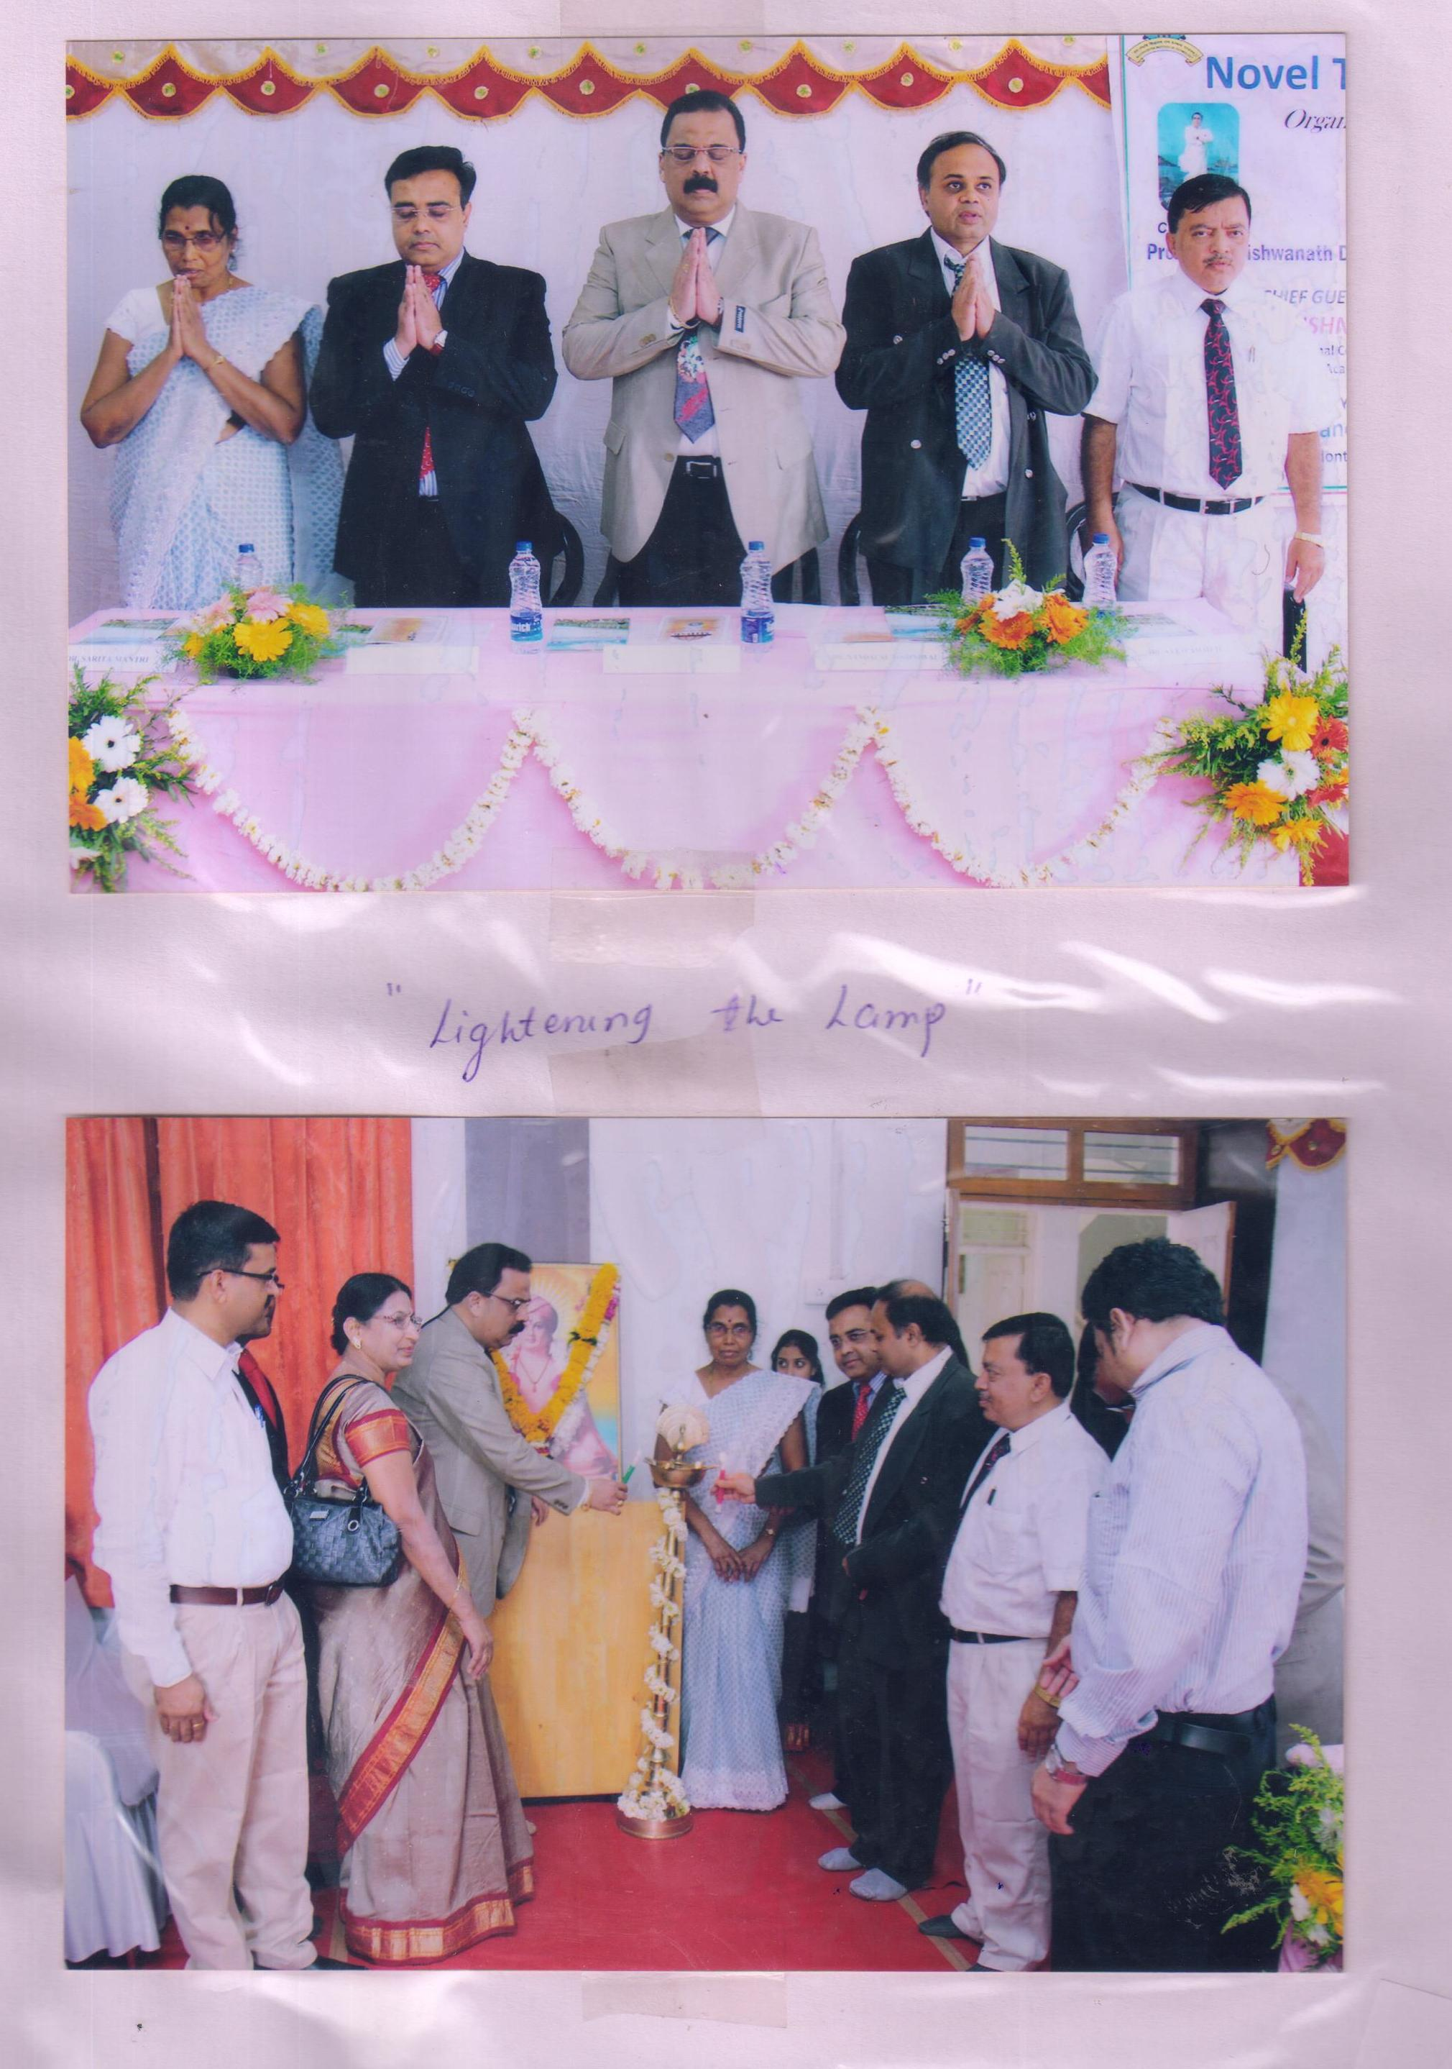

“ Guest Speakers”

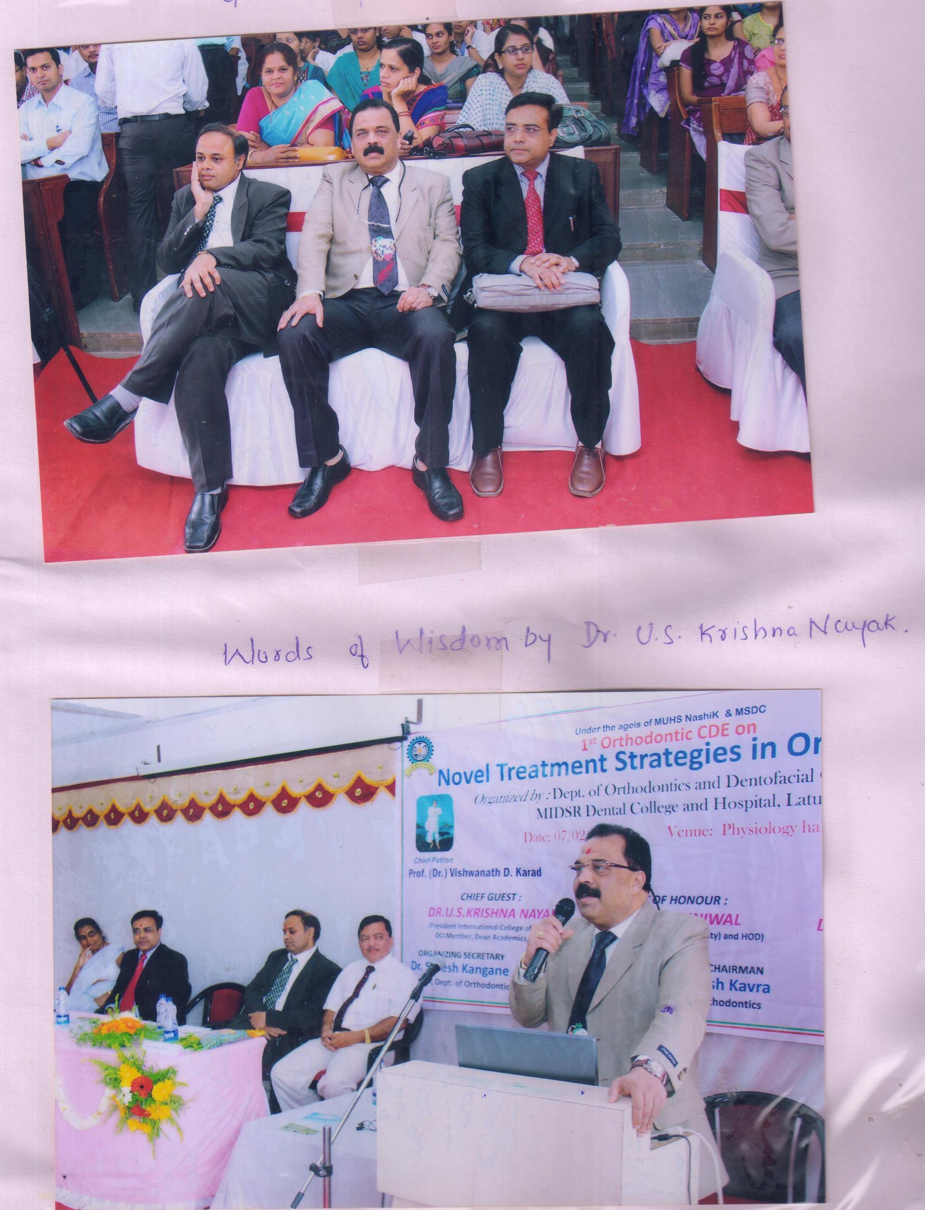

“ Felicitation & the Guest Speakers”

