DEPARTMENT OF ORTHODONTICS & DENTOFACIAL ORTHOPEDICS
Orthodontic day celebration was organized by Department Of Orthodontics & Dentofacial Orthopedics on 7th October 2018 at MIDSR, Latur. The day was graced by Principal Dr. Suresh Kamble, & vice Principal Dr Suresh Kangane, as chief guest.
Dr. E. Angle photo frame at the hands of the chief guest and other dignitaries.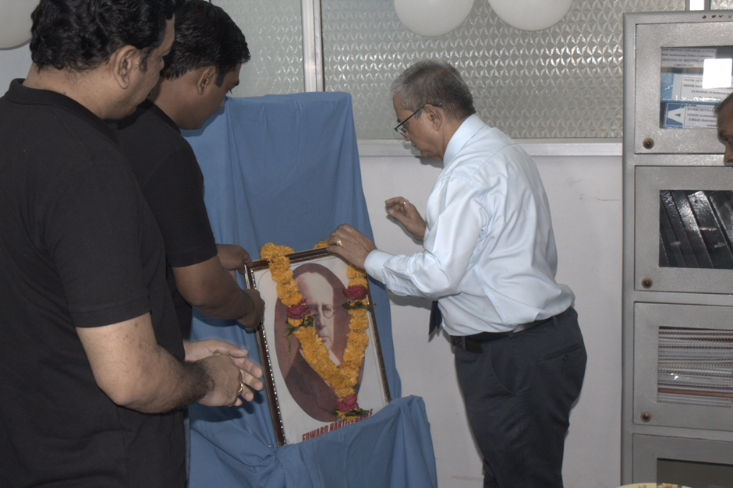

Dr. Suresh Kamble inaugurated the programme by cutting cake.
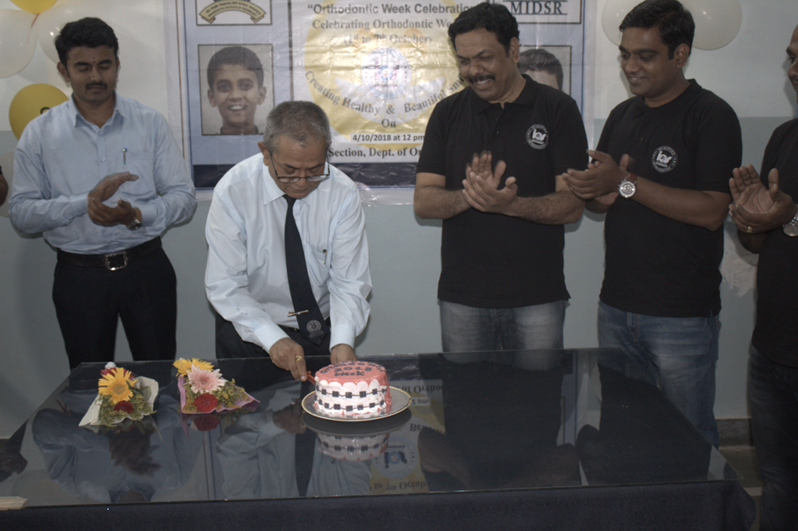
Teaching staff group picture along with our administrative officer Mr. Handge Sir and Principal Dr. Suresh Kamble sir.
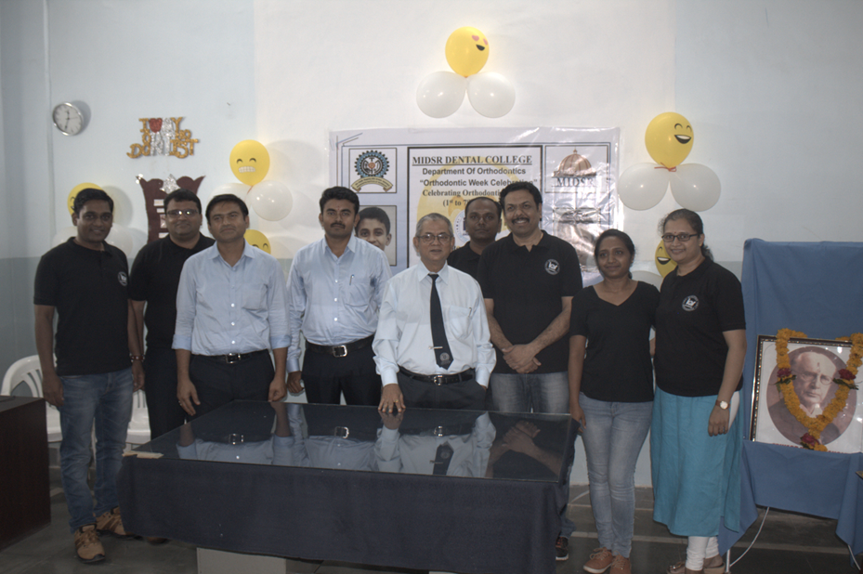

Teaching staff group picture along with Post graduate students and Under graduate students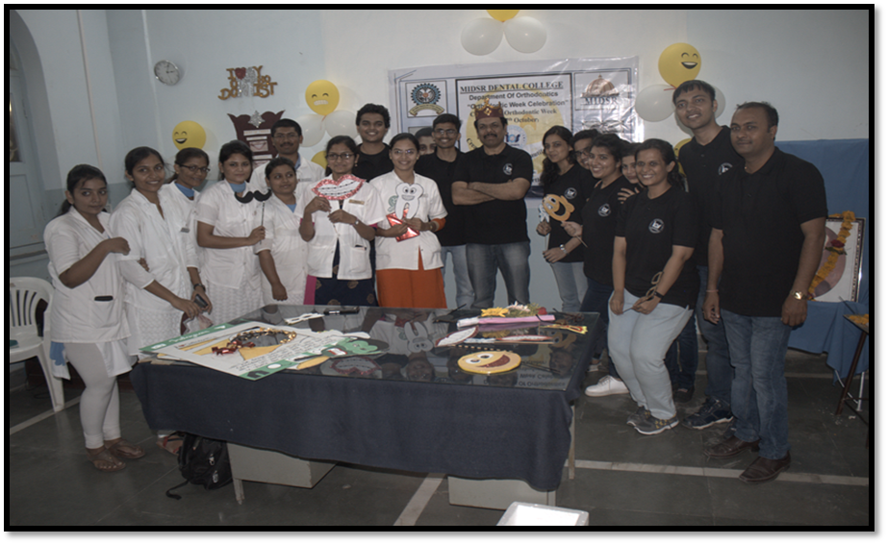
Rangoli competition was held and prize was distributed for the same.

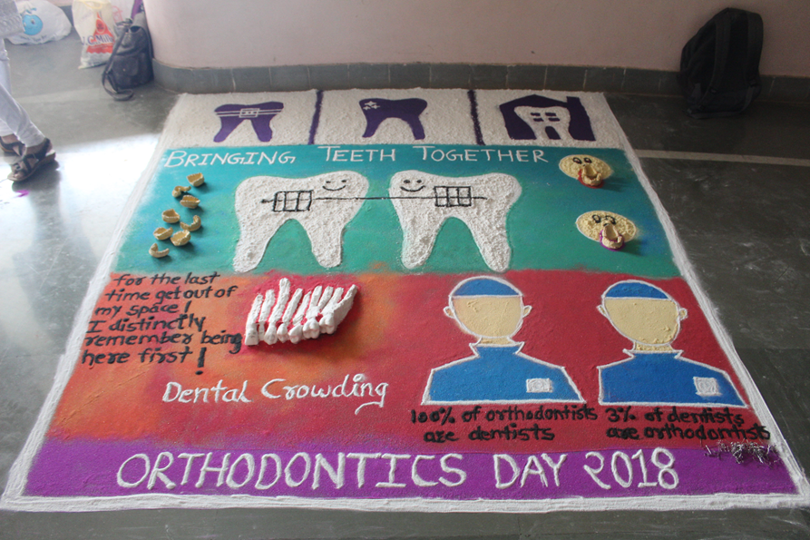

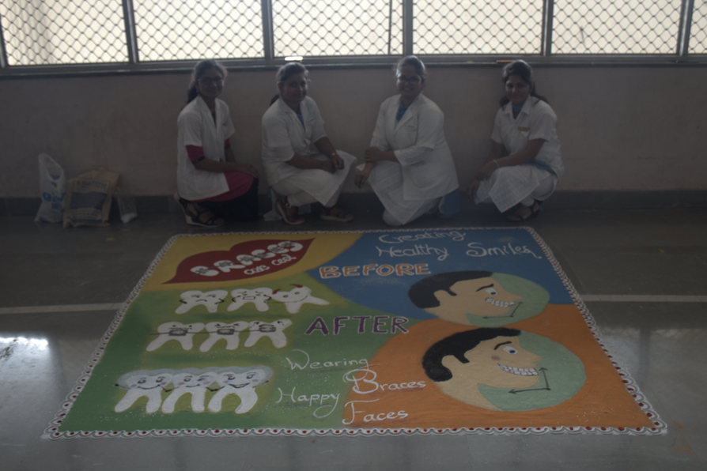

Prize distribution ceremony was conducted for the “BEST SMILE”.
