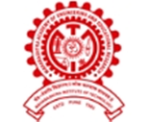
MAEER PUNE’S
MAHARASHTRA INSTITUTE OF DENTAL SCIENCE & RESEARCH, LATUR

Report

Hepatitis B Vaccination Drive 2023

Department of Oral & Maxillofacial Surgery

Maharashtra Institute Of Dental Sciences And Research (Dental College), Latur pledged to organize hepatitis B vaccination drive 2023 under the guidance of Hon’ble Dr. Hanumant Karad, Executive Director of MIDSR Dental College.
Department of Oral and Maxillofacial Surgery in collaboration with Welfare And Grievance Committee conducted a “HEPATITIS B VACCINATION DRIVE 2023” on 10TH AND 11TH JANUARY for first year BDS students and interested individuals
The vaccination drive was conducted in the Orthotech Lecture Hall, MIDSR Dental College, Latur. The drive was inaugurated by our respected Principal Dr.Anand Ambekar in presence of Vice Principal Dr.Suresh Kangane , And Dr. Yatishkumar Joshi, our HOD Dr. Sheeraz Badal, Chairman of Welfare and Grievance Committee Dr. Ajit Jankar and Our Event Coordinator Dr. Amol Doiphode.
Arrangements of the programme were done by Event Incharges Dr. Govind Changule,Dr. Punam Nagargoje and Dr.Shital Wagh. Information and awareness about Hepatitis B infection and its prevention with vaccine was presented by Dr. Punam. Inauguration was followed by vaccination. On 10th January, vaccinations were given to all the first years students and others. Total 165 individuals were vaccinated on 1st day. On 11th January, 131 individuals were vaccinated which included other UG students, PG students, Teaching and Non-Teaching staffs.

The vaccination drive received a massive response with total of 296 participants including staff and students of all the departments.

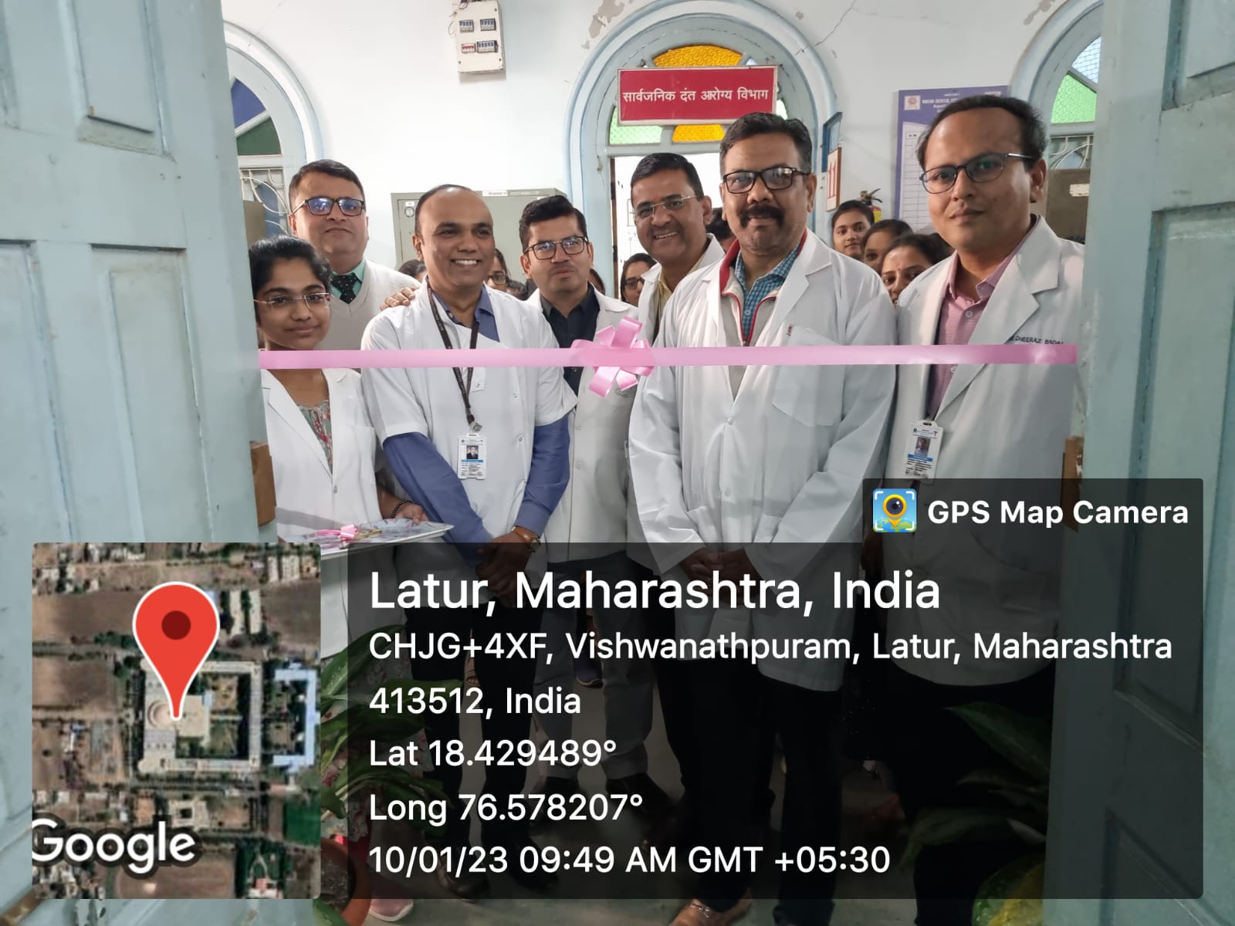

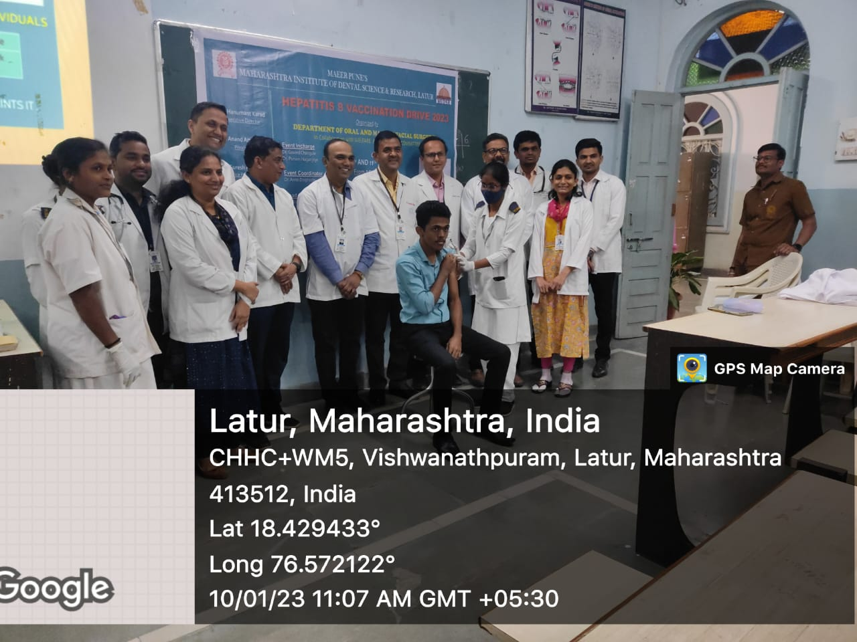
Inauguration ceremony

Vaccination for 1st BDS students

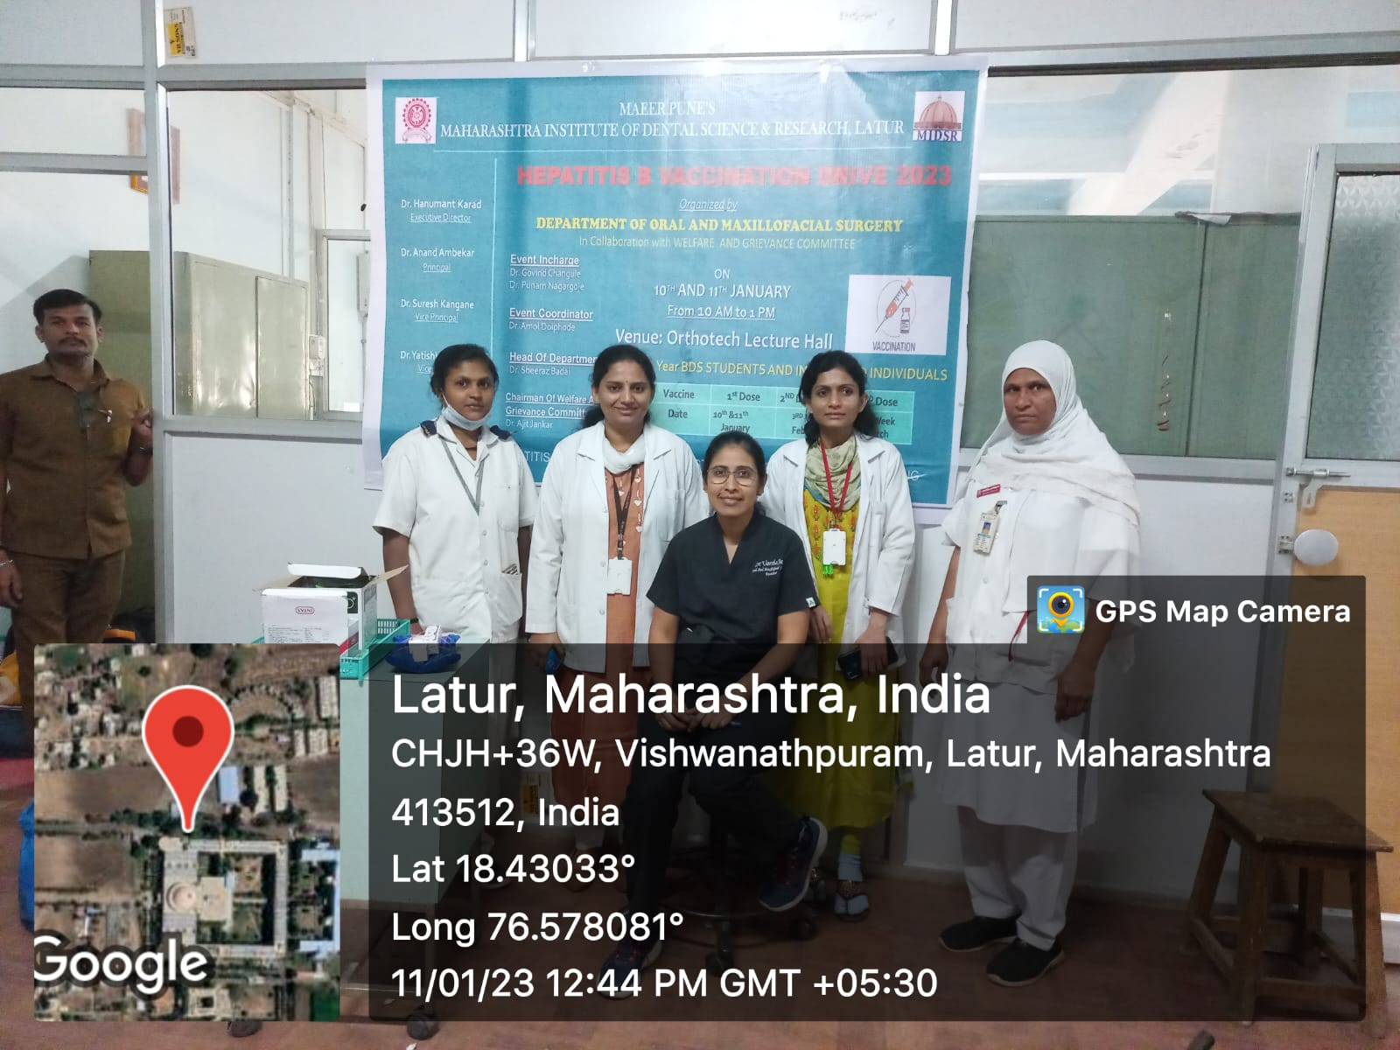

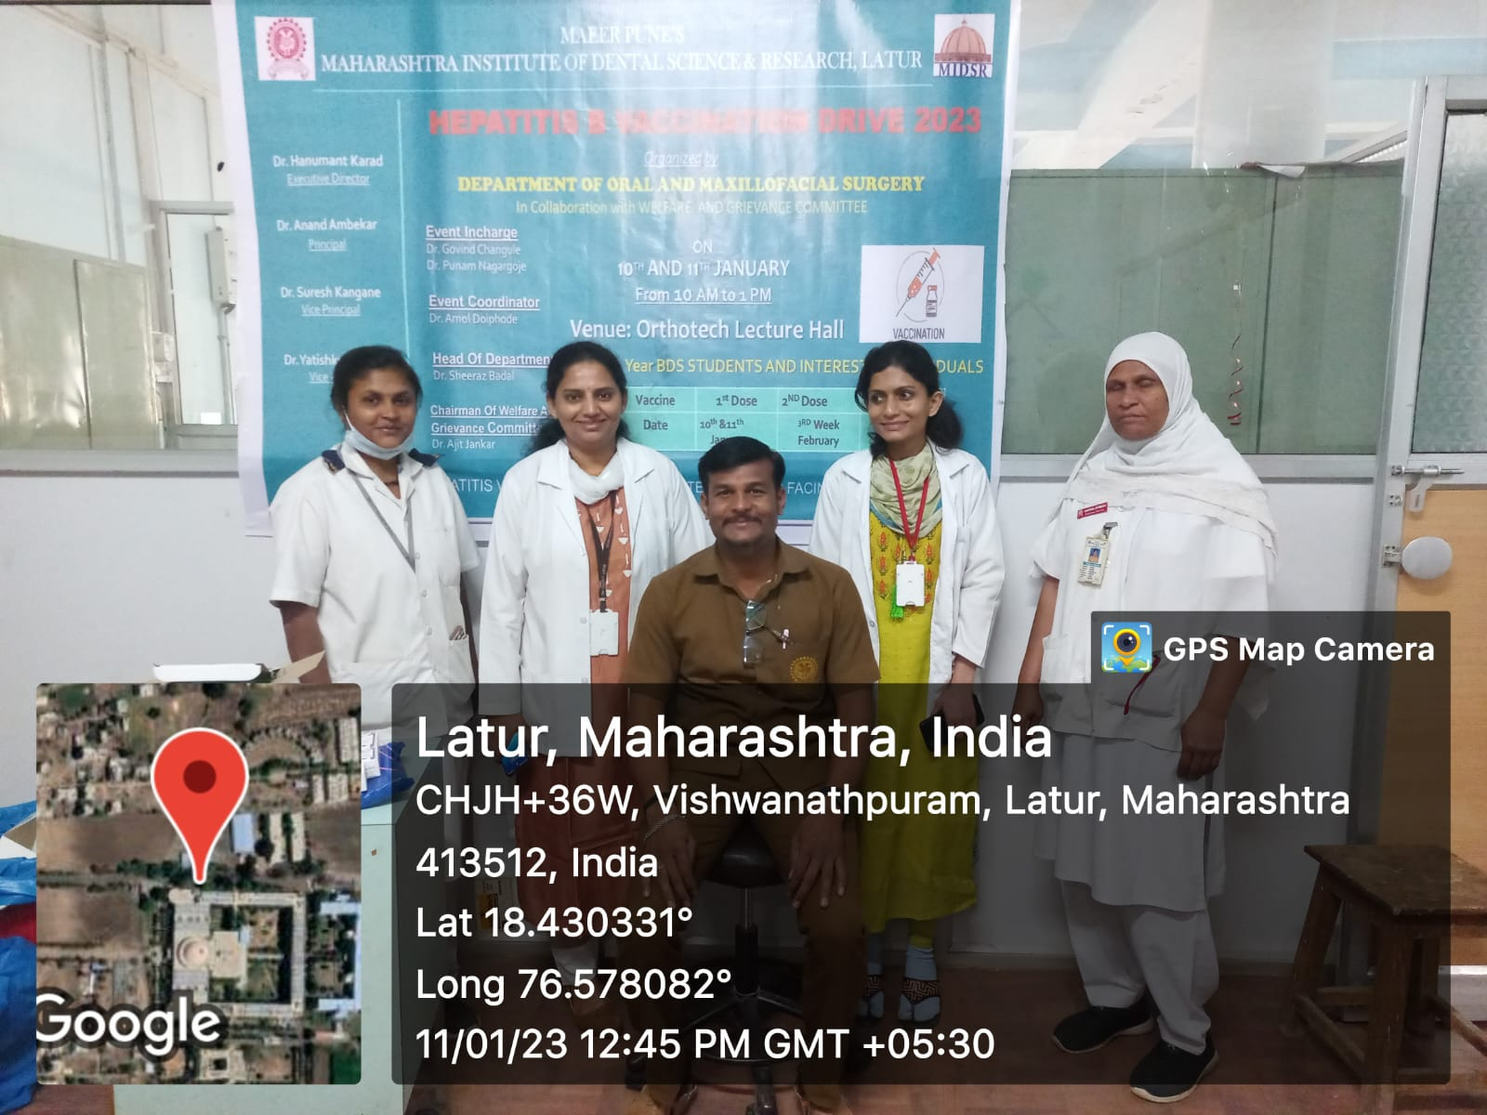
Vaccination for non teaching staff
Vaccination for PG student

Report

Hepatitis b vaccination drive 2023

Department of Oral & Maxillofacial Surgery

Maharashtra Institute Of Dental Sciences And Research (Dental College), Latur pledged to organize hepatitis B vaccination drive 2023 under the guidance of Hon’ble Dr. Hanumant Karad, Executive Director of MIDSR Dental College.
Department of Oral and Maxillofacial Surgery in collaboration with Welfare And Grievance Committee conducted a “HEPATITIS B VACCINATION DRIVE 2023 (2nd dose)” on 17thand21st February for first year BDS students and interested individuals respectively.
The 2nd dose for vaccination drive was conducted in oral and maxillofacial surgery, MIDSR Dental College, Latur for 1st year BDS students and interested individuals.
Vaccination was given in presence of Dr. Punam Nagargoje and Dr.Shital Wagh under the guidance of Dr. Sheeraz Badal. On 17th February, vaccinations were given to all the first years students. Total 91 individuals were vaccinated on 1st day. On 21st February, 164 individuals were vaccinated which included other UG students, PG students, Teaching and Non-Teaching staffs.

The vaccination drive received a massive response with total of 255 participants including staff and students of all the departments.
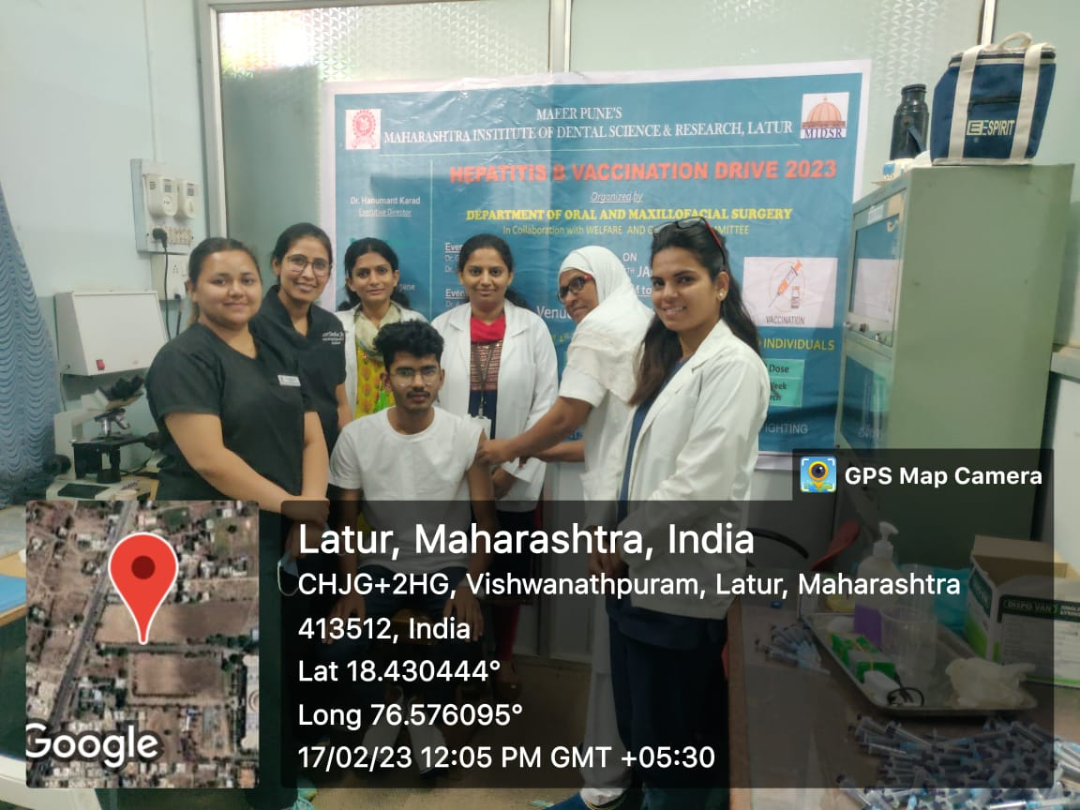
Vaccination for students

Report

Hepatitis b vaccination drive 2023

Department of Oral & Maxillofacial Surgery

Maharashtra Institute Of Dental Sciences And Research (Dental College), Latur pledged to organize hepatitis B vaccination drive 2023 under the guidance of Hon’ble Dr. Hanumant Karad, Executive Director of MIDSR Dental College.
Department of Oral and Maxillofacial Surgery in collaboration with Welfare And Grievance Committee conducted a “HEPATITIS B VACCINATION DRIVE 2023 (3rd dose)” on 6th and 7th April for first year BDS students and interested individuals respectively.
The 3rd dose for vaccination drive was conducted in oral and maxillofacial surgery, MIDSR Dental College, Latur for 1st year BDS students and interested individuals.
Vaccination was given in presence of Dr. Punam Nagargoje and Dr.Shital Wagh under the guidance of Dr. Sheeraz Badal. On 6th April , vaccinations were given to all the first years students. Total 100 individuals were vaccinated on 1st day. On 7thApril , 130 individuals were vaccinated which included other UG students, PG students, Teaching and Non-Teaching staffs.

The vaccination drive received a massive response with total of 230 participants including staff and students of all the departments.

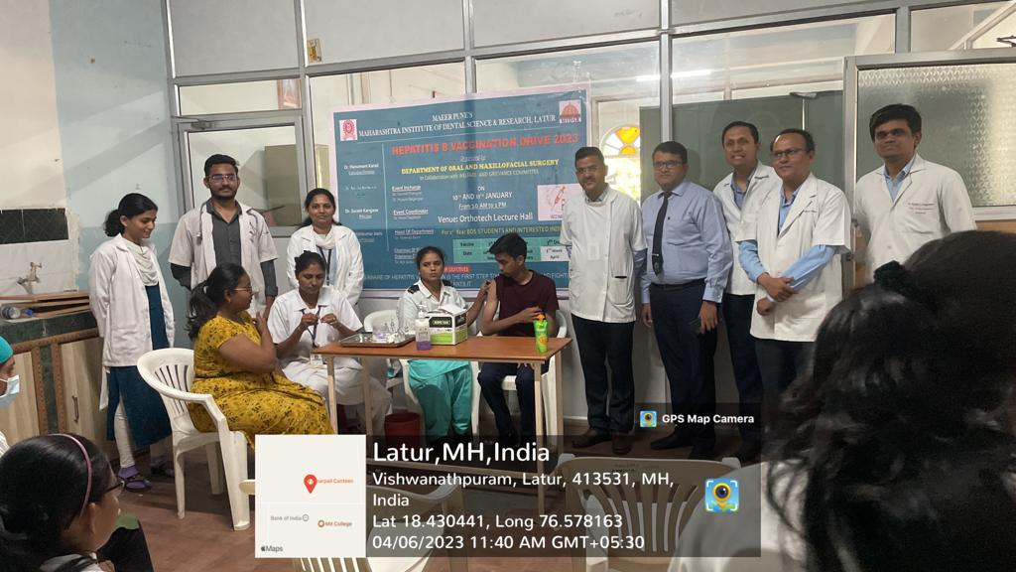
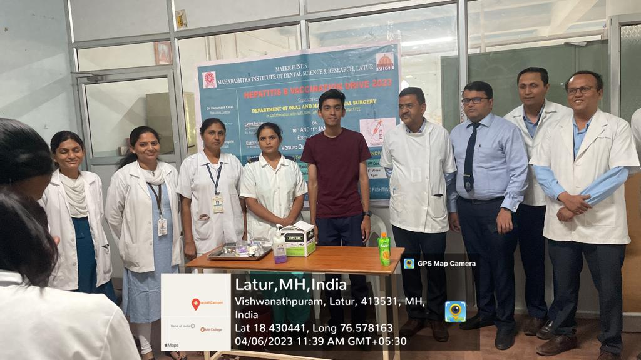
Vaccination for students

