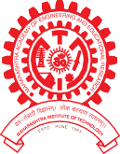MAEER PUNE’s

MAHARASHTRA INSTITUTE OF DENTAL SCIENCES & RESEARCH (DENTAL COLLEGE)
ESTD 2006

M I D S R

Address : Vishwanathpuram Ambajogai Road, Tel : (02382),227703, Email: principal@mitmidsr.edu.in Latur. 413531 (Maharashtra) 227424 midsr.latur@gmail.com
Fax : (02382) 228063 Website :www.mitmidsr.edu.in

Oral & Maxillofacial Surgery : Pioneer in Oral Health Care 2020-21
(Celebrating the 52 Years of Oral & Maxillofacial Surgery)

Introduction:
The programme was conducted with 25 participants including head of department, staff, P.G. & Interns of Department of Oral & Maxillofacial Surgery.
The programme was conducted in the Department of Oral & Maxillofacial Surgery, MIDSR Dental college, Latur. The programme started with inauguration by lighting the lamp at the hands of Dr. Suresh Kamble (Principal MIDSR Dental College, Latur) Dr. Rahul Lature (Professor), Dr. Sheeraz Badal (Professor), Dr. Amol Doiphode (Professor) and Dr. Suresh Kamble was felicitated by Dr. Rahul Lature, Dr. Rahul Lature was felicitated by Dr. Sheeraz Badal, Dr. Amol Doiphode was felicitated by Dr. Gopal Nagargoje This was followed by the welcome address by Dr. Ruchika Raj
Events Conducted :
- Treasure hunt competition
- Poster Competition
- Poem Competition
- Oral Submucous Fibrosis (OSMF) Patients Screening
Venue, Date and Time :
Venue : - Department of Oral and Maxillofacial Surgery, MIDSR Dental College, Latur.
Date and Time :- 13th Feb 2021, Time : 09.00am to 01.00pm

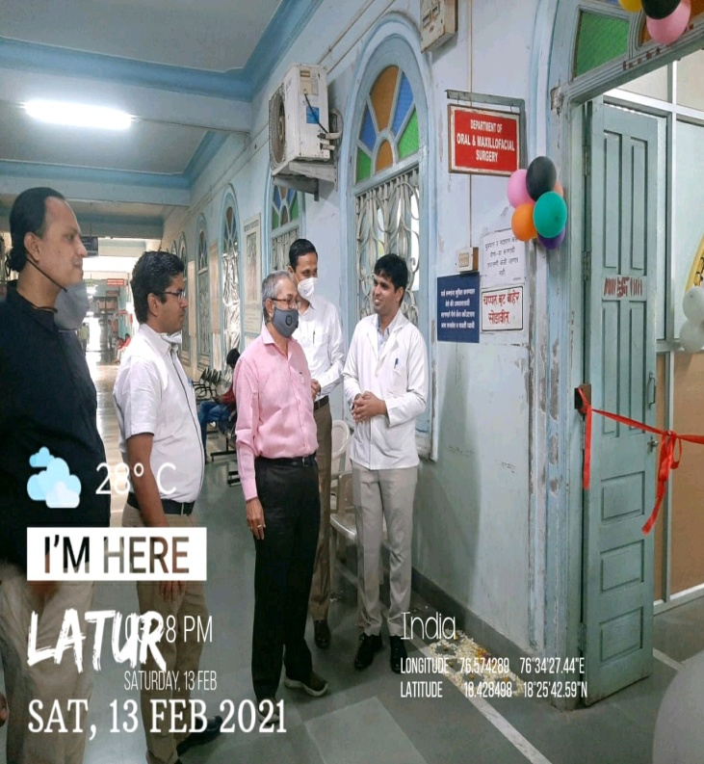
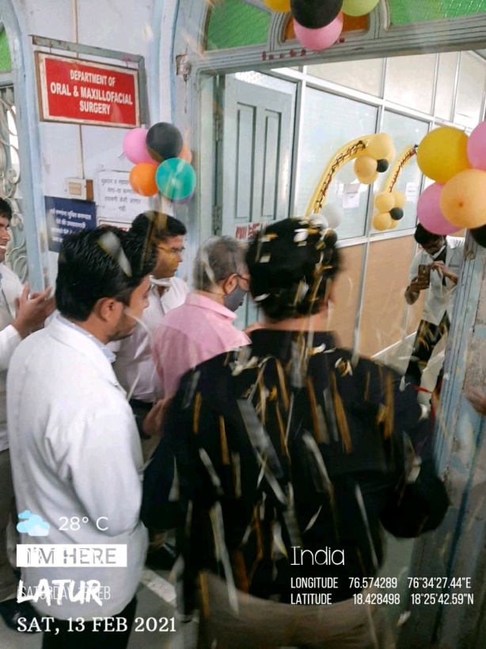

Welcome speech by Dr . Sanjeev (PG III yr )

Ribbon cutting ceremony by Dr. Suresh Kamble sir*(Principal)

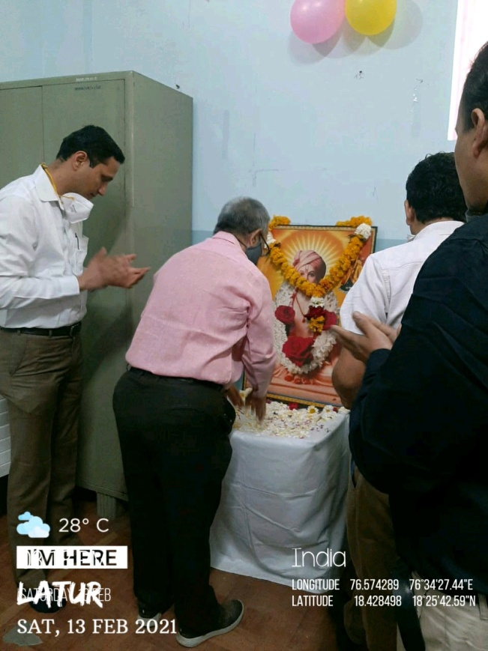

Offereing their prayers and flowers to saint Dnyaneshwar

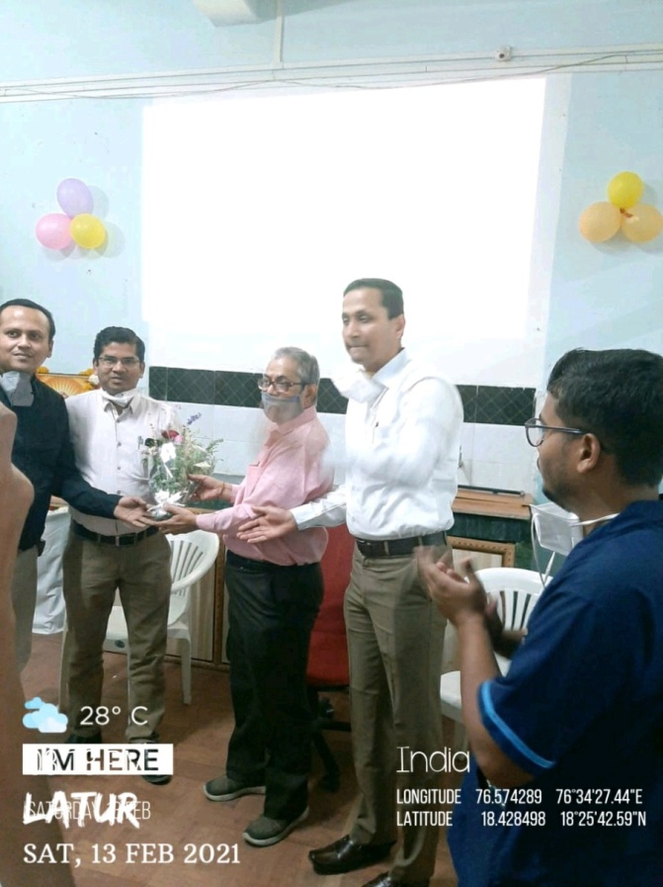

Felicitation ceremony

