Report of Department Day 13th Feb - 2019 Programme

Department of Oral & Maxillofacial Surgery

Department of Oral and Maxillofacial Surgery department conducted a Departmental Day Programme on 13th Feb 2019 due to celebration of 50 years of Inspiring Achievements in Oral & Maxillofacial Surgery.
Details of the Department Day Programme:
- Rally in Department Campus
- Poster Competition
- Treasure hunt
The programme was a huge success with 25 participants including head of department, staff, P.G. & Interns of Department of Oral & Maxillofacial Surgery.
The programme was conducted in the Department of Oral & Maxillofacial Surgery, MIDSR Dental college, Latur. The programme started with inauguration by lighting the lamp at the hands of Dr. Suresh Kangane (Vice Principal MIDSR Dental College, Latur) Dr. Rahul Lature (Professor), Dr. Sheeraz Badal (Reader), Dr. Amol Doiphode (Reader) and Dr. Suresh Kangane was felicitated by Dr. Rahul Lature, Dr. Rahul Lature was felicitated by Dr. Sheeraz Badal, Dr. Amol Doiphode was felicitated by This was followed by the welcome address by Dr. Gopal Nagargoje.
The inauguration was followed by the Rally in the MIT Campus Celebrating the 50 years of Oral & Maxillofacial Surgery, the aim of rally was to motivate the people to plant more and more trees, as “Better Environment, Better Tomorrow, Save the Planet”. After that Poster Competition was Conducted in the Department many students were participated in the competition. The Theme of Competition was “Plant Trees and Save Trees”.. After that Tea break was taken.
.

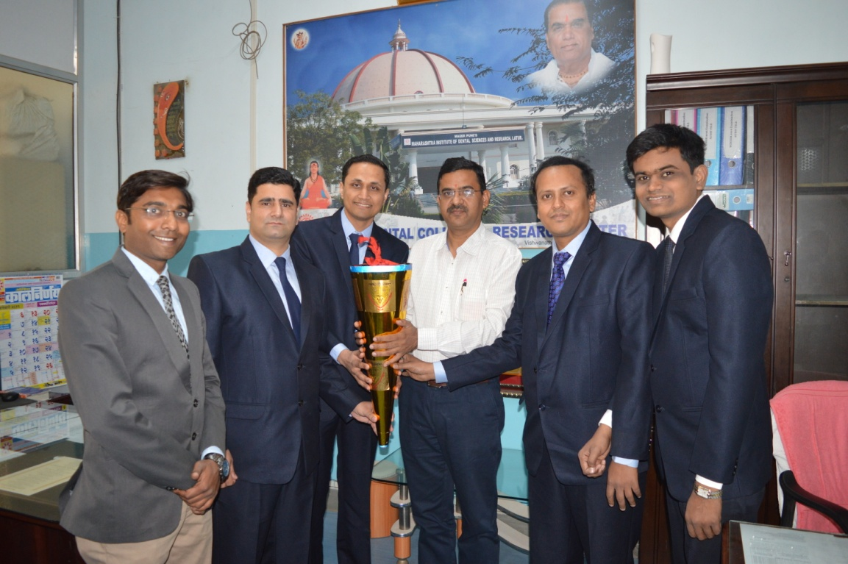

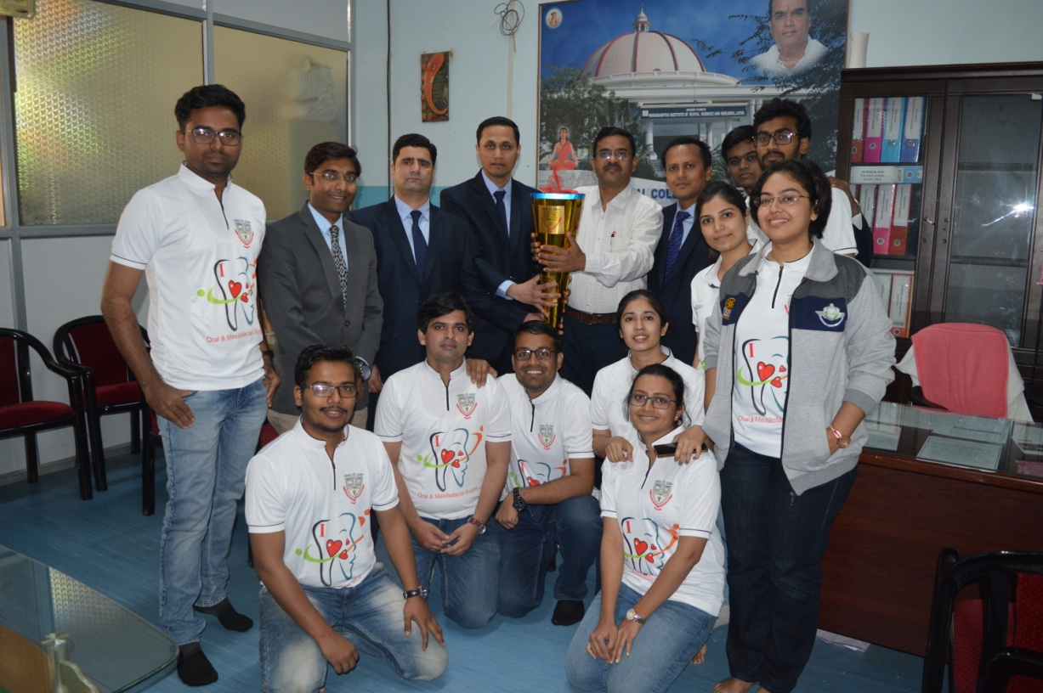

MIDSR DENTAL COLLEGE & HOSPITAL, LATUR
DEPARTMENT OF ORAL & MAXILLOFACIAL SURGERY
DEPARTMENT DAY CELIBRATION ON 13th FEB – 2019
List of Participants
Sr. No | Name of the person | Designation | Mob. No.
01 | Dr. Syed Ahmed | Professor & HOD | 9422071259
02 | Dr. Rahul Lature | Professor | 9850500765
03 | Dr. Sheeraz Badal | Reader | 9049974005
04 | Dr. Amol Doiphode | Reader | 9975456109
05 | Dr. Ahtesham Qureshi | Reader | 7057904010
06 | Dr. Pavan Khichade | Lecturer | 9538217087
07 | Dr. Gopal Nagargoje | Lecturer | 9834850350
08 | Dr. Punam Nagargoje | Lecturer | 8208222256
09 | Dr. Ashok Munde | Tutor | 9423928510
10 | Dr. Nilofar Jamadar | Tutor | 7057904020
11 | Dr. Swati Jadhav | P.G. III Year | 7722000825
12 | Dr. Priyanka Samel | P.G. III Year | 9987758741
13 | Dr. Shraddha Patil | P.G. III Year | 9650414869
14 | Dr. Swapnil Jadhav | P.G. II Year | 7588062332
15 | Dr. Dnayndeep Bholane | P.G. II Year | 8087708958
16 | Dr. Kshitija Sonawane | P.G. II Year | 9823383990
17 | Dr. Tushar Kale | P.G. I Year | 8149536624
18 | Dr. Ashitosh Dod | P.G. I Year | 8275493218
19 | Dr. Sanjeev Sharma | P.G. I Year | 9987374173
20 | Dr. Sushil Ghadge | Intern Student | -
21 | Dr. Belsare Nikita | Intern Student | -
22 | Dr. Sarika Buddepatil | Intern Student | -
23 | Dr. Ghuge Jashri | Intern Student | -
24 | Dr. Pawar Aishwarya | Intern Student | -
25 | Dr. Rutuja Narhare | Intern Student | -

