7.1.7: The Institution has disabled-friendly, barrier-free environment

Built environment with ramps/lifts for easy access to classrooms

Aiming to this, the Institute made ramps in the premises, near classrooms, inside the hospital, and the library, for the benefit of the special population.
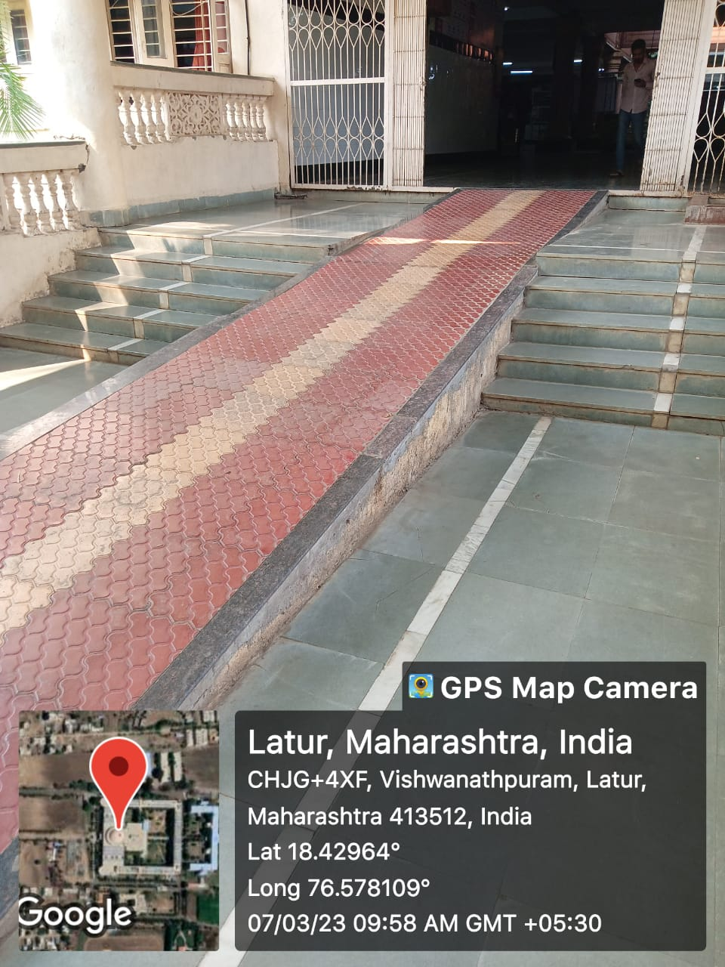
RAMPS FOR EASY ACCESS
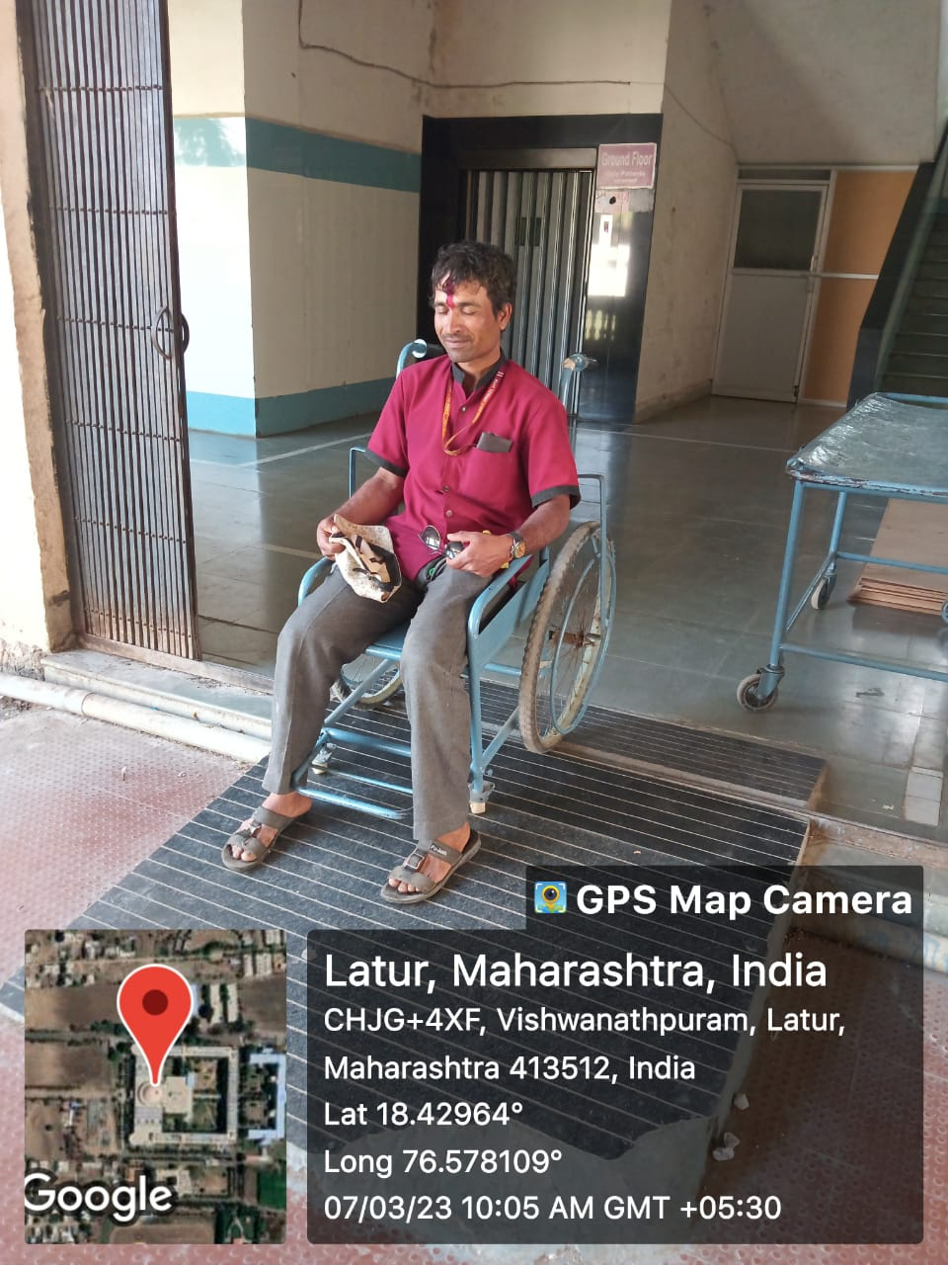
RAMPS FOR EASY ACCESS OF WHEEL CHAIR
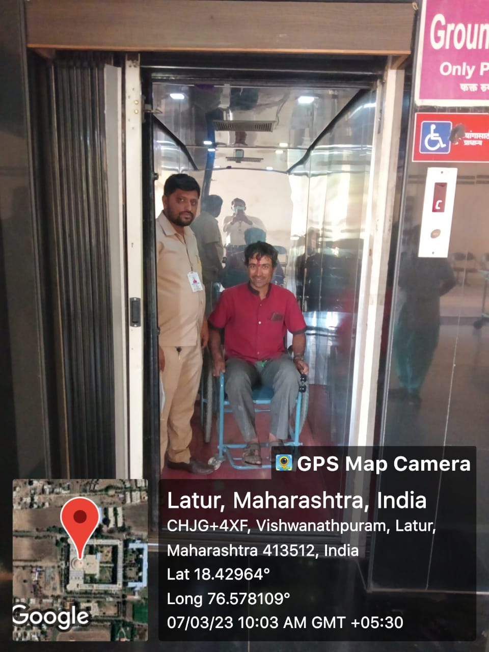
LIFTS FOR EASY ACCESS FOR PATIENTS
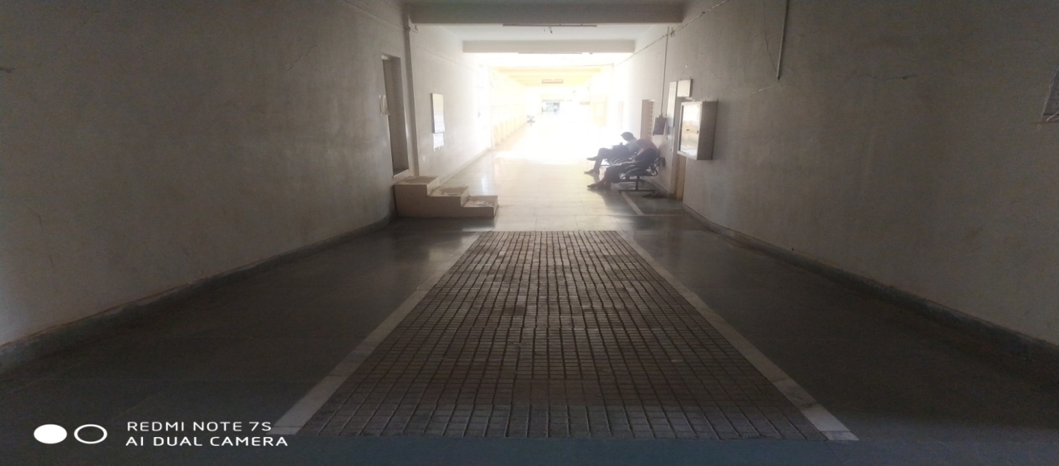RAMPS FOR EASY ACCESS

7.1.7: The Institution has disabled-friendly, barrier-free environment

Divyangjan friendly washrooms

7.1.7: The Institution has disabled-friendly, barrier-free environment

Signage including tactile path, lights, display boards and signposts

Inside the campus there are several signage and display to direct the building or department or the facilities available in the institute

DISPLAY BOARDS AND SIGNPOSTS
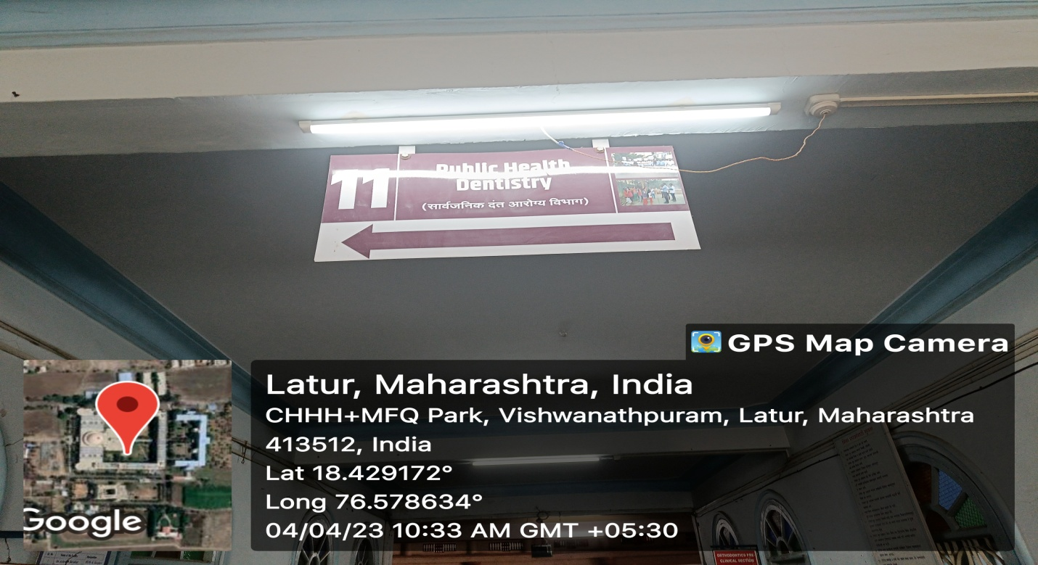
DISPLAY BOARDS AND SIGNPOSTS
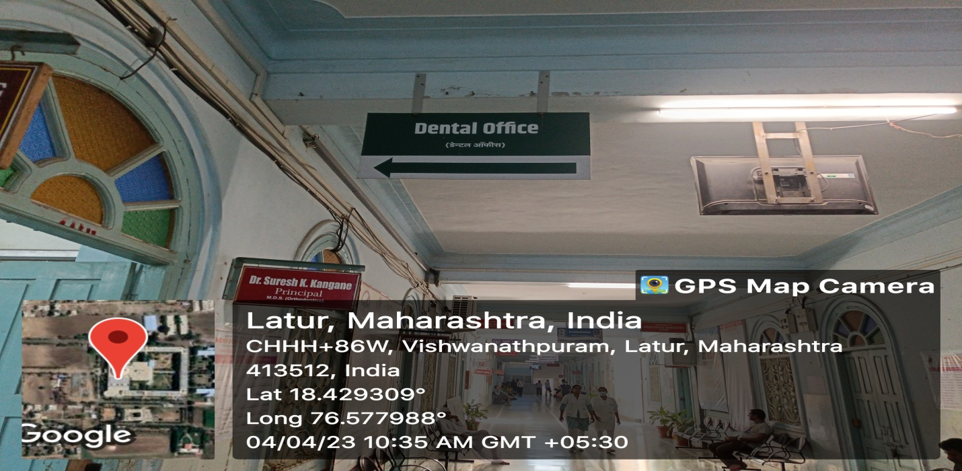
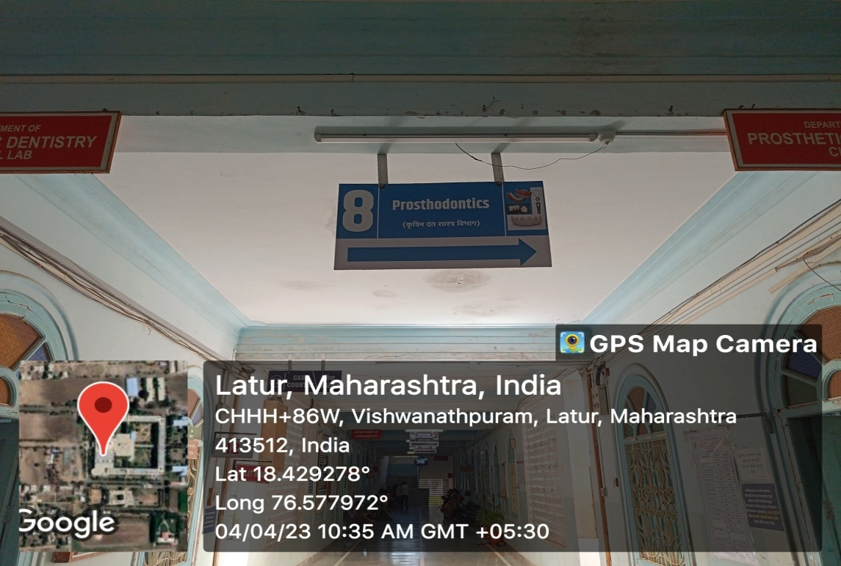
DISPLAY BOARDS AND SIGNPOSTS

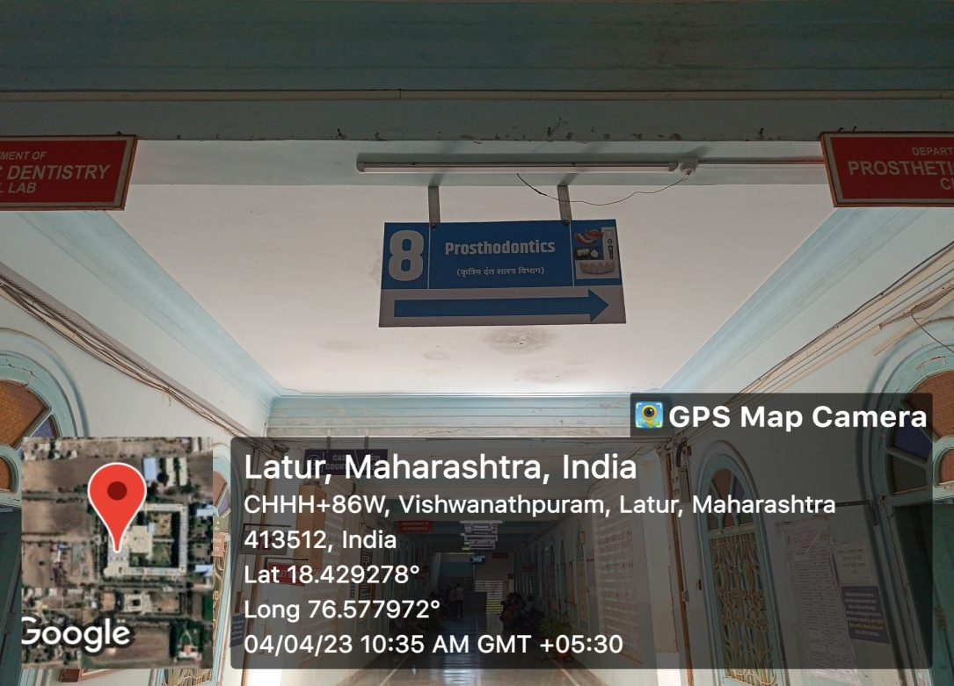
DISPLAY BOARDS AND SIGNPOSTS

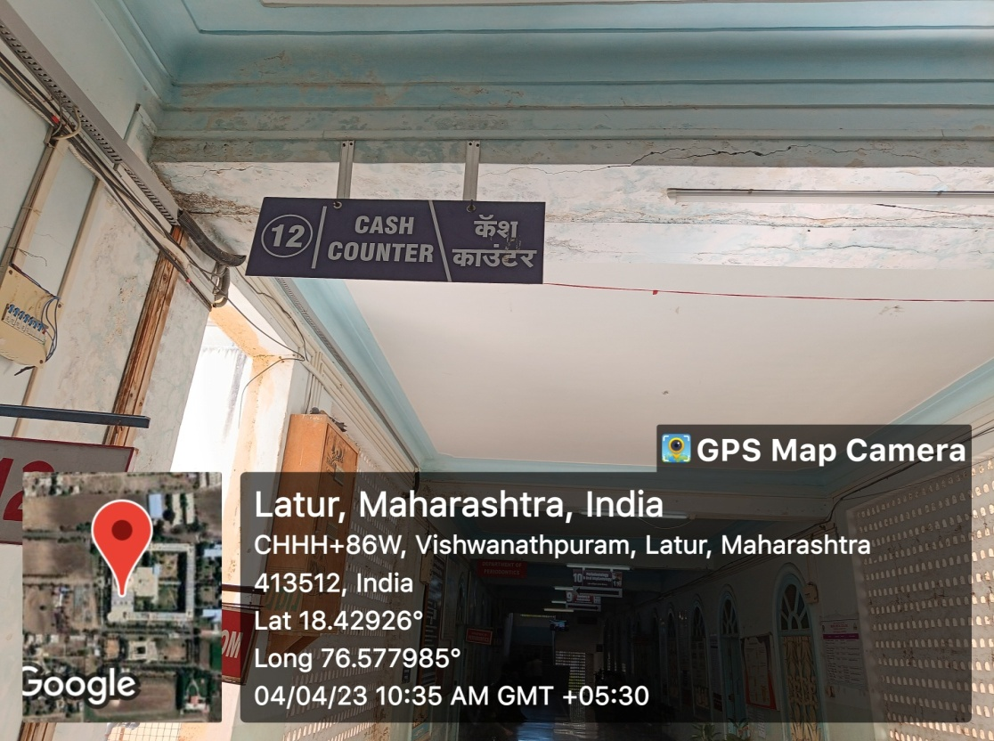
DISPLAY BOARDS AND SIGNPOSTS
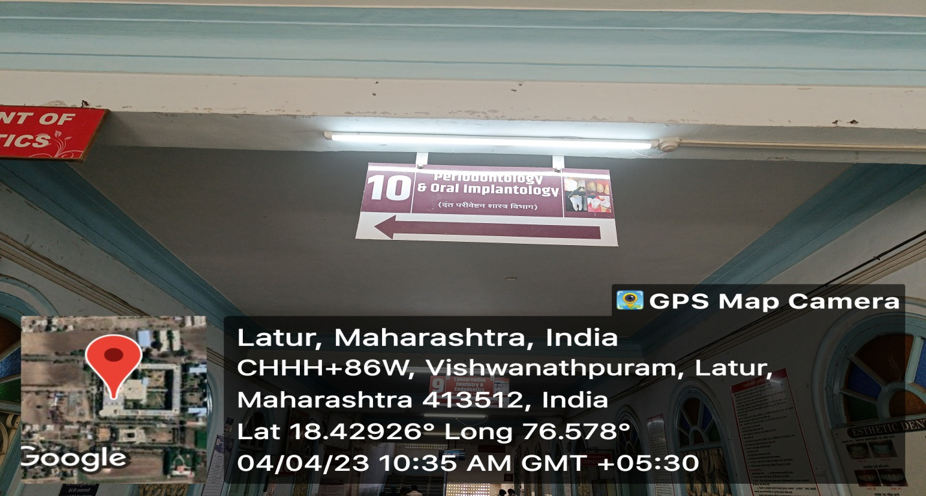
DISPLAY BOARDS AND SIGNPOSTS

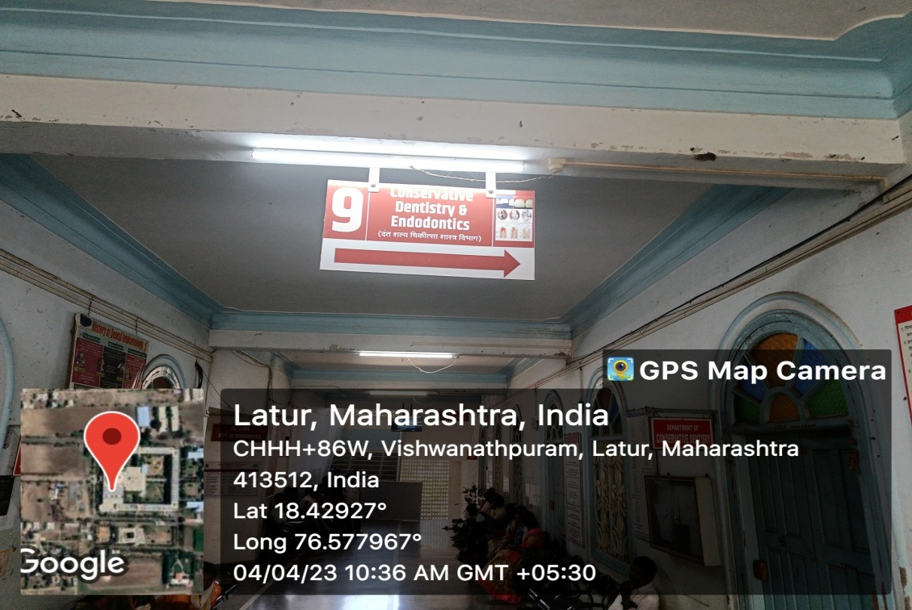
DISPLAY BOARDS AND SIGNPOSTS
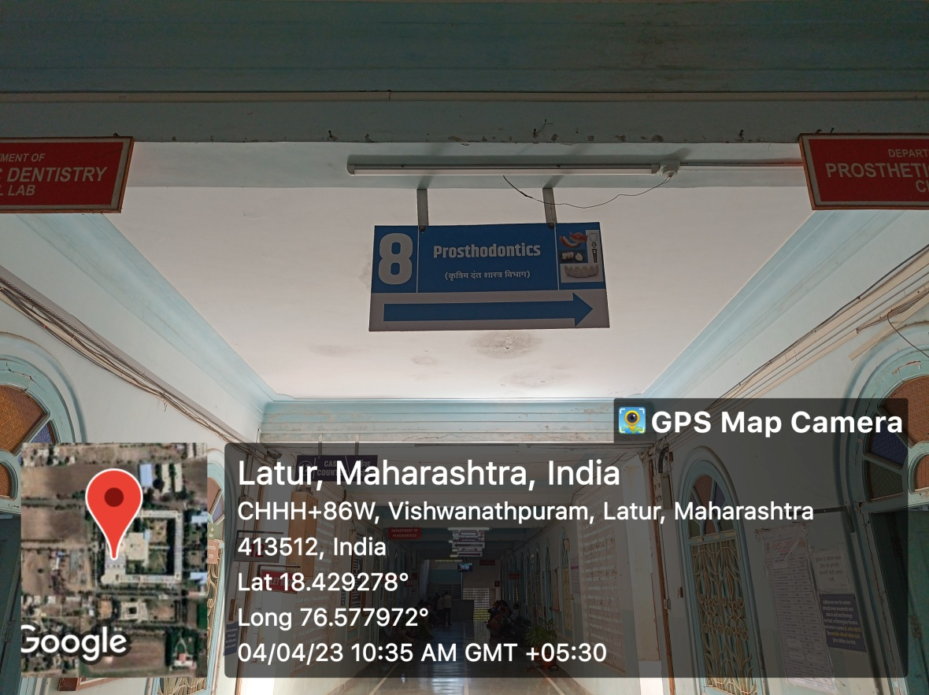
DISPLAY BOARDS AND SIGNPOSTS

DISPLAY BOARDS AND SIGNPOSTS

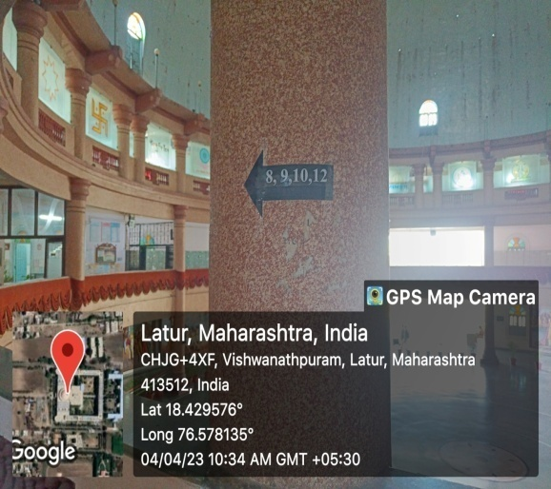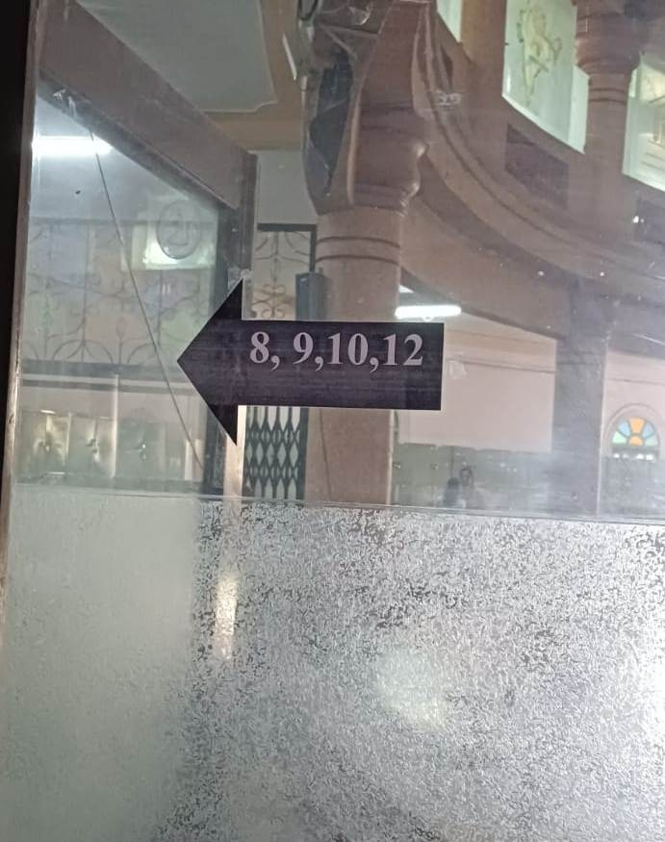
DISPLAY BOARDS AND SIGNPOSTS

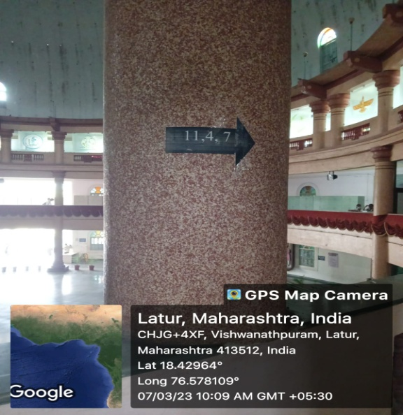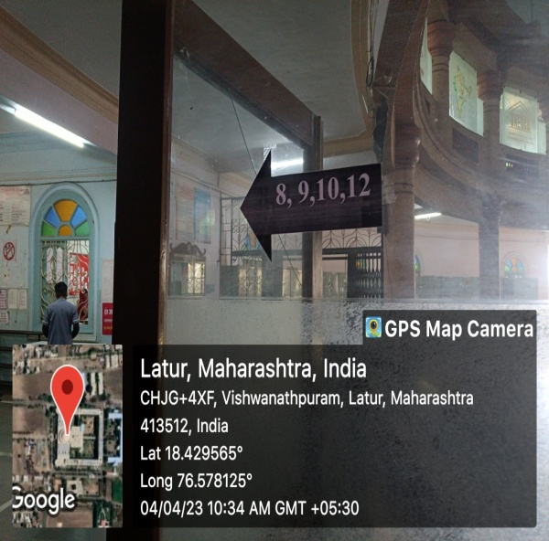

7.1.7: The Institution has disabled-friendly, barrier-free environment

Provision for enquiry and information: Human assistance, reader, scribe, soft copies of reading material, screen reading

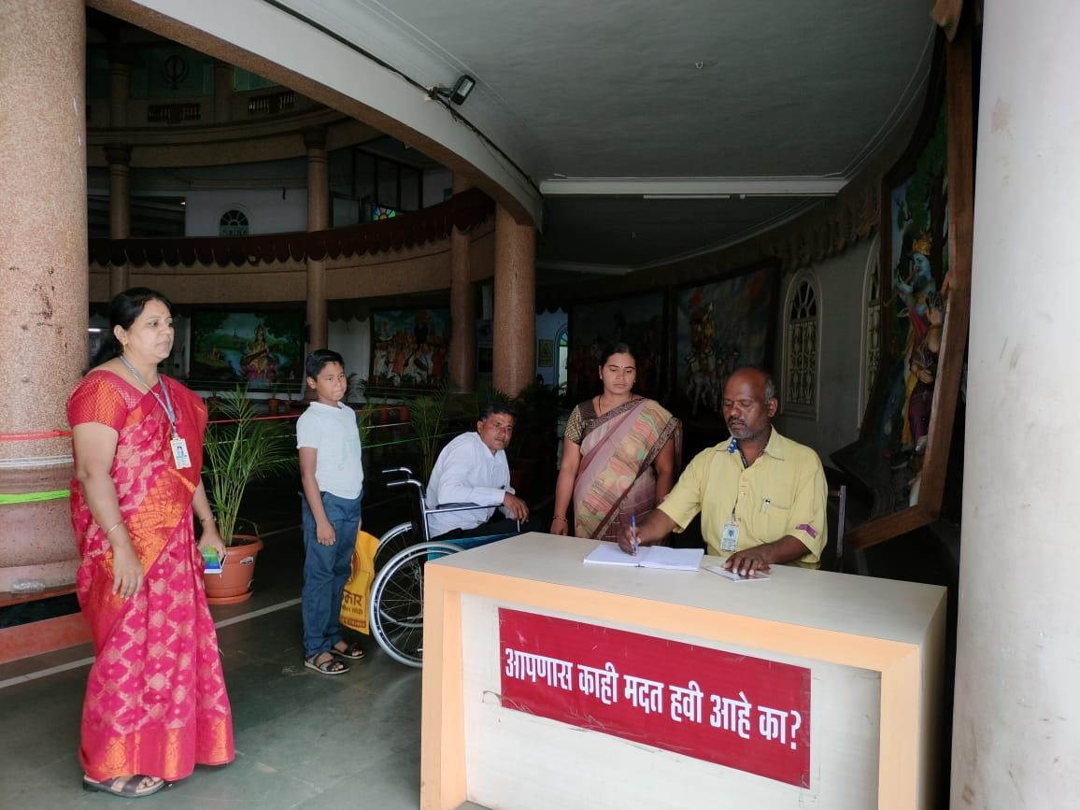
PROVISION FOR ENQUIRY AND INFORMATION
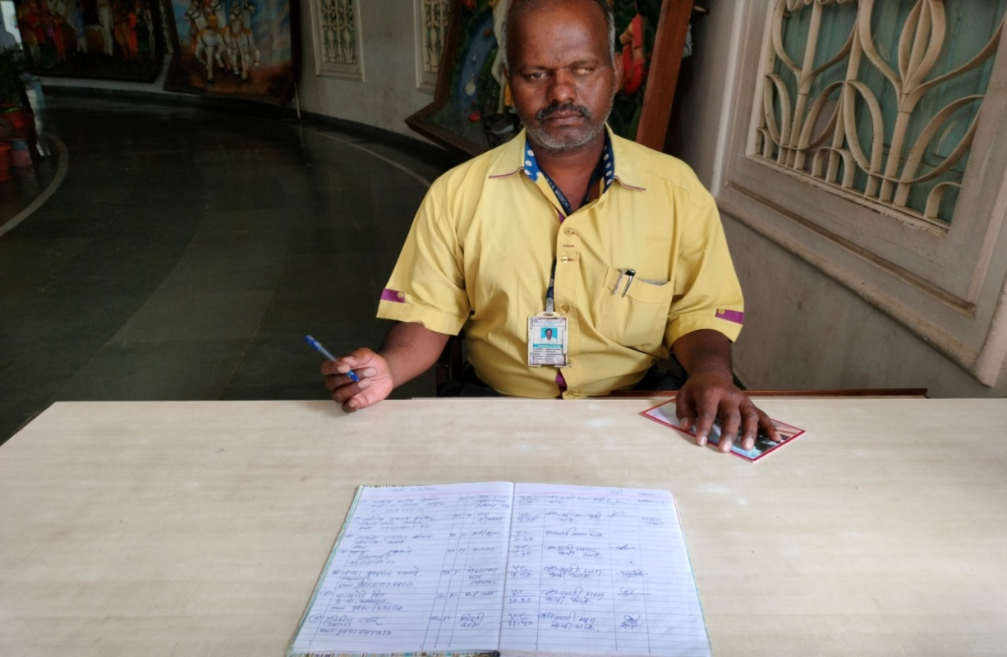
PROVISION FOR HUMAN ASSISTANCE
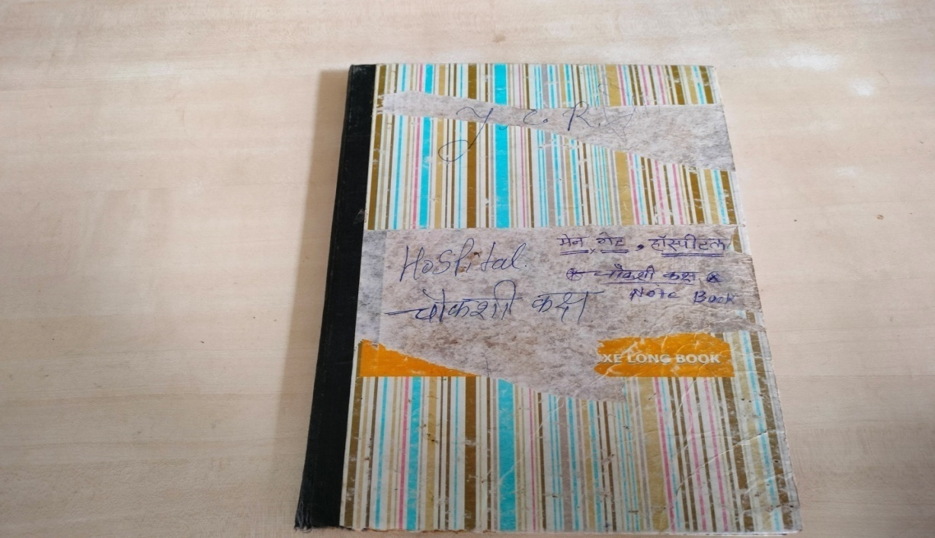
RECORD OF PROVIDING INFORMATION
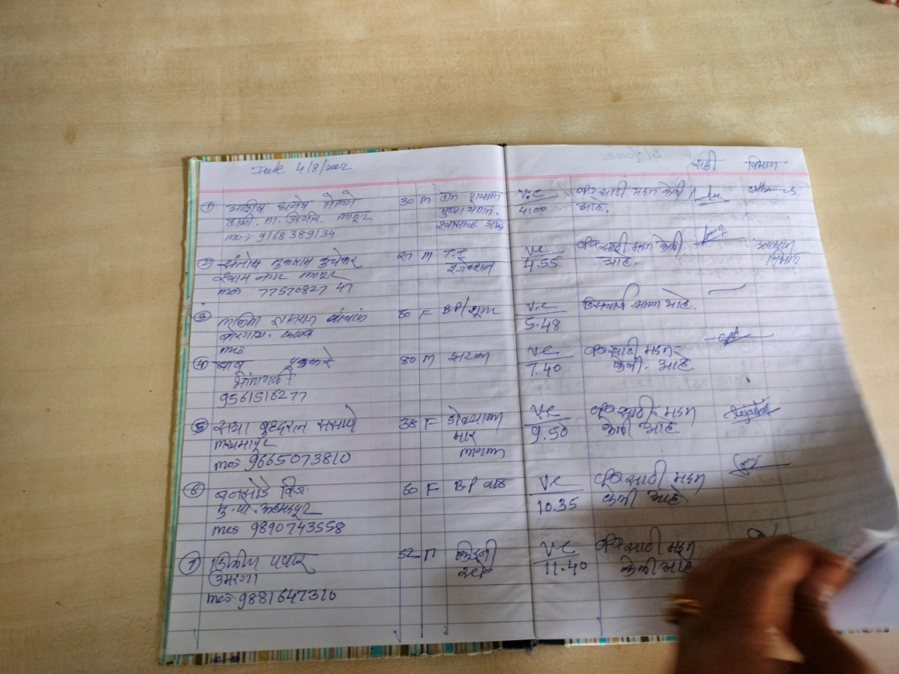
RECORD OF PROVIDING INFORMATION

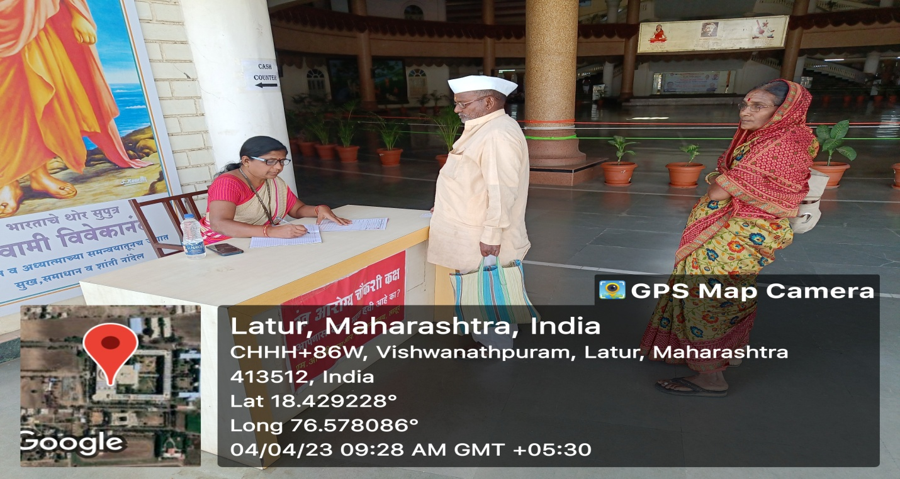
PROVISION FOR HUMAN ASSISTANCE
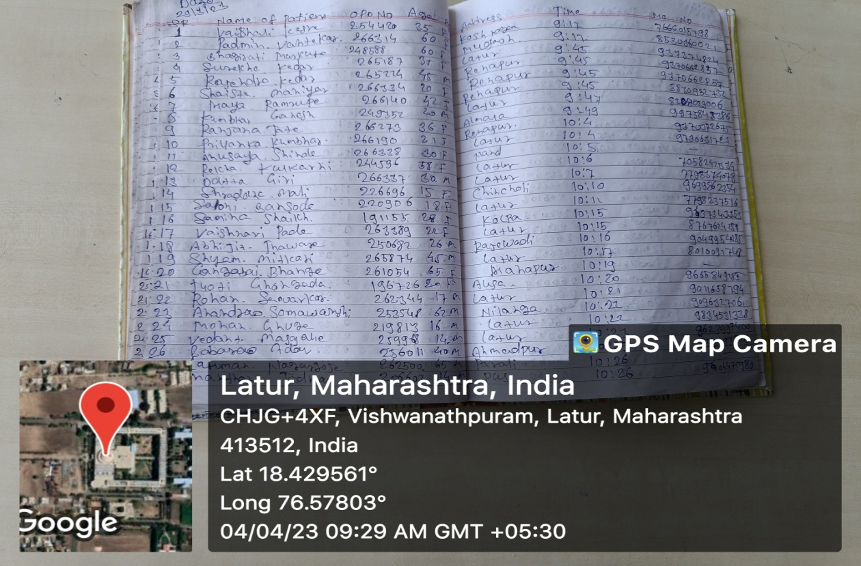
RECORD OF PROVIDING INFORMATION

